Canon Davis Memorial Church
Anglican Church of Canada
Sunday, June 18, 2023 – Third Sunday after Pentecost

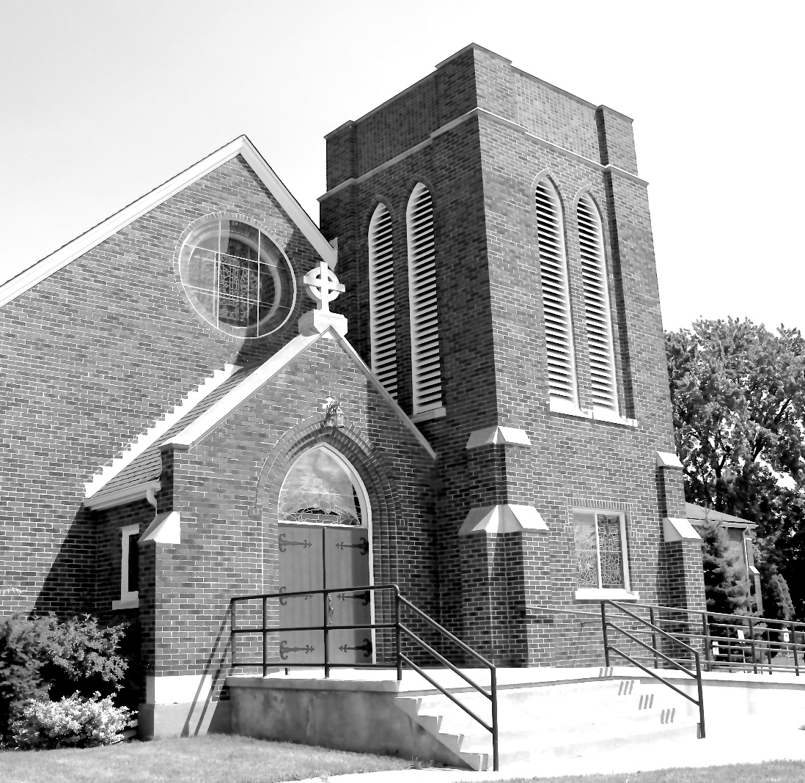

Worship Service: Sunday 9:30 a.m.
Officiant—Rev’d Jon Forbes — Assisted By — Bill Blunt
Organist—Dorothy Miller
380 Russell St. North (at Maxwell St.), Sarnia, Ontario, N7T 6S6
(519) 344-9531 - http://www.canondavis.com – canondavis@gmail.com

Prelude

Announcements
THE GATHERING OF THE COMMUNITY
Sentence
The kingdom of God is at hand; repent, and believe in the gospel.
Mark 1:15

Opening Hymn #505 Be Thou My Vision

The grace of our Lord Jesus Christ, and the love of God, and the fellowship of the Holy Spirit, be with you all.
And also with you.

Almighty God, to you all hearts are open, all desires known, and from you no secrets are hidden. Cleanse the thoughts of our hearts by the inspiration of your Holy Spirit, that we may perfectly love you, and worthily magnify your holy name; through Christ our Lord. Amen.

Glory to God in the highest, and peace to his people on earth.
Lord God, heavenly king, almighty God and Father, we worship you, we give you thanks, we praise you for your glory.

Lord Jesus Christ, only Son of the Father, Lord God, Lamb of God, you take away the sin of the world: have mercy on us; you are seated at the right hand of the Father: receive our prayer.

For you alone are the Holy One, you alone are the Lord, you alone are the Most High, Jesus Christ, with the Holy Spirit, in the glory of God the Father. Amen.

Lord, have mercy. Christ, have mercy. Lord, have mercy.
Collect of the Day
Almighty God, without you we are not able to please you. Mercifully grant that your Holy Spirit may in all things direct and rule our hearts; through Jesus Christ our Lord, who is alive and reigns with you and the Holy Spirit, one God, now and for ever.

THE PROCLAMATION OF THE WORD

1st Reading: Genesis 18: 1-15

The Word of the Lord.
Thanks be to God.

Psalm 116: 1, 10-17 (to be read responsively)

I love the Lord, because he has heard the voice of my supplication, because he has inclined his ear to me whenever I called upon him. How shall I repay the Lord for all the good things he has done for me?
I will lift up the cup of salvation and call upon the name of the Lord.
I will fulfil my vows to the Lord in the presence of all his people.
Precious in the sight of the Lord is the death of his servants.
O Lord, I am your servant; I am your servant and the child of your handmaid; you have freed me from my bonds.
I will offer you the sacrifice of thanksgiving and call upon the name of the Lord.
I will fulfil my vows to the Lord in the presence of all his people.
In the courts of the Lord's house, in the midst of you, O Jerusalem. Hallelujah!

2nd Reading: Romans 5: 1-8

The Word of the Lord
Thanks be to God.

Gradual Hymn # 572 Let There Be Light

Gospel

The Holy Gospel of our Lord Jesus Christ according to Matthew

Glory to you, Lord Jesus Christ.

Matthew 5: 9:35-10:8

The Gospel of Christ.
Praise to you, Lord Jesus Christ.

Sermon

The Apostles’ Creed:

Let us confess the faith of our baptism, as we say,
I believe in God, the Father almighty, creator of heaven and earth. I believe in Jesus Christ, his only Son, our Lord. He was conceived by the power of the Holy Spirit and born of the Virgin Mary. He suffered under Pontius Pilate, was crucified, died, and was buried. He descended to the dead. On the third day he rose again. He ascended into heaven, and is seated at the right hand of the Father. He will come again to judge the living and the dead. I believe in the Holy Spirit, the holy catholic Church, the communion of saints, the forgiveness of sins, the resurrection of the body, and the life everlasting. Amen.

Prayers of the People #1
(In peace let us pray to the Lord, saying, “Lord, have mercy.”)

For the peace from on high and for our salvation, let us pray to the Lord.
Lord, have mercy.

For the peace of the whole world, for the welfare of the holy Church of God, and for the unity of all, let us pray to the Lord.
Lord, have mercy.

For our bishops, and for all the clergy and people, let us pray to the Lord.
Lord, have mercy.

For Charles our King, for the leaders of the nations, and for all authority, let us pray to the Lord.
Lord, have mercy.

For Sarnia, for every city and community, and for those who live in them in faith, let us pray to the Lord.
Lord, have mercy.

For good weather, and for abundant harvests for all to share, let us pray to the Lord.
Lord, have mercy.

For those who travel by land, water, or air, for the sick and the suffering (especially), for prisoners and captives, and for their safety, health, and salvation, let us pray to the Lord.
Lord, have mercy.

For our deliverance from all affliction, strife, and need, let us pray to the Lord.
Lord, have mercy.

For the absolution and remission of our sins and offences, let us pray to the Lord.
Lord, have mercy.

For all who have died (especially ), let us pray to the Lord.
Lord, have mercy.

Remembering (… and) all the saints, we commit ourselves, one another, and our whole life to Christ our God.
To you, O Lord.

Almighty God, you have given us grace at this time with one accord to make our common supplications to you, and you have promised through your well-beloved Son that when two or three are gathered together you will hear their requests. Fulfil now our desires and petitions, as may be best for us, granting us in this world knowledge of your truth, and in the age to come eternal life; for you, Father, are good and loving, and we glorify you through your Son Jesus Christ our Lord, in the Holy Spirit, now and for ever. Amen.

In our parish cycle of prayer, we pray for…

Prayer for a Renewed Church
Almighty God, give us a new vision of you, of your love, of your grace and power, and then, give us a new vision of what you would have us do as your Church in this nation and at this time, and an awareness that in the strength of your Spirit, we can do it to your glory. In Jesus’ name we pray. Amen.

Confession and Absolution: Dear friends in Christ, God is steadfast in love and infinite in mercy; he welcomes sinners and invites them to his table. Let us confess our sins, confident in God’s forgiveness.

The Confession: Most merciful God,
we confess that we have sinned against you in thought, word, and deed, by what we have done, and by what we have left undone. We have not loved you with our whole heart; we have not loved our neighbours as ourselves. We are truly sorry and we humbly repent. For the sake of your Son Jesus Christ, have mercy on us and forgive us, that we may delight in your will, and walk in your ways, to the glory of your name. Amen.

Absolution: Almighty God have mercy upon you, pardon and deliver you from all your sins, confirm and strengthen you in all goodness, and keep you in eternal life; through Jesus Christ our Lord. Amen.

The Peace
The peace of the Lord be always with you.
And also with you.

Offertory Hymn #430 Will You Come and Follow Me

Offertory Response Doxology

Praise God, from Whom all blessings flow
Praise Him, all creatures here below.
Praise Him above, ye Heavenly Host.
Praise Father, Son, and Holy Ghost.

Prayer over the Gifts
God of reconciliation and forgiveness, the saving work of Christ has made our peace with you. May that work grow toward its perfection in all we offer you this day. We ask this in his name.

Eucharist Prayer #1

The Lord be with you.
And also with you.

Lift up your hearts.
We lift them to the Lord.

Let us give thanks to the Lord our God.
It is right to give our thanks and praise.

It is indeed right that we should praise you, gracious God, for you created all things. You formed us in your own image: male and female you created us. When we turned away from you in sin, you did not cease to care for us, but opened a path of salvation for all people. You made a covenant with Israel, and through your servants Abraham and Sarah gave the promise of a blessing to all nations. Through Moses you let your people from bondage into freedom; through the prophets you renewed your promise of salvation. Therefore, with them, and with all your saints who have served you in every age, we give thanks and raise our voices to proclaim the glory of your name.

Holy, holy, holy Lord,
God of power and might,
heaven and earth are full of your glory.
Hosanna in the highest.

Blessed is he who comes in the name of the Lord. Hosanna in the highest.

Holy God, source of life and goodness, all creation rightly give you praise. In the fullness of time, you sent your Son Jesus Christ, to share our human nature, to live and die as one of us, to reconcile us to you, the God and Father of all. He healed the sick and ate and drank with outcasts and sinners; he opened the eyes of the blind and proclaimed the good news of your kingdom to the poor and to those in need. In all things he fulfilled your gracious will.

On the night he freely gave himself to death, our Lord Jesus Christ took bread, and when he had given thanks to you, he broke it, and gave it to his disciples, and said, “Take, eat: this is my body which is given for you. Do this for the remembrance of me.”

After supper, He took the cup of wine, and when he had given thanks, he gave it to them, and said, “Drink this, all of you: this is my blood of the new covenant, which is shed for you and for many for the forgiveness of sins. Whenever you drink it, do this for the remembrance of me.”

Gracious God, his perfect sacrifice destroys the power of sin and death; by raising him to life you give us life for evermore.

Therefore, we proclaim the mystery of faith.
Christ has died.
Christ if risen.
Christ will come again.

Recalling his death, proclaiming his resurrection, and looking for his coming again in glory, we offer you, Father, this brad and this cup. Send your Holy Spirit upon us and upon these gifts, that all who eat and drink at this table may be one body and one holy people, a living sacrifice in Jesus Christ, our Lord.

Through Christ, with Christ, and in Christ, in the unity of the Holy Spirit, all glory is yours, almighty Father, now and for ever. Amen.

The Lord’s Prayer: Our Father, who art in heaven, hallowed be thy name, thy kingdom come, thy will be done, on earth as it is in heaven. Give us this day our daily bread. And forgive us our trespasses, as we forgive those who trespass against us. And lead us not into temptation, but deliver us from evil. For thine is the kingdom, the power, and the glory, for ever and ever. Amen.
Breaking of the Bread:
“I am the bread of life,” says the Lord. “Whoever comes to me will never by hungry; whoever believes in me will never thirst.”
Taste and see that the Lord is good; happy are they who trust in him?

The Communion
The gifts of God for the people of God.
Thanks be to God.

Prayer after Communion
Holy and blessed God, as you give us the body and blood of your Son, guide us with your Holy Spirit, that we may honour you not only with our lips but also in our lives. This we ask in the name of Jesus Christ our Lord.

Doxology
Glory to God, Whose power, working in us, can do infinitely more than we can ask or imagine. Glory to God from generation to generation, in the Church and in Christ Jesus, for ever and ever. Amen.

Recessional Hymn # 560 God Whose Almighty Word

Blessing
The peace of God which passes all understanding, keep your hearts and minds in the knowledge and love of God and of his son Jesus Christ and the blessing of God Almighty the Father, the Son and the Holy Spirit be with you and those you love for ever more. Amen.

Benediction Song Go Now in Peace
(found in the back of the blue hymn book)
Dismissal
The flowers on the Altar today are given to
the Glory of God and in loving memory of Kathy,
a gift of Bill and family.

Please enter names in the Intercessions Book each week to be read in the service.
NEWS AND EVENTS

- Please send all announcements for the bulletin to Karen by 11:00 a.m. Tuesday of each week. Call 519-344-9531 or E-mail: canondavis@gmail.com.
- If you would like a home visit with Communion, please contact the office as a Lay Visitor will be available in the coming weeks.
- Please join us for Coffee Hour after service for a time of fellowship in the
parish hall.
- Turkey pies $5.50, Shepherd's Pie $6.00 each. To order, call
519-344-9531.

Upcoming Events:
- On Wednesday June 21, The ACW Ladies Guild and Friends Annual Luncheon will be held at 12:30 p.m. in the Parish Hall. Please RSVP by June 11 by contacting Carol at 519 491 9319 or Karen at 519 344 9531. A sign-in sheet will also be available at the back of the church. Free Will Offering.
- Service at Canatara Park The parishes of St Bart’s, St Paul's and St John in the Wilderness are inviting us to join them for a coming together at the pavilion at Canatara Park for a shared worship and lunch. The service is planned for June 25 at 10 AM with a lunch afterward of a BBQ, sides and dessert. Joyce Hodgson is scheduled to preach. Everyone is asked to bring their own chair, coffee or tea if they'd like. For lunch the plan is to BBQ and folks to bring a side or dessert to share. The cost of the pavilion and BBQ’ d food is being split between the three churches. If another parish decides to come and would like to contribute to these costs, that would be welcome. Amanda would like a headcount before June 18. There is a sign-up sheet at the back of the church. Thank you.

Reminders
21 June ACW Ladies Guild and Friends Annual Luncheon – 12:30 p.m.
25 June Service at Canatara Park 10:00 a.m.
28 June Parish Council Meeting – Boardroom 10:00 a.m.

