Canon Davis Memorial Church
Anglican Church of Canada
Twentieth Sunday after Pentecost
23rd October, 2022

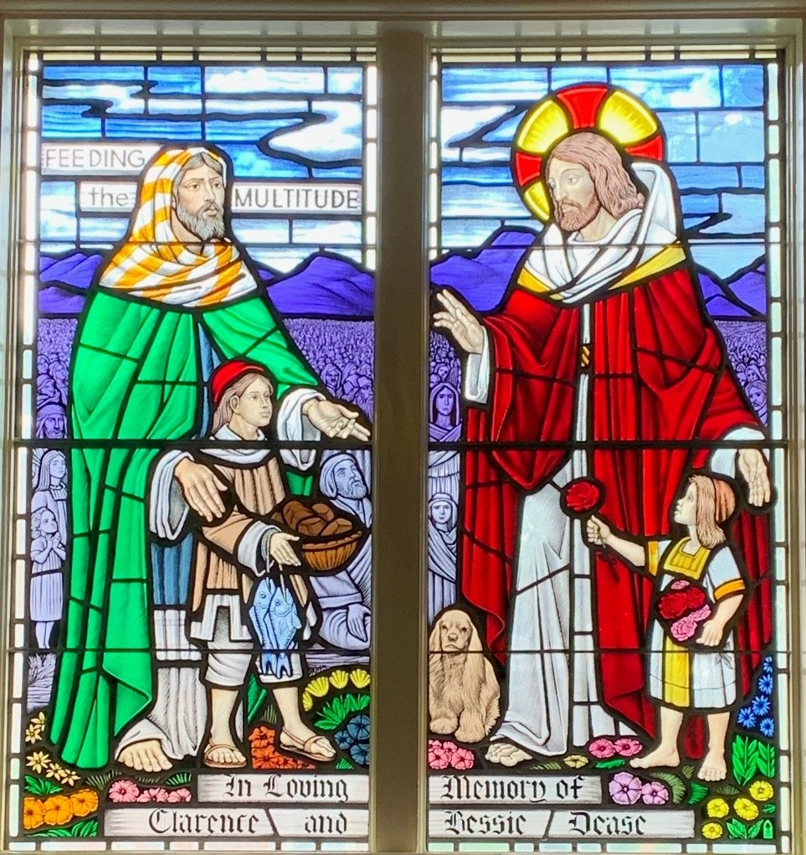

Officiant: Ginny Schleihauf -- Organist: Dorothy Miller -- Reader: Carol Turner
380 Russell St. North (at Maxwell St.), Sarnia, Ontario, N7T 6S6
Tel: (519) 344-9531 - Email: canondavis@gmail.com – http://www.canondavis.com

23rd October 2022 — 20th Sunday after Pentecost

Service of the Word

Gathering Hymn # 384 Praise to the Lord, the Almighty (vs 1,2,3 & 6)

Officiant: The grace of our Lord Jesus Christ and the love of God and the
fellowship of the Holy Spirit be with you all.
People: And also with you.

Officiant: Let us pray.
We thank you, O God, that you have again brought us together on the Lord’s Day to praise you for your goodness and to ask your blessing. Give us grace to see your hand in the week that is past, and your purpose in the week to come; through Christ our Lord.
People: Amen.

Officiant: Dear friends in Christ, as we turn our hearts and minds to
worship almighty God, let us confess our sins.

People: Most merciful God, we confess that we have sinned
against you in thought, word, and deed, by what we have done and by what we have left undone. We have not loved you with our whole heart; we have not loved our neighbours as ourselves. We are truly sorry and we humbly repent. For the sake of your Son Jesus Christ, have mercy on us and forgive us, that we may delight in your will, and walk in your ways, to the glory of your name. Amen.

Officiant: Merciful God, grant to us, your faithful people, pardon and
peace, that we may be cleansed from all our sins and serve you with a quiet mind through Jesus Christ our Lord, who is alive and reigns with you and the Holy Spirit, one God, now and for ever.
People: Amen.
Officiant: The Peace of the Lord be always with you.
People: And also with you.

Officiant: Let us reconcile to God and one another a sign of Christ’s
peace.

The Collect of the Day
Lord God our redeemer, who heard the cry of your people and sent your servant Moses to lead them out of slavery, free us from the tyranny of sin and death, and by the leading of your Spirit bring us to our promised land; through Jesus Christ our Lord, who lives and reigns with you and the Holy Spirit, one God, now and for ever.

The Proclamation of the Word

First Reading Joel 2: 23-32
Officiant: The Word of the Lord.
People: Thanks be to God.

Psalm 65 (Response in bold.)

You are to be praised, O God, in Zion; to you shall vows be performed in Jerusalem.
To you that hear prayer shall all flesh come, because of their transgressions.
Our sins are stronger than we are, but you will blot them out.
Happy are they whom you choose and draw to your courts to dwell there! they will be satisfied by the beauty of your house, by the holiness of your temple.
Awesome things will you show us in your righteousness, O God of our salvation, O Hope of all the ends of the earth and of the seas that are far away.
You make fast the mountains by your power; they are girded about with might.
You still the roaring of the seas, the roaring of their waves, and the clamour of the peoples.
Those who dwell at the ends of the earth will tremble at your marvellous signs; you make the dawn and the dusk to sing for joy.
You visit the earth and water it abundantly; you make it very plenteous; the river of God is full of water.
You prepare the grain, for so you provide for the earth.
You drench the furrows and smooth out the ridges; with heavy rain you soften the ground and bless its increase.
You crown the year with your goodness, and your paths overflow with plenty.
May the fields of the wilderness be rich for grazing, and the hills be clothed with joy.
May the meadows cover themselves with flocks, and the valleys cloak themselves with grain; let them shout for joy and sing.

Second Reading II Timothy 4: 6-8, 16-18
Officiant: The Word of the Lord.
People: Thanks be to God.

Officiant: The Lord be with you.
People: And also with you.

Officiant: The Holy Gospel of our Lord Jesus Christ according to Luke.
People: Glory to you, Lord Jesus Christ.

The Gospel Luke 18: 9-14

THE HOLY GOSPEL OF OUR LORD JESUS CHRIST
ACCORDING TO LUKE
Jesus also told this parable to some who trusted in themselves that they were righteous and regarded others with contempt: "Two men went up to the temple to pray, one a Pharisee and the other a tax collector. The Pharisee, standing by himself, was praying thus, 'God, I thank you that I am not like other people: thieves, rogues, adulterers, or even like this tax collector. I fast twice a week; I give a tenth of all my income.' But the tax collector, standing far off, would not even look up to heaven, but was beating his breast and saying, 'God, be merciful to me, a sinner!' I tell you, this man went down to his home justified rather than the other; for all who exalt themselves will be humbled, but all who humble themselves will be exalted.

Officiant: The Gospel of the Christ
People: Praise to you, Lord Jesus Christ.

Sermon

Sermon Hymn #644 Come, Gracious Spirit, Heavenly Dove

Officiant: Let us confess our faith as we say.
People: I believe in God, the Father Almighty, creator of heaven
and earth.
I believe in Jesus Christ, his only Son, our Lord.
He was conceived by the power of the Holy Spirit and
born of the Virgin Mary.
He suffered under Pontius Pilate, was crucified, died, and
was buried.
He descended to the dead.
On the third day he rose again.
He ascended into heaven, and is seated at the right hand
of the Father.
He will come again to judge the living and the dead.
I believe in the Holy Spirit, the holy catholic Church, the communion of saints, the forgiveness of sins, the resurrection of the body, and the life everlasting. Amen.

Prayers of the People

In peace we pray to you, Lord God.
Silence
For all people in their daily life and work;
For our families, friends, and neighbours, and for all those who are alone.
For this community, our country, and the world;
For all who work for justice, freedom, and peace.
For the just and proper use of your creation;
For the victims of hunger, fear, injustice, and oppression.
For all who are in danger, sorrow, or any kind of trouble;
For those who minister to the sick, the friendless, and needy.
For the peace and unity of the Church of God;
For all who proclaim the gospel, and all who seek the truth.
For Todd our bishop, and for all bishops and other ministers;
For all who serve God in the Church.
For our own needs and those of others.
Silence.
In our parish cycle of prayer, we pray for…
Hear us, Lord.
For your mercy is great.
We thank you, Lord, for all the blessings of this life.
Silence. (The people may add their own thanksgivings.)

We will exalt you, O God our king;
And praise your name for ever and ever.
We pray for those who have died in the peace of Christ, and for those whose faith is known to you alone, that they may have a place in your eternal kingdom.
Silence.
Lord, let your loving kindness be upon them;
Who put their trust in you.
Gracious God, you have heard the prayers of your faithful people; you know our needs before we ask, and our ignorance in asking. Grant our requests as may be best for us. This we ask in the name of your Son Jesus Christ our Lord.
Amen

Offertory Hymn #533 Jesus, Lover of My Soul

Offertory Response All Things Come of Thee

People: Yours, Lord, is the greatness, the power, the glory, the
splendour, and the majesty; for everything in heaven and on earth is yours. All things come from you, and of your own do we give you.

Officiant: And now, as our Saviour Christ has taught us,
we are bold to say,
People: Our Father, who art in heaven,
hallowed be thy name,
thy kingdom come,
thy will be done, on earth as it is in heaven.
Give us this day our daily bread.
And forgive us our trespasses,
as we forgive those who trespass against us.
And lead us not into temptation, but deliver us from evil.
For thine is the kingdom,
the power, and the glory, for ever and ever. Amen.

Officiant: Glory to God
People: whose power, working in us, can do infinitely more than
we can ask or imagine. Glory to God from generation to generation, in the Church and in Christ Jesus, for ever and ever. Amen.

Announcements

Closing Hymn #380 O Worship the King

Officiant: May the God of hope fill us all with joy and peace in believing
through the power of the Holy Spirit. Amen.

Sung Benediction Howard’s Blessing (vs 1-2)
(in the back of the blue Hymn book)

The Flowers on the Altar today are given to the Glory of God and with loving memories of Nancy Dease’s family, Don, Baby son, Bruce, parents, Alice and Bert Taylor and
brothers, Jim and Murray.

Please enter names in the Intercessions Book each week to be read in the service.

News and Events

- Please send all announcements for the bulletin to Karen by 11:00 a.m. Tuesday of each week. Call: 519-344-9531 or E-mail: canondavis@gmail.com.

- If you would like a home visit with Communion or know of someone who would, please let Rev. Ray know as he and/or a Lay Visitor will be available in the coming weeks.

- Please join us for Coffee Hour after service for a time of fellowship in the parish hall.

- Mark your calendars as on Saturday October 29 and November 26 Sew Day returns to CDM from 9:00 till 3:00 p.m. Cost $20.00, lunch included. Bring your projects for a show and tell Sew Day.

Upcoming Events:

Oct 26 Please note: The Parish Council Meeting originally scheduled for at 10:00 a.m. in the Boardroom has been changed to 3:00 p.m.
Oct 29 Sew Day in the Parish Hall
Nov 26 Sew Day in the Parish Hall

