Canon Davis Memorial Church
Anglican Church of Canada
Fourth Sunday in Lent
19th March, 2023

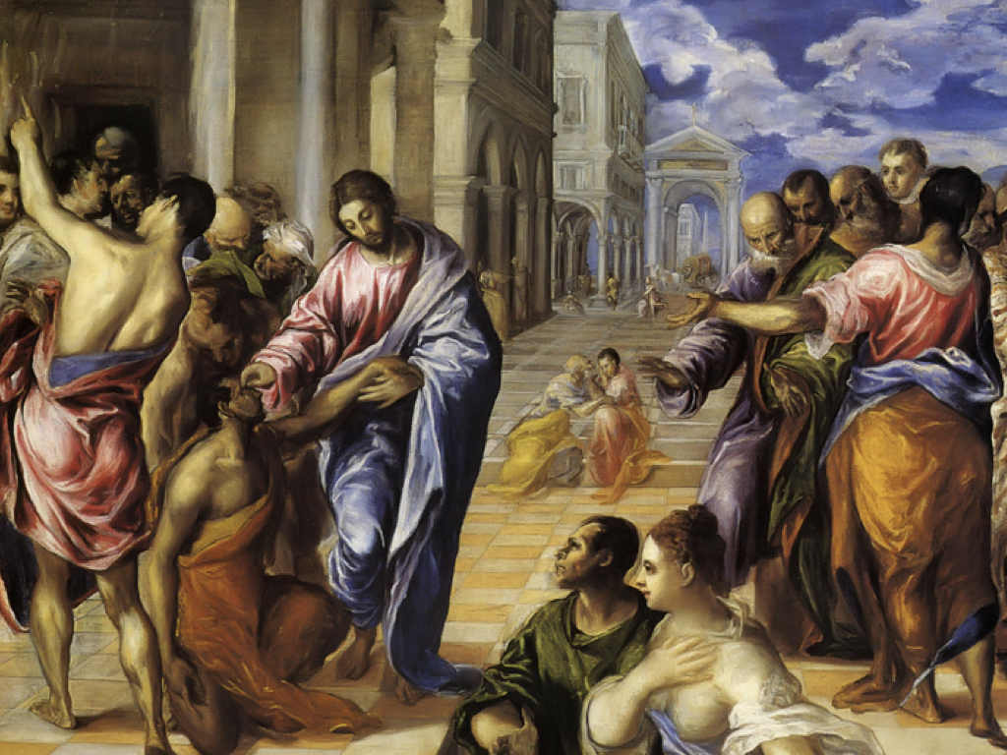

Healing of the Blind Man

Officiant: Rev’d Paul Woolley
Reader: Elaine Hayter Organist: Dorothy Miller
Acolyte: Tom Brown Intercessor: Bill Graham
380 Russell St. North (at Maxwell St.), Sarnia, Ontario, N7T 6S6
Tel: (519) 344-9531 - Email: canondavis@gmail.com – http://www.canondavis.com

March 19, 2023 — Fourth Sunday in Lent

THE GATHERING OF THE COMMUNITY

Gathering Hymn # 341 God of Mercy, God of Grace
Greeting p. 185
Kyrie Eleison p. 186

Collect of the Day: Almighty God, through the waters of baptism your Son has made us children of light. May we ever walk in his light and show forth your glory in the world; through Jesus Christ our Lord, who is alive and reigns with you and the Holy Spirit, one God, now and for ever. AMEN

THE PROCLAMATION OF THE WORD

1st reading 1 Samuel 16: 1-13

Psalm 23 REFRAIN The Lord is my shepherd, I shall not be in want.
The Lord is my shepherd; I shall not be in want. He makes me lie down in green pastures and leads me beside still waters.
The Lord is my shepherd, I shall not be in want.
He revives my soul and guides me along right pathways for his name's sake. Though I walk through the valley of the shadow of death, I shall fear no evil; for you are with me; your rod and your staff, they comfort me.
The Lord is my shepherd, I shall not be in want.
You spread a table before me in the presence of those who trouble me; you have anointed my head with oil, and my cup is running over. Surely your goodness and mercy shall follow me all the days of my life, and I will dwell in the house of the Lord for ever.
The Lord is my shepherd, I shall not be in want.
2nd reading Ephesians 5: 8-14
Gradual Hymn # 606 There’s a Wideness in God’s Mercy
Gospel John 9: 1-41
Sermon - Paul+
The Apostles’ Creed p. 189

Prayers of the People Let us pray for spiritual renewal in our church so that we may walk by the light of gospel faith. Our prayer response today is: Guide us by your Spirit, O Christ.

For the pastors of the universal church, Bishop Todd and all bishops and priests who have been anointed for service; may their personal love for Christ bring spiritual refreshment to God’s people. We ask in faith:
Guide us by your Spirit, O Christ.

For those who are preparing for confirmation or baptism; may the Spirit of truth rush upon their hearts and minds and claim their futures for Christ. We ask in faith:
Guide us by your Spirit, O Christ.

For Christians who have grown slack in faith and morals; may the Spirit renew within them the light of baptismal grace and remove any moral blindness to racism, violence, drug abuse, and gender discrimination. We ask in faith:
Guide us by your Spirit, O Christ.

For all who proclaim the gospel; may the Spirit of knowledge and understanding bless their efforts to help the church in teaching about goodness, justice, and truth. We ask in faith:
Guide us by your Spirit, O Christ.

For those who are ill or who suffer with pain and medical conditions; may the healing hand of Jesus bring them comfort. We ask in faith:
Guide us by your Spirit, O Christ. >>

For those who have died in Christ; may the Spirit who raised Jesus from the dead fill them with eternal light and life. We ask in faith:
Guide us by your Spirit, O Christ.

God of eternal light, you have cast out the power of darkness through the life-giving death of Christ. Continue to draw the church into the fullness of your divine life by the working of your Spirit. Grant our prayers through Christ, our Lord. Amen.

Prayer for a Renewed Church: Almighty God, give us a new vision of you, of your love, of your grace and power, and then, give us a new vision of what you would have us do as your Church in this nation and at this time, and an awareness that in the strength of your Spirit, we can do it to your glory. In Jesus’ name we pray. Amen.

Confession and Absolution p. 191
The Peace
Offertory Hymn # 615 Just As I Am
Offertory Response Doxology (sung)
Praise God, from Whom all blessings flow.
Praise Him, all creatures here below.
Praise Him above, ye Heavenly Host.
Praise Father, Son, and Holy Ghost.

THE CELEBRATION OF THE HOLY EUCHARIST

Prayer over the Gifts: God of light, your Word brings to us a new vision of your glory. Accept our offering of praise and thanksgiving, through Jesus Christ our Lord. Amen.

Eucharistic Prayer # 5 p. 204
The Lord’s Prayer p. 211
Breaking of the Bread # 7 p. 213
Communion

Prayer After Communion: Father, through your goodness we receive your Son in word and sacrament. May we always have faith in him, Jesus Christ the Lord. Amen.

Glory to God & Blessing p. 214

Announcements

Mission Hymn # 444 Your Hand, O God, Has Guided

Go in peace to love and serve the Lord.
Thanks be to God.

Sung Benediction Go Now in Peace
(in the back of the blue Hymn book)

The Flowers on the Altar today are given to the glory of God, and in loving memory of Andrew, a gift from his family.

Please enter names in the Intercessions Book each week to be read in the service.

__________________________________

News and Events

- Please send all announcements for the bulletin to Karen by 11:00 a.m. Tuesday of each week. Call: 519-344-9531 or E-mail: canondavis@gmail.com.

- If you would like a home visit with Communion or know of someone who would, please let Rev. Ray know as he and/or a Lay Visitor will be available in the coming weeks.

- Please join us for Coffee Hour after service for a time of fellowship in the parish hall.

- To all the ladies of Canon Davis. As I stated in my report to Vestry this year the Ladies Guild has not held formal meetings since the advent of COVID. I thought perhaps you would enjoy holding a social get-together other than our lunch at Olive’s in June. Please let me know if you would like to attend a lunch on Wednesday, March 29 at 12:30 p.m. in the Parish Hall (free will offering). Carol Mercurio 519-491-9319. Hope to see you there.

- Easter Lily Memorial: If you have any changes or updates for our Easter Memorial list, please contact Karen at 519-344-9531. Thank you.

Reminders
Mar 22 Parish Council 10:00 a.m. in the Boardroom
Mar 25 Sew Day 9:00 a.m. to 3:00 p.m.
Mar 29 Ladies Lunch – Parish Hall 12:30 p.m.

