Canon Davis Memorial Church
Anglican Church of Canada
Sixth Sunday after Epiphany
12th February, 2023

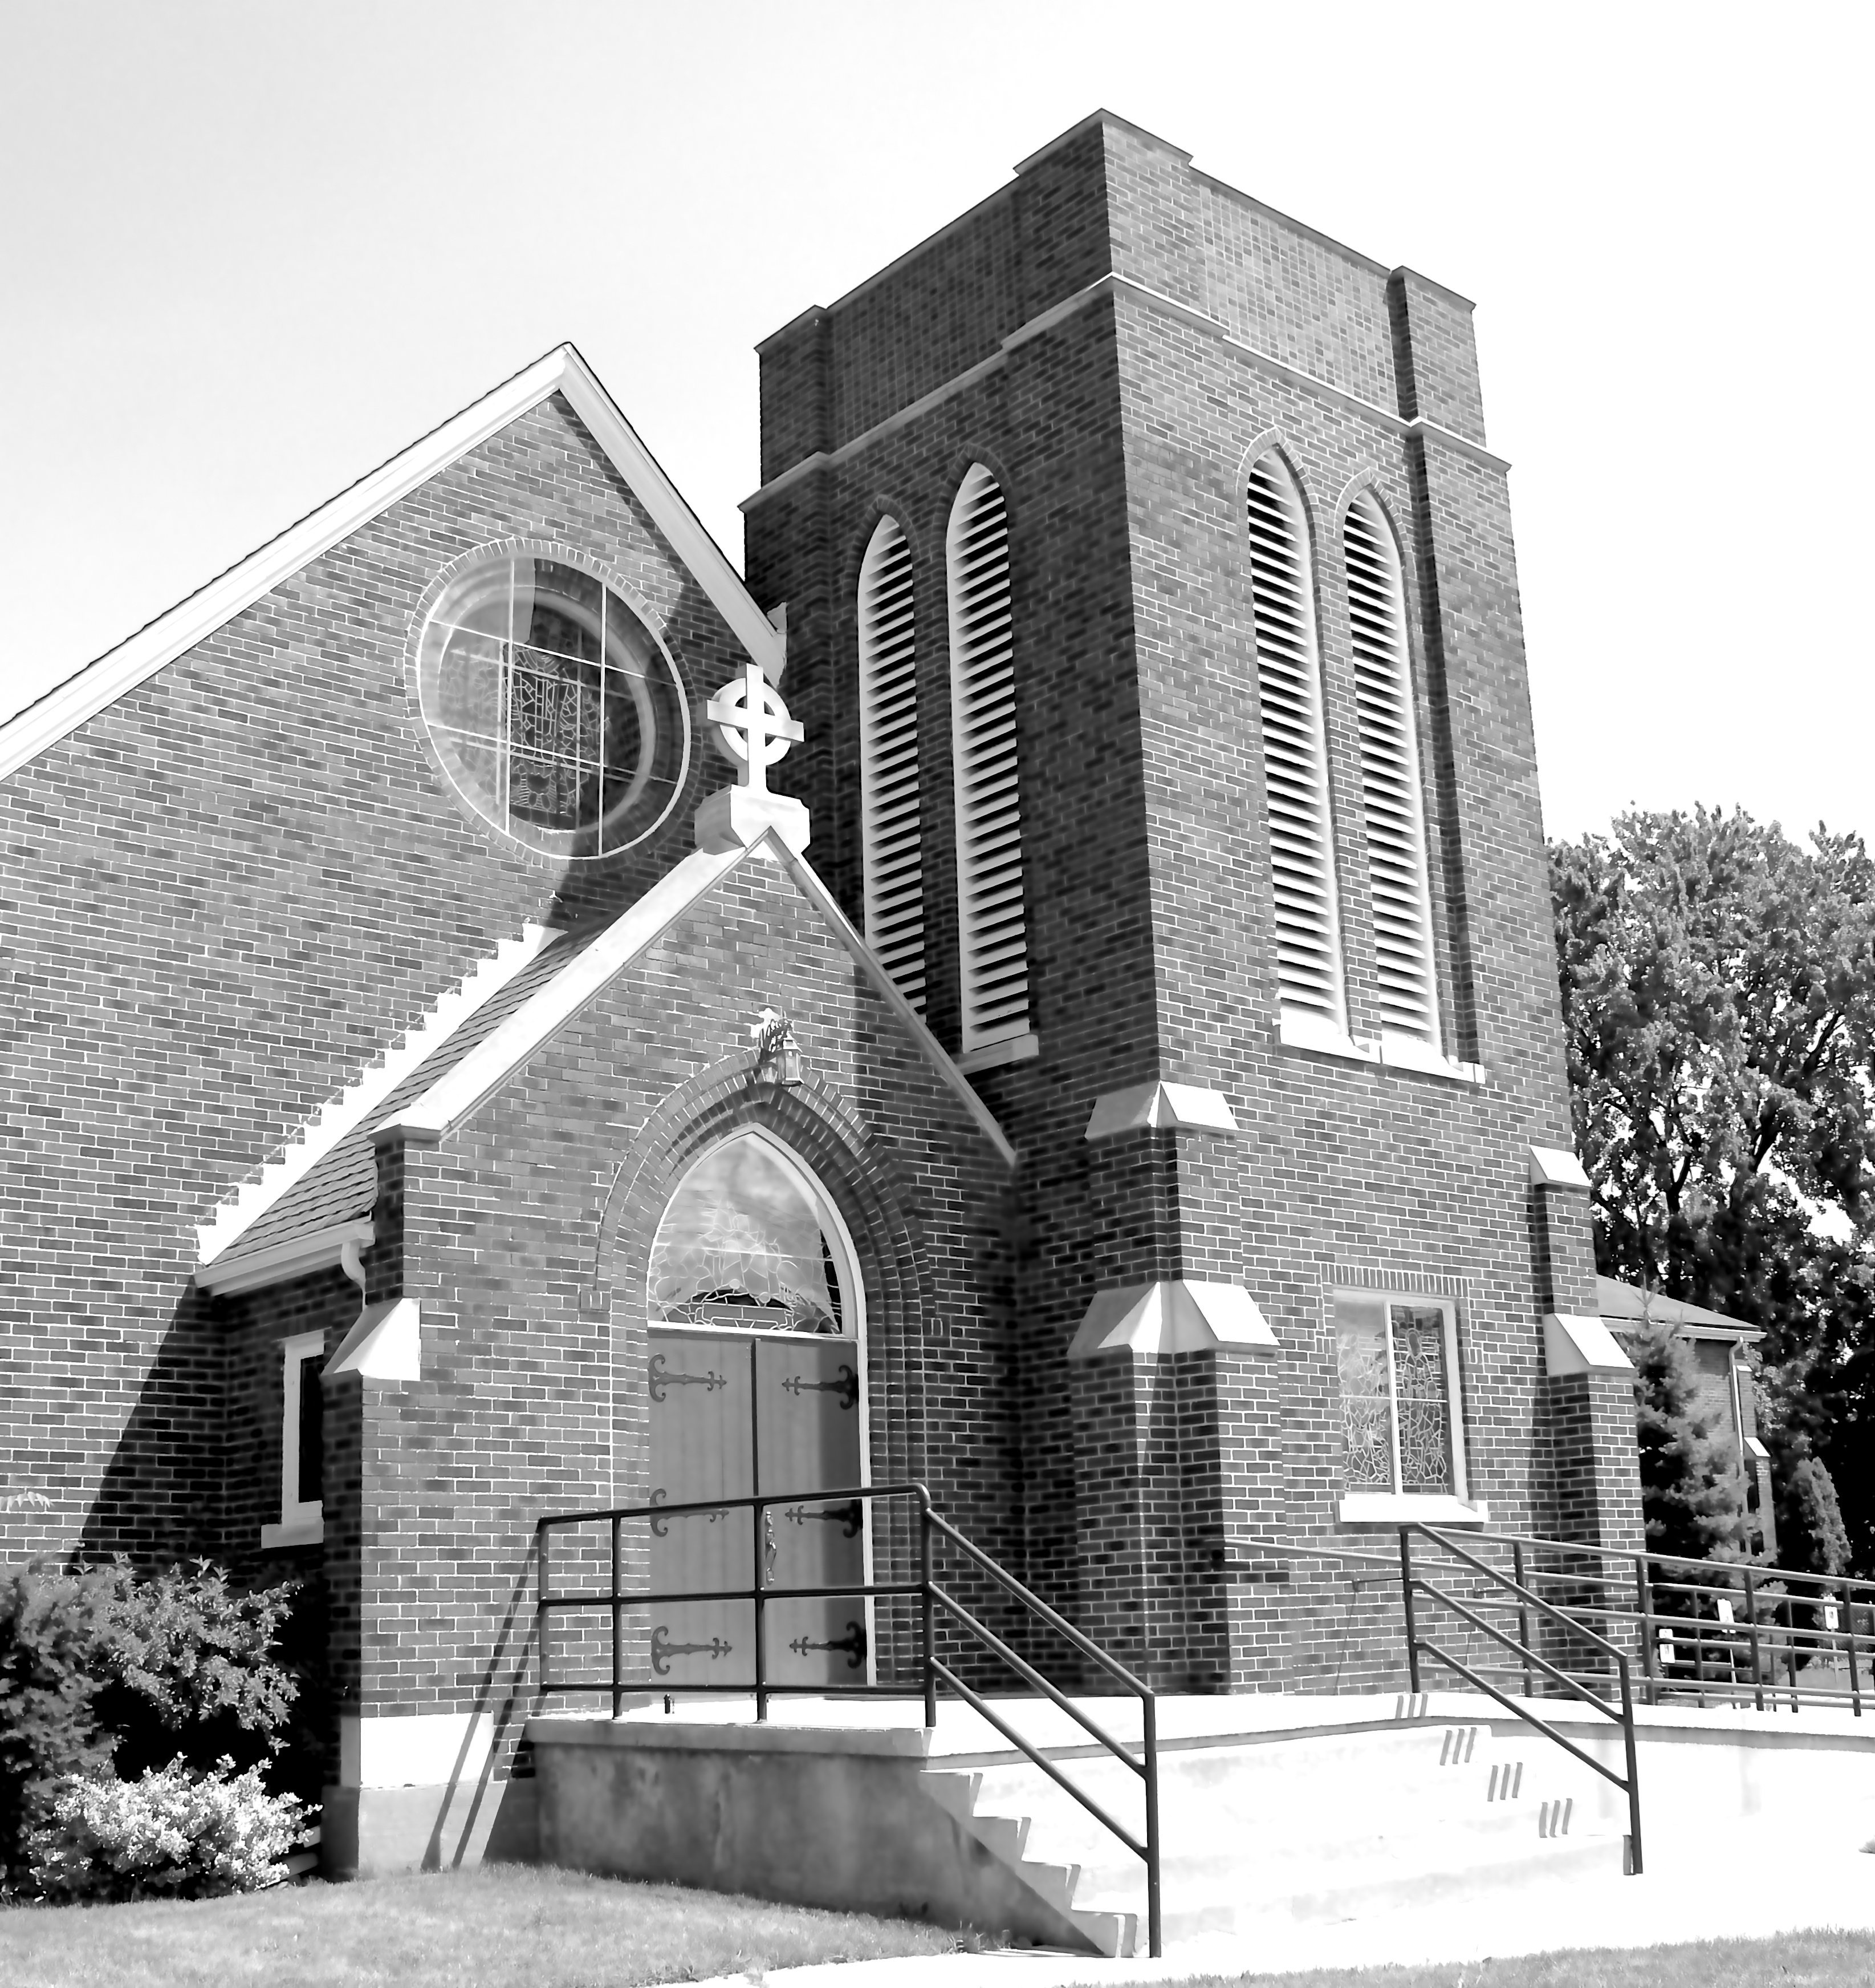

We Come and worship God.
We go our way with souls nourished.

Officiant: Ginny Schleihauf Organist: Dorothy Miller
380 Russell St. North (at Maxwell St.), Sarnia, Ontario, N7T 6S6
Tel: (519) 344-9531 - Email: canondavis@gmail.com – http://www.canondavis.com

12th of February, 2023 — Six Sunday after Epiphany

Service of the Word

Gathering Hymn # 381 Praise, My Soul

Officiant: The grace of our Lord Jesus Christ and the love of God and the
fellowship of the Holy Spirit be with you all.
People: And also with you.

Officiant: Let us pray.
We thank you, O God, that you have again brought us together on the Lord’s Day to praise you for your goodness and to ask your blessing. Give us grace to see your hand in the week that is past, and your purpose in the week to come; through Christ our Lord.
People: Amen.

Officiant: Dear friends in Christ, as we turn our hearts and minds to
worship almighty God, let us confess our sins.

People: Most merciful God, we confess that we have sinned
against you in thought, word, and deed, by what we have done and by what we have left undone. We have not loved you with our whole heart; we have not loved our neighbours as ourselves. We are truly sorry and we humbly repent. For the sake of your Son Jesus Christ, have mercy on us and forgive us, that we may delight in your will, and walk in your ways, to the glory of your name. Amen.

Officiant: Merciful God, grant to us, your faithful people, pardon and
peace, that we may be cleansed from all our sins and serve you with a quiet mind through Jesus Christ our Lord, who is alive and reigns with you and the Holy Spirit, one God, now and for ever.
People: Amen.
Officiant: The Peace of the Lord be always with you.
People: And also with you.

Officiant: Let us reconcile to God and one another a sign of Christ’s
peace.

The Collect of the Day
Almighty and everliving God, whose Son Jesus Christ healed the sick and restored them to wholeness of life, look with compassion on the anguish of the world, and by your power make whole all peoples and nations; through Jesus Christ our Lord, who lives and reigns with you and the Holy Spirit, one God, now and for ever.

First Reading Deuteronomy 30: 15-20
Officiant: The Word of the Lord.
People: Thanks be to God.

Psalm 119: 1-8 (Response in bold.)
Happy are they whose way is blameless, who walk in the law of the Lord!
Happy are they who observe his decrees and seek him with all their hearts!
Who never do any wrong, but always walk in his ways.
You laid down your commandments, that we should fully keep them.
Oh, that my ways were made so direct that I might keep your statutes!
Then I should not be put to shame, when I regard all your commandments.
I will thank you with an unfeigned heart, when I have learned your righteous judgements.
I will keep your statutes; do not utterly forsake me.
Second Reading I Corinthians 3: 1-9
Officiant: The Word of the Lord.
People: Thanks be to God.

Officiant: The Lord be with you.
People: And also with you.

Officiant: The Holy Gospel of our Lord Jesus Christ
according to Matthew.
People: Glory to you, Lord Jesus Christ.

The Gospel Matthew 5: 21-37

THE HOLY GOSPEL OF OUR LORD JESUS CHRIST
ACCORDING TO MATTHEW

Jesus said, "You have heard that it was said to those of ancient times, 'You shall not murder'; and 'whoever murders shall be liable to judgement.' But I say to you that if you are angry with a brother or sister, you will be liable to judgement; and if you insult a brother or sister, you will be liable to the council; and if you say, 'You fool,' you will be liable to the hell of fire. So when you are offering your gift at the altar, if you remember that your brother or sister has something against you, leave your gift there before the altar and go; first be reconciled to your brother or sister, and then come and offer your gift. Come to terms quickly with your accuser while you are on the way to court with him, or your accuser may hand you over to the judge, and the judge to the guard, and you will be thrown into prison. Truly I tell you, you will never get out until you have paid the last penny. You have heard that it was said, 'You shall not commit adultery.' But I say to you that everyone who looks at a woman with lust has already committed adultery with her in his heart. If your right eye causes you to sin, tear it out and throw it away; it is better for you to lose one of your members than for your whole body to be thrown into hell. And if your right hand causes you to sin, cut it off and throw it away; it is better for you to lose one of your members than for your whole body to go into hell. It was also said, 'Whoever divorces his wife, let him give her a certificate of divorce.' But I say to you that anyone who divorces his wife, except on the ground of unchastity, causes her to commit adultery; and whoever marries a divorced woman commits adultery. Again, you have heard that it was said to those of ancient times, 'You shall not swear falsely, but carry out the vows you have made to the Lord.' But I say to you, Do not swear at all, either by heaven, for it is the throne of God, or by the earth, for it is his footstool, or by Jerusalem, for it is the city of the great King. And do not swear by your head, for you cannot make one hair white or black. Let your word be 'Yes, Yes' or 'No, No'; anything more than this comes from the evil one."
Officiant: The Gospel of the Christ
People: Praise to you, Lord Jesus Christ.

Sermon

Sermon Hymn # 429 For the Beauty of the Earth

Officiant: Let us confess our faith as we say.
People: I believe in God, the Father Almighty, creator of heaven
and earth.
I believe in Jesus Christ, his only Son, our Lord.
He was conceived by the power of the Holy Spirit and
born of the Virgin Mary.
He suffered under Pontius Pilate, was crucified, died, and
was buried.
He descended to the dead.
On the third day he rose again.
He ascended into heaven, and is seated at the right hand
of the Father.
He will come again to judge the living and the dead.
I believe in the Holy Spirit, the holy catholic Church, the communion of saints, the forgiveness of sins, the resurrection of the body, and the life everlasting. Amen.
Prayers of the People

In peace we pray to you, Lord God.
Silence
For all people in their daily life and work;
For our families, friends, and neighbours, and for all those who are alone.
For this community, our country, and the world;
For all who work for justice, freedom, and peace.
For the just and proper use of your creation;
For the victims of hunger, fear, injustice, and oppression.
For all who are in danger, sorrow, or any kind of trouble;
For those who minister to the sick, the friendless, and needy.
For the peace and unity of the Church of God;
For all who proclaim the gospel, and all who seek the truth.
For Todd our bishop, and for all bishops and other ministers;
For all who serve God in the Church.
For our own needs and those of others.
Silence.
In our parish cycle of prayer, we pray for…
Hear us, Lord.
For your mercy is great.
We thank you, Lord, for all the blessings of this life.
Silence. (The people may add their own thanksgivings.)

We will exalt you, O God our king;
And praise your name for ever and ever.
We pray for those who have died in the peace of Christ, and for those whose faith is known to you alone, that they may have a place in your eternal kingdom.
Silence.
Lord, let your loving kindness be upon them;
Who put their trust in you.
Gracious God, you have heard the prayers of your faithful people; you know our needs before we ask, and our ignorance in asking. Grant our requests as may be best for us. This we ask in the name of your Son Jesus Christ our Lord.
Amen

Offertory Hymn # 435 Take My Life and Let it Be

Offertory Response All Things Come of Thee

People: Yours, Lord, is the greatness, the power, the glory, the
splendour, and the majesty; for everything in heaven and on earth is yours. All things come from you, and of your own do we give you.

Officiant: And now, as our Saviour Christ has taught us,
we are bold to say,
People: Our Father, who art in heaven,
hallowed be thy name,
thy kingdom come,
thy will be done, on earth as it is in heaven.
Give us this day our daily bread.
And forgive us our trespasses,
as we forgive those who trespass against us.
And lead us not into temptation, but deliver us from evil.
For thine is the kingdom,
the power, and the glory, for ever and ever. Amen.

Officiant: Glory to God
People: whose power, working in us, can do infinitely more than
we can ask or imagine. Glory to God from generation to generation, in the Church and in Christ Jesus, for ever and ever. Amen.

Announcements

Closing Hymn # 500 Sister, Let Me be your Servant

Officiant: May the God of hope fill us all with joy and peace in believing
through the power of the Holy Spirit. Amen.

Sung Benediction Howard’s Blessing (vs 1-2)
(in the back of the blue Hymn book)

The Flowers on the Altar today are given to
the Glory of God, and in loving memory of
John Manton, a wonderful husband, Dad and
Grandad, love you forever, Joyce and family.

Please enter names in the Intercessions Book each week to be read in the service.
News and Events

- Please send all announcements for the bulletin to Karen by 11:00 a.m. Tuesday of each week. Call: 519-344-9531 or E-mail: canondavis@gmail.com.

- If you would like a home visit with Communion or know of someone who would, please let Rev. Ray know as he and/or a Lay Visitor will be available in the coming weeks.

- Please join us for Coffee Hour after service for a time of fellowship in the parish hall.

Upcoming Events:

- Wednesday February 15 for a scrumptious Pork Roast Dinner and Raffle Night. Call 519 344-9531 to reserve your seat. Cost: Adults $20.00 and take out is available.

- Shrove Tuesday for a Pancake Dinner in the Parish Hall at 5:00 p.m. Cost: Adults $10.00. No reservation needed. And, No Take-Out.

Reminders

Feb 15 Pork Roast Dinner 5:00 p.m.
Feb 21 Shrove Tuesday Pancake Dinner 5:00 p.m.
Feb 23 Parish Council Meeting – Boardroom 10:00 a.m.

