Sunday June 26, 2022—Third Sunday after Pentecost
9:30 a.m. Morning Prayer (BCP) p.4

Opening Hymn # 520 The King of Love My Shepherd Is
Greeting

THE GATHERING OF THE COMMUNITY
Exhortation p. 4
General Confession p. 4
Absolution p. 5
The Lord’s Prayer p. 5
Responses p. 6
Venite p. 6

THE PROCLAMATION OF THE WORD
1st Reading 2 Kings 2: 1-2, 6-14
Psalm 77: 1-2, 11-20 (said responsively at the half verse) BCP p. 425, 426
2nd Reading Galatians 5:1, 13-25
Gospel Luke 9: 51-62

Benedictus p. 9
The Apostles’ Creed p. 10
Versicles p. 10
The Lord’s Prayer p. 11
Responses p. 11

Collect of the Day Almighty God, you have taught us through your Son that love fulfils the law. May we love you with all our heart, all our soul, all our mind, and all our strength, and may we love our neighbour as ourselves; through Jesus Christ our Lord, who lives and reigns with you and the Holy Spirit, one God, now and for ever. Amen.
Collect for Peace p. 11
Collect for Grace p. 11
Offertory Hymn # 509 Precious Lord, Take My Hand

Offertory Response All Things Come of Thee (sung)

Sermon
Sermon Hymn # 572 Let There Be Light
Prayer for the Queen and Commonwealth p. 12
Prayer for the Clergy and People p. 13
Prayer for All Conditions of Mortals p. 14
General Thanksgiving (said by all) p. 14
Prayer of Saint Chrysostom p. 15

Prayer for a Renewed Church: Almighty God, give us a new vision of you, of your love, of your grace and power, and then, give us a new vision of what you would have us do as your Church in this nation and at this time, and an awareness that in the strength of your Spirit, we can do it to your glory. In Jesus’ name we pray. Amen.

The Grace p. 15

Announcements

Closing Hymn # 438 O Jesus, I Have Promised

Dismissal
Officiant Go in peace to love and serve the Lord.
People Thanks be to God.
Sung Benediction Howard’s Blessing
(found in the back of the blue hymn book)

.NEWS AND EVENTS

- Please send all announcements for the bulletin to Karen by 10:00 a.m. Tuesday of each week. E-mail: canondavis@gmail.com. Or Call: 519-344-9531

- If you would like a home visit with Communion or know of someone who would, please let Rev. Ray know as he and/or a Lay Visitor will be available in the coming weeks.

- Please join us for Coffee Hour after service for a time of fellowship in the parish hall. Volunteers for coffee goodies needed for July and August. Please see the sign-up sheet at the back of the church.

Upcoming Events:

Reminders:

Canon Davis Memorial Church
Anglican Church of Canada
June 26, 2022 – Third Sunday after Pentecost

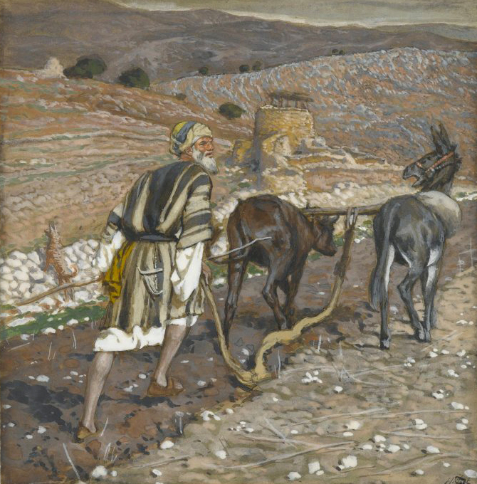

Looking Back—The Man at the Plow

Worship Service: Sunday 9:30 a.m.
Officiant – Bill Graham — Organist – Dorothy Miller
380 Russell St. North (at Maxwell St.), Sarnia, Ontario N7T 6S6
(519) 344-9531 – Email: canondavis@gmail.com -- http://www.canondavis.com

