Sunday July 10, 2022—Fifth Sunday after Pentecost
9:30 a.m. Morning Prayer (BCP) p.4

Opening Hymn # 342 We Praise You, O God
Greeting

THE GATHERING OF THE COMMUNITY
Exhortation p. 4
General Confession p. 4
Absolution p. 5
The Lord’s Prayer p. 5
Responses p. 6
Venite p. 6

THE PROCLAMATION OF THE WORD
1st Reading Amos 7: 7-17
Psalm 82 (said responsively at the half verse) BCP p. 435, 436
2nd Reading Colossians 1: 1-14
Gospel Luke 10: 25-37

Benedictus p. 9
The Apostles’ Creed p. 10
Versicles p. 10
The Lord’s Prayer p. 11
Responses p. 11

Collect of the Day Almighty God, you have made us for yourself,
and our hearts are restless until they find their rest in you. May we find peace in your service, and in the world to come, see you face to face; through Jesus Christ our Lord, who lives and reigns with you and the Holy Spirit, one God, now and for ever. Amen.
Collect for Peace p. 11
Collect for Grace p. 11
Offertory Hymn (see insert) Make Me a Channel of Your Peace
Offertory Response All Things Come of Thee (sung)

Sermon
Sermon Hymn # 500 Sister, Let Me Be Your Servant
Prayer for the Queen and Commonwealth p. 12
Prayer for the Clergy and People p. 13
Prayer for All Conditions of Mortals p. 14
General Thanksgiving (said by all) p. 14
Prayer of Saint Chrysostom p. 15

Prayer for a Renewed Church: Almighty God, give us a new vision of you, of your love, of your grace and power, and then, give us a new vision of what you would have us do as your Church in this nation and at this time, and an awareness that in the strength of your Spirit, we can do it to your glory. In Jesus’ name we pray. Amen.

The Grace p. 15

Announcements

Closing Hymn #592 Where Cross the Crowded Ways of Life
Officiant Go in peace to love and serve the Lord.
People Thanks be to God.
Sung Benediction Go Now in Peace
(found in the back of the blue hymn book)

Please enter names in the Intercessions Book each week to be read in the service.

The Flowers on the Altar today are given to the Glory of God in loving memory of my parents, Roy and Doreen Turner, a gift from their daughter, Carol Mercurio.

NEWS AND EVENTS

- Please send all announcements for the bulletin to Karen by 10:00 a.m. Tuesday of each week. E-mail: canondavis@gmail.com. Or Call: 519-344-9531.

- If you would like a home visit with Communion or know of someone who would, please let Rev. Ray know as he and/or a Lay Visitor will be available in the coming weeks.

- Please join us for Coffee Hour after service for a time of fellowship in the parish hall. Volunteers for coffee goodies are still needed for July and August. Please see the sign-up sheet at the back of the church. Thank you.

Upcoming Events

Reminders:

Canon Davis Memorial Church
Anglican Church of Canada
July 10 – Fifth Sunday after Pentecost

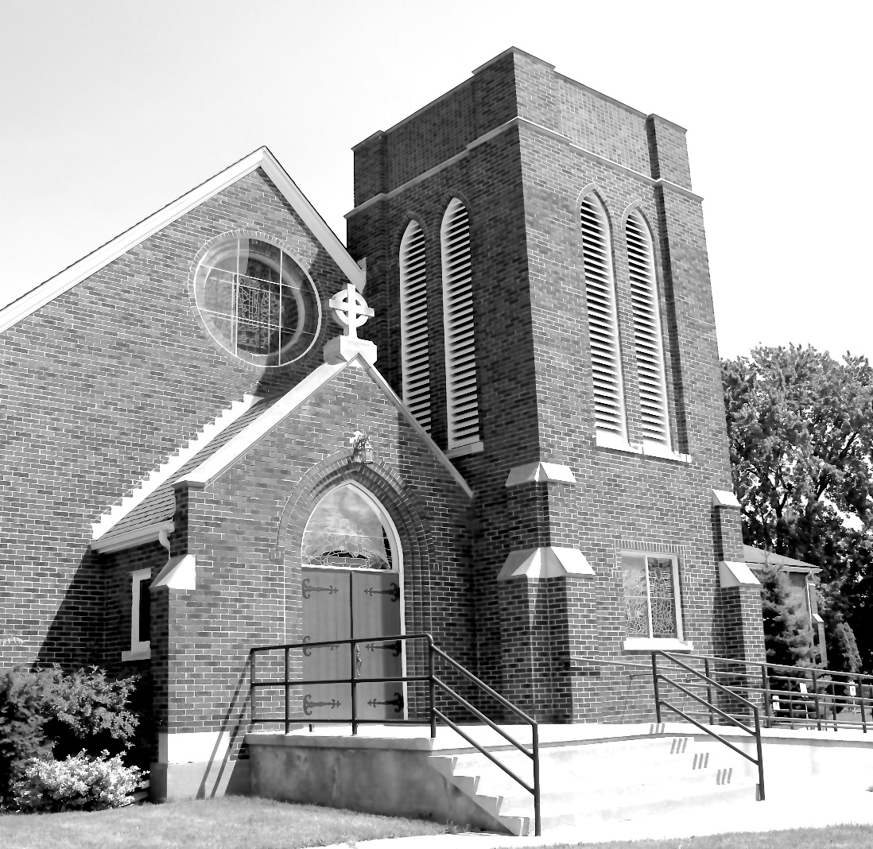

Worship Service: Sunday 9:30 a.m.
Officiant – Ginny Schleihauf — Organist – Dorothy Miller
380 Russell St. North (at Maxwell St.), Sarnia, Ontario N7T 6S6
(519) 344-9531 – Email: canondavis@gmail.com -- http://www.canondavis.com

