Canon Davis Memorial Church
Anglican Church of Canada
Sunday, August 6, 2023 – The Transfiguration of the Lord

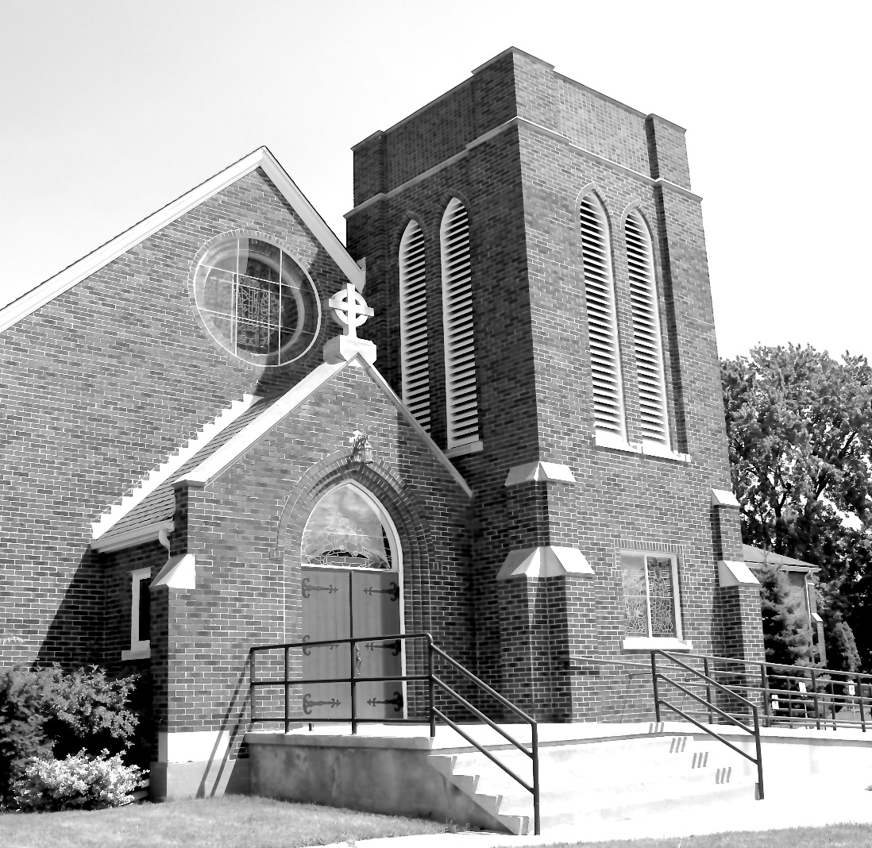

Worship Service: Sunday 9:30 a.m.
Officiant—Rev’d Jon Forbes — Assisted By — Tom Brown
Organist—Dorothy Miller
380 Russell St. North (at Maxwell St.), Sarnia, Ontario, N7T 6S6
(519) 344-9531 - http://www.canondavis.com – canondavis@gmail.com
Prelude

Announcements

THE GATHERING OF THE COMMUNITY

Sentence
Therefore, if anyone is in Christ, the new creation has come: The old has gone, the new is here!” 2 Corinthians 5:17

Processional Hymn #380 O Worship the King

The grace of our Lord Jesus Christ, and the love of God, and the fellowship of the Holy Spirit, be with you all.
And also with you.

Almighty God, to you all hearts are open, all desires known, and from you no secrets are hidden. Cleanse the thoughts of our hearts by the inspiration of your Holy Spirit, that we may perfectly love you, and worthily magnify your holy name; through Christ our Lord. Amen.

Glory to God in the highest, and peace to his people on earth.
Lord God, heavenly king, almighty God and Father, we worship you, we give you thanks, we praise you for your glory.

Lord Jesus Christ, only Son of the Father, Lord God, Lamb of God, you take away the sin of the world: have mercy on us; you are seated at the right hand of the Father: receive our prayer.

For you alone are the Holy One, you alone are the Lord, you alone are the Most High, Jesus Christ, with the Holy Spirit, in the glory of God the Father. Amen.

Lord, have mercy.
Christ, have mercy.
Lord, have mercy.
Collect of the Day
Almighty God, on the holy mount you revealed to chosen witnesses your well-beloved Son, wonderfully transfigured: mercifully deliver us from the darkness of this world, and change us into his likeness from glory to glory; through Jesus Christ our Lord who lives and reigns with you and the Holy Spirit, one God, now and for ever.

THE PROCLAMATION OF THE WORD

1st Reading: Daniel 7:9-10, 13-14

The Word of the Lord.
Thanks be to God.

Psalm 99 (to be read responsively)
The Lord is king; let the people tremble; he is enthroned upon the Cherubim; let the earth shake. The Lord is great in Zion; he is high above all peoples.
Let them confess his name, which is great and awesome; he is the Holy One.
"O mighty King, lover of justice, you have established equity; you have executed justice and righteousness in Jacob."
Proclaim the greatness of the Lord our God and fall down before his footstool; he is the Holy One.
Moses and Aaron among his priests, and Samuel among those who call upon his name, they called upon the Lord, and he answered them.
He spoke to them out of the pillar of cloud; they kept his testimonies and the decree that he gave them.
"O Lord our God, you answered them indeed; you were a God who forgave them, yet punished them for their evil deeds."
Proclaim the greatness of the Lord our God and worship him upon his holy hill; for the Lord our God is the Holy One.
2nd Reading: Peter 1:16-19

The Word of the Lord
Thanks be to God.

Gradual Hymn # 393 Immortal, Invisible, God Only Wise

Gospel

The Holy Gospel of our Lord Jesus Christ according to Luke
Glory to you, Lord Jesus Christ.

Luke 9: 28-36

The Gospel of Christ.
Praise to you, Lord Jesus Christ.

Sermon

The Nicene Creed:
Let us confess our faith, as we say,
We believe in one God, the Father, the Almighty, maker of heaven and earth, of all that is, seen and unseen.

We believe in one Lord, Jesus Christ, the only Son of God, eternally begotten of the Father, God from God, Light from Light, true God from true God, begotten, not made, of one being with the Father. Through him all things were made. For us and four our salvation he came down from heaven: by the power of the Holy Spirit he became incarnate from the Virgin Mary, and was made man. For our sake he was crucified under Pontius Pilate; he suffered death and was buried. On the third day he rose again in accordance with the scriptures; he ascended into heaven and is seated at the right hand of the Father. He will come again in glory to judge the living and the dead, and his kingdom will have no end.

We believe in the Holy Spirit, the Lord, the giver of life, who proceeds from the Father. With the Father and the Son he is worshipped and glorified. He has spoken through the prophets. We believe in one holy catholic and apostolic Church. We acknowledge one baptism for the forgiveness of sins. We look for the resurrection of the dead, and the life of the world to come. Amen.

Prayers of the People
(In peace let us pray to the Lord, saying, “Lord, have mercy.”)

For the peace from on high and for our salvation, let us pray to the Lord.
Lord, have mercy.

For the peace of the whole world, for the welfare of the holy Church of God, and for the unity of all, let us pray to the Lord.
Lord, have mercy.

For our bishops, and for all the clergy and people, let us pray to the Lord.
Lord, have mercy.

For Charles our King, for the leaders of the nations, and for all authority, let us pray to the Lord.
Lord, have mercy.

For Sarnia, for every city and community, and for those who live in them in faith, let us pray to the Lord.
Lord, have mercy.

For good weather, and for abundant harvests for all to share, let us pray to the Lord.
Lord, have mercy.

For those who travel by land, water, or air, for the sick and the suffering (especially), for prisoners and captives, and for their safety, health, and salvation, let us pray to the Lord.
Lord, have mercy.

For our deliverance from all affliction, strife, and need, let us pray to the Lord.
Lord, have mercy.

For the absolution and remission of our sins and offences, let us pray to the Lord.
Lord, have mercy.

For all who have died (especially ), let us pray to the Lord.
Lord, have mercy.

Remembering (… and) all the saints, we commit ourselves, one another, and our whole life to Christ our God.
To you, O Lord.

Almighty God, you have given us grace at this time with one accord to make our common supplications to you, and you have promised through your well-beloved Son that when two or three are gathered together you will hear their requests. Fulfil now our desires and petitions, as may be best for us, granting us in this world knowledge of your truth, and in the age to come eternal life; for you, Father, are good and loving, and we glorify you through your Son Jesus Christ our Lord, in the Holy Spirit, now and for ever. Amen.

In our parish cycle of prayer, we pray for…

Prayer for a Renewed Church
Almighty God, give us a new vision of you, of your love, of your grace and power, and then, give us a new vision of what you would have us do as your Church in this nation and at this time, and an awareness that in the strength of your Spirit, we can do it to your glory. In Jesus’ name we pray. Amen.

Confession and Absolution: Dear friends in Christ, God is steadfast in love and infinite in mercy; he welcomes sinners and invites them to his table. Let us confess our sins, confident in God’s forgiveness.

The Confession: Most merciful God,
we confess that we have sinned against you in thought, word, and deed, by what we have done, and by what we have left undone. We have not loved you with our whole heart; we have not loved our neighbours as ourselves. We are truly sorry and we humbly repent. For the sake of your Son Jesus Christ, have mercy on us and forgive us, that we may delight in your will, and walk in your ways, to the glory of your name. Amen.

Absolution: Almighty God have mercy upon you, pardon and deliver you from all your sins, confirm and strengthen you in all goodness, and keep you in eternal life; through Jesus Christ our Lord. Amen.

The Peace
The peace of the Lord be always with you.
And also with you.

Offertory Hymn # 374 Alleluia! Sing to Jesus

Prayer over the Gifts
Holy God, receive all we offer you this day, and bring us to that radiant glory which we see in the transfigured face of Jesus Christ our Lord

Eucharist Prayer
The Lord be with you.
And also with you.

Lift up your hearts.
We lift them to the Lord.
Let us give thanks to the Lord our God.
It is right to give our thanks and praise.

It is indeed right that we should praise you, gracious God, for you created all things. You formed us in your own image: male and female you created us. When we turned away from you in sin, you did not cease to care for us,
but opened a path of salvation for all people. You made a covenant with Israel, and through your servants Abraham and Sarah gave the promise of a blessing to all nations. Through Moses you led your people from bondage into freedom; through the prophets you renewed your promise of salvation. Therefore, with them, and with all your saints who have served you in every age, we give thanks and raise our voices to proclaim the glory of your name.

Holy, holy, holy Lord,
God of power and might,
heaven and earth are full of your glory.
Hosanna in the highest.

Blessed is he who comes in the name of the Lord.
Hosanna in the highest.

Holy God, source of life and goodness, all creation rightly gives you praise. In the fullness of time, you sent your Son Jesus Christ, to share our human nature, to live and die as one of us, to reconcile us to you, the God and Father of all. He healed the sick and ate and drank with outcasts and sinners; he opened the eyes of the blind and proclaimed the good news of your kingdom to the poor and to those in need. In all things he fulfilled your gracious will.

On the night he freely gave himself to death, our Lord Jesus Christ took bread, and when he had given thanks to you, he broke it, and gave it to his disciples, and said, “ Take, eat: this is my body which is given for you. Do this for the remembrance of me.”

After supper he took the cup of wine; and when he had given thanks, he gave it to them, and said, “ Drink this, all of you: this is my blood of the new covenant, which is shed for you and for many for the forgiveness of sins. Whenever you drink it, do this for the remembrance of me.”

Gracious God, his perfect sacrifice destroys the power of sin and death; by raising him to life you give us life for evermore.

Therefore we proclaim the mystery of faith.
Christ has died.
Christ is risen.
Christ will come again.

Recalling his death, proclaiming his resurrection, and looking for his coming again in glory, we offer you, Father, this bread and this cup. Send your Holy Spirit upon us and upon these gifts, that all who eat and drink at this table may be one body and one holy people, a living sacrifice in Jesus Christ, our Lord.

Through Christ, with Christ, and in Christ, in the unity of the Holy Spirit,
all glory is yours, almighty Father, now and for ever.
Amen.

The Lord’s Prayer:
Our Father, who art in heaven, hallowed be thy name, thy kingdom come, thy will be done, on earth as it is in heaven. Give us this day our daily bread. And forgive us our trespasses, as we forgive those who trespass against us. And lead us not into temptation, but deliver us from evil. For thine is the kingdom, the power, and the glory, for ever and ever. Amen.

Breaking of the Bread
“I am the bread of life,” says the Lord.
“Whoever comes to me will never be hungry;
whoever believes in me will never thirst.”
Taste and see that the Lord is good;
happy are they who trust in him!

The Communion
The gifts of God for the people of God.
Thanks be to God.

Prayer after Communion
Holy God, we see your glory in the face of Jesus Christ. May we who are partakers of his table reflect his life in word and deed, that all the world may know his power to change and save. We ask this in his name.

Doxology
Glory to God, Whose power, working in us, can do infinitely more than we can ask or imagine. Glory to God from generation to generation, in the Church and in Christ Jesus, for ever and ever. Amen.

Recessional Hymn # 321 All Hail the Power of Jesus’ Name

Blessing
The peace of God which passes all understanding, keep your hearts and minds in the knowledge and love of God and of his son Jesus Christ and the blessing of God Almighty the Father, the Son and the Holy Spirit be with you and those you love for ever more. Amen.

Benediction Song Go Now in Peace
(found in the back of the blue hymn book)
Dismissal
The flowers on the Altar today are given to the Glory of God and in memory of Reginald and Kate Haddon, a gift of their family.

Please enter names in the Intercessions Book each week to be read in the service.
CANON DAVIS MEMORIAL CHURCH
UPDATE AS OF JUNE 30, 2023

The members of Canon Davis Memorial have had a very busy first half of the year. We have all been fundraising for ACW, pie making and we held two delicious luncheons and a Strawberry Social. The Sew Day group was busy with their monthly luncheons and activities and the Ways & Means with their monthly dinners and raffles.

We have had the continued support from our tenants with their rental incomes. Through our current giving’s we have reached 49% of our goal.

Fundraising in our community for London Rd School Playground Equipment has been successful. Through monthly Meat Raffles so far $1680.00 has been raised.

CDM is sending two youth to Camp Huron from London Rd School. The Lambton Deanery, CDM's Ladies Guild and CDM have covered the cost of camp for these two youth.

Everyone has worked very hard these past six months to support their church. As of the end of June we have brought in a total of $55,700.93.
We thank you!

Our expenses unfortunately have increased due to a huge increase to our annual insurance costs, major maintenance for the organ repairs and the boiler system. Along with our monthly expenses in Repair & Maintenance and Utilities which have increased as well. Due to increasing cost, it has left us with a total of $67,258.24. This leaves us with a deficit of ($11,557.31). With all that said, we feel we remain in a good financial position.

On a lighter note, we have had new members join CDM. We have celebrated the retirement of Rev Ray Jenkins and the Installation of a new licensed lay reader, Ginny Schleihauf. We have also been able to fill the position of Deputy Rector's Warden which had been vacant for a couple of years with Ginny Schleihauf. We have had two baptisms, the great grandchildren of Doug and Shirley Frew. We also had a wedding at CDM between Wendy Vicary and Greg Baker.

Last but far from least, CDM has been blessed with our new minister, Rev'd Jon Forbes. It has been a wonderful two months already. Parish Council is so pleased with all the great comments from parishioners. Jon is truly a joyous addition to our family. Let us continue to move forward as a loving, caring and hospitable church in Sarnia.

God Bless 🙏
Carol Spence, John Hayter and
Sheree Lynn Hayter

NEWS AND EVENTS

- Please send all announcements for the bulletin to Karen by 11:00 a.m. Tuesday of each week. Call 519-344-9531 or E-mail: canondavis@gmail.com.
- If you would like a home visit with Communion, please contact the office as a Lay Visitor will be available in the coming weeks.
- Please join us for Coffee Hour after service for a time of fellowship in the
parish hall.

Upcoming Events:

Reminders

15 Sept 7:00 p.m. Free Concert All Saints Anglican Church: An
Evening of Music in Memory of Eleanor Vargo.

