Canon Davis Memorial Church
Anglican Church of Canada
Fourth Sunday after Pentecost
25th June, 2023

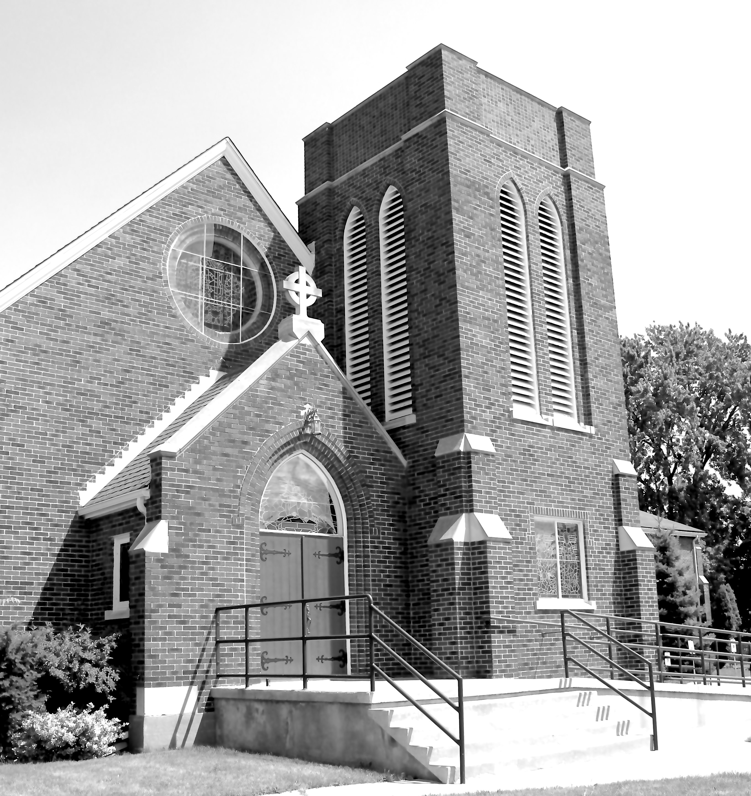

We Come and worship God.
We go our way with souls nourished.

Officiant: Ginny Schleihauf Organist: Dorothy Miller
380 Russell St. North (at Maxwell St.), Sarnia, Ontario, N7T 6S6
Tel: (519) 344-9531 - Email: canondavis@gmail.com – http://www.canondavis.com

June 25, 2023 — Fourth Sunday after Pentecost

Service of the Word

Gathering Hymn # 564 Lead Us, Heavenly Father, Lead Us

Officiant: The grace of our Lord Jesus Christ and the love of God and the
fellowship of the Holy Spirit be with you all.
People: And also with you.

Officiant: Let us pray.
We thank you, O God, that you have again brought us together on the Lord’s Day to praise you for your goodness and to ask your blessing. Give us grace to see your hand in the week that is past, and your purpose in the week to come; through Christ our Lord.
People: Amen.

Officiant: Dear friends in Christ, as we turn our hearts and minds to
worship almighty God, let us confess our sins.

People: Most merciful God, we confess that we have sinned
against you in thought, word, and deed, by what we have done and by what we have left undone. We have not loved you with our whole heart; we have not loved our neighbours as ourselves. We are truly sorry and we humbly repent. For the sake of your Son Jesus Christ, have mercy on us and forgive us, that we may delight in your will, and walk in your ways, to the glory of your name. Amen.

Officiant: Merciful God, grant to us, your faithful people, pardon and
peace, that we may be cleansed from all our sins and serve you with a quiet mind through Jesus Christ our Lord, who is alive and reigns with you and the Holy Spirit, one God, now and for ever.
People: Amen.
Officiant: The Peace of the Lord be always with you.
People: And also with you.

Officiant: Let us reconcile to God and one another a sign of Christ’s
peace.

The Collect of the Day
O God our defender, storms rage about us and cause us to be afraid. Rescue your people from despair, deliver your sons and daughters from fear, and preserve us all from unbelief; through your Son, Jesus Christ our Lord, who lives and reigns with you and the Holy Spirit, one God, now and ever.

First Reading Genesis 21: 8-21
Officiant: The Word of the Lord.
People: Thanks be to God.

Psalm 86: 1-10, 16-17 (Response in bold.)

Bow down your ear, O Lord, and answer me, for I am poor and in misery.
Keep watch over my life, for I am faithful; save your servant who puts his trust in you.
Be merciful to me, O Lord, for you are my God; I call upon you all the day long. Gladden the soul of your servant, for to you, O Lord, I lift up my soul.
For you, O Lord, are good and forgiving, and great is your love toward all who call upon you.
Give ear, O Lord, to my prayer, and attend to the voice of my supplications.
In the time of my trouble I will call upon you, for you will answer me.
Among the gods there is none like you, O Lord, nor anything like your works. All nations you have made will come and worship you, O Lord, and glorify your name.
For you are great; you do wondrous things; and you alone are God.
Turn to me and have mercy upon me; give your strength to your servant; and save the child of your handmaid.
Show me a sign of your favour, so that those who hate me may see it and be ashamed; because you, O Lord, have helped me and comforted me.

Second Reading Romans 6: 1B-11
Officiant: The Word of the Lord.
People: Thanks be to God.

Officiant: The Lord be with you.
People: And also with you.

Officiant: The Holy Gospel of our Lord Jesus Christ
according to John.
People: Glory to you, Lord Jesus Christ.

The Gospel Matthew 10: 24-39

THE HOLY GOSPEL OF OUR LORD JESUS CHRIST
ACCORDING TO MATTHEW

Jesus said, "A disciple is not above the teacher, nor a slave above the master; it is enough for the disciple to be like the teacher, and the slave like the master. If they have called the master of the house Beelzebul, how much more will they malign those of his household! So have no fear of them; for nothing is covered up that will not be uncovered, and nothing secret that will not become known. What I say to you in the dark, tell in the light; and what you hear whispered, proclaim from the housetops. Do not fear those who kill the body but cannot kill the soul; rather fear him who can destroy both soul and body in hell. Are not two sparrows sold for a penny? Yet not one of them will fall to the ground apart from your Father. And even the hairs of your head are all counted. So do not be afraid; you are of more value than many sparrows. Everyone therefore who acknowledges me before others, I also will acknowledge before my Father in heaven; but whoever denies me before others, I also will deny before my Father in heaven. Do not think that I have come to bring peace to the earth; I have not come to bring peace, but a sword. For I have come to set a man against his father, and a daughter against her mother, and a daughter-in-law against her mother-in-law; and one's foes will be members of one's own household. Whoever loves father or mother more than me is not worthy of me; and whoever loves son or daughter more than me is not worthy of me; and whoever does not take up the cross and follow me is not worthy of me. Those who find their life will lose it, and those who lose their life for my sake will find it."

Officiant: The Gospel of the Christ
People: Praise to you, Lord Jesus Christ.

Sermon

Sermon Hymn # 205 The Day of Resurrection

Officiant: Let us confess our faith as we say.

People: I believe in God, the Father Almighty, creator of heaven
and earth.
I believe in Jesus Christ, his only Son, our Lord.
He was conceived by the power of the Holy Spirit and
born of the Virgin Mary.
He suffered under Pontius Pilate, was crucified, died, and
was buried.
He descended to the dead.
On the third day he rose again.
He ascended into heaven, and is seated at the right hand
of the Father.
He will come again to judge the living and the dead.
I believe in the Holy Spirit, the holy catholic Church, the communion of saints, the forgiveness of sins, the resurrection of the body, and the life everlasting. Amen.

Prayers of the People
In peace we pray to you, Lord God.
Silence
For all people in their daily life and work;
For our families, friends, and neighbours, and for all those who are alone.
For this community, our country, and the world;
For all who work for justice, freedom, and peace.
For the just and proper use of your creation;
For the victims of hunger, fear, injustice, and oppression.
For all who are in danger, sorrow, or any kind of trouble;
For those who minister to the sick, the friendless, and needy.
For the peace and unity of the Church of God;
For all who proclaim the gospel, and all who seek the truth.
For Todd our bishop, and for all bishops and other ministers;
For all who serve God in the Church.
For our own needs and those of others.
Silence.
In our parish cycle of prayer, we pray for…
Hear us, Lord.
For your mercy is great.
We thank you, Lord, for all the blessings of this life.
Silence. (The people may add their own thanksgivings.)

We will exalt you, O God our king;
And praise your name for ever and ever.
We pray for those who have died in the peace of Christ, and for those whose faith is known to you alone, that they may have a place in your eternal kingdom.
Silence.
Lord, let your loving kindness be upon them;
Who put their trust in you.
Gracious God, you have heard the prayers of your faithful people; you know our needs before we ask, and our ignorance in asking. Grant our requests as may be best for us. This we ask in the name of your Son Jesus Christ our Lord.
Amen

Offertory Hymn # 431 Take Up Your Cross, the Saviour Said

Offertory Response All Things Come of Thee

People: Yours, Lord, is the greatness, the power, the glory, the
splendour, and the majesty; for everything in heaven and on earth is yours. All things come from you, and of your own do we give you.

Officiant: And now, as our Saviour Christ has taught us,
we are bold to say,
People: Our Father, who art in heaven,
hallowed be thy name,
thy kingdom come,
thy will be done, on earth as it is in heaven.
Give us this day our daily bread.
And forgive us our trespasses,
as we forgive those who trespass against us.
And lead us not into temptation, but deliver us from evil.
For thine is the kingdom,
the power, and the glory, for ever and ever. Amen.

Officiant: Glory to God
People: whose power, working in us, can do infinitely more than
we can ask or imagine. Glory to God from generation to generation, in the Church and in Christ Jesus, for ever and ever. Amen.

Announcements

Closing Hymn # 415 All Things Bright and Beautiful

Officiant: May the God of hope fill us all with joy and peace in believing
through the power of the Holy Spirit. Amen.

Sung Benediction Howard’s Blessing (vs 1-2)
(in the back of the blue Hymn book)

The Flowers on the Altar today are given to
the Glory of God, and in memory of
Les and Marion Dickinson, Nellie Palmer and
Margaret Conn in gratitude for their commitment to our church, a gift of the Chancel Guild.

Please enter names in the Intercessions Book each week to be read in the service.

NEWS AND EVENTS

- Please send all announcements for the bulletin to Karen by 11:00 a.m. Tuesday of each week. Call 519-344-9531 or E-mail: canondavis@gmail.com.
- If you would like a home visit with Communion, please contact the office as a Lay Visitor will be available in the coming weeks.
- Please join us for Coffee Hour after service for a time of fellowship in the parish hall.
- A reminder that CDM is looking for volunteers for July and August to fill in for coffee hour. Please see the sign-up sheet at the back of the church if you are willing to help out. Thank you.
- Bluewater Family Support Services Inc. is looking for families with clear and consistent values willing to open their homes and hearts to children needing care. If you are interested or know of someone who might be please have them contact Terri Jensen at 519 294 6213 or www.bluewatercares.com

Upcoming Events:
- Service at Canatara Park for a shared worship and lunch. The service is planned for June 25 at 10 AM with a lunch afterward of a BBQ, sides and dessert. Joyce Hodgson is scheduled to preach. Everyone is asked to bring their own chair, coffee or tea if they'd like. For lunch the plan is to BBQ and folks to bring a side or dessert to share. The cost of the pavilion and BBQ’ d food is being split between the three churches. If another parish decides to come and would like to contribute to these costs, that would be welcome.

- Everyone is Invited to our Hot Dog and Strawberry Social/Penny Auction on Wednesday July 5, from 5:00 p.m. to 6:30 p.m. Please contact Ginny Schleihauf at 519 312 2297 or Carol Mercurio at 519 491 9319. A sign-up sheet is also available at the back of the church. Cost: $10.00.

- London Road School Meat Raffle The next meat raffle will be held on Tuesday July 11 from 6:00 to 8:00 p.m. at Imperial City Brew House, 1330 Exmouth Street. Draws are $2.00 each and there are 9 draws.

Reminders
25 June Service at Canatara Park 10:00 a.m.
28 June Parish Council Meeting – Boardroom 10:00 a.m.
5 July Hot Dog and Strawberry Social/Penny Auction 5:00 p.m.
to 6:30 p.m.
11 July London Road School Meat Raffle 6:00 to 8:00 p.m.
Imperial Brew House

