Canon Davis Memorial Church
Anglican Church of Canada
Third Sunday of Easter
23rd April, 2023

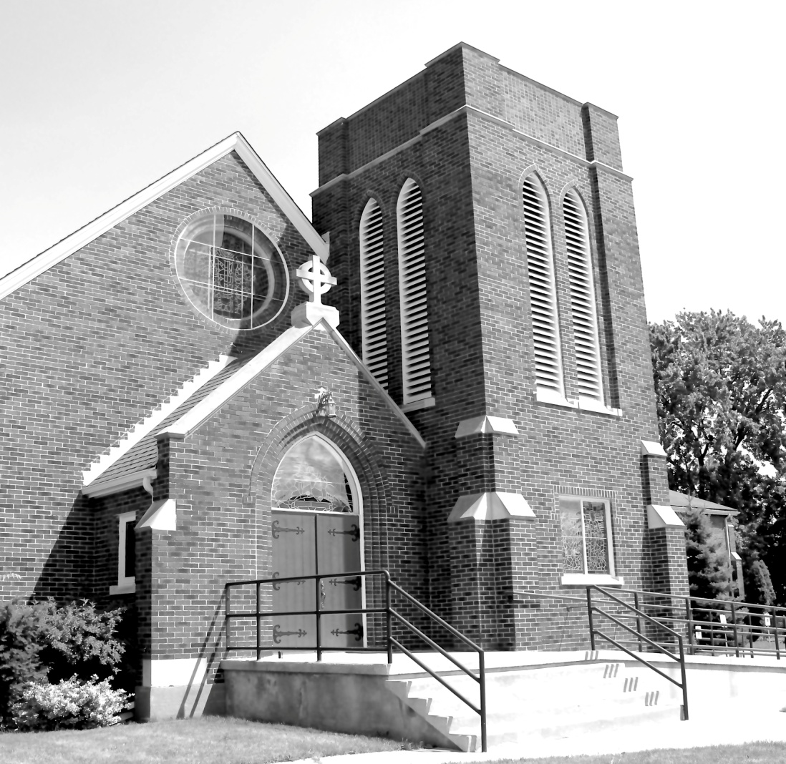

We Come and worship God.
We go our way with souls nourished.

Officiant: Ginny Schleihauf Organist: Dorothy Miller
380 Russell St. North (at Maxwell St.), Sarnia, Ontario, N7T 6S6
Tel: (519) 344-9531 - Email: canondavis@gmail.com – http://www.canondavis.com
23rd April, 2023 — Third Sunday of Easter

Service of the Word

Gathering Hymn # 220 Christ is Risen, Christ is Risen

Officiant: The grace of our Lord Jesus Christ and the love of God and the fellowship of the Holy Spirit be with you all.
People: And also with you.

Officiant: Let us pray.
We thank you, O God, that you have again brought us together on the Lord’s Day to praise you for your goodness and to ask your blessing. Give us grace to see your hand in the week that is past, and your purpose in the week to come; through Christ our Lord.
People: Amen.

Officiant: Dear friends in Christ, as we turn our hearts and minds to
worship almighty God, let us confess our sins.

People: Most merciful God, we confess that we have sinned
against you in thought, word, and deed, by what we have done and by what we have left undone. We have not loved you with our whole heart; we have not loved our neighbours as ourselves. We are truly sorry and we humbly repent. For the sake of your Son Jesus Christ, have mercy on us and forgive us, that we may delight in your will, and walk in your ways, to the glory of your name. Amen.

Officiant: Merciful God, grant to us, your faithful people, pardon and
peace, that we may be cleansed from all our sins and serve you with a quiet mind through Jesus Christ our Lord, who is alive and reigns with you and the Holy Spirit, one God, now and for ever.
People: Amen.

Officiant: The Peace of the Lord be always with you.
People: And also with you.

Officiant: Let us reconcile to God and one another a sign of Christ’s
peace.

The Collect of the Day
O God, your Son made himself known to his disciples in the breaking of bread. Open the eyes of our faith, that we may see him in his redeeming work, who is alive and reigns with you and the Holy Spirit, one God, now and for ever.

First Reading Acts 2: 14A, 36-41

A READING FROM THE BOOK OF ACTS
Peter, standing with the eleven, raised his voice and addressed the crowd, "Let the entire house of Israel know with certainty that God has made him both Lord and Messiah, this Jesus whom you crucified." Now when they heard this, they were cut to the heart and said to Peter and to the other apostles, "Brothers, what should we do?" Peter said to them, "Repent, and be baptized every one of you in the name of Jesus Christ so that your sins may be forgiven; and you will receive the gift of the Holy Spirit. For the promise is for you, for your children, and for all who are far away, everyone whom the Lord our God calls to him." And he testified with many other arguments and exhorted them, saying, "Save yourselves from this corrupt generation." So those who welcomed his message were baptized, and that day about three thousand persons were added.

Officiant: The Word of the Lord.
People: Thanks be to God.

Psalm 116: 1-3, 10-17 (Response in bold.)

I love the Lord, because he has heard the voice of my supplication, because he has inclined his ear to me whenever I called upon him. The cords of death entangled me; the grip of the grave took hold of me; I came to grief and sorrow.
Then I called upon the name of the Lord: "O Lord, I pray you, save my life."
How shall I repay the Lord for all the good things he has done for me?
I will lift up the cup of salvation and call upon the name of the Lord.
I will fulfil my vows to the Lord in the presence of all his people.
Precious in the sight of the Lord is the death of his servants.
O Lord, I am your servant; I am your servant and the child of your handmaid; you have freed me from my bonds.
I will offer you the sacrifice of thanksgiving and call upon the name of the Lord.
I will fulfil my vows to the Lord in the presence of all his people.
In the courts of the Lord's house, in the midst of you, O Jerusalem.
Hallelujah!

Second Reading I Peter 1: 17-23

A READING FROM THE FIRST LETTER OF PETER
If you invoke as Father the one who judges all people impartially according to their deeds, live in reverent fear during the time of your exile. You know that you were ransomed from the futile ways inherited from your ancestors, not with perishable things like silver or gold, but with the precious blood of Christ, like that of a lamb without defect or blemish. He was destined before the foundation of the world, but was revealed at the end of the ages for your sake. Through him you have come to trust in God, who raised him from the dead and gave him glory, so that your faith and hope are set on God. Now that you have purified your souls by your obedience to the truth so that you have genuine mutual love, love one another deeply from the heart. You have been born anew, not of perishable but of imperishable seed, through the living and enduring word of God.

Officiant: The Word of the Lord.
People: Thanks be to God.

Officiant: The Lord be with you.
People: And also with you.

Officiant: The Holy Gospel of our Lord Jesus Christ
according to Luke.
People: Glory to you, Lord Jesus Christ.

The Gospel Luke 24: 13-35

THE HOLY GOSPEL OF OUR LORD JESUS CHRIST
ACCORDING TO LUKE

Now on that same day two of them were going to a village called Emmaus, about seven miles from Jerusalem, and talking with each other about all these things that had happened. While they were talking and discussing, Jesus himself came near and went with them, but their eyes were kept from recognizing him. And he said to them, "What are you discussing with each other while you walk along?" They stood still, looking sad. Then one of them, whose name was Cleopas, answered him, "Are you the only stranger in Jerusalem who does not know the things that have taken place there in these days?" He asked them, "What things?" They replied, "The things about Jesus of Nazareth, who was a prophet mighty in deed and word before God and all the people, and how our chief priests and leaders handed him over to be condemned to death and crucified him. But we had hoped that he was the one to redeem Israel. Yes, and besides all this, it is now the third day since these things took place. Moreover, some women of our group astounded us. They were at the tomb early this morning, and when they did not find his body there, they came back and told us that they had indeed seen a vision of angels who said that he was alive. Some of those who were with us went to the tomb and found it just as the women had said; but they did not see him." Then he said to them, "Oh, how foolish you are, and how slow of heart to believe all that the prophets have declared! Was it not necessary that the Messiah should suffer these things and then enter into his glory?" Then beginning with Moses and all the prophets, he interpreted to them the things about himself in all the scriptures. As they came near the village to which they were going, he walked ahead as if he were going on. But they urged him strongly, saying, "Stay with us, because it is almost evening and the day is now nearly over." So he went in to stay with them. When he was at the table with them, he took bread, blessed and broke it, and gave it to them. Then their eyes were opened, and they recognized him; and he vanished from their sight. They said to each other, "Were not our hearts burning within us while he was talking to us on the road, while he was opening the scriptures to us?" That same hour they got up and returned to Jerusalem; and they found the eleven and their companions gathered together. They were saying, "The Lord has risen indeed, and he has appeared to Simon!" Then they told what had happened on the road, and how he had been made known to them in the breaking of the bread.

Officiant: The Gospel of the Christ
People: Praise to you, Lord Jesus Christ.

Sermon
Road to Emmaus

When people leave the church today, it can sometimes be because the church they belonged to no longer exists. They no longer feel they have a place in it. Such people are sometimes those who have faithfully served among the inner circle. They have contributed greatly, were supportive, hung in, but then reached a point where they could no longer bear what was taking place, and had to get away.
Beyond Jerusalem, a figure draws alongside the two disciples on the road to Emmaus. He leans in and gently asks. “What are you talking about?” They stop, not knowing how to respond, when one says, “Are you the only person in Jerusalem who doesn’t know what happened there this weekend?”
It’s not a particularly kind response, but the stranger responds, “No, tell me.” And they begin to pour out their story.
Churches sometimes discount those who leave their ranks. There can be the projection of blame that it is “their fault” or “their problem.” But there is actually much to be gained by the kind of truth-telling and unburdening we overhear on the road to Emmaus. For every disappointed and exhausted Christian who has walked away from their church, there is an important story to be told, heard and understood.
As the stranger walks with the disciples, he listens. They describe what had been hopeful and what had carried them along. They recite the traumatizing events, their dashed hopes and sorrow even up to the early hours of that day. It is a profound pastoral moment of intimacy and trust as they walk along the dusty cartway.
But then, the stranger begins to speak; and with great care, begins to unravel their bundled account, drawing links to their sacred story. But most importantly, he does not dismiss or diminish their agonizing experience, but rather presents their experiences as necessary to a new reality of God, already upon them.
The result ignites a surge of restored hope; and their faith takes new form as never before understood.
And when the stranger appears to part company, they plead, “Stay with us, for it is almost evening, and the day is now nearly over,”
For the disciples, the moment of recognition takes place when they sit with their companion at the table, and He takes bread, breaks it and gives thanks. But as He takes the bread, they see before them His hands and the print of nails, and they know with certainty, that the presence of Jesus was with them.
So what do we learn from this?
- To pay attention to those who are hurting, especially if they have decided to pull away from the fellowship of the church. To go and see them. To listen to their pain, as Jesus did on the road leading away from Jerusalem.
- To understand that it can take an enormous amount of disappointment and confusion to undo someone’s attachment to an earlier experience of Jesus – but the void of that loss can also create the conditions for a new journey, where in time, a new revelation of God, greater than ever imagined, might be given and embraced.
This is what happened to me when I came to Canon Davis. I believe that God has led me here; to a caring people of faith, who took the time to listen to my story of dashed hopes and sorrow; but ultimately where my faith took on a new form, one I never understood, until now.
We don't always recognize what God is doing in our lives, but I believe if we journey together on this road, it will become like a spiritual awareness to live better lives as a people of God. Amen.

Sermon Hymn # 230 The Tomb Is Empty! Come and See

Officiant: Let us confess our faith as we say.
People: I believe in God, the Father Almighty, creator of heaven
and earth.
I believe in Jesus Christ, his only Son, our Lord.
He was conceived by the power of the Holy Spirit and
born of the Virgin Mary.
He suffered under Pontius Pilate, was crucified, died, and
was buried.
He descended to the dead.
On the third day he rose again.
He ascended into heaven, and is seated at the right hand
of the Father.
He will come again to judge the living and the dead.
I believe in the Holy Spirit, the holy catholic Church, the communion of saints, the forgiveness of sins, the resurrection of the body, and the life everlasting. Amen.

Prayers of the People

In peace we pray to you, Lord God.
Silence
For all people in their daily life and work;
For our families, friends, and neighbours, and for all those who are alone.
For this community, our country, and the world;
For all who work for justice, freedom, and peace.
For the just and proper use of your creation;
For the victims of hunger, fear, injustice, and oppression.
For all who are in danger, sorrow, or any kind of trouble;
For those who minister to the sick, the friendless, and needy.
For the peace and unity of the Church of God;
For all who proclaim the gospel, and all who seek the truth.
For Todd our bishop, and for all bishops and other ministers;
For all who serve God in the Church.
For our own needs and those of others.
Silence.
In our parish cycle of prayer, we pray for…
Hear us, Lord.
For your mercy is great.
We thank you, Lord, for all the blessings of this life.
Silence. (The people may add their own thanksgivings.)

We will exalt you, O God our king;
And praise your name for ever and ever.
We pray for those who have died in the peace of Christ, and for those whose faith is known to you alone, that they may have a place in your eternal kingdom.
Silence.
Lord, let your loving kindness be upon them;
Who put their trust in you.
Gracious God, you have heard the prayers of your faithful people; you know our needs before we ask, and our ignorance in asking. Grant our requests as may be best for us. This we ask in the name of your Son Jesus Christ our Lord.
Amen

Offertory Hymn # 491 The Head That Once Was Crowned

Offertory Response All Things Come of Thee

People: Yours, Lord, is the greatness, the power, the glory, the
splendour, and the majesty; for everything in heaven and on earth is yours. All things come from you, and of your own do we give you.

Officiant: And now, as our Saviour Christ has taught us,
we are bold to say,
People: Our Father, who art in heaven,
hallowed be thy name,
thy kingdom come,
thy will be done, on earth as it is in heaven.
Give us this day our daily bread.
And forgive us our trespasses,
as we forgive those who trespass against us.
And lead us not into temptation, but deliver us from evil.
For thine is the kingdom,
the power, and the glory, for ever and ever. Amen.

Officiant: Glory to God
People: whose power, working in us, can do infinitely more than
we can ask or imagine. Glory to God from generation to generation, in the Church and in Christ Jesus, for ever and ever. Amen.

Closing Hymn # 231 That Eastertide with Joy Was Bright

Officiant: May the God of hope fill us all with joy and peace in believing
through the power of the Holy Spirit. Amen.

Sung Benediction Howard’s Blessing (vs 1-2)
(in the back of the blue Hymn book)

The Flowers on the Altar today are given to
the Glory of God, and in loving memory of
dearest friends John and Audrey Summerfield and in honour of all who fought in the Great War, the Second World War, and all subsequent wars and peace-keeping missions, a gift of the Heasmans.

Please enter names in the Intercessions Book each week to be read in the service.News and Events

- Please send all announcements for the bulletin to Karen by 11:00 a.m. Tuesday of each week. Call: 519-344-9531 or E-mail: canondavis@gmail.com.

- If you would like a home visit with Communion or know of someone who would, please let Rev. Ray know as he and/or a Lay Visitor will be available in the coming weeks.

- Please join us for Coffee Hour after service for a time of fellowship in the parish hall.

- They're Here!. The Ladies Guild is excited to announce their pies are ready to be sold. Turkey or Beef $5.50 each Shepherd's Pie $6.00 each. To place your order call the office at 519-344-9531.

Upcoming Events:

- Special Vestry--Sunday, May 14, 2023
We have an individual put forth their name for the position of Deputy Rector's Warden. This is the 1st of 3 consecutive notices. On Sunday, May 14, 2023 we will be holding a Special Vestry after church in the Parish Hall to complete this election. Please plan on attending. God Bless Rev Ray Jenkins, John W. Hayter, Rector's Warden and Sheree Lynn Hayter, People's Warden.

Reminders

Apr 25 Parish Council Meeting – Boardroom 10:00 a.m.
May 14 Special Vestry Meeting after service – Parish Hall

