Canon Davis Memorial Church
Anglican Church of Canada
Sixth Sunday of Easter
14th May, 2023

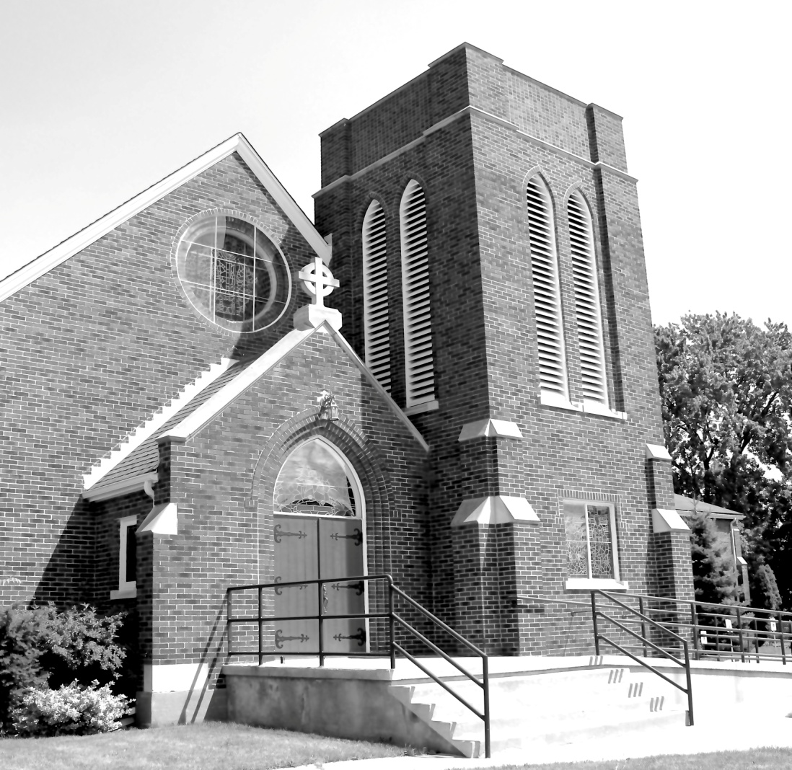

We Come and worship God.
We go our way with souls nourished.

Officiant: Ginny Schleihauf Organist: Dorothy Miller
380 Russell St. North (at Maxwell St.), Sarnia, Ontario, N7T 6S6
Tel: (519) 344-9531 - Email: canondavis@gmail.com – http://www.canondavis.com
May 14, 2023 — Sixth Sunday of Easter

Service of the Word

Gathering Hymn # 527 How Firm a Foundation

Officiant: The grace of our Lord Jesus Christ and the love of God and
the fellowship of the Holy Spirit be with you all.
People: And also with you.

Officiant: Let us pray.
We thank you, O God, that you have again brought us together on the Lord’s Day to praise you for your goodness and to ask your blessing. Give us grace to see your hand in the week that is past, and your purpose in the week to come; through Christ our Lord.
People: Amen.

Officiant: Dear friends in Christ, as we turn our hearts and minds to
worship almighty God, let us confess our sins.

People: Most merciful God, we confess that we have sinned
against you in thought, word, and deed, by what we have done and by what we have left undone. We have not loved you with our whole heart; we have not loved our neighbours as ourselves. We are truly sorry and we humbly repent. For the sake of your Son Jesus Christ, have mercy on us and forgive us, that we may delight in your will, and walk in your ways, to the glory of your name. Amen.

Officiant: Merciful God, grant to us, your faithful people, pardon and
peace, that we may be cleansed from all our sins and serve you with a quiet mind through Jesus Christ our Lord, who is alive and reigns with you and the Holy Spirit, one God, now and for ever.
People: Amen.
Officiant: The Peace of the Lord be always with you.
People: And also with you.

Officiant: Let us reconcile to God and one another a sign of Christ’s
peace.

The Collect of the Day
Merciful God, you have prepared for those who love you riches
beyond imagination. Pour into our hearts such love toward you, that we, loving you above all things, may obtain your promises,
which exceed all that we can desire; through Jesus Christ our Lord, who is alive and reigns with you and the Holy Spirit, one God, now and for ever..

Duet: Donna Taylor and Lora If We Could See Beyond Today

First Reading Acts 17: 22-31
Paul stood in front of the Areopagus and said, "Athenians, I see how extremely religious you are in every way. For as I went through the city and looked carefully at the objects of your worship, I found among them an altar with the inscription, 'To an unknown God.' What therefore you worship as unknown, this I proclaim to you. The God who made the world and everything in it, he who is Lord of heaven and earth, does not live in shrines made by human hands, nor is he served by human hands, as though he needed anything, since he himself gives to all mortals life and breath and all things. From one ancestor he made all nations to inhabit the whole earth, and he allotted the times of their existence and the boundaries of the places where they would live, so that they would search for God and perhaps grope for him and find him - though indeed he is not far from each one of us. For 'In him we live and move and have our being'; as even some of your own poets have said, 'For we too are his offspring.' Since we are God's offspring, we ought not to think that the deity is like gold, or silver, or stone, an image formed by the art and imagination of mortals. While God has overlooked the times of human ignorance, now he commands all people everywhere to repent, because he has fixed a day on which he will have the world judged in righteousness by a man whom he has appointed, and of this he has given assurance to all by raising him from the dead."

Officiant: The Word of the Lord.
People: Thanks be to God.

Psalm 66: 7-18 (Response in bold.)

Bless our God, you peoples; make the voice of his praise to be heard;
Who holds our souls in life, and will not allow our feet to slip.
For you, O God, have proved us; you have tried us just as silver is tried.
You brought us into the snare; you laid heavy burdens upon our backs.
You let enemies ride over our heads; we went through fire and water; but you brought us out into a place of refreshment.
I will enter your house with burnt offerings and will pay you my vows, which I promised with my lips and spoke with my mouth when I was in trouble.
I will offer you sacrifices of fat beasts with the smoke of rams; I will give you oxen and goats.
Come and listen, all you who fear God, and I will tell you what he has done for me.
I called out to him with my mouth, and his praise was on my tongue.
If I had found evil in my heart, the Lord would not have heard me;
But in truth God has heard me; he has attended to the voice of my prayer.
Blessed be God, who has not rejected my prayer, nor withheld his love from me.
Second Reading I Peter 3: 13-22
Now who will harm you if you are eager to do what is good? But even if you do suffer for doing what is right, you are blessed. Do not fear what they fear, and do not be intimidated, but in your hearts sanctify Christ as Lord. Always be ready to make your defence to anyone who demands from you an accounting for the hope that is in you; yet do it with gentleness and reverence. Keep your conscience clear, so that, when you are maligned, those who abuse you for your good conduct in Christ may be put to shame. For it is better to suffer for doing good, if suffering should be God's will, than to suffer for doing evil. For Christ also suffered for sins once for all, the righteous for the unrighteous, in order to bring you to God. He was put to death in the flesh, but made alive in the spirit, in which also he went and made a proclamation to the spirits in prison, who in former times did not obey, when God waited patiently in the days of Noah, during the building of the ark, in which a few, that is, eight persons, were saved through water. And baptism, which this prefigured, now saves you not as a removal of dirt from the body, but as an appeal to God for a good conscience, through the resurrection of Jesus Christ, who has gone into heaven and is at the right hand of God, with angels, authorities, and powers made subject to him.
Officiant: The Word of the Lord.
People: Thanks be to God.

Officiant: The Lord be with you.
People: And also with you.

Officiant: The Holy Gospel of our Lord Jesus Christ
according to John.
People: Glory to you, Lord Jesus Christ.

The Gospel John 14: 15-21

THE HOLY GOSPEL OF OUR LORD JESUS CHRIST
ACCORDING TO JOHN

Jesus said, "If you love me, you will keep my commandments. And I will ask the Father, and he will give you another Advocate, to be with you forever. This is the Spirit of truth, whom the world cannot receive, because it neither sees him nor knows him. You know him, because he abides with you, and he will be in you. I will not leave you orphaned; I am coming to you. In a little while the world will no longer see me, but you will see me; because I live, you also will live. On that day you will know that I am in my Father, and you in me, and I in you. They who have my commandments and keep them are those who love me; and those who love me will be loved by my Father, and I will love them and reveal myself to them."

Officiant: The Gospel of the Christ
People: Praise to you, Lord Jesus Christ.

Sermon
Mother's love vs God's.
How does mother's love compare to God's love for us?
Mother's love and God's love are both considered to be among the purest and most selfless forms of love.
A mother's love is often described as unconditional and all-encompassing. A mother's love is nurturing, supportive, and protective, and is often characterized by its selflessness and willingness to care for and support her children, even when they make mistakes or misbehave. It is a bond that is forged through the physical and emotional connection between a mother and her child.
There are many stories that illustrate a mother's sacrificial love for her child. One such story is the tale of "The Giving Tree" by Shel Silverstein.
In this story, a young boy and a tree become friends, and the tree spends its life giving to the boy, whether it be its leaves to play with, branches to build a house, or its trunk to carve a boat. As the boy grows older, he visits the tree less and less until he becomes an old man. The tree, now only a stump, offers its last gift to the old man by inviting him to sit on it and rest.
The story of "The Giving Tree" is often seen as a metaphor for a mother's love for her child. Like the tree, a mother gives selflessly to her child throughout her life, offering her time, energy, and resources to nurture and support her child. Even when her child grows older and becomes independent, a mother's love continues to be a source of comfort and strength.
God's love, on the other hand, is considered to be infinite and boundless. It is a love that transcends human understanding and is not dependent on any external factors. God's love is said to be unconditional and offered freely to all who seek it.
While there are similarities between mother's love and God's, there are also differences. A mother's love is a human love that is grounded in the physical world and is limited by our human capacity for love. God's love is a divine love that is not constrained by any human limitations.
Ultimately, both forms are essential to our emotional and spiritual well-being, and both have the power to bring us comfort, healing, and strength. Ultimately, while the nature of a mother's love and God's love may be different, they are both powerful and can have a profound impact on our lives.
The Gospel for today can be related to mother's teaching in several ways:
Importance of obedience: Just as Jesus emphasized the importance of obedience to his commands, mothers also emphasize the importance of obeying rules and following instructions.
Presence and guidance: Just as Jesus promised to send the Holy Spirit to help and guide his disciples, mothers are often seen as sources of guidance and support for their children
Love and sacrifice: Jesus demonstrated his love for his disciples through his willingness to sacrifice himself for them. Mothers demonstrate their love for their children through the countless sacrifices they make on a daily basis.
Mutual indwelling: Jesus spoke of the mutual indwelling between himself, his Father, and his followers. Mothers often share a deep connection with their children, and their lives are intertwined in a way that is hard to describe.

Listen to proverbs 31: 25-28…..
"She is clothed with strength and dignity;
she can laugh at the days to come.
She speaks with wisdom, and faithful instruction is on her tongue.
She watches over the affairs of her household and does not eat the bread of idleness.
Her children arise and call her blessed; her husband also, and he praises her."
Amen.

“To all our Mothers here today…Happy Mother’s Day!

Sermon Hymn # 653 Gracious Spirit, Holy Ghost

Officiant: Let us confess our faith as we say.

People: I believe in God, the Father Almighty, creator of heaven
and earth.
I believe in Jesus Christ, his only Son, our Lord.
He was conceived by the power of the Holy Spirit and
born of the Virgin Mary.
He suffered under Pontius Pilate, was crucified, died, and
was buried.
He descended to the dead.
On the third day he rose again.
He ascended into heaven, and is seated at the right hand
of the Father.
He will come again to judge the living and the dead.
I believe in the Holy Spirit, the holy catholic Church, the communion of saints, the forgiveness of sins, the resurrection of the body, and the life everlasting. Amen.

Prayers of the People

In peace we pray to you, Lord God.
Silence
For all people in their daily life and work;
For our families, friends, and neighbours, and for all those who are alone.
For this community, our country, and the world;
For all who work for justice, freedom, and peace.
For the just and proper use of your creation;
For the victims of hunger, fear, injustice, and oppression.
For all who are in danger, sorrow, or any kind of trouble;
For those who minister to the sick, the friendless, and needy.
For the peace and unity of the Church of God;
For all who proclaim the gospel, and all who seek the truth.
For Todd our bishop, and for all bishops and other ministers;
For all who serve God in the Church.
For our own needs and those of others.
Silence.
In our parish cycle of prayer, we pray for…
Hear us, Lord.
For your mercy is great.
We thank you, Lord, for all the blessings of this life.
Silence. (The people may add their own thanksgivings.)

We will exalt you, O God our king;
And praise your name for ever and ever.
We pray for those who have died in the peace of Christ, and for those whose faith is known to you alone, that they may have a place in your eternal kingdom.
Silence.
Lord, let your loving kindness be upon them;
Who put their trust in you.
Gracious God, you have heard the prayers of your faithful people; you know our needs before we ask, and our ignorance in asking. Grant our requests as may be best for us. This we ask in the name of your Son Jesus Christ our Lord.
Amen

Offertory Hymn # 342 We Praise You, O God

Offertory Response All Things Come of Thee

People: Yours, Lord, is the greatness, the power, the glory, the
splendour, and the majesty; for everything in heaven and on earth is yours. All things come from you, and of your own do we give you.

Officiant: And now, as our Saviour Christ has taught us,
we are bold to say,
People: Our Father, who art in heaven,
hallowed be thy name,
thy kingdom come,
thy will be done, on earth as it is in heaven.
Give us this day our daily bread.
And forgive us our trespasses,
as we forgive those who trespass against us.
And lead us not into temptation, but deliver us from evil.
For thine is the kingdom,
the power, and the glory, for ever and ever. Amen.

Officiant: Glory to God
People: whose power, working in us, can do infinitely more than
we can ask or imagine. Glory to God from generation to generation, in the Church and in Christ Jesus, for ever and ever. Amen.

Duet: Donna Taylor and Lora Hymn of Promise

Announcements

Closing Hymn # 435 Take My Life, and Let it Be

Officiant: May the God of hope fill us all with joy and peace in believing
through the power of the Holy Spirit. Amen.

Sung Benediction Howard’s Blessing (vs 1-2)
(in the back of the blue Hymn book)

The Flowers on the Altar today are given to
the Glory of God, and in loving memory of
Betty Blunt and Vera LaVecque-Ronholm
a gift of Bill and Mary Jane Blunt.

Please enter names in the Intercessions Book each week to be read in the service.
News and Events

- Please send all announcements for the bulletin to Karen by 11:00 a.m. Tuesday of each week. Call: 519-344-9531 or E-mail:
canondavis@gmail.com.

- If you would like a home visit with Communion or know of someone who would, please let Rev. Ray know as he and/or a Lay Visitor will be available in the coming weeks.

- Please join us for Coffee Hour after service for a time of fellowship in the parish hall.

- The Ladies Guild pies are still available. Turkey or Beef $5.50 each Shepherd's Pie $6.00 each. To place your order call the office at 519-344-9531.

Upcoming Events:

- Sunday June 4, 2023 – 2 Special Services
Installation Service for Ginny Schleihauf, our new licensed Lay Reader, and Rev. Ray who will officiate his last service at C.D.M. Church. It will be a Celtic Service with guest harpist, Wendy Rideout.

Parish Council will be hosting a Reception/Luncheon for Ray and Ginny following the church service in the Parish Hall. Please call the office by Sunday May 21, at 519-344-9531 or sign up on the sheet on the table at the back of the church by Sunday May 21 if you will be attending the luncheon. We require a head count for preparation of food and beverage. Thank you. John, Sheree Lynn and Carol.
- Join us on Wednesday May 17 in the Parish Hall for a delicious BBQ Chicken Dinner. Call 519 344-9531 to reserve your seat. Cost: Adults $20.00 and take out is available.

Reminders
May 14 Special Vestry Meeting after service – Parish Hall
May 17 BBQ Chicken Dinner – Parish Hall.
May 27 Forest United Church “Yard Sale”
May 31 Parish Council Meeting – Boardroom 10:00 a.m.
Jun 4 Luncheon and Reception for Rev. Ray Jenkins and
Ginny Schleihauf

