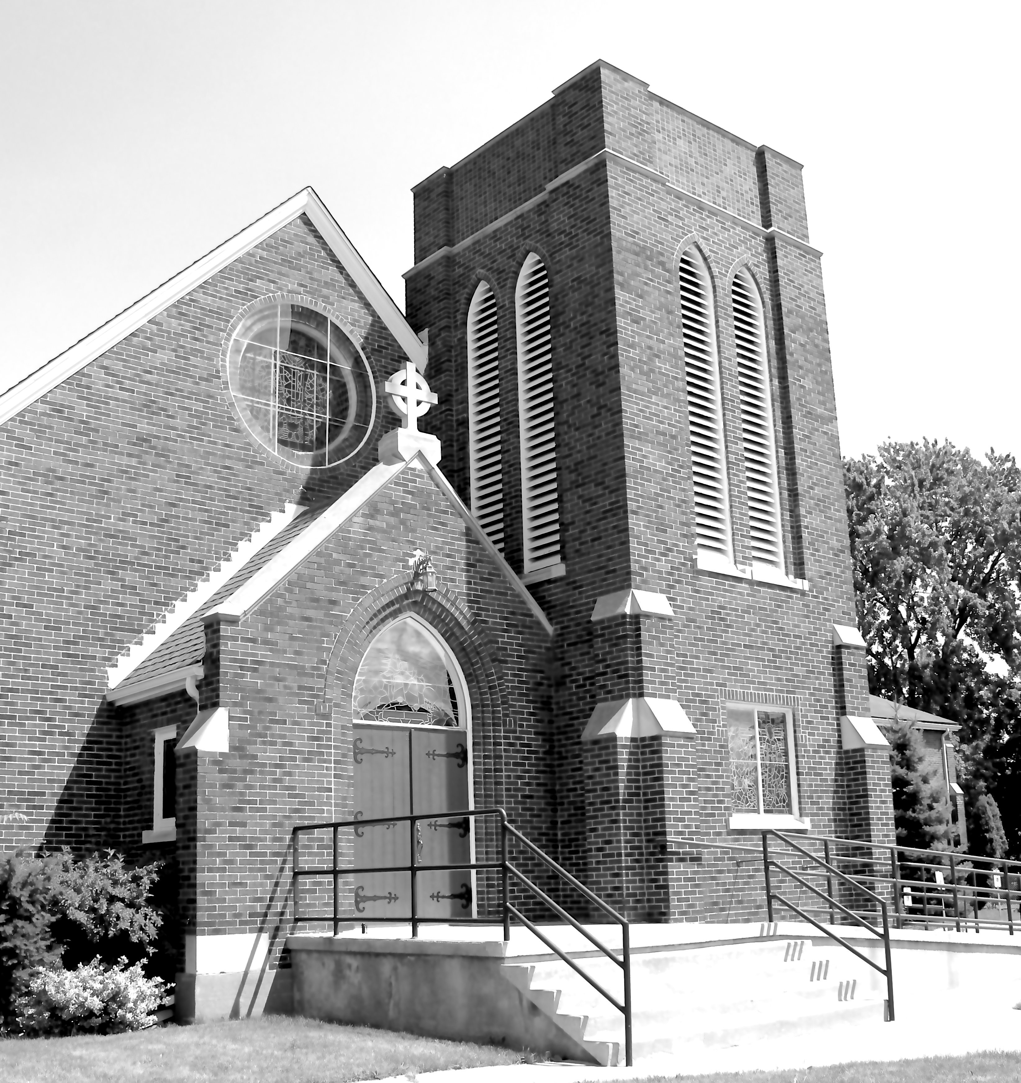
Canon Davis Memorial Church
380 Russell St. North, Sarnia, Ontario, N7T 6S6
(519) 344-9531 • http://www.canondavis.com

21st Sunday after pentecost • october 17, 2021

Sermon -- Being great

Job 38: 1-7 • Psalm 104: 1-9, 25, 37B • Hebrews 5: 1-10 • Mark 10: 35-45

Today’s Gospel is about the greatness of humility, contrasted with the sickness of pride.

Do you remember the story of the eagle’s egg that was placed into the nest of a prairie chicken?
The eaglet hatched with the brood of chicks and grew up with them. All his life, the eagle, thinking he was a prairie chicken, did what the prairie chickens did. He scratched in the dirt for seeds and insects to eat. He clucked and cackled, and he flew in a brief thrashing of wings and flurry of feathers no more than a few feet off the ground. After all, that’s how prairie chickens were supposed to fly.

Years passed, and the eagle grew very old. One day, he saw a magnificent bird far above him in the cloudless sky. Hanging with graceful majesty on the powerful wind currents, it soared with scarcely a beat of its strong golden wings. “What a beautiful bird,” said the eagle to his neighbour, “what is it?”

“That’s an eagle–the chief of the birds,” the neighbour clucked. “But don’t give it a second thought. You could never be like him.” So the changeling eagle never gave it another thought, and it died, thinking it was a prairie chicken.

So, what does greatness look like?

Those who are great don’t always look like they are; and we would never guess who they are.

But according to Jesus, the greatest among us won’t look very great at all. In fact, true greatness will often look like weakness, surrender or defeat

How do we measure greatness?

Our world tends to define greatness in terms of power, privilege, and prestige. We measure the importance of a person by external markers – the house they own, the car they drive or the nature of their lifestyle. We are impressed by the visible achievement of people: their prestigious honours and academic degrees, the importance of their profession, and sometimes even the accomplishments of their children.

But when Jesus speaks of greatness he inevitably links it with service. As he said to James and John, “that which makes us great is not our ability to rule over others, but, rather, our ability to invest ourselves for the welfare of others.”

To be of real service in this world, we must add something to other people's lives that cannot be bought.

Jesus calls us to that “better way” today. Only when we are willing to put more into life than we take out .. to put service to others in a place of honour .. only then, Jesus tells us, are we worthy to be called his followers.

The disciples learned an important lesson about Jesus and about being great.
They learned that a consistent, sincere lifestyle of putting others first, while placing their own desires and ambitions on hold, was the path to true greatness. There is no other path.

Greatness is not achieved by how outstanding we are, or how many followers we have on Facebook or even the way we look. God did not call us to be outstanding, He called us to be obedient.

If only the eagle had known who he really was…he truly could have served to be the great bird he was born to be.

Amen

Today in lieu of memorial flowers from Faye Farnworth and Family, in Loving Memory, we remember Cliff Farnworth

News & Events

Please send all announcements for bulletin to Karen by 11:00 am Tuesday of each week. Call 519-344-9531 or email canondavis@gmail.com

Wednesday, October 27th BBQ'd Beef Take-Out Dinner. Cost Adults $20, Children $12. Please bring correct change in zip-lock baggie. Thank you. Call the church at 519-344-953 to place your order and arrange your pick-up time slot

Wednesday, November 24th, Ham and Scalloped Potato Take-Out Dinner. Cost Adults $20 and Children $12

Sunday, October 24, 2021
BAS - Holy Eucharist
Twenty-Second Sunday after Pentecost
Officiant -Rev Ray Jenkins

