Sunday May 28, 2023—The Day of Pentecost
9:30 a.m. Morning Prayer (BCP) p.4

Opening Hymn # 350 Stand Up and Bless the Lord
Greeting

THE GATHERING OF THE COMMUNITY
Exhortation p. 4
General Confession p. 4
Absolution p. 5
The Lord’s Prayer p. 5
Responses p. 6
Venite p. 6

THE PROCLAMATION OF THE WORD
1st Reading Numbers 11: 24-30
Psalm 104: 25-36 (responsively alternate verses) BCP p. 463
2nd Reading I Corinthians 12: 3b-13
Gospel John 7: 37-39

Benedictus p. 9
The Apostles’ Creed p. 10
Versicles p. 10
The Lord’s Prayer p. 11
Responses p. 11

Collect of the Day Almighty and everliving God, who fulfilled the promises of Easter by sending us your Holy Spirit and opening to every race and nation the way of life eternal, keep us in the unity of your Spirit, that every tongue may tell of your glory; through Jesus Christ our Lord, who lives and reigns with you and the Holy Spirit, one God, now and for ever. Amen.
Collect for Peace p. 11
Collect for Grace p. 11
Offertory Hymn # 504 Jesu, Jesu, Fill Us with Your Love
Offertory Response All Things Come of Thee (sung)

Sermon
Sermon Hymn # 643 Holy Spirit, Come with Power
Prayer for the King and Commonwealth p. 12
Prayer for the Clergy and People p. 13
Prayer for All Conditions of Mortals p. 14
General Thanksgiving (said by all) p. 14
Prayer of Saint Chrysostom p. 15

Prayer for a Renewed Church: Almighty God, give us a new vision of you, of your love, of your grace and power, and then, give us a new vision of what you would have us do as your Church in this nation and at this time, and an awareness that in the strength of your Spirit, we can do it to your glory. In Jesus’ name we pray. Amen.

The Grace p. 15

Announcements

Closing Hymn # 249 Wind Who Makes All Winds That Blow
Dismissal
Officiant Go in peace to love and serve the Lord.
People Thanks be to God.
Sung Benediction Howard’s Blessing (vs. 1-2)
(found in the back of the blue hymn book)

The Flowers on the Altar this morning are given to the
Glory of God and in loving memory of Chuck Curran,
a gift of his wife, Marion and children.

NEWS AND EVENTS

- Please send all announcements for the bulletin to Karen by 11:00 a.m. Tuesday of each week. Call 519-344-9531 or E-mail: canondavis@gmail.com.
- If you would like a home visit with Communion or know of someone who would, please let Rev. Ray know as he and/or a Lay Visitor will be available in the coming weeks.
- Please join us for Coffee Hour after service for a time of fellowship in the
parish hall.
- The Ladies Guild pies are still available. Turkey or Beef $5.50 each Shepherd's Pie $6.00 each. To place your order, call the office at 519-344-9531.
- CDM has held two meat raffles with London Rd. School. Each raffle raised $420.00 for a total of $840.00. The next meat raffle will be held on Tuesday June 13 from 6:00 to 8:00 p.m. at Imperial City Brew House, 1330 Exmouth Street. Draws are $2.00 each and there are 9 draws.

- On Wednesday June 21, The ACW Ladies Guild and Friends Annual Luncheon will be held at 12:30 p.m. in the Parish Hall. Chef John, Sheree and I have met the challenge with our “Olives” menu. Select either Salmon Asparagus Quiche or Chicken Pot Pie as your entrée and for dessert, either Frozen Lemon Meringue or Chocolate Caramel, Pecan Cheesecake (Turtle). Mixed greens, berry salad with house dressing, cheese and fruit biscuits will also offered. If you wish to attend, please RSVP by June 11 by contacting Carol at 519 491 9319 or Karen at 519 344 9531. A sign-in sheet will also be available at the back of the church. Free Will Offering.

Upcoming Events:
Reminders
May 31 Parish Council Meeting – Boardroom 10:00 a.m.
Jun 4 Luncheon and Reception for Rev. Ray Jenkins and
Ginny Schleihauf
Canon Davis Memorial Church
Anglican Church of Canada

May28,2023 – The Day of Pentecost

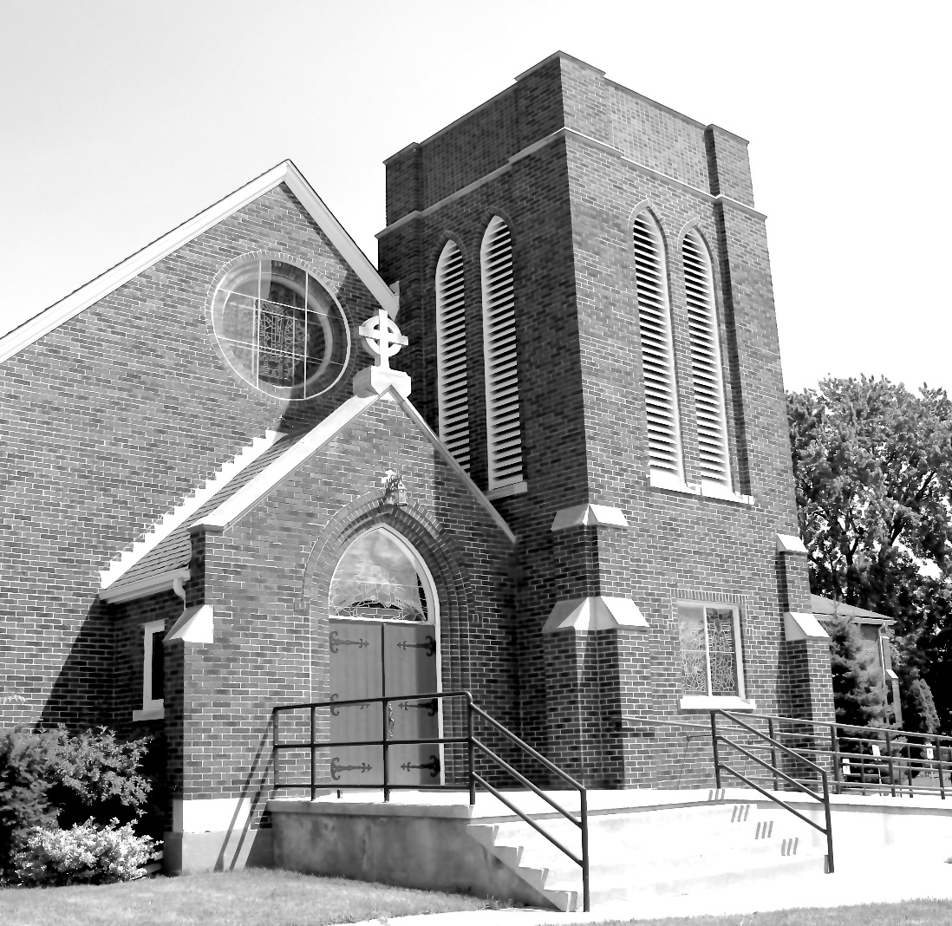

Worship Service: Sunday 9:30 a.m.

Officiant: Bill Graham Organist: Dorothy Miller

380 Russell St. North (at Maxwell St.), Sarnia, Ontario N7T 6S6
(519) 344-9531 – Email: canondavis@gmail.com -- http://www.canondavis.com

