Canon Davis Memorial Church

380 Russell St. North, Sarnia, Ontario, N7T 6S6
(519) 344-9531 • http://www.canondavis.com
4TH SUNDAY OF EASTER • April 25, 2021
Acts 4:5-12 • Psalm 23 • 1 John 3:16-24 • John 10:11-18

Dear Friends,
People are many things to each other. We are organizers, and we allow ourselves to be organized. Along the way, we support leaders, who in theory support us.

We tend to be joiners; probably more than we think. Our identities are often defined by those with whom we share our time and other resources. We also can find ourselves defined by our choices of what we do not wish to join. And while we cannot join everything, we would probably be astounded by the inter-relationships we have in many directions — many directions other people see; but we tend to overlook in our daily routines.

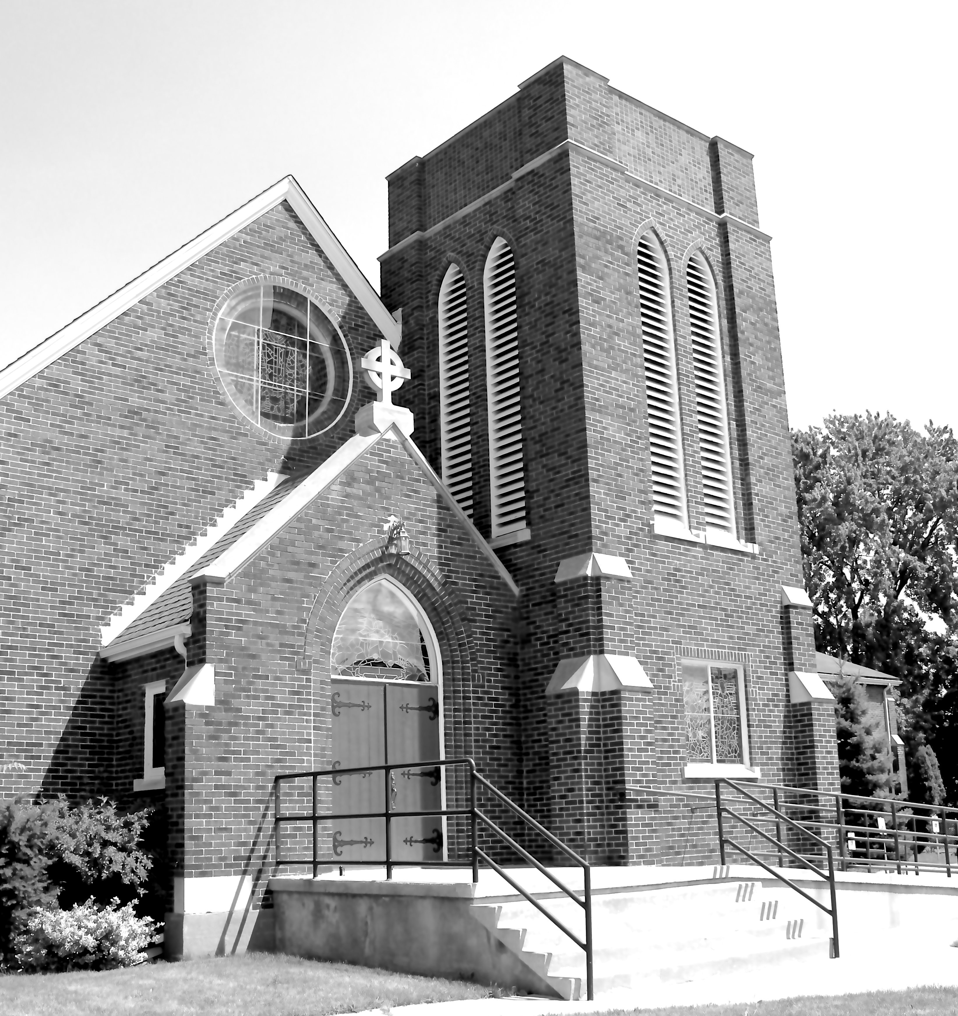
In addition to the clubs, professional organizations, corporations, hobby groups, and a large grouping of formal alliances, there is another whole grouping of relationships. These, while more subtle, may speak volumes about us to those around us. Sometimes we are aware of these belongings; sometimes not at all.

What am I talking about? The sense of belonging that comes from feeling association with any number expressions. These say a lot about who we are as people. These can be surprisingly important in defining who we are, or who we are becoming.

Now, what is in a name? The answer often can be a strong bit of our identity. We can hear terms like: conservative; liberals; old fashioned; millennials; baby boomers; world travellers; news junkies; star gazers; etc. Examples are endless. When someone is referred to as any of these, they may or may not be offended. Many people are pleased. For we are in a sense describing more about who they are as people and a sense of their belonging.

In summary: as we enter into relationships, they become a part of us; as we become part of them.

Enter Jesus.
I once read a magazine article about a man who had become obsessed with popular images of our Lord. His bedroom walls were covered over with images of Jesus from newspapers, magazines, posters, and prints. Some were fresh off the press, others looked ancient. In addition this fellow had likenesses in ceramic, metal castings, pottery, and wood carvings. In collecting this outstanding assembly of images, one can easily wonder what effect all of these likenesses of our Lord had on this man. Certainly, there had to be some effect. What we do does leave its mark upon us. Did this make him a better person? It would be nice to think so! But we will never know.

What we experience in life does effect our perspective on life. This is true about what was taking place 2000 years ago by the Jesus Movement. As the followers of Christ grew in numbers, we begin to see a new spirituality emerged along with them in a very positive sense. But they quickly observed that the changes taking place came mainly not from any organization among their members.

For it can be observed that they were witnessing a transformation that came (and comes today) from the actual presence of Christ within our hearts! Your heart — and my heart! We begin living differently on the basis of our coming to know Christ; rather than from acquiring any knowledge about him. Organizations may point the way. Direct experience will bring us home. A new world awaits and we rejoice!

Wherever we are, we are called upon to be bearers of love; of healing; and of peace. We are known and loved by God! The blessings of our loving, Creator God be upon you and those you love.

——————————————————————————
You are invited to go each Sunday and/or Wednesday to the link:
tinyurl.com/StAlbans-CDMC

That is the link to St. Alban’s Anglican Church in Burnaby B.C. Follow the instructions. You will find links to the Rev’d Greg Jenkins officiating at an Anglican church service with children’s focus, church music, readings, prayers and a sermon.
If you are also interested in joining their weekly Bible Study, contact Rev. Greg at revgregjenkins@gmail.com He will be more than happy to be in touch about joining in with their group by ZOOM. I hope you will find these services help to deepen your faith.

tinyurl.com/StAlbans-CDMC

——————————————————————————-
We are joining with many parishes in our deanery in providing telephone support to our members and friends. This support is designed to keep us up to date, while not requiring a computer. A CDMC Pastoral Letter will be read this week through our phone ministry.

