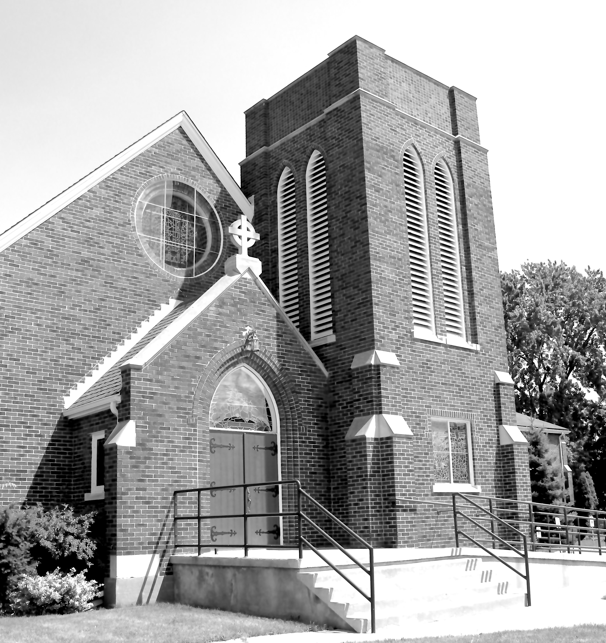
Canon Davis Memorial Church
380 Russell St. North, Sarnia, Ontario, N7T 6S6
(519) 344-9531 • http://www.canondavis.com

PRESENTATION OF THE LORD • February 2, 2022

Sermon

Malachi 3:1-4 • Psalm 84 • Luke 2:2-24 • Luke 2:5-26 • Luke 2:7-32 • Luke 236-40

Dear Friends,

As we may know, the housing market has been vibrant over the past 2 years or so. People are finding that they are not restricted to living in big cities in order to get a really good job. A lot may depend on the nature of one’s career choice. But with the growing options for enhancing our communication abilities, we can do a lot more from our homes than we would have ever thought possible only a few years ago!

People who moved to smaller settlements only a few years ago knew they would likely change from good career opportunities to smaller based agricultural activities. Indeed, there are many success stories — from the creation of new rural based agri-business establishments — to young couples successfully living off the land.

But the majority of adventures seem to involve highly motivated people who are computer savvy and and have a strong work ethic. And the money? — where does the money come from? Massive borrowing? — Maybe.

But there is another source of funds to help the cash flow. One’s home! The sale of a home in higher cost Toronto markets often may buy a much better residence an hour or more outside the Toronto city limits!

One can still get burned; but with good research and the right kind of job. Such a move may provide some options that can be worth considering. But there is also the potential for risk-taking. The other day, I heard of a couple who were so anxious to move that they sold their urban area place, without having bought a place into which they could move. They panicked, as they read the real estate columns, and called real estate people. One description seem just right. So they bought it site unseen! Yes, that could lead to situations that are good; or not so good.

Now, God’s children can find themselves in a similar position, We live our lives believing in/depending on our invisible God! At times that my seem to be a real problem. On one hand, God dwells within each of us. On the other hand, God chooses to be invisible to the human eye. We as Christians, have mostly learned to function reasonably well.

But this arrangement can be pretty hard for someone new to the faith. How can a prospective home buyer know an unseen home is a real place as described? Similarly, how can a person tell if the invisible God exists at all? The answers can be many.

But in today’s readings we are given a glimpse of God being remembered in
biblical history. Today, in the advertising industry, we would refer to such statements as testimonials. In the olden days, they would have called these as giving witness. The presence of what is holy is described by someone who has seen or heard some aspect of God in their midst. Often, the experience of God is a narrative describing how God’s call into God’s service came about. This call also may convey enough information as to why we can trust God’s witnesses and what they have to say.

This is similar to the necessity for a good real estate agent to be able to suggest someone in assessing the true condition and value of a property not able to readily be seen by a potential buyer. In drawing on the experience and dearness of Simeon of Jerusalem and the prophet, and Anna the daughter of Phanuel, God was sharing these people with a close relationship through the Holy Spirit to inform all who would listen about who the baby Jesus was and the impact of his mission.

We, in the 21st century have a further blessing upon which to bolster our faith. We have the lessons of history which show the Godly wisdom of what Jesus can mean in every age. Examples abound — many are the examples that occur in our own lives as we interact with other people.

As time passes, may we take seriously the call of Jesus for us to live lives of love. A potentially wonderful world awaits,

We pray now in the words of Brother Roger.
God of peace, you do not want us to know relentless worry, but rather a humble repentance of heart. It is like a surge of trusting that enables us to place our burdens on you. And then, by the light of forgiveness, we discover a peace of heart.
Amen.

——————————————————————————

Call the CDMC office Tuesday or Thursday mornings
to confirm that you plan to be at our next Sunday service.
(seating is limited) (519) 344-9531

——————————————————————————

You are invited to go each Sunday and/or Wednesday to the link:
tinyurl.com/StAlbans-CDMC

That is the link to St. Alban’s Anglican Church in Burnaby B.C. Follow the instructions. You will find links to the Rev’d Greg Jenkins officiating at an Anglican church service with children’s focus, church music, readings, prayers and a sermon.

If you are also interested in joining their weekly Bible Study, contact Rev. Greg at revgregjenkins@gmail.com He will be more than happy to be in touch about joining in with their group by ZOOM. I hope you will find these services help to deepen your faith.
tinyurl.com/StAlbans-CDMC

——————————————————————————-

