Canon Davis Memorial Church
Anglican Church of Canada
Sunday December 19, 2021 – 4th Sunday of Advent

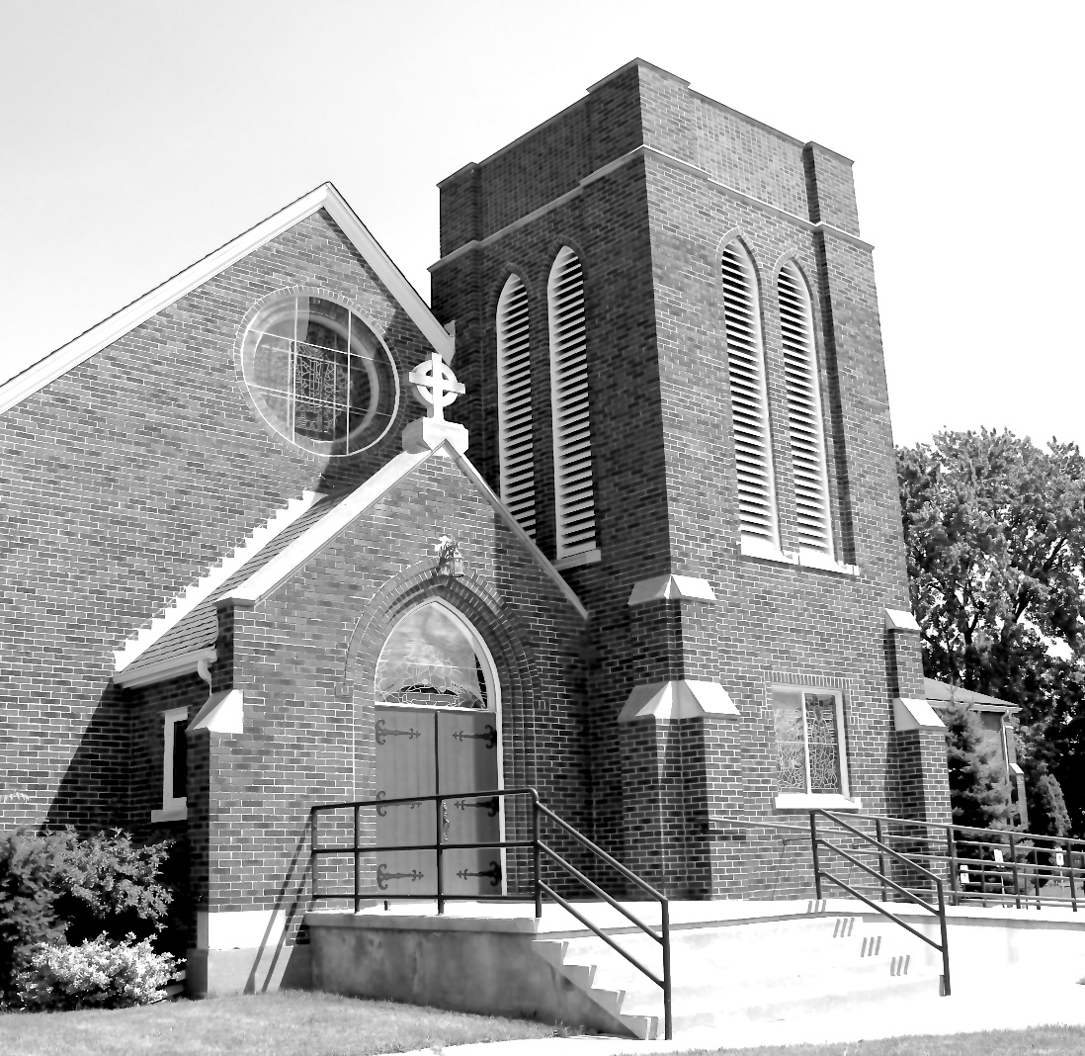

We come and worship God.
We go our way with souls nourished.
Worship Service: Sunday 9:30 a.m.
380 Russell St. North (at Maxwell St.), Sarnia, Ontario, N7T 6S6
(519) 344-9531 - http://www.canondavis.com

The Diocese has announced that we may, while wearing a mask, sing the first two verses of the hymns during the service.

Canon Davis Memorial Church
Anglican Church of Canada
Sunday, December 19, 2021 – 4th Sunday of Advent
9:30 a.m. Holy Eucharist
Officiant—Rev’d Paul Woolley — Organist—Dorothy Miller

Greeting

Advent 4 – Today is the fourth Sunday of Advent, the Sunday of Love. Jesus shows us God’s perfect love. He is God’s perfect love in human form. Those who believe in him and live in him, live in love. Love transforms and perfects all things. It never ends.

We light this candle today to remind us that God is love. We thank God for the hope he gives us, for the peace he bestows, for the joy he pours into our hearts, and for the love that redeems us and shows us the way.

Advent Candle
“A Candle is Burning”
words by Sandra Dean, 1986.Tune by James Murray 1887 (public domain)

A candle is burning, a candle of love,
A candle to point us to heaven above.
A baby for Christmas, a wonderful birth,
For Jesus is bringing God’s love to our earth.

THE GATHERING OF THE COMMUNITY

Opening Hymn # 98 Hark the Glad Sound!
The grace of our Lord Jesus Christ, and the love of God, and the fellowship of the Holy Spirit, be with you all.
And also with you.
Almighty God, to you all hearts are open, all desires known, and from you no secrets are hidden. Cleanse the thoughts of our hearts by the inspiration of your Holy Spirit, that we may perfectly love you, and worthily magnify your holy name; through Christ our Lord. Amen.
Glory to God in the highest, and peace to his people on earth.
Lord God, heavenly king, almighty God and Father, we worship you, we give you thanks, we praise you for your glory.
Lord Jesus Christ, only Son of the Father, Lord God, Lamb of God, you take away the sin of the world: have mercy on us; you are seated at the right hand of the Father: receive our prayer.
For you alone are the Holy One, you alone are the Lord, you alone are the Most High, Jesus Christ, with the Holy Spirit, in the glory of God the Father. Amen.
Lord, have mercy. Christ, have mercy. Lord, have mercy.
COLLECT OF THE DAY: Heavenly Father, who chose the Virgin Mary, full of grace, to be the mother of our Lord and Saviour, now fill us with your grace, that we in all things may embrace your will and with her rejoice in your salvation; through Jesus Christ our Lord, who lives and reigns with you and the Holy Spirit, one God, now and for ever.Amen.
THE PROCLAMATION OF THE WORD

1st Reading: Micah 5: 2-5a
Psalm Canticle 18 (Luke 1: 47-55)
2nd Reading: Hebrews 10: 5-10
Gospel: Luke 1: 39-45

THE HOLY GOSPEL OF OUR LORD JESUS CHRIST
ACCORDING TO LUKE
In those days Mary set out and went with haste to a Judean town in the hill country, where she entered the house of Zechariah and greeted Elizabeth. When Elizabeth heard Mary's greeting, the child leaped in her womb. And Elizabeth was filled with the Holy Spirit and exclaimed with a loud cry, "Blessed are you among women, and blessed is the fruit of your womb. And why has this happened to me, that the mother of my Lord comes to me? For as soon as I heard the sound of your greeting, the child in my womb leaped for joy. And blessed is she who believed that there would be a fulfilment of what was spoken to her by the Lord."
Sermon
Sermon Hymn # 125 Infant Holy, Infant Lowly

The Apostles’ Creed: Let us confess the faith of our baptism, as we say,
I believe in God, the Father almighty, creator of heaven and earth. I believe in Jesus Christ, his only Son, our Lord. He was conceived by the power of the Holy Spirit and born of the Virgin Mary. He suffered under Pontius Pilate, was crucified, died, and was buried. He descended to the dead. On the third day he rose again. He ascended into heaven, and is seated at the right hand of the Father. He will come again to judge the living and the dead. I believe in the Holy Spirit, the holy catholic Church, the communion of saints, the forgiveness of sins, the resurrection of the body, and the life everlasting. Amen.

Prayers of the People

PRAYER FOR A RENEWED CHURCH: Almighty God, give us a new vision of you, of your love, of your grace and power, and then, give us a new vision of what you would have us do as your Church in this nation and at this time, and an awareness that in the strength of your Spirit, we can do it to your glory. In Jesus’ name we pray. Amen.

Confession and Absolution:
Dear friends in Christ, God is steadfast in love and infinite in mercy; he welcomes sinners and invites them to his table. Let us confess our sins, confident in God’s forgiveness.

The Confession: Most merciful God,
we confess that we have sinned against you in thought, word, and deed, by what we have done, and by what we have left undone. We have not loved you with our whole heart; we have not loved our neighbours as ourselves. We are truly sorry and we humbly repent. For the sake of your Son Jesus Christ, have mercy on us and forgive us, that we may delight in your will, and walk in your ways, to the glory of your name. Amen.

Absolution: Almighty God have mercy upon you, pardon and deliver you from all your sins, confirm and strengthen you in all goodness, and keep you in eternal life; through Jesus Christ our Lord. . Amen.

The Peace

Offering Hymn # 139 The First Nowell

PRAYER OVER THE GIFTS: Gracious God, by the power of the Spirit who sanctified the mother of your Son, make holy all we offer you this day. We ask this in the name of Jesus Christ the Lord.

Eucharistic Prayer # 5
The Lord be with you.
And also with you.

Lift up your hearts.
We lift them to the Lord.

Let us give thanks to the Lord our God.
It is right to give our thanks and praise.

We give you thanks and praise, almighty God, for the gift of a world full of wonder, and for our life which comes from you. By your power you sustain the universe.
Glory to you for ever and ever.

You created us to love you with all our heart, and to love each other as ourselves, but we rebel against you by the evil that we do.

In Jesus, your son, you bring healing to our world and gather us into one great family. Therefore, with all who serve you on earth and in heaven, we praise your wonderful name, as we say,

Holy, holy, holy Lord, God of power and might, heaven and earth are full of your glory. Hosanna in the highest.

Blessed is he who comes in the name of the Lord. Hosanna in the highest.

We give you thanks and praise, loving Father, because in sending Jesus, your Son, to us you showed us how much you love us. He cares for the poor and the hungry. He suffers with the sick and the rejected.

Betrayed and forsaken, he did not strike back but overcame hatred with love.

On the cross he defeated the power of sin and death.

By raising him from the dead you show us the power of your love to bring new life to all your people.
Glory to you for ever and ever.

On the night before he gave up his life for us, Jesus, at supper with his friends, took bread, gave thanks to you, broke it, and gave it to them, saying, “Take this, all of you, and eat it: this is my body which is given for you.”

After supper, Jesus took the cup of wine, said the blessing, gave it to his friends, and said, “Drink this, all of you: this is the cup of my blood, the blood of the new and eternal covenant, which is shed for you and for many, so that sins may be forgiven. Do this in memory of me.”
Glory to you for ever and ever.

Gracious God, with this bread and wine we celebrate the death and resurrection of Jesus, and we offer ourselves to you in him.
Send your Holy Spirit on us and on these gifts, that we may know the presence of Jesus in the breaking of bread, and share in the life of the family of your children.
Glory to you for ever and ever.

Father, you call us to be your servants; fill us with the courage and love of Jesus, that all the world may gather in joy at the table of your kingdom.

We sing your praise, almighty Father, through Jesus, our Lord, in the power of the Holy Spirit, now and for ever.
Glory to you for ever and ever. Amen.
The Lord’s Prayer: Our Father, who art in heaven, hallowed be thy name, thy kingdom come, thy will be done, on earth as it is in heaven. Give us this day our daily bread. And forgive us our trespasses, as we forgive those who trespass against us. And lead us not into temptation, but deliver us from evil. For thine is the kingdom, the power, and the glory, for ever and ever. Amen.

Breaking of the Bread:
We break this bread to share in the body of Christ.
We, being many, are one body, for we all share in the one bread.

Communion
The gifts of God for the people of God.
Thanks be to God.

PRAYER AFTER COMMUNION: Faithful God, in this sacrament we receive the promise of salvation. May we, like the Virgin Mary, be obedient to your will. We ask this in the name of Jesus Christ the Lord.
Doxology
Glory to God, Whose power, working in us, can do infinitely more than we can ask or imagine. Glory to God from generation to generation, in the Church and in Christ Jesus, for ever and ever. Amen.

Blessing
The peace of God which passes all understanding, keep your hearts and minds in the knowledge and love of God and of his son Jesus Christ and the blessing of God Almighty the Father, the Son and the Holy Spirit be with you and those you love for ever more. Amen.

Announcements
Hymn # Angels We Have Heard on High
Benediction Song
Howard’s Blessing (Back of the hymn book vs 1-2)

Today in lieu of memorial flowers from Gordon Simmons, Pam, Joel, Anna and Molly Eagleson, and Brad, Mary-Elizabeth, McKenna and Camryn Carol, we, in loving memory, remember Mary Switzer.

The Christmas Wreath on the front of the pulpit is given to the Glory of God and in loving memory of Wendy Heasman and family members and friends at this blessed Christmas Season, a gift of Reg and family.

MERRY CHRISTMAS!
News and Events

- Please send all announcements for the bulletin to Karen by 11:00 a.m. Tuesday of each week. Please call: 519-344-9531 or email: canondavis@gmail.com.

- To register your attendance at Sunday Services please contact the office at 519-344-9531. Thank you.

- Please join us after service for a time of fellowship in the parish hall.

Reminders:

- Dec 24 – Christmas Eve service will be held at 5:00 p.m. Please remember to call to register. MASKS ARE MANDATORY.
Our guest vocalists for this service will be Mary Abma, and Brian Abma, accompanied by Tony Wing on the clavinova.

Christmas Memorials—2021

In loving memory of my husband Hugo, mother and dad Henry and Verna Tomlinson, remembered by Faith Archer.

In loving memory of members of the Ayers family, remembered by Greta Ayers.

In loving memory of Ray Chalifoux, and Melody Chalifoux (VanSickle), a gift of Pat, Debbie and Michelle and family.

In loving memory of Ollie and Nancy Haddon and Sue Chalmers and my husband Les Chalmers, remembered by Marg and their families.

In memory of Chuck, Marg, Grace, Edgar, Alice, Gord and Kathy, Bill, and for blessings received, lovingly remembered by Marion Curran and family.

In memory of Margaret and Garth, lovingly remembered by Joan Dew.

In loving memory of Web Dixon, remembered by wife Joyce and children Joy and Gay.

In loving memory of Mr. and Mrs. William Frew, Mr. and Mrs. Thomas Spencer, brothers, Raymond, Russell and George Spencer, sister, Marion Bradley and great-grand daughter, Winnie Mae l remembered by Doug and Shirley Frew and family.

In memory of loved ones, remembered by Helen and Glenn Forbes.

In loving memory of Kenneth and Ev George, and Brian George, remembered by the family.

In loving memory of Kathy Graham, remembered by Bill Graham and family.

In loving memory of Bill and Hettie Graham, Jean and Jim Bell, and Marjorie and David Ashcroft, remembered by Bill Graham and family.

In loving memory of parents and grandparents, Merien and Earl Sloat, and George and Edith Scott, remembered by Raymond, Rebecca and Katie Grandis.
In loving memory of Mr. and Mrs. Reginald Haddon, remembered by their family.

To the glory of God and in loving memory of Harrison, Knowles’ family members and in thanks for Blessings received, remembered by the Harrison and Knowles’ families.

In loving memory of Margaret and Glen Hayter, Mom, Dad, Gram and Gramps, Great Grammie and Great Granpooh, a gift of Sheree Lynn, Mike, Jason and Lucy.

In memory of our ‘Mum’ and ‘Gran,’ Mary Tracy, our aunts and sisters, Christine Labrasceur, and Lynn McCann, our ‘Papa’ and ‘Dad,’ Gerry Tracy and our ‘Gramma’ and Grampa, Mother and Dad, Glen and Margaret Hayter, lovingly remembered by John, Elaine, Joanna, Sarah, and Nikki Hayter and Jeremy Wickham.

In thanksgiving for blessings received and in memory of loved ones, lovingly remembered by Ruth and Charlie Lavigne.

In memory of our parents, Kathleen and Gordon McPhail, lovingly remembered by the family.

In memory of loved ones, and in thanksgiving for many blessings, lovingly remembered by Mary and Lyle Moran.

In memory of Kathy Wilson, lovingly remembered by the Pusey family and the Morphew family.

In loving memory of Sarah Jane Churchman, Mr. and Mrs. R. Kershaw, A. Louisa Hibbert, and Bill Phillips, remembered by Janey Phillips.
In memory of the Rinker and Redden families, lovingly remembered by Gerry Rinker and family.

In memory of my husband Alexander Scrimgeour, and loving son, Ian, lovingly remembered by Sylvia Scrimgeour, and family.

In loving memory of Beth Simmons, Mary Switzer, Mary Walker-Thiel and Georgina and Gordon Simmons, Sr., remembered by Gord, Mary-Elizabeth and Brad, Pamela, and Joel, and families.

In loving memory of Marg and Bill Spence, a gift from Bob and Carol.

In loving memory of Eve and Earle Armstrong and grandson Ryan Andrew Stallibrass, remembered by Wendy, Ron and Robyn Stallibrass.

In memory of loved ones, remembered by Jim and Pat Struthers.

In loving memory of Ted Wood, remembered by Pat Wood and family.

In loving memory of dear parents, Mary and Fred Wyville, remembered by Pat, Barbara and Dave, Bonnie and Ed, and families.

In loving memory of Gary Laidlaw, a gift of Seonaid and family.

To the glory of God and in loving memory of my Granny, Zola May, remembered by Ginny Schleihauf.

