July 17, 2022 — 6th Sunday after Pentecost

THE GATHERING OF THE COMMUNITY

Gathering Hymn Great is Thy Faithfulness
Greeting p. 185
Gloria - Hymn #365 Glory to God on High
Kyrie Eleison p. 186

Collect of the Day: Almighty God, your Son has opened for us a new and living way into your presence. Give us pure hearts and constant wills to worship you in spirit and in truth; through Jesus Christ our Lord, who lives and reigns with you and the Holy Spirit, one God, now and forever. Amen.

THE PROCLAMATION OF THE WORD

1st reading AMOS 8:1-12
Psalm 52 “I trust in the mercy of God for ever and ever.” p. 771-772
2nd reading COLOSSIANS 1:15-28
Gradual Hymn #439 Blest are the Pure in Heart
Gospel LUKE 10:38-42

Sermon
The Apostles’ Creed p. 189
Prayers of the People # 17 p. 123

Prayer for a Renewed Church: Almighty God, give us a new vision of you, of your love, of your grace and power, and then, give us a new
vision of what you would have us do as your Church in this nation and at this time, and an awareness that in the strength of your Spirit, we can do it to your glory. In Jesus’ name we pray. Amen.

Confession and Absolution p. 191
The Peace p. 192
Offertory Hymn #385 Worship the Lord in the Beauty of Holiness

Offertory Response Doxology (sung)
Praise God, from Whom all blessings flow.
Praise Him, all creatures here below.
Praise Him above, ye Heavenly Host.
Praise Father, Son, and Holy Ghost.

THE CELEBRATION OF THE HOLY EUCHARIST

Prayer over the Gifts: O God, accept our praise and thanksgiving. Help us in all we do to offer ourselves as a true and living sacrifice; through Jesus Christ the Lord. Amen.
Eucharistic Prayer # 4 p. 201
The Lord’s Prayer p. 211
Breaking of the Bread # 4 p. 212
Communion

Prayer After Communion: O God, as we are strengthened in these holy mysteries, may our lives be a continual offering, holy and acceptable in your sight; through Jesus Christ our Lord. Amen.
Glory to God p. 214
Blessing
Announcements
Mission Hymn #505 Be Thou My Vision
Officiant: Go in peace to love and serve the Lord.
People: Thanks be to God.
Sung Benediction Howard’s Blessing (vs 1-2)

The Flowers on the Altar today are given to the Glory of God and in loving memory of John Manton and loved ones, a gift of Joyce Manton and family.
News and Events

- Please send all announcements for the bulletin to Karen by 10:00 a.m. Tuesday of each week. E-mail: canondavis@gmail.com. Or Call: 519-344-9531

- If you would like a home visit with Communion or know of someone who would, please let Rev. Ray know as he and/or a Lay Visitor will be available in the coming weeks.

- Please join us for Coffee Hour after service for a time of fellowship in the parish hall. Volunteers for coffee goodies needed for July and
August. Please see the sign-up sheet at the back of the church.

- Day by Day book for August, September and October is available at the back of the church. Cost: $1.50

Upcoming Events:

- 18 September 2:00 p.m. The Christian Music Café is coming to Canon Davis. Please join us for this monthly musical event. Refreshments and treats will be available.. Free will offering.
Reminders:

Canon Davis Memorial Church
Anglican Church of Canada
Sixth Sunday after Pentecost
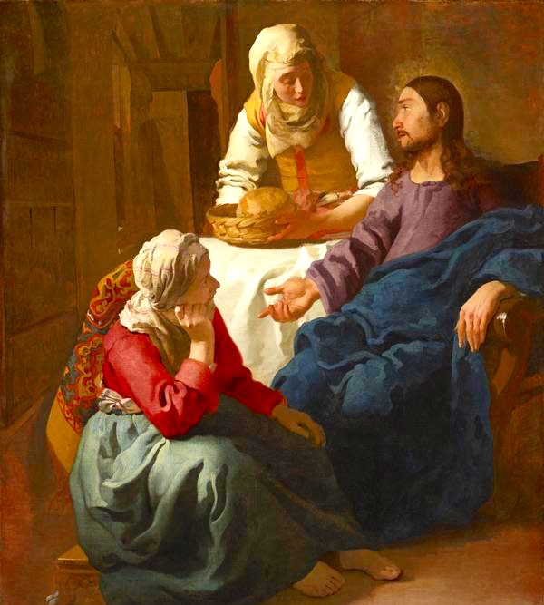
July 17, 2022
“Christ in the House of Mary and Martha”

Rev’d Paul Woolley – Officiant – Assisted by Tom Brown
Dorothy Miller - Organist
380 Russell St. North (at Maxwell St.), Sarnia, Ontario, N7T 6S6
Tel: (519) 344-9531 - Email: canondavis@gmail.com – http://www.canondavis.com

