BCP Morning Prayer

Opening Hymn For the Healing of the Nations (vs 1&2) # 576
Greeting

THE GATHERING OF THE COMMUNITY
Exhortation p. 4
General Confession p. 4
Absolution p. 5
The Lord’s Prayer p. 5
Responses p. 6
Venite p. 6

THE PROCLAMATION OF THE WORD
1st Reading Acts 16: 9-15
Psalm 67 BCP p. 409
2nd Reading Revelation 21: 10, 22-22:5
Gospel John 5: 1-9

Benedictus p. 9
The Apostles’ Creed p. 10
Versicles p. 10
The Lord’s Prayer p. 11
Responses p. 11

Collect of the Day Merciful God, you have prepared for those who love you riches beyond imagination. Pour into our hearts such love toward you, that we, loving you above all things, may obtain your promises, which exceed all that we can desire; through Jesus Christ our Lord, who is alive and reigns with you and the Holy Spirit, one God, now and for ever. Amen.
Collect for Peace p. 11
Collect for Grace p. 11
Offertory Hymn Breathe on Me, Breath of God #649
Offertory Response All Things Come of Thee (sung)
Sermon
Sermon Hymn God, Whose Almighty Word (vs 1 & 2) #560
Prayer for the Queen and Commonwealth p. 12
Prayer for the Clergy and People p. 13
Prayer for All Conditions of Mortals p. 14
General Thanksgiving (said by all) p. 14
Prayer of Saint Chrysostom p. 15

Prayer for a Renewed Church: Almighty God, give us a new vision of you, of your love, of your grace and power, and then, give us a new vision of what you would have us do as your Church in this nation and at this time, and an awareness that in the strength of your Spirit, we can do it to your glory. In Jesus’ name we pray. Amen.

The Grace p. 15

Announcements

Closing Hymn Lord, Whose Love in Humble Service (vs 1 & 2) #585

Dismissal
Officiant Go in peace to love and serve the Lord.
People Thanks be to God.
Sung Benediction Go Now in Peace
(Found in the back of the blue hymn book)

The Flowers on the Altar this morning are given to the Glory of God and in loving memory of Chuck Curran, a gift of his wife, Marion and children.

NEWS AND EVENTS

- Please send all announcements for the bulletin to Karen by 10:00 a.m. Tuesday of each week. E-mail: canondavis@gmail.com. Or Call: 519-344-9531.

- If you would like to speak with Rev’d Paul Woolley, he can be reached at 519-464-2055 or Email: paul@woolley.com.

- Please join us for Coffee Hour after service for a time of fellowship in the parish hall. Volunteers for coffee goodies are needed. Please see the sign-up sheet at the back of the church.

- A huge thank you to all the volunteers who came out for CDM’s Clean Up Day Saturday May 14th. What a difference you have made! Thank you.

Upcoming Events:

Wednesday, June 22
LADIES LUNCH GET TOGETHER
OLIVE’S AT 12:00 NOON
A GET TOGETHER for all the ladies (members, volunteers & friends) of Canon Davis Memorial Church. We used to do this in the past and thought it would be nice to bring this tradition back again. It was always nice to sit around, chat and have someone wait on us. No cooking or cleaning-up required. It has been some time since some of us have seen each other.
We need to let Olive's know our head count on Thursday, June 16th. Also, if on the day of the luncheon you are unable to attend please let Carol Mercurio know. We need to confirm our head count that morning. If you require a ride to and from Olive's please let us know and a ride will be available. Please contact :
Carol Mercurio at 519-491-9319 or Karen in Office at 519-344-9531.
Praying everyone will be able to make it out for this relaxing and fun event. See you there.

Reminders:

May 25 Parish Council Meeting in the boardroom.
Canon Davis Memorial Church
Anglican Church of Canada
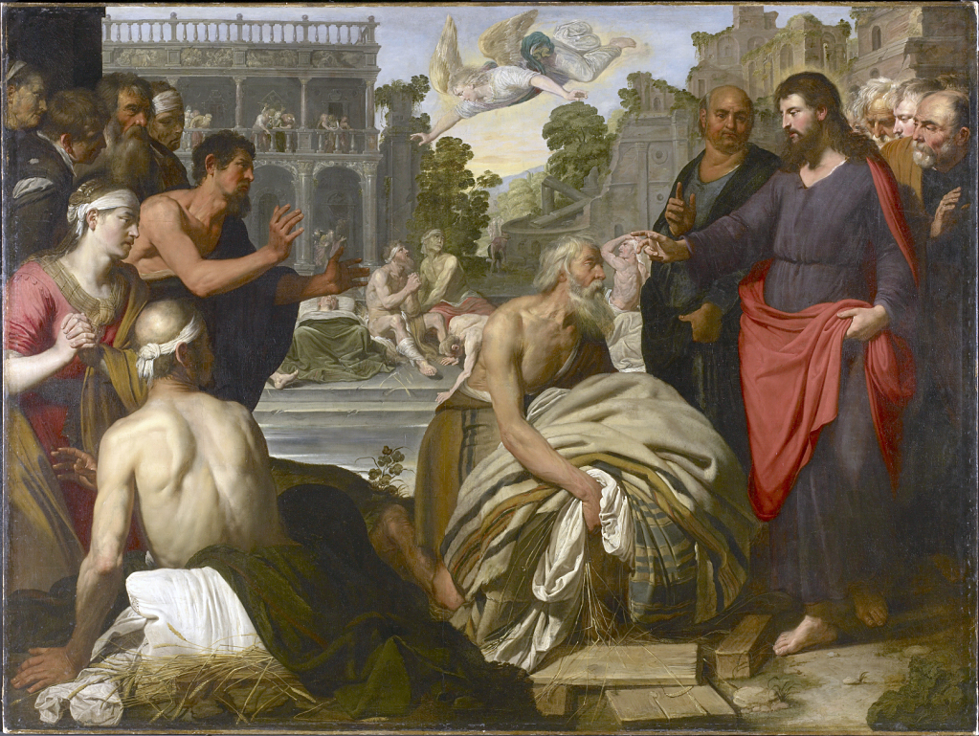
22nd May 2022 – Sixth Sunday of Easter

Jesus Healing at the Pool of Bethesda

Worship Service: Sunday 9:30 a.m.

Officiant – Ginny Schleihauf — Organist – Dorothy Miller
380 Russell St. North (at Maxwell St.), Sarnia, Ontario N7T 6S6
(519) 344-9531 – Email: canondavis@gmail.com -- http://www.canondavis.com

