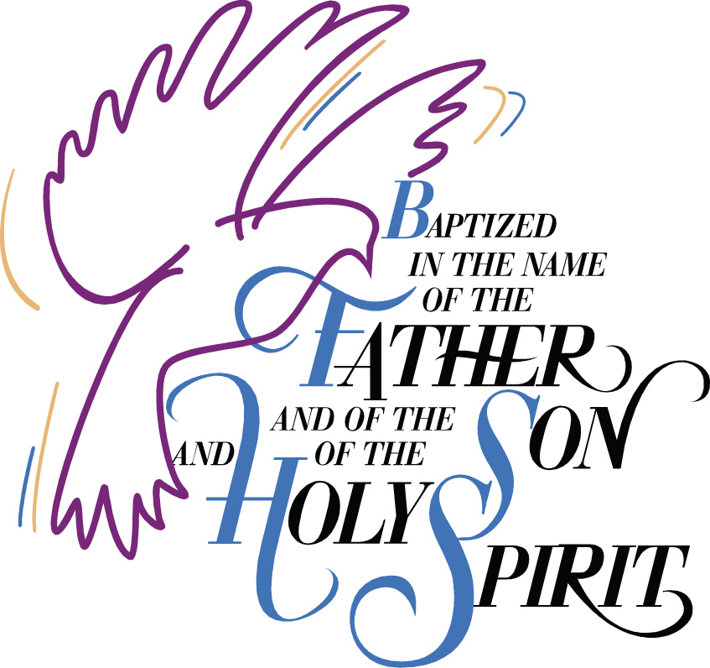

Baptism
of
Charlie Thomas Clubb
07 May 2023
Born 23 July 2022
Sarnia, Ontario
Canada

Canon Davis Memorial Church
Anglican Church of Canada
Sunday, May 7, 2023—Fifth Sunday of Easter
9:30 a.m. Holy Baptism and Holy Eucharist
Officiant—Rev. Ray Jenkins
Assisted by: John Hayter and Ginny Schleihauf
Organist—Dorothy Miller

The Gathering of the Community

Opening Hymn #379 Rejoice the Lord is King

Welcome
Celebrant: The grace of our Lord Jesus Christ, and the love of God
and the fellowship of the Holy Spirit, be with you all.
People: And also with you.

Celebrant: There is one body and one Spirit,
People: There is one hope in God’s call to us;

Celebrant: One Lord, one faith, one baptism,
People: One God and Father of all.

Collect of the Day: Almighty God, your Son Jesus Christ is the way, the truth, and the life. Give us grace to love one another and walk in the way of his commandments, who lives and reigns with you and the Holy Spirit, one God, now and for ever. Amen.

PRESENTATION AND EXAMINATION OF THE CANDIDATES

Celebrant: The candidate(s) for Holy Baptism will now be presented.
Parents & Sponsors: I present Charlie Thomas Clubb to receive the
sacrament of baptism.

Celebrant: Will you be responsible for seeing that the child you
present is nurtured in the faith and life of the Christian
community?
Parents & Sponsors: I will, with God’s help.

Celebrant: Will you by your prayers and witness help this child to
grow into the full stature of Christ?
Parents & Sponsors: I will, with God’s help.

Celebrant: Do you renounce Satan and all the spiritual forces of
wickedness that rebel against God?
Parents & Sponsors: I renounce them.

Celebrant: Do you renounce the evil powers of this world which
corrupt and destroy the creatures of God?
Parents & Sponsors: I renounce them.

Celebrant: Do you renounce all sinful desires that draw you from the
love of God?
Parents & Sponsors: I renounce them.

Celebrant: Do you turn to Jesus Christ and accept him as your
Saviour?
Parents & Sponsors: I do.

Celebrant: Do you put your whole trust in his grace and love?
Parents & Sponsors: I do.

Celebrant: Do you promise to obey him as your Lord?
Parents & Sponsors: I do.

Celebrant: Will you who witness these vows do all in your power to
support Charlie Thomas Clubb in his life in Christ?
People: We will.

PRAYERS FOR THE CANDIDATE

Celebrant: Let us pray.

(All pray in the position most comfortable.)

Celebrant: Let us now pray for Charlie, who is to receive the
sacrament of new birth.

Celebrant: Deliver him, O Lord, from the way of sin and death.
People: Lord, hear our prayer.

Celebrant: Open his heart to your grace and truth.
People: Lord, hear our prayer.

Celebrant: Fill him with your holy and life-giving Spirit.
People: Lord, hear our prayer.

Celebrant: Teach him to love others in the power of the Spirit.
People: Lord, hear our prayer.

Celebrant: Send him into the world in witness to your love.
People: Lord, hear our prayer.

Celebrant: Bring him to the fullness of your peace and glory.
People: Lord, hear our prayer.

Celebrant: And this day, Dear Lord, we remember all those in any kind
of need, and also those on our parish cycle of prayer.

Celebrant: Grant, O Lord, that all who are baptized into the death of
Jesus Christ your Son may live in the power of his
resurrection and look for him to come again in glory; who lives and reigns now and forever.
People: Lord, hear our prayer. Amen.

CELEBRATION OF BAPTISM

Thanksgiving Over the Water

Celebrant: The Lord be with you.
People: And also with you.

Celebrant: Let us give thanks to the Lord our God.
People: It is right to give our thanks and praise.

Celebrant: We give you thanks, almighty God and Father, for by the
gift of water you nourish and sustain all living things.
People: Blessed be God for ever.

Celebrant: We give you thanks that through the waters of the Red
Sea, you led your people out of slavery to freedom in the promised land.
People: Blessed be God for ever.
Celebrant: We give you thanks for sending your son Jesus. For us he
was baptized by John in the river Jordan. For us he was anointed as Christ by your Holy Spirit. For us he suffered the baptism of his own death and resurrection, setting us free from the bondage of sin and death, and opening to us the joy and freedom of everlasting life.
People: Blessed be God for ever.

Celebrant: We give you thanks for your Holy Spirit who teaches us
and leads us into all truth, filling us with his gifts so that we might proclaim the Gospel to all nations and serve you as a royal priesthood.
People: Blessed be God for ever.

Celebrant: We give you thanks for you have called Charlie to new life
through the waters of baptism. Now sanctify this water, that your servant who is washed in it may be made one with Christ in his death and resurrection, to be cleansed and delivered from all sin. Anoint him with your Holy Spirit and bring him to new birth in the family of your Church, that he may become an inheritor of your glorious kingdom. We give you praise and honour and worship through your Son Jesus Christ our Lord, in the unity of the Holy Spirit, now and for ever.
People: Blessed are you, our strength and song, and our
salvation.

Celebrant: Let us join with he who is committing himself to
Christ and renew our own baptismal covenant.

BAPTISMAL COVENANT

Celebrant: Do you believe in God the Father?
People: I believe in God, the Father almighty, creator of heaven and earth.

Celebrant: Do you believe in Jesus Christ, the Son of God?
People: I believe in Jesus Christ, his only Son, our Lord. He was conceived by the power of the Holy Spirit and born of the Virgin Mary. He suffered under Pontius Pilate, was crucified, died, and was buried. He descended to the dead. On the third day he rose again. He ascended into heaven, and is seated at the right hand of the Father. He will come again to judge the living and the dead.

Celebrant: Do you believe in God the Holy Spirit?
People: I believe in God the Holy Spirit, the holy catholic Church, the communion of saints, the forgiveness of sins, the resurrection of the body, and the life everlasting.

Celebrant: Will you continue in the apostles’ teaching and fellowship,
in the breaking of bread, and in the prayers?
People: I will, with God’s help.

Celebrant: Will you persevere in resisting evil and, whenever you fall
into sin, repent and return to the Lord?
People: I will, with God’s help.

Celebrant: Will you proclaim by word and example the good news of
God in Christ?
People: I will, with God’s help.
Celebrant: Will you seek and serve Christ in all persons, loving your neighbour as yourself?
People: I will, with God’s help.

Celebrant: Will you strive for justice and peace among all people, and respect the dignity of every human being?
People: I will, with God’s help.

Celebrant: Will you strive to safeguard the integrity of God's creation, And respect, sustain and renew the life of the Earth?
People: I will, with God’s help.

THE BAPTISM

Celebrant: Charlie, I baptize you in the name of the Father, and of the
Son, and of the Holy Spirit. Amen.

Celebrant: I sign you with the cross, and mark you as Christ’s own forever.

Celebrant: Heavenly Father, we thank you that by water and the Holy
Spirit you have bestowed upon your servant Charlie the forgiveness of sin, and have raised him to the new life of grace. Sustain him, O Lord, in your Holy Spirit. Give him an inquiring and discerning heart, the courage to will and to persevere, a spirit to know and to love you, and the gift of joy and wonder in all your works. Amen.

The Giving of the Light

Celebrant: Receive the light of Christ, to show that you have passed
from darkness to light.
People: Let your light so shine before others that they may see
your good works and glorify your Father in heaven.

Celebrant: Let us welcome newly baptized Charlie Thomas Clubb.
People: We receive you into the household of God. Confess the
faith of Christ crucified, proclaim his resurrection, and share with us in his eternal priesthood.

THE PROCLAMATION OF THE WORD

First Reading: Ezekiel 36:24-28
Canticle 3 Isaiah 12:2-6 Song of Thanksgiving
Surely, it is God who saves me;
I will trust in him and not be afraid.

For the Lord is my stronghold and my sure defence,
and he will be my Saviour.

Therefore you shall draw water with rejoicing
from the springs of salvation.

And on that day you shall say,
Give thanks to the Lord and call upon his name;
make his deeds known among the peoples;
see that they remember that his name is exalted.

Sing the praises of the Lord, for he has done great things,
and this is known in all the world.

Cry aloud, inhabitants of Zion, ring out your joy,
for the great one in the midst of you is the Holy One of Israel.
Second Reading: 2 Corinthians 5:17-20
The Holy Gospel: John 14: 1-14

Reader: The Lord be with you.
People: And also with you.

(The Congregation stands for the Gospel Reading)

Reader: The Holy Gospel of our Lord Jesus Christ according to John
People: Glory to you, Lord Jesus Christ.

Jesus said, “Do not let your hearts be troubled. Believe in God, believe also in me. In my Father’s house there are many dwelling places. If it were not so, would I have told you that I go to prepare a place for you? And if I go and prepare a place for you, I will come again and will take you to myself, so that where I am, there you may be also. And you know the way to the place where I am going.”

Thomas said to him, “Lord, we do not know where you are going. How can we know the way?”

Jesus said to him, “I am the way, and the truth, and the life. No one comes to the Father except through me. If you know me, you will know my Father also. From now on you do know him and have seen him.”

Philip said to him, “Lord, show us the Father, and we will be satisfied.

Jesus said to him, “Have I been with you all this time, Philip, and you still do not know me? Whoever has seen me has seen the Father. How can you say, ‘Show us the Father’? Do you not believe that I am in the Father and the Father is in me? The words that I say to you I do not speak on my own; but the Father who dwells in me does his works. Believe me that I am in the Father and the Father is in me; but if you do not, then believe me because of the works themselves. Very truly, I tell you, the one who believes in me will also do the works that I do and, in fact, will do greater works than these, because I am going to the Father. I will do whatever you ask in my name, so that the Father may be glorified in the Son. If in my name you ask me for anything, I will do it.”

(at the conclusion of the Gospel reading)

Reader: The Gospel of Christ.
People: Praise to you, Lord Jesus Christ.

Sermon Hymn #482 Come and Journey with a Saviour

SERMON
The Peace

Hymn #647 Spirit of the Living God
(verse 2)
(we remain seated as we gently sing the words below)

Spirit of the living God, fall afresh on me;
Spirit of the living God, fall afresh on me;
break me, melt me, mould me, fill me —Spirit of the living God, fall afresh on me!

Celebrant: God of Peace,
relax the tensions of our bodies.....
Still the anxieties of our minds.....
Calm the storms of our hearts.....
Give us courage to wait.....
Let peace flow in us, through us, from us,
the deep, deep, peace of God. Amen.
Celebrant: We are a people of love.
The peace of the Lord be always with you.
People: And also with you.

OFFERTORY HYMN: #525 The Church’s One Foundation

Offertory Response (The Doxology sung)

Praise God, from Whom all blessings flow.
Praise Him, all creatures here below.
Praise Him above, ye Heavenly Host.
Praise Father, Son, and Holy Ghost.

Prayer Over the Gifts: Gracious God, you show us your way and give us your divine life. May everything we do be directed by the knowledge of your truth. We ask this in the name of Jesus Christ the risen Lord. Amen.
Eucharistic Prayer 4

Celebrant: The Lord be with you.
People: And also with you.

Celebrant: Lift up your hearts.
People: We lift them to the Lord.

Celebrant: Let us give thanks to the Lord our God.
People: It is right to give our thanks and praise.

Celebrant: It is right to give you thanks and praise, O Lord, our God, sustainer of the universe, you are worthy of glory and praise.
People: Glory to you for ever and ever.
Celebrant: At your command all things came to be: the vast expanse of
interstellar space, galaxies, suns, the planets in their courses, and this fragile earth, our island home; by your will they were created and have their being.
People: Glory to you for ever and ever.

Celebrant: From the primal elements you brought forth the human
race, and blessed us with memory, reason, and skill; you made us the stewards of creation.
People: Glory to you for ever and ever.

Celebrant: But we turn against you, and betray your trust;
and we turn against one another.
Again and again you call us to return.
Through the prophets and sages
you reveal your righteous law.

In the fullness of time you sent your Son,
born of a woman, to be our Saviour.
He was wounded for our transgressions,
and bruised for our iniquities.
By his death he opened to us
the way of freedom and peace.
People: Glory to you for ever and ever.

Celebrant: Therefore we praise you,
joining with the heavenly chorus,
with prophets, apostles, and martyrs,
and with those in every generation
who have looked to you in hope,
to proclaim with them your glory,
in their unending hymn:
People: Holy, holy, holy Lord,
God of power and might,
heaven and earth are full of your glory.
Hosanna in the highest.
Blessed is he who comes in the name of the Lord.
Hosanna in the highest.

Celebrant: Blessed are you, Lord our God,
for sending us Jesus, the Christ,
who on the night he was handed over
to suffering and death,
took bread, said the blessing,
broke the bread, gave it to his friends,
and said, “Take this, and eat it:
this is my body which is given for you.
Do this for the remembrance of me.”

In the same way, after supper,
he took the cup of wine;
he gave you thanks,
and said, “Drink this, all of you:
this is my blood of the new covenant,
which is shed for you and for many for the
forgiveness of sins.
Whenever you drink it,
do this for the remembrance of me.”
People: Glory to you for ever and ever.

Celebrant: Gracious God,
we recall the death of your Son Jesus Christ,
we proclaim his resurrection and ascension,
and we look with expectation for his coming
as Lord of all the nations.
We who have been redeemed by him,
and made a new people by water and the Spirit,
now bring you these gifts.
Send your Holy Spirit upon us
and upon this offering of your Church,
that we who eat and drink at this holy table
may share the divine life of Christ our Lord.
People: Glory to you for ever and ever.

Celebrant: Pour out your Spirit upon the whole earth
and make it your new creation.
Gather your Church together from
the ends of the earth into your kingdom,
where peace and justice are revealed,
that we, with all your people,
of every language, race, and nation,
may share the banquet you have promised;
through Christ, with Christ, and in Christ,
all honour and glory are yours,
creator of all.
People: Glory to you for ever and ever. Amen.

The Lord’s Prayer
Celebrant: And now, as our Saviour Christ has taught us,
we are bold to say,
People: Our Father, who art in heaven,
hallowed be thy name,
thy kingdom come,
thy will be done,
on earth as it is in heaven.
Give us this day our daily bread.
And forgive us our trespasses,
as we forgive those who trespass against us.
And lead us not into temptation,
but deliver us from evil.
For thine is the kingdom,
the power, and the glory,
for ever and ever. Amen.

THE BREAKING OF THE BREAD

Celebrant: “I am the bread of life,” says the Lord.
“Whoever comes to me will never be hungry;
whoever believes in me will never thirst.”
People: Taste and see that the Lord is good; happy are they who trust in him!

THE COMMUNION

Celebrant: The gifts of God for the People of God.
People: Thanks be to God.

(Communion Hymns)

Prayer after Communion: God of love, in this eucharist we have heard your truth and shared in your life. May we always walk in your way, in the name of Jesus Christ the Lord. Amen.

Celebrant: Glory to God,
People: whose power, working in us, can do infinitely more
than we can ask or imagine. Glory to God from generation to generation, in the Church and in Christ Jesus, for ever and ever. Amen.
The Blessing

Celebrant: The peace of God which passes all understanding keep
your hearts and minds in the knowledge and love of God and of his Son Jesus Christ our Lord. And the blessing of God Almighty, the Father, the Son, and the Holy Spirit be upon you and those you love and remain with you always. Amen.

Announcements

Recessional Hymn #383 Jesus Shall Reign Where’er the Sun

Dismissal
Celebrant: Go in peace to love and serve the Lord.
People: Thanks be to God.

Sung Benediction: ‘Howard’s Blessing’

O may the peace of God be with you evermore,
And may the power of His great love your soul again restore,
And may you feel His hand upon you every day,
to strengthen and sustain you, along your way.

O may He be your guide as long as life shall last,
And in the time of trial, may His strong arm hold you fast,
And may you always know His never-ending care,
And may His gracious Spirit be with you everywhere.

The Flowers on the Altar today are given to the glory of God, and in loving memory of Lois and Harry Turner, a gift of their children, Carol, Chris and Blair and families.

Please enter names in the Intercessions Book each week to be read in the service.
____________________

News and Events

- Please send all announcements for the bulletin to Karen by 11:00 a.m. Tuesday of each week. Call: 519-344-9531 or E-mail: canondavis@gmail.com.
- If you would like a home visit with Communion or know of someone who would, please let Rev. Ray know as he and/or a Lay Visitor will be available in the coming weeks.
- Please join us for Coffee Hour after service for a time of fellowship in the parish hall.
- Happy Birthday and best wishes to Mary Jane Blunt, Sally Jenkins and Phyllis Leckie from all your friends and CDM.
- The Ladies Guild pies are still available. Turkey or Beef $5.50 each Shepherd's Pie $6.00 each. To place your order call the office at 519-344-9531.

Upcoming Events:
- London Road Meat Raffle --in partnership with London Rd school Tuesday May 9 from 6:00-8:00 p.m. at Imperial City Brew House. Draws are $2.00 each and there are 9 draws.
- Join us on Wednesday May 17 in the Parish Hall for a delicious BBQ Chicken Dinner. Call 519 344-9531 to reserve your seat. Cost: Adults $20.00 and take out is available.

- 3rd Announcement -- Special Vestry--Sunday, May 14, 2023
We have an individual put forth their name for the position of Deputy Rector's Warden. This is the 3rd of 3 consecutive notices. On Sunday, May 14, 2023 we will be holding a Special Vestry after church in the Parish Hall to complete this election. Please plan on attending. God Bless Rev. Ray Jenkins, John W. Hayter, Rector's Warden and Sheree Lynn Hayter, People's Warden.
- Forest United Church “Yard Sale” Saturday May 27, 2023 from 8:00 a.m. to 2:00 p.m. Baking, Bargains and BBQ. Ya Gotta Love that!

- Sunday June 4, 2023 – 2 Special Services
  - Installation Service for Ginny Schleihauf, our new licensed Lay Reader, and
  - Rev. Ray who will officiate his last service at C.D.M. Church. It will be a Celtic Service with guest harpist, Wendy Rideout.

  - Parish Council will be hosting a Reception/Luncheon for Ray and Ginny following the church service in the Parish Hall. Please call the office by Sunday May 21, at 519-344-9531 or sign up on the sheet on the table at the back of the church by Sunday May 21 if you will be attending the luncheon. We require a head count for preparation of food and beverage. Thank you. John, Sheree Lynn and Carol.
Reminders
May 9 London Rd. Meat Raffle 6-8 Imperial City Brew House
May 14 Special Vestry Meeting after service – Parish Hall
May 17 BBQ Chicken Dinner – Parish Hall.
May 27 Forest United Church “Yard Sale”
May 31 Parish Council Meeting – Boardroom 10:00 a.m.
Jun 4 Luncheon and Reception for Rev. Ray Jenkins and
Ginny Schleihauf

