Canon Davis Memorial Church
Anglican Church of Canada

Twelfth Sunday after Pentecost
28th August, 2022

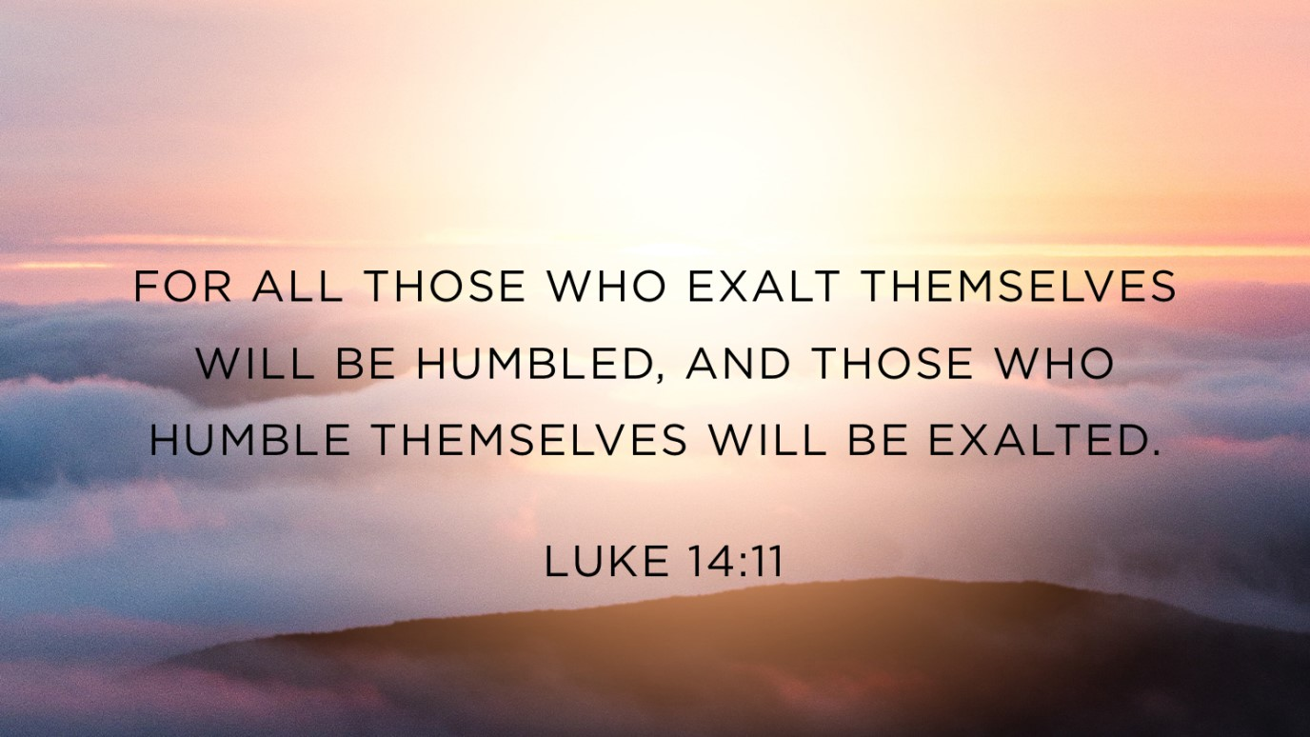

Officiant: Ginny Schleihauf
Organist: Dorothy Miller
Reader: Carol Turner

380 Russell St. North (at Maxwell St.), Sarnia, Ontario, N7T 6S6
Tel: (519) 344-9531 - Email: canondavis@gmail.com – http://www.canondavis.com
28th August 2022 — 12th Sunday after Pentecost

Service of the Word

Gathering Hymn #381 Praise, My Soul

Officiant: The grace of our Lord Jesus Christ and the love of God and the
fellowship of the Holy Spirit be with you all.
People: And also with you.

Officiant: Let us pray.
We thank you, O God, that you have again brought us together on the Lord’s Day to praise you for your goodness and to ask your blessing. Give us grace to see your hand in the week that is past, and your purpose in the week to come; through Christ our Lord.
People: Amen.

Officiant: Dear friends in Christ, as we turn our hearts and minds to
worship almighty God, let us confess our sins.

People: Most merciful God, we confess that we have sinned
against you in thought, word, and deed, by what we have done and by what we have left undone. We have not loved you with our whole heart; we have not loved our neighbours as ourselves. We are truly sorry and we humbly repent. For the sake of your Son Jesus Christ, have mercy on us and forgive us, that we may delight in your will, and walk in your ways, to the glory of your name. Amen.

Officiant: Merciful God, grant to us, your faithful people, pardon and
peace, that we may be cleansed from all our sins and serve you with a quiet mind through Jesus Christ our Lord, who is alive and reigns with you and the Holy Spirit, one God, now and for ever.
People: Amen.
Officiant: The Peace of the Lord be always with you.
People: And also with you.

Officiant: Let us reconcile to God and one another a sign of Christ’s
peace.

The Collect of the Day
Author and Giver of all good things, graft in our hearts the love of your name, increase in us true religion, nourish us in all goodness, and of your great mercy keep us in the same; through Jesus Christ our Lord, who lives and reigns with you and the Holy Spirit, one God, now and for ever.

The Proclamation of the Word

First Reading Jeremiah 2: 4-13
Officiant: The Word of the Lord.
People: Thanks be to God.

Psalm 81: 1, 10-16 (Response in bold.)
Sing with joy to God our strength and raise a loud shout to the God of Jacob.
I am the Lord your God, who brought you out of the land of Egypt and said, "Open your mouth wide, and I will fill it."
And yet my people did not hear my voice, and Israel would not obey me.
So I gave them over to the stubbornness of their hearts, to follow their own devices.
Oh, that my people would listen to me! that Israel would walk in my ways!
I should soon subdue their enemies and turn my hand against their foes.
Those who hate the Lord would cringe before him, and their punishment would last for ever.

But Israel would I feed with the finest wheat and satisfy him with honey from the rock.

Second Reading Hebrews 13: 1-8; 15-16
Officiant: The Word of the Lord.
People: Thanks be to God.

Officiant: The Lord be with you.
People: And also with you.

Officiant: The Holy Gospel of our Lord Jesus Christ according to Luke.
People: Glory to you, Lord Jesus Christ.

The Gospel Luke 14: 1, 7-14

Officiant: The Gospel of the Christ
People: Praise to you, Lord Jesus Christ.

Sermon

Sermon Hymn #645 Come Down, O Love Divine

Officiant: Let us confess our faith as we say.
People: I believe in God, the Father almighty, creator of heaven
and earth.
I believe in Jesus Christ, his only Son, our Lord.
He was conceived by the power of the Holy Spirit and
born of the Virgin Mary.
He suffered under Pontius Pilate, was crucified, died, and
was buried.
He descended to the dead.
On the third day he rose again.
He ascended into heaven, and is seated at the right hand
of the Father.
He will come again to judge the living and the dead.
I believe in the Holy Spirit, the holy catholic Church, the communion of saints, the forgiveness of sins, the resurrection of the body, and the life everlasting. Amen.

Prayers of the People (see insert)

Hear us, Lord.
For your mercy is great.

Offertory Hymn #631 The Kingdom of God Is Justice and Joy

Offertory Response All Things Come of Thee

People: Yours, Lord, is the greatness, the power, the glory, the
splendour, and the majesty; for everything in heaven and on earth is yours. All things come from you, and of your own do we give you.

Officiant: And now, as our Saviour Christ has taught us,
we are bold to say,
People: Our Father, who art in heaven,
hallowed be thy name,
thy kingdom come,
thy will be done, on earth as it is in heaven.
Give us this day our daily bread.
And forgive us our trespasses,
as we forgive those who trespass against us.
And lead us not into temptation, but deliver us from evil.
For thine is the kingdom,
the power, and the glory, for ever and ever. Amen.

Officiant: Glory to God
People: whose power, working in us, can do infinitely more than
we can ask or imagine. Glory to God from generation to generation, in the Church and in Christ Jesus, for ever and ever. Amen.

Announcements

Closing Hymn #388 Glorious Things of Thee Are Spoken

Officiant: May the God of hope fill us all with joy and peace in believing
through the power of the Holy Spirit. Amen.

Sung Benediction Howard’s Blessing (vs 1-2)
(in the back of the blue Hymn book)

The Flowers on the Altar today are given to the Glory of God and in loving memory of the Rinker and Redden family members, a gift of Gerry Rinker.

We pray for the repose of the soul of
Pat Knowles Harrison

Please enter names in the Intercessions Book each week to be read in the service.

News and Events

- Please send all announcements for the bulletin to Karen by 11:00 a.m. Tuesday of each week. Call: 519-344-9531 or E-mail: canondavis@gmail.com.

- If you would like a home visit with Communion or know of someone who would, please let Rev. Ray know as he and/or a Lay Visitor will be available in the coming weeks.

- Please join us for Coffee Hour after service for a time of fellowship in the parish hall.

- Moore Museum’s Downriver Craft & Gift Sale Sunday September 18th 2022 10:00 a.m. to 4:00 pm. Cost: Adults $2.00 Children Free – Over 100 tables.

Upcoming Events:

10 Sept Fall Clean Up of the parking lot and church. If you are
available to help, please call Karen at 519-344-9531.

18 Sept 2:00 p.m. The Christian Music Café is coming to Canon Davis.
Please join us for this monthly musical event. Refreshments and treats will be available. Free will offering.

21 Sept Please mark your calendar and plan to join us as CDM’s famous and delicious “Fish Dinner” is back with in-house
dining.

28 Sept Parish Council Meeting 10:00 a.m. in the boardroom.

The Chancel Guild

The Chancel Guild is inquiring if

- anyone is interested in adopting one of the following days to provide flowers for the Altar to please put your name and contact number beside the date on the list provided at the back of the church.
Dates available are
2nd and 4th week of January
3rd week of March
2nd week of April
2nd and 4th week of April
2nd week of October.

And,

- If anyone is interested in joining the Chancel Guild or would like more information, please see Seonaid Laidlaw

The Chancel Guild meets at 10:00 a.m. on the 3rd Wednesday of the month in the church. At this time, we polish all brasses, wash all vessels, top up candles and briefly discuss any special tasks for the month. Time taken is 1 1/2 to 2 hours depending on numbers. The Chancel Guild presently has six active members. We could use a few more willing hands.

Saturday duties are: setting up church for services including arranging Altar Flowers. Morning Prayer – approximately ½ hour. – flowers only. Holy Eucharist – approximately 1 hour. HE Sunday after service – remove all vessels, wash, take linen home to launder. Christmas and Harvest Thanksgiving call for extra time.

