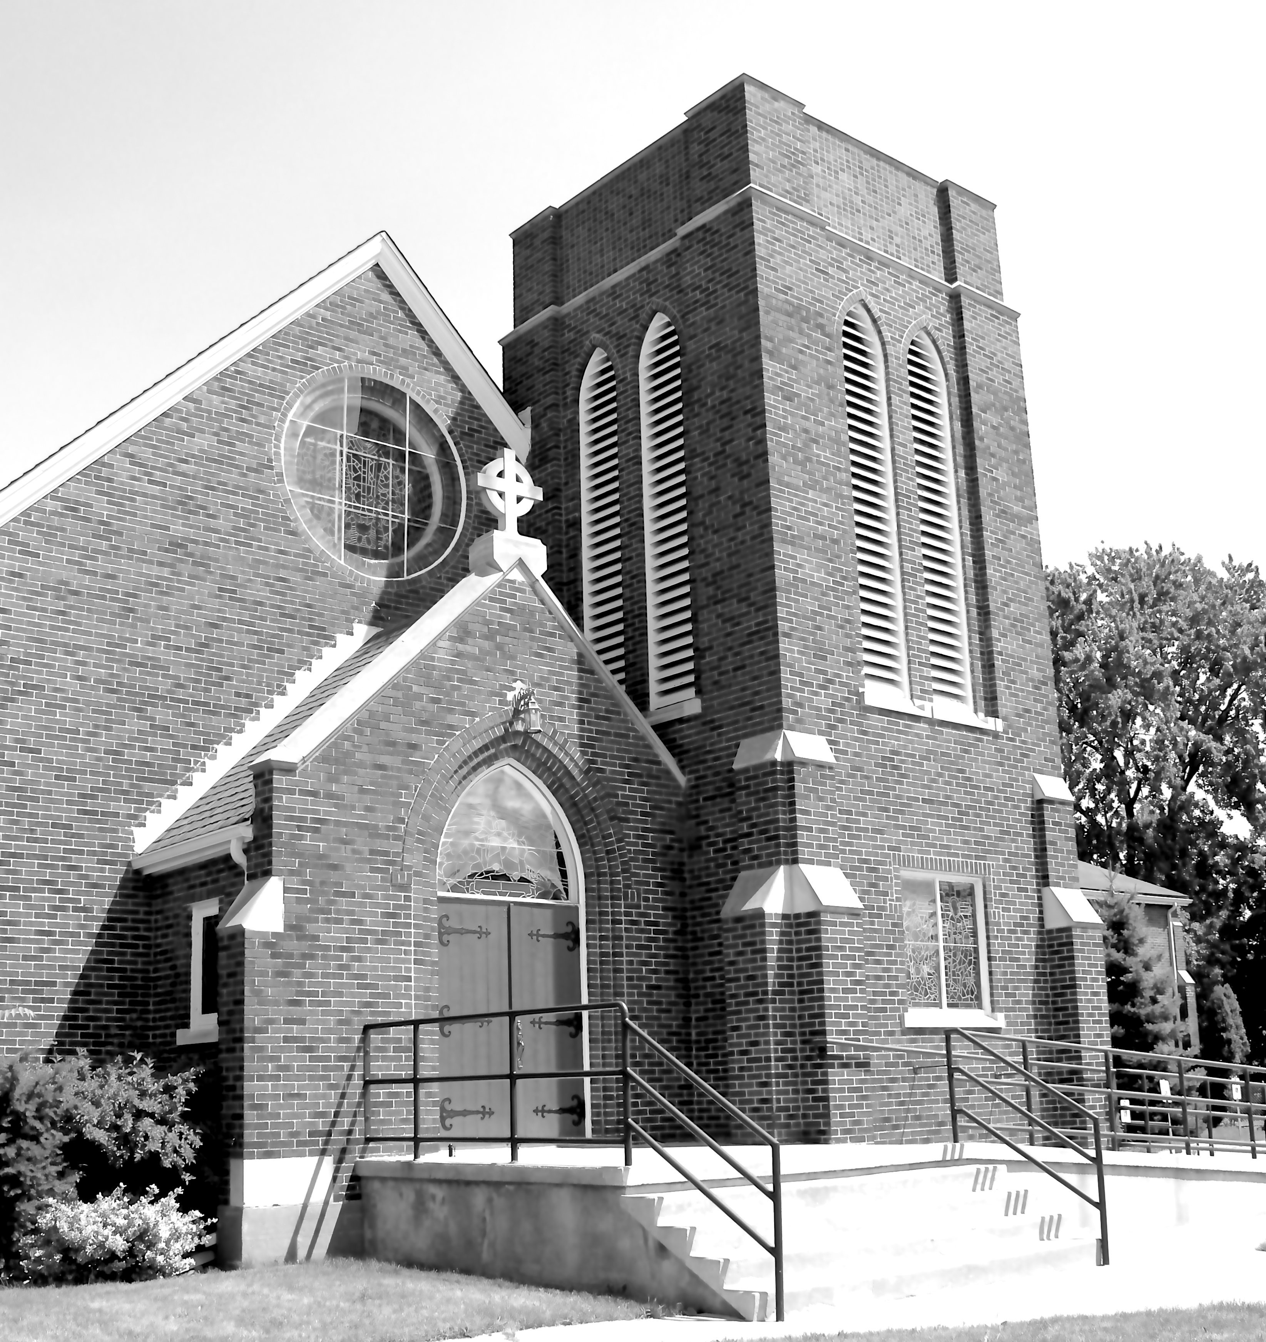
Canon Davis Memorial Church

380 Russell St. North, Sarnia, Ontario, N7T 6S6
(519) 344-9531 • http://www.canondavis.com
FOURTH SUNDAY AFTER THE EPIPHANY
January 30, 2022
Nehemiah 8:1-3, 5-6, 8-10 • Psalm 19 • 1 Corinthians 12:12-31a • Luke 4:14-21

Dear Friends,
When I first got my drivers’ licence, we owned a second hand 1953 Willys Aero Ace. To me, it was a great little car. It was shiny black with two small tail fins. Although it was made in Toledo Ohio by the manufacturer of Jeeps, it looked nothing like a Jeep.

As one might guess, I really liked driving that car! It handled well and even was responsive on glare-ice. I did not hesitate telling people that I loved that car.

About ½ way through Grade 10, I headed routinely to my afternoon English class. Our English teacher was Miss Oerkfitz. She was a good teacher who occasionally shared some interesting insights not found in our textbooks.

Out of the blue, one day she informed the class that people are to love God and people —— but not objects! We as human beings were not lovers of houses, bicycles, artworks, and certainly not automobiles. Other words should come to mind in describing strong feelings toward objects, she declared. So henceforth, I found myself describing our car as something I really liked!

Enter the Apostle Paul. If we want to think about love, this week’s reading of I Corinthians 13 is at the top of the list in leading us to understand much about the meaning of this word. But first, we also need to hear the words of Jesus from the Gospel according to John — ³⁴I give you a new commandment, that you love one another. Just as I have loved you, you also should love one another. ³⁵By this everyone will know that you are my disciples, if you have love for one another.’

In Matthew, Jesus also stressed the importance of love when he said, “You shall love the Lord your God with all your heart, and with all your soul, and with all your mind.” ³⁸This is the greatest and first commandment. ³⁹And a second is like it: “You shall love your neighbour as yourself.” ⁴⁰On these two commandments hang all the law and the prophets.’

I hope you will take time to thoughtfully read I Corinthians 13. It provides a most insightful description of what love is about as it relates to what love can mean in regard to human dynamics. Paul not only writes about what love is; he also helps us out by references to what love is not!

To me, it is no surprise to find I Corinthians 13 is a frequently requested reading in wedding and other special services. What a wonderful basis upon which to build good relationships!

Now, few people have memorized I Corinthians 13. But I am going to share a suggestion that I have occasionally make to people. And that suggestion is to read this valuable bit of scripture at some point every year.

This suggestion is one for personal reflection.

We pray now the words concerning the wellbeing of today’s church

PRAYER FOR A RENEWED CHURCH: Almighty God, give us a new vision of you, of your love, of your grace and power, and then, give us a new vision of what you would have us do as your Church in this nation and at this time, and an awareness that in the strength of your Spirit, we can do it to your glory. In Jesus’ name we pray. Amen.

— Please note —

In person worship services
are scheduled to resume on February 6th at 9:30 a.m.

Diocese of Huron COVID-19 guidelines remain in place.

In this changing environment,
Please check with the church office to confirm if the February 6th service is still being held. (519) 344-9531

————————————————

You are invited to go each Sunday and/or Wednesday to the link:
tinyurl.com/StAlbans-CDMC

That is the link to St. Alban’s Anglican Church in Burnaby B.C. Follow the instructions. You will find links to the Rev’d Greg Jenkins officiating at an Anglican church service with children’s focus, church music, readings, prayers and a sermon.
If you are also interested in joining their weekly Bible Study, contact Rev. Greg at revgregjenkins@gmail.com He will be more than happy to be in touch about joining in with their group by ZOOM. We hope you will find these services help to deepen your faith.
tinyurl.com/StAlbans-CDMC

——————————————————————————-

