Canon Davis Memorial Church
Anglican Church of Canada
The Baptism of the Lord
8th January 2023

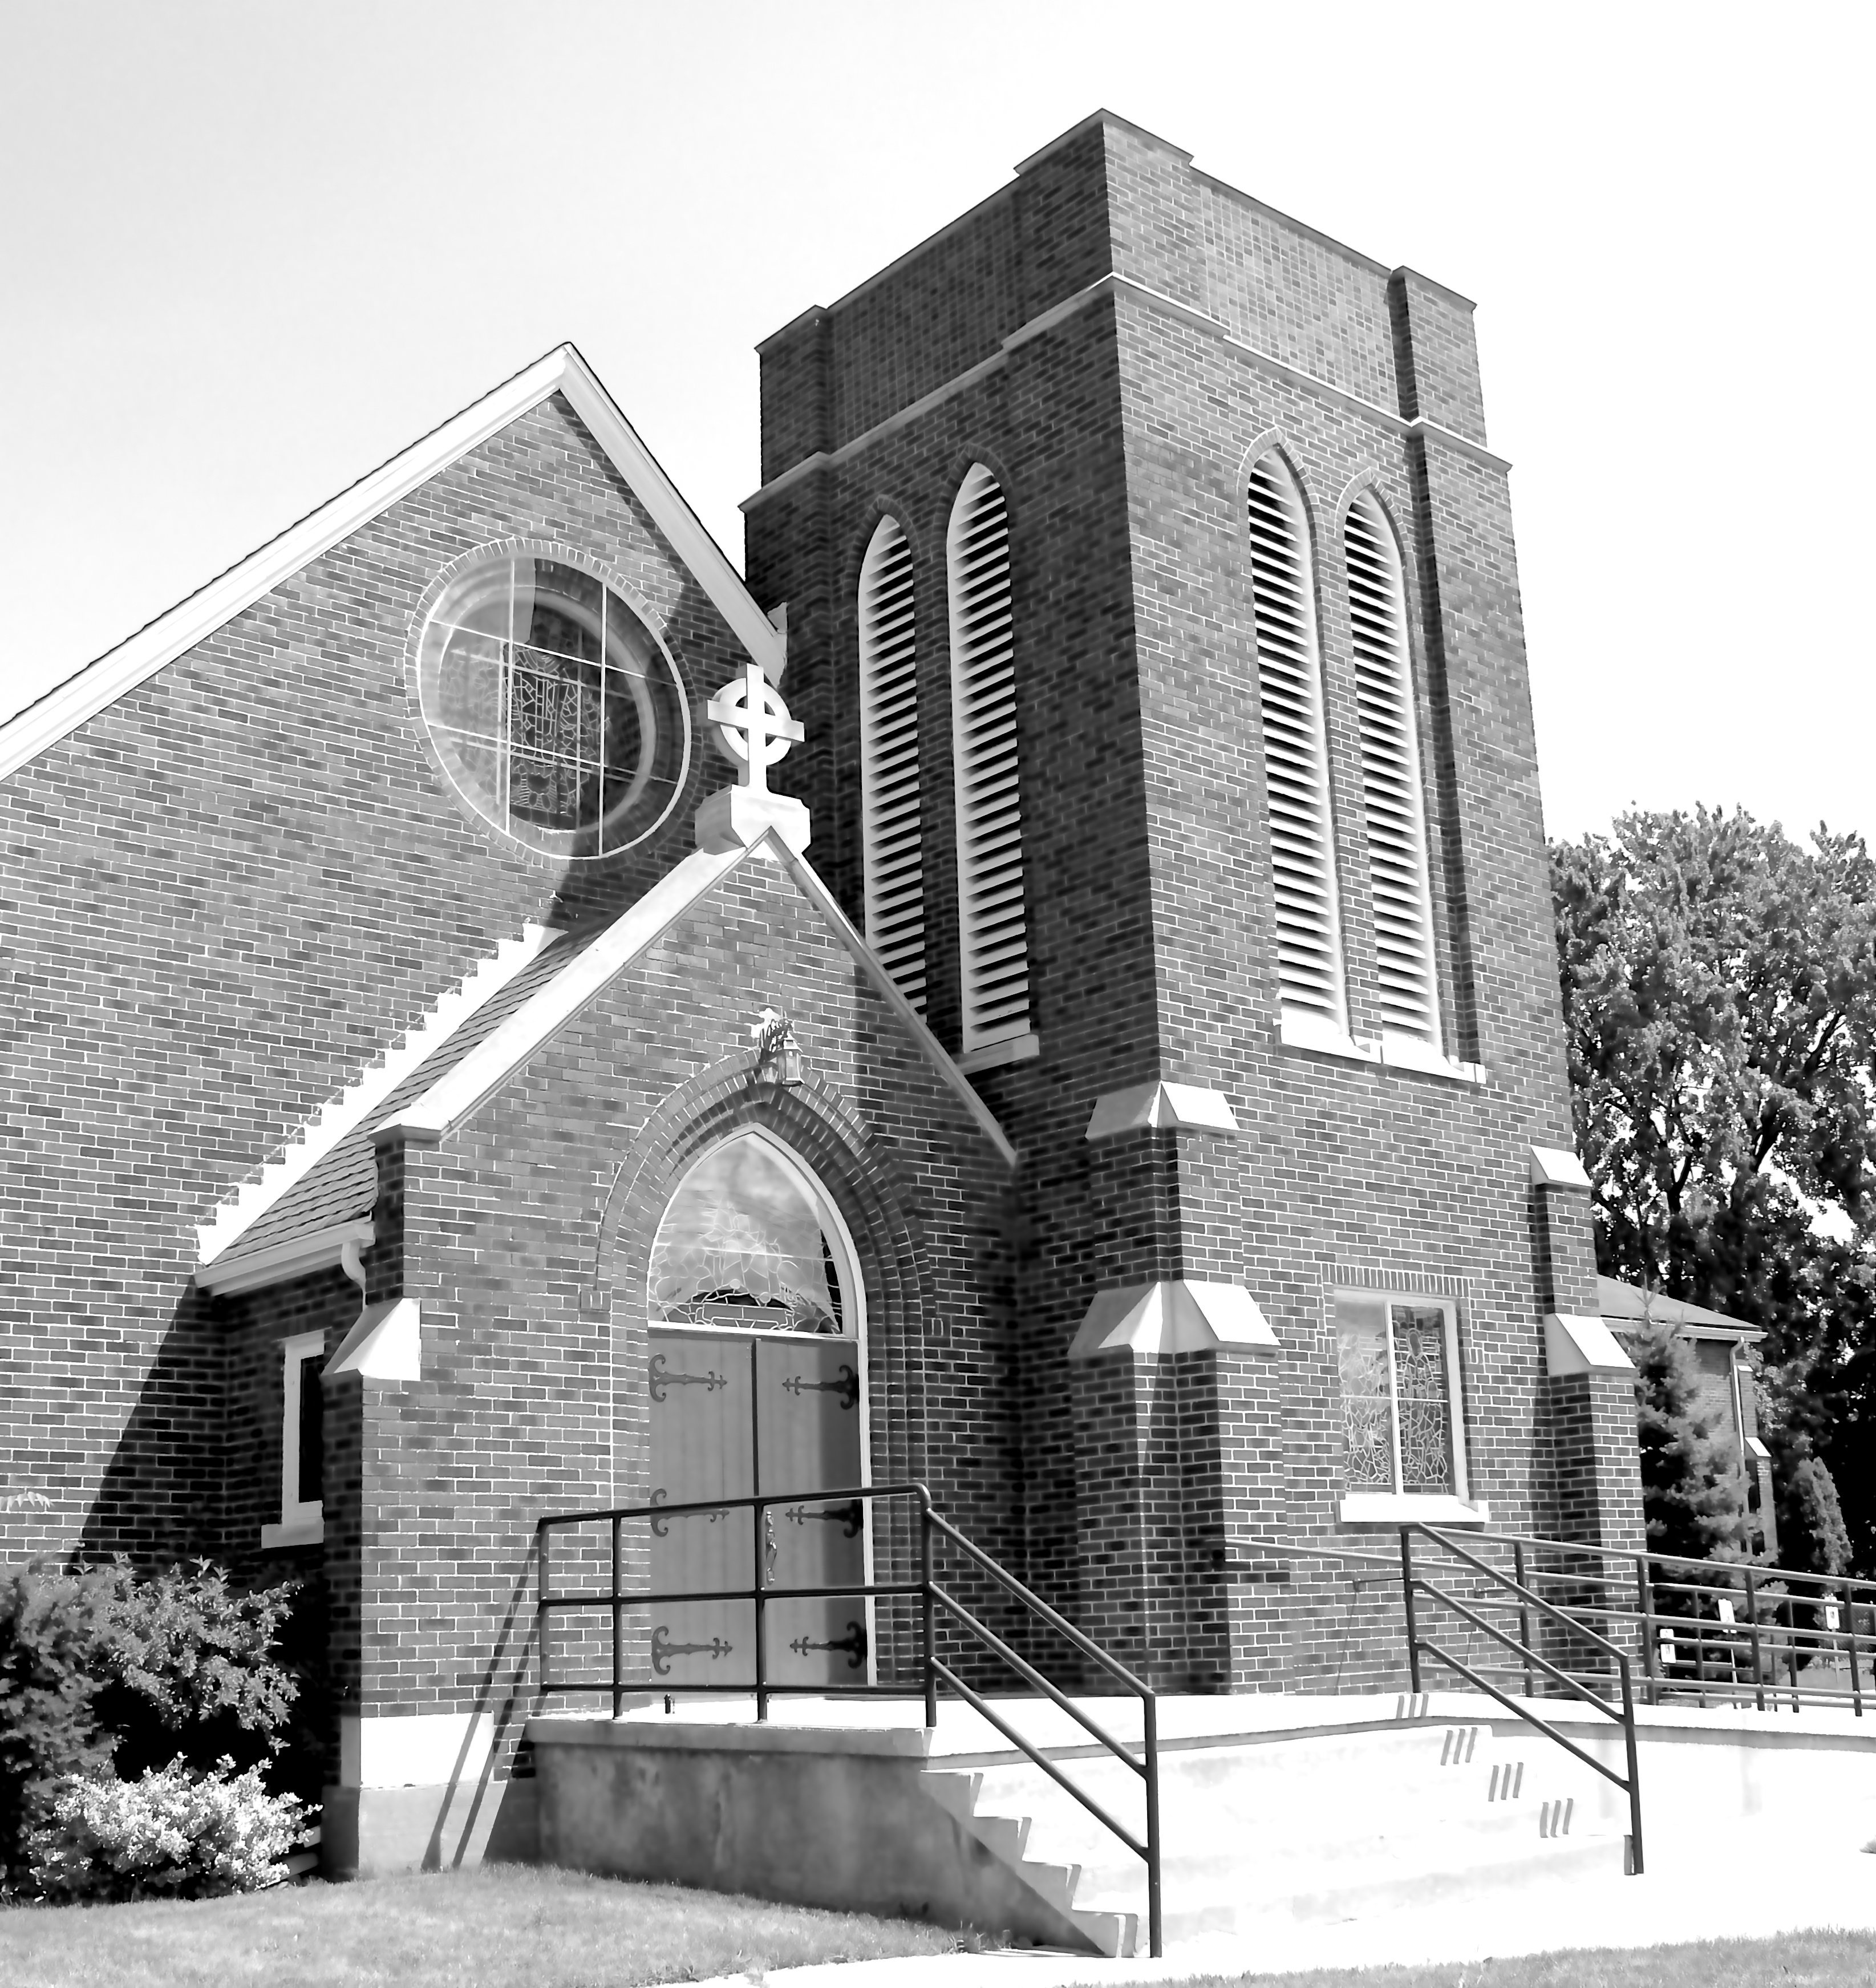

We Come and worship God.
We go our way with souls nourished.

Officiant: Ginny Schleihauf -- Organist: Dorothy Miller
380 Russell St. North (at Maxwell St.), Sarnia, Ontario, N7T 6S6
Tel: (519) 344-9531 - Email: canondavis@gmail.com – http://www.canondavis.com
8th January 2023 — The Baptism of the Lord

Service of the Word

Gathering Hymn # 103 On Jordan’s Bank, the Baptist’s Cry

Officiant: The grace of our Lord Jesus Christ and the love of God and the
fellowship of the Holy Spirit be with you all.
People: And also with you.

Officiant: Let us pray.
We thank you, O God, that you have again brought us together on the Lord’s Day to praise you for your goodness and to ask your blessing. Give us grace to see your hand in the week that is past, and your purpose in the week to come; through Christ our Lord.
People: Amen.

Officiant: Dear friends in Christ, as we turn our hearts and minds to
worship almighty God, let us confess our sins.

People: Most merciful God, we confess that we have sinned
against you in thought, word, and deed, by what we have done and by what we have left undone. We have not loved you with our whole heart; we have not loved our neighbours as ourselves. We are truly sorry and we humbly repent. For the sake of your Son Jesus Christ, have mercy on us and forgive us, that we may delight in your will, and walk in your ways, to the glory of your name. Amen.

Officiant: Merciful God, grant to us, your faithful people, pardon and
peace, that we may be cleansed from all our sins and serve you with a quiet mind through Jesus Christ our Lord, who is alive and reigns with you and the Holy Spirit, one God, now and for ever.
People: Amen.
Officiant: The Peace of the Lord be always with you.
People: And also with you.

Officiant: Let us reconcile to God and one another a sign of Christ’s
peace.

The Collect of the Day

Eternal Father, who at the baptism of Jesus revealed him to be your Son, anointing him with the Holy Spirit, keep your children, born of water and the Spirit, faithful to their calling; through Jesus Christ our Lord, who lives and reigns with you and the Holy Spirit, one God, now and for ever.

First Reading Isaiah 42: 1-9
Officiant: The Word of the Lord.
People: Thanks be to God.

Psalm 29: 1-10 (Response in bold.)

Ascribe to the Lord, you gods, ascribe to the Lord glory and strength.
Ascribe to the Lord the glory due his name; worship the Lord in the beauty of holiness.
The voice of the Lord is upon the waters; the God of glory thunders; the Lord is upon the mighty waters.
The voice of the Lord is a powerful voice; the voice of the Lord is a voice of splendour.
The voice of the Lord breaks the cedar trees; the Lord breaks the cedars of Lebanon;
He makes Lebanon skip like a calf, and Mount Hermon like a young wild ox.
The voice of the Lord splits the flames of fire; the voice of the Lord shakes the wilderness; the Lord shakes the wilderness of Kadesh.
The voice of the Lord makes the oak trees writhe and strips the forests bare.
And in the temple of the Lord all are crying, "Glory!"
The Lord sits enthroned above the flood; the Lord sits enthroned as king for evermore.
The Lord shall give strength to his people; the Lord shall give his people the blessing of peace.

Second Reading Acts 10: 34-43
Officiant: The Word of the Lord.
People: Thanks be to God.

Officiant: The Lord be with you.
People: And also with you.

Officiant: The Holy Gospel of our Lord Jesus Christ
according to Matthew.
People: Glory to you, Lord Jesus Christ.

The Gospel Matthew 3: 13-17
THE HOLY GOSPEL OF OUR LORD JESUS CHRIST
ACCORDING TO MATTHEW

Then Jesus came from Galilee to John at the Jordan, to be baptized by him. John would have prevented him, saying, "I need to be baptized by you, and do you come to me?" But Jesus answered him, "Let it be so now; for it is proper for us in this way to fulfil all righteousness." Then he consented. And when Jesus had been baptized, just as he came up from the water, suddenly the heavens were opened to him and he saw the Spirit of God descending like a dove and alighting on him. And a voice from heaven said, "This is my Son, the Beloved, with whom I am well pleased."

Officiant: The Gospel of the Christ
People: Praise to you, Lord Jesus Christ.

Sermon

Sermon Hymn #628 O Love, How Deep, How Broad, How High

Officiant: Let us confess our faith as we say.
People: I believe in God, the Father Almighty, creator of heaven
and earth.
I believe in Jesus Christ, his only Son, our Lord.
He was conceived by the power of the Holy Spirit and
born of the Virgin Mary.
He suffered under Pontius Pilate, was crucified, died, and
was buried.
He descended to the dead.
On the third day he rose again.
He ascended into heaven, and is seated at the right hand
of the Father.
He will come again to judge the living and the dead.
I believe in the Holy Spirit, the holy catholic Church, the communion of saints, the forgiveness of sins, the resurrection of the body, and the life everlasting. Amen.

Prayers of the People

In peace we pray to you, Lord God.
Silence
For all people in their daily life and work;
For our families, friends, and neighbours, and for all those who are alone.
For this community, our country, and the world;
For all who work for justice, freedom, and peace.
For the just and proper use of your creation;
For the victims of hunger, fear, injustice, and oppression.
For all who are in danger, sorrow, or any kind of trouble;
For those who minister to the sick, the friendless, and needy.
For the peace and unity of the Church of God;
For all who proclaim the gospel, and all who seek the truth.
For Todd our bishop, and for all bishops and other ministers;
For all who serve God in the Church.
For our own needs and those of others.
Silence.
In our parish cycle of prayer, we pray for…
Hear us, Lord.
For your mercy is great.
We thank you, Lord, for all the blessings of this life.
Silence. (The people may add their own thanksgivings.)

We will exalt you, O God our king;
And praise your name for ever and ever.
We pray for those who have died in the peace of Christ, and for those whose faith is known to you alone, that they may have a place in your eternal kingdom.
Silence.
Lord, let your loving kindness be upon them;
Who put their trust in you.
Gracious God, you have heard the prayers of your faithful people; you know our needs before we ask, and our ignorance in asking. Grant our requests as may be best for us. This we ask in the name of your Son Jesus Christ our Lord.
Amen

Offertory Hymn #505 Be Thou My Vision

Offertory Response All Things Come of Thee

People: Yours, Lord, is the greatness, the power, the glory, the
splendour, and the majesty; for everything in heaven and on earth is yours. All things come from you, and of your own do we give you.

Officiant: And now, as our Saviour Christ has taught us,
we are bold to say,
People: Our Father, who art in heaven,
hallowed be thy name,
thy kingdom come,
thy will be done, on earth as it is in heaven.
Give us this day our daily bread.
And forgive us our trespasses,
as we forgive those who trespass against us.
And lead us not into temptation, but deliver us from evil.
For thine is the kingdom,
the power, and the glory, for ever and ever. Amen.

Officiant: Glory to God
People: whose power, working in us, can do infinitely more than
we can ask or imagine. Glory to God from generation to generation, in the Church and in Christ Jesus, for ever and ever. Amen.

Announcements

Closing Hymn #423 How Great Thou Art

Officiant: May the God of hope fill us all with joy and peace in believing
through the power of the Holy Spirit. Amen.

Sung Benediction Howard’s Blessing (vs 1-2)
(in the back of the blue Hymn book)

The Flowers on the Altar today are given to
the Glory of God, a gift of the Chancel Guild.

Please enter names in the Intercessions Book each week to be read in the service.
News and Events

- Please send all announcements for the bulletin to Karen by 11:00 a.m. Tuesday of each week. Call: 519-344-9531 or E-mail: canondavis@gmail.com.

- If you would like a home visit with Communion or know of someone who would, please let Rev. Ray know as he and/or a Lay Visitor will be available in the coming weeks.

- Please join us for Coffee Hour after service for a time of fellowship in the parish hall.

Upcoming Events:

Reminders

Jan 16 Vestry Reports are due
Jan 19 Parish Council Meeting
Jan 22 Vestry reports issued
Jan 29 Vestry meeting after church service in the parish hall.

