Fourth Sunday of Advent
18 December 2 0 2 2

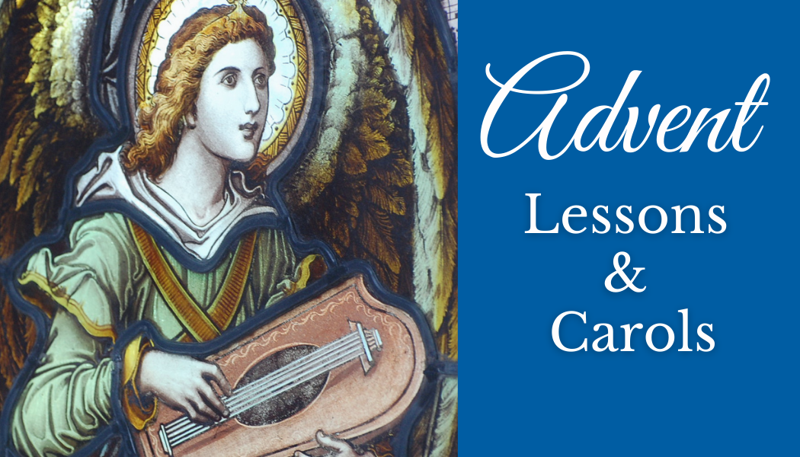

Canon Davis Memorial Church
Anglican Church of Canada

We come and worship God.
We go our way with souls nourished.

Worship Service: Sunday 9:30 a.m.
Office Hours: Tuesday and Thursday 9:00 a.m. to Noon
Email: canondavis@gmail.com Website: www.canondavis.com
380 Russell St. North (at Maxwell St.)
Sarnia, Ontario N7T 6S6 Phone: 519-344-9531

December 18, 2022 — Fourth Sunday of Advent
Officiant – Rev’d Paul Woolley — Organist – Dorothy Miller

Advent Festival of Lessons and Carols

Gathering Carol #123 Once in Royal David’s City
Lighting of the Advent Wreath (Hope, Peace, and Joy)
Advent 4 -Today is the fourth Sunday of Advent, the Sunday of Love.
Jesus shows us God's perfect love. He is God's perfect love in human form. Those who believe in him and live in him, live in love. Love transforms and perfects all things. It never ends.
We light this candle today to remind us that God is love. We thank God for the hope he gives us, for the peace he bestows, for the joy he pours into our hearts, and for the love that redeems us and shows us the way.
Lighting of the Fourth Candle (Love)
Leader: Let us pray: O God of love, Emmanuel, send your light into our hearts at this time. Help us to be ready for the time of Christ’s appearing. Grant that we may so dwell in him that His perfect love fills our entire being. Make our worship a time in which we celebrate your love and are made ready to show that love to the whole world – both today and forevermore. Amen.
All sing: “A Candle is Burning”
Words by Sandra Dean, 1986. Tune by James Murray 1887 (public domain)
A candle is burning, a candle of love,
a candle to point us to heaven above.
A baby for Christmas, a wonderful birth,
For Jesus is bringing God’s love to our earth
THE GATHERING OF THE COMMUNITY

The grace of our Lord Jesus Christ, and the love of God, and the fellowship of the Holy Spirit, be with you all.
And also with you.

Collect for the Fourth Sunday of Advent:
Heavenly Father, who chose the Virgin Mary, full of grace, to be the mother of our Lord and Saviour, now fill us with your grace, that we in all things may embrace your will and with her rejoice in your salvation; through Jesus Christ our Lord, who lives and reigns with you and the Holy Spirit, one God, now and for ever. Amen.
First Lesson John 1:1-5
In the beginning was the Word, and the Word was with God, and the Word was God.
Carol #89 (verses 1, 6, 7) O Come, O Come, Emmanuel
Second Lesson Genesis 3: 8-15
Now the Lord said to Abram, go from your country and your kindred and your father’s house to the land that I will show you.
Carol #109 When the King Shall Come Again
Third Lesson Isaiah 9: 2, 6-9
The people who walked in darkness have seen a great light; those who lived in a land of deep darkness on them light has shined.
Carol #140, (verses 1, 2, 5) It Came Upon the Midnight Clear
Fourth Lesson Isaiah 11:1-9
The spirit of the Lord shall rest on him, the spirit of wisdom and understanding, the spirit of counsel and might, the spirit of knowledge and the fear of the Lord.
Carol #137 What Child is This
Fifth Lesson Matthew 1:18-25
Now the birth of Jesus the Messiah took place in this way.
Carol #153 Good Christians All, Rejoice
Sixth Lesson Luke 2:1-7
In those days a decree went out from Emperor Augustus that all the world be registered.
Carol #120 (verses 1-3) O Little Town of Bethlehem
Seventh Lesson Luke 2:8-16
In that region there were shepherds living in the fields, keeping watch over their flock by night.
Carol #136 (verses 1-4) While Shepherds Watched Their Flocks
Eighth Lesson Matthew 2:1-11
In the time of King Herod, after Jesus was born in Bethlehem of Judea, wise men from the East came to Jerusalem, asking, “Where is the child who has been born King of the Jews? For we observed his star at rising and have come to pay him homage.”
Carol #160 As With Gladness Men of Old
Ninth Lesson John 1:6-18
No one has ever seen God. It is God the only Son, who is close to the Father’s heart, who has made him known

Carol #118 (verses 1-4) O Come, All Ye Faithful

The Apostles’ Creed p. 189

Prayers for Advent p. 119
Response: “Lord Jesus, come soon!”

Confession and Absolution p. 191
The Peace

Carol #118 (verses 1-4) O Come, All Ye Faithful

Offertory Response:
What can I give him, poor as I am?
If I were a shepherd, I would bring a lamb;
If I were a wise man, I would do my part;
What I can, I give him – I give him my heart.

Prayer over the Gifts: Gracious God, by the power of the Spirit who sanctified the mother of your Son, make holy all we offer you this day. We ask this in the name of Jesus Christ the Lord. Amen.

THE CELEBRATION OF THE HOLY EUCHARIST

Eucharistic Prayer # 2 p. 201
The Lord’s Prayer p. 211
Breaking of the Bread # 5 p. 212
Communion

Prayer After Communion: Faithful God, in this sacrament we receive the promise of salvation. May we, like the Virgin Mary, be obedient to your will. We ask this in the name of Jesus Christ the Lord. Amen.
Glory to God & Blessing p. 214
Announcements
Recessional Carol #138 Hark! The Harold Angels Sing
Dismissal
Go in peace to love and serve the Lord.
Thanks be to God.

The Flowers on the Altar today are given to the Glory of God and in memory of Mary Switzer,
a gift from Gordon Simmons, Pam, Joel, Anna and Molly Eagleson, and Brad, Mary-Elizabeth, McKenna and Camryn Carroll.

The Christmas Wreath on the front of the pulpit is given to the Glory of God and in loving memory of our many family members and friends at this blessed Christmas Season, a gift of the Heasman family.

News and Events
- Please send all announcements for the bulletin to Karen by 11:00 a.m. Tuesday of each week. Call: 519-344-9531 or E-mail: canondavis@gmail.com.
- If you would like a home visit with Communion or know of someone who would, please let Rev. Ray know as he and/or a Lay Visitor will be available in the coming weeks.
- Please join us for Wassail/Coffee Hour after service for a time of fellowship in the parish hall.
- The Chancel Guild still has four Sunday openings available for altar flower donors. They are: 2nd Sunday in April, 4th Sunday in June, 2nd Sunday in August and 2nd Sunday in September. If you are interested in being an altar flower donor please contact Seonaid Laidlaw. Thank you.
- Church calendars are still available for purchase for $6.00 after church.
- This year, our Candle Light Service on December 24 will be held at 5:00 p.m. and
- Our Christmas Day Service of the Word on December 25 at 9:30 a.m. Please join us.
- Thank you to Betty Falloon and Karen McBride for the donation of poinsettias.
- 2023 Vestry is Sunday, January 29, after the service in the Parish Hall. Reports are due to Karen McBride by January 16. Vestry packages will be available Sunday January 22.

Reminders
Dec 24 CDM Candle Light Service at 5:00 p.m.
Dec 25 CDM Christmas Day Service at 9:30 a.m.

