Canon Davis Memorial Church

380 Russell St. North, Sarnia, Ontario, N7T 6S6
(519) 344-9531 • http://www.canondavis.com
6th SUNDAY OF EASTER • May 9, 2021

Acts 10:44-48 • Psalm 98 • 1 John 5:1-6 • John 15:9-17

Dear Friends,
While we wait for things to get better in the world around us, we may find ourselves becoming increasingly impatient. It seems that everywhere we look, very little appears to be coming together as it could, or should.

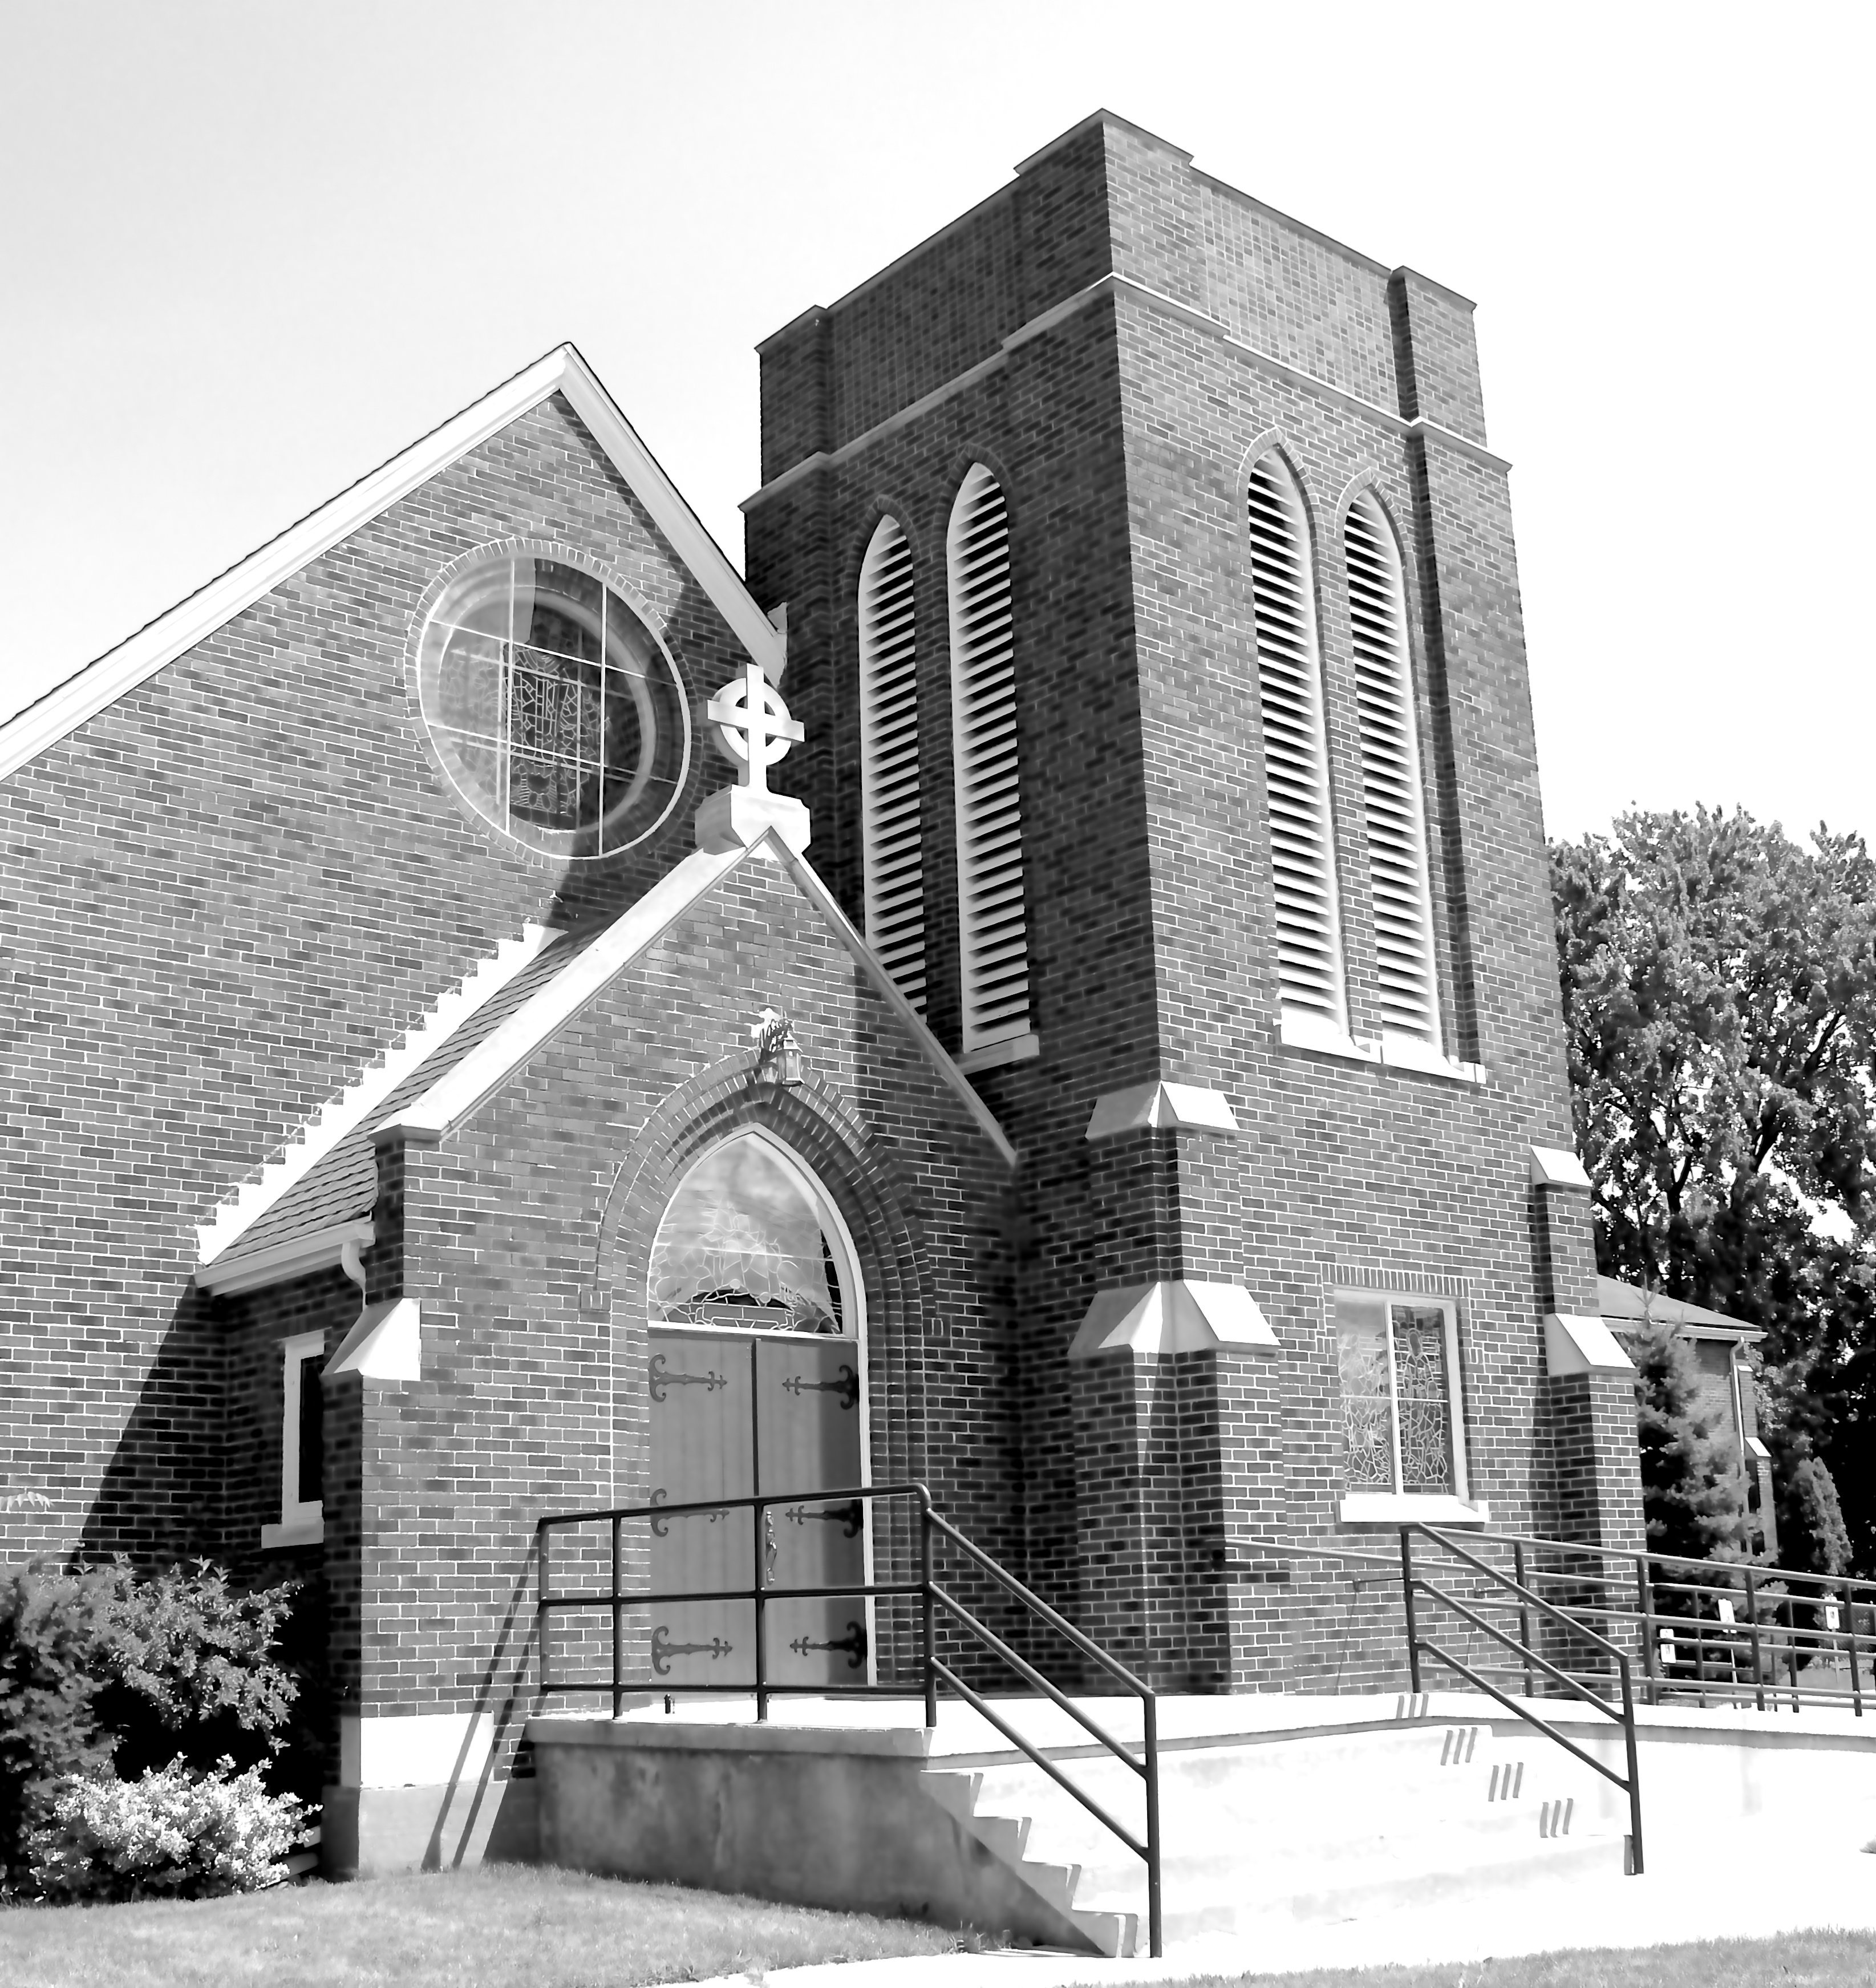
Indeed, signs of helplessness are emerging in places we would not have ever guessed. As worshippers of the God of the universe; the one who created all that there is, we have always admired and depended on the underlying order in creation. This order, and the laws that control it allow us to go about our daily activities with a reasonable level of confidence concerning what God has created. The day continues to be light; the night shrouded in darkness. Water flows downward; gravity continues to hold us on the planet. We live in a remarkable world created by a God who continues to see to its complex functioning.

We are encouraged to follow God’s lead as we go about doing some creating on our own. We are given the ability to create all manner of structures; objects; art works; institutions and recreation facilities. In building these, we find quickly, the need to continue to follow God’s laws!

We generally find failure or limited returns if we ignore the fullness of God’s laws of nature, for example. Chaos can be one powerful result — potentially, a very destructive result! Sadly in recent years, we are witnessing a growing amount of chaos. Some intentional; some not.

In today’s Gospel readings, Jesus gives us reasons for optimism and joy. For we are invited into God’s world. Christ tells us: I have said these things to you so that my joy may be in you, and that your joy may be complete. This is my commandment, that you love one another as I have loved you.

Reflecting the wisdom of God, Jesus lays out love as the pathway to truly being alive! Jesus passes along to us what he hears from God the Father. But there is more. Elsewhere, our Lord lets us know that he is the God of surprises. As we learn the power of love to bring people in touch with the kingdom of God, we see people being transformed. They are leading their lives in new and productive ways — productive in positive ways.

A new world awaits and we rejoice!

God, indeed, works with and through God’s people, as they seek to be agents of God’s love, healing and peace. We are known and loved by God! The blessings of our loving, Creator God be upon you and those you love.

——————————————————————————
You are invited to go each Sunday and/or Wednesday to the link:
tinyurl.com/StAlbans-CDMC

That is the link to St. Alban’s Anglican Church in Burnaby B.C. Follow the instructions. You will find links to the Rev’d Greg Jenkins officiating at an Anglican church service with children’s focus, church music, readings, prayers and a sermon.
If you are also interested in joining their weekly Bible Study, contact Rev. Greg at revgregjenkins@gmail.com He will be more than happy to be in touch about joining in with their group by ZOOM. I hope you will find these services help to deepen your faith.

tinyurl.com/StAlbans-CDMC

——————————————————————————-

We are joining with many parishes in our deanery in providing telephone support to our members and friends. This support is designed to keep us up to date, while not requiring a computer. A CDMC Pastoral Letter will be read this week through our phone ministry.

