Canon Davis Memorial Church
Anglican Church of Canada
Sunday, August 20, 2023 – Twelfth Sunday after Pentecost

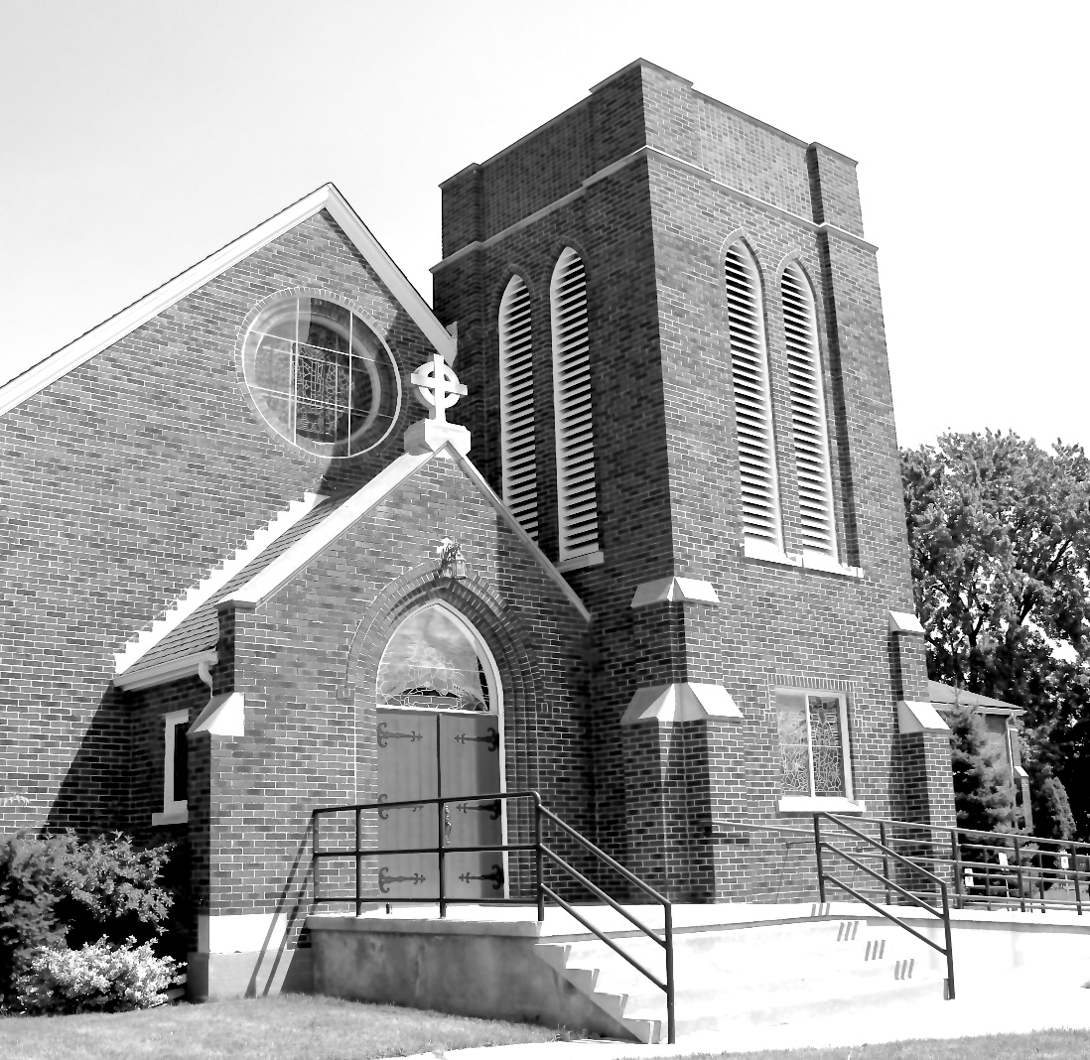

Worship Service: Sunday 9:30 a.m.
Officiant—Rev’d Jon Forbes — Assisted By — John Hayter
Organist—Dorothy Miller
380 Russell St. North (at Maxwell St.), Sarnia, Ontario, N7T 6S6
(519) 344-9531 - http://www.canondavis.com – canondavis@gmail.com
Prelude

Announcements

THE GATHERING OF THE COMMUNITY

Sentence
Jesus preached the gospel of the kingdom and healed every infirmity among the people. Matthew 4: 23

Processional Hymn # 560 God, Whose Almighty Word

The grace of our Lord Jesus Christ, and the love of God, and the fellowship of the Holy Spirit, be with you all.
And also with you.

Almighty God, to you all hearts are open, all desires known, and from you no secrets are hidden. Cleanse the thoughts of our hearts by the inspiration of your Holy Spirit, that we may perfectly love you, and worthily magnify your holy name; through Christ our Lord. Amen.

Glory to God in the highest, and peace to his people on earth.
Lord God, heavenly king, almighty God and Father, we worship you, we give you thanks, we praise you for your glory.

Lord Jesus Christ, only Son of the Father, Lord God, Lamb of God, you take away the sin of the world: have mercy on us; you are seated at the right hand of the Father: receive our prayer.

For you alone are the Holy One, you alone are the Lord, you alone are the Most High, Jesus Christ, with the Holy Spirit, in the glory of God the Father. Amen.

Lord, have mercy.
Christ, have mercy.
Lord, have mercy.
Collect of the Day
Almighty God, you have broken the tyranny of sin and sent into our hearts the Spirit of your Son. Give us grace to dedicate our freedom to your service, that all people may know the glorious liberty of the children of God; through Jesus Christ our Lord, who lives and reigns with you and the Holy Spirit, one God, now and for ever.

THE PROCLAMATION OF THE WORD

1st Reading: Genesis 45: 1-15

The Word of the Lord.
Thanks be to God.

Psalm133 (to be read responsively)

Oh, how good and pleasant it is, when brethren live together in unity! It is like fine oil upon the head that runs down upon the beard, Upon the beard of Aaron, and runs down upon the collar of his robe.
It is like the dew of Hermon that falls upon the hills of Zion. For there the Lord has ordained the blessing: life for evermore.

2nd Reading: Romans 11: 1-2A, 29-32

The Word of the Lord
Thanks be to God.

Gradual Hymn # 485 Love Divine, All Loves Excelling

Gospel

The Holy Gospel of our Lord Jesus Christ according to Matthew.
Glory to you, Lord Jesus Christ.

Matthew 15: 10-28
The Gospel of Christ.
Praise to you, Lord Jesus Christ.

Sermon

The Apostles’ Creed:
Let us confess the faith of our baptism, as we say,
I believe in God, the Father almighty, creator of heaven and earth. I believe in Jesus Christ, his only Son, our Lord. He was conceived by the power of the Holy Spirit and born of the Virgin Mary. He suffered under Pontius Pilate, was crucified, died, and was buried. He descended to the dead. On the third day he rose again. He ascended into heaven, and is seated at the right hand of the Father. He will come again to judge the living and the dead. I believe in the Holy Spirit, the holy catholic Church, the communion of saints, the forgiveness of sins, the resurrection of the body, and the life everlasting. Amen.
Amen.

Prayers of the People
(In peace let us pray to the Lord, saying, “Lord, have mercy.”)

For the peace from on high and for our salvation, let us pray to the Lord.
Lord, have mercy.

For the peace of the whole world, for the welfare of the holy Church of God, and for the unity of all, let us pray to the Lord.
Lord, have mercy.

For our bishops, and for all the clergy and people, let us pray to the Lord.
Lord, have mercy.

For Charles our King, for the leaders of the nations, and for all authority, let us pray to the Lord.
Lord, have mercy.

For Sarnia, for every city and community, and for those who live in them in faith, let us pray to the Lord.
Lord, have mercy.

For good weather, and for abundant harvests for all to share, let us pray to the Lord.
Lord, have mercy.

For those who travel by land, water, or air, for the sick and the suffering (especially), for prisoners and captives, and for their safety, health, and salvation, let us pray to the Lord.
Lord, have mercy.

For our deliverance from all affliction, strife, and need, let us pray to the Lord.
Lord, have mercy.

For the absolution and remission of our sins and offences, let us pray to the Lord.
Lord, have mercy.

For all who have died (especially ), let us pray to the Lord.
Lord, have mercy.

Remembering (… and) all the saints, we commit ourselves, one another, and our whole life to Christ our God.
To you, O Lord.

Almighty God, you have given us grace at this time with one accord to make our common supplications to you, and you have promised through your well-beloved Son that when two or three are gathered together you will hear their requests. Fulfil now our desires and petitions, as may be best for us, granting us in this world knowledge of your truth, and in the age to come eternal life; for you, Father, are good and loving, and we glorify you through your Son Jesus Christ our Lord, in the Holy Spirit, now and for ever. Amen.
In our parish cycle of prayer, we pray for…

Prayer for a Renewed Church
Almighty God, give us a new vision of you, of your love, of your grace and power, and then, give us a new vision of what you would have us do as your Church in this nation and at this time, and an awareness that in the strength of your Spirit, we can do it to your glory. In Jesus’ name we pray. Amen.

Confession and Absolution: Dear friends in Christ, God is steadfast in love and infinite in mercy; he welcomes sinners and invites them to his table. Let us confess our sins, confident in God’s forgiveness.

The Confession: Most merciful God,
we confess that we have sinned against you in thought, word, and deed, by what we have done, and by what we have left undone. We have not loved you with our whole heart; we have not loved our neighbours as ourselves. We are truly sorry and we humbly repent. For the sake of your Son Jesus Christ, have mercy on us and forgive us, that we may delight in your will, and walk in your ways, to the glory of your name. Amen.

Absolution: Almighty God have mercy upon you, pardon and deliver you from all your sins, confirm and strengthen you in all goodness, and keep you in eternal life; through Jesus Christ our Lord. Amen.

The Peace
The peace of the Lord be always with you.
And also with you.

Offertory Hymn # 312 Sing a New Son unto the Lord

Prayer over the Gifts
Loving God and Father, you have adopted us to be your heirs. Accept all we offer you this day and give us grace to live as faithful children. We ask this in the name of Jesus Christ our Lord.
Eucharist Prayer
The Lord be with you.
And also with you.

Lift up your hearts.
We lift them to the Lord.

Let us give thanks to the Lord our God.
It is right to give our thanks and praise.

We give you thanks and praise, almighty God, through your beloved Son, Jesus Christ, our Saviour and Redeemer.
He is your living Word, through whom you have created all things.

By the power of the Holy Spirit he took flesh of the Virgin Mary and shared our human nature. He lived and died as one of us, to reconcile us to you, the God and Father of all.

In fulfilment of your will he stretched out his hands in suffering, to bring release to those who place their hope in you; and so he won for you a holy people.
He chose to bear our griefs and sorrows, and to give up his life on the cross, that he might shatter the chains of evil and death, and banish the darkness of sin and despair. By his resurrection he brings us into the light of your presence.

Now with all creation we raise our voices to proclaim the glory of your name

Holy, holy, holy Lord,
God of power and might,
heaven and earth are full of your glory.
Hosanna in the highest.

Blessed is he who comes in the name of the Lord.
Hosanna in the highest.
Holy and gracious God, accept our praise, through your Son our Saviour Jesus Christ; who on the night he was handed over to suffering and death,
took bread and gave you thanks, saying, “Take, and eat: this is my body which is broken for you.” In the same way he took the cup, saying, “This is my blood which is shed for you. When you do this, you do it in memory of me.”

Remembering, therefore, his death and resurrection, we offer you this bread and this cup, giving thanks that you have made us worthy to stand in your presence and serve you.

We ask you to send your Holy Spirit upon the offering of your holy Church. Gather into one all who share in these sacred mysteries, filling them with the Holy Spirit and confirming their faith in the truth, that together we may praise you and give you glory through your Servant, Jesus Christ.

All glory and honour are yours, Father and Son, with the Holy Spirit in the holy Church, now and for ever. Amen.

The Lord’s Prayer:
Our Father, who art in heaven, hallowed be thy name, thy kingdom come, thy will be done, on earth as it is in heaven. Give us this day our daily bread. And forgive us our trespasses, as we forgive those who trespass against us. And lead us not into temptation, but deliver us from evil. For thine is the kingdom, the power, and the glory, for ever and ever. Amen.

Breaking of the Bread

We break this bread
to share in the body of Christ.

We, being many, are one body,
for we all share in the one bread.
The Communion
The gifts of God for the people of God.
Thanks be to God.

Prayer after Communion
Eternal God, we have received a token of your promise. May we who have been nourished by holy things live as faithful heirs of your promised kingdom, in the name of Jesus Christ our Lord.

Doxology
Glory to God, Whose power, working in us, can do infinitely more than we can ask or imagine. Glory to God from generation to generation, in the Church and in Christ Jesus, for ever and ever. Amen.

Recessional Hymn # 577 God of Grace and God of Glory

Blessing
The peace of God which passes all understanding, keep your hearts and minds in the knowledge and love of God and of his son Jesus Christ and the blessing of God Almighty the Father, the Son and the Holy Spirit be with you and those you love for ever more. Amen.

Dismissal

Benediction Song Go Now in Peace
(found in the back of the blue hymn book)

The flowers on the Altar today are given to the Glory of God and in memory of Garth Dew,
a gift of his wife, Joan and family.

Please enter names in the Intercessions Book each week to be read in the service.
NEWS AND EVENTS

- Please send all announcements for the bulletin to Karen by 11:00 a.m. Tuesday of each week. Call 519-344-9531 or E-mail: canondavis@gmail.com.
- If you would like to contact Rev’d Jon Forbes, he may be reached at
1 905 818 9488 or email jonforbes@outlook.com.
- Please join us for Coffee Hour after service for a time of fellowship in the parish hall.
- Five Sundays are available for anyone who would like to provide flowers for the altar. The Sundays are the 4th Sunday of March, 2nd Sunday of April, 4th Sunday of June, 2nd Sunday of August and 2nd Sunday of September. If you would like to provide flowers please contact Seonaid Laidlaw.
- Many thanks to our friends at CDMC for the birthday card! The flowers, phone calls, thoughts, well wishes, and prayers are deeply appreciated and make a difference as our health improves. We look forward to seeing you in September. — Love, Sally and Ray

Upcoming Events:
- Sew Days are coming back to CDM. Saturday September 23, and Saturday October 28 from 9:00 am to 3:00 p.m. Cost $20.00 and lunch is provided. To sign up, please call Carol Turner at 519 384 3015
Reminders
16 Aug Chancel Guild meeting in the church
15 Sept 7:00 p.m. Free Concert All Saints Anglican Church: An
Evening of Music in Memory of Eleanor Vargo.
23 Sep Sew Days 9:00 am to 3:00 pm

