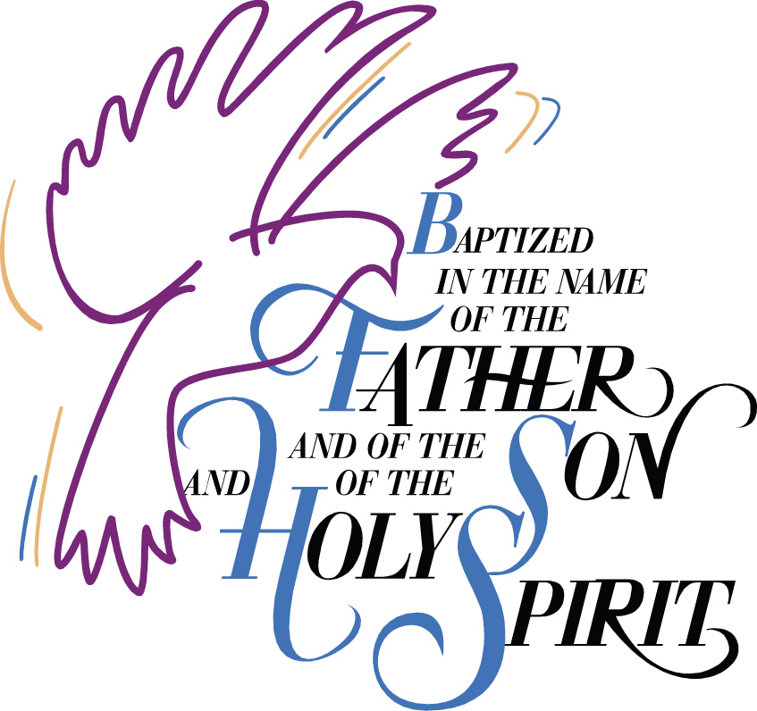

Baptism
of
Sutton Sarah D’Ippolito
16 July 2023
Born 25 March 2023
Sarnia, Ontario
Canada

Canon Davis Memorial Church
Anglican Church of Canada
Sunday, July 16, 2023—Seventh Sunday after Pentecost
9:30 a.m. Holy Baptism and Holy Eucharist
Officiant—Rev’d Jon Forbes
Assisted by: Bill Blunt
Organist—Dorothy Miller

The Gathering of the Community

Opening Hymn #381 Praise, My Soul

Welcome
Celebrant: The grace of our Lord Jesus Christ, and the love of God
and the fellowship of the Holy Spirit, be with you all.
People: And also with you.

Celebrant: There is one body and one Spirit,
People: There is one hope in God’s call to us;

Celebrant: One Lord, one faith, one baptism,
People: One God and Father of all.

Collect of the Day: Almighty God, you have made us for yourself, and our hearts are restless until they find their rest in you. May we find peace in your service and in the world to come, see you face to face; through Jesus Christ our Lord, who lives and reigns with you and the Holy Spirit, one God, now and forever. Amen.

PRESENTATION AND EXAMINATION OF THE CANDIDATES

Celebrant: The candidate(s) for Holy Baptism will now be presented.
Parents & Sponsors: I present Sutton Sarah D’Ippolito to receive the
sacrament of baptism.

Celebrant: Will you be responsible for seeing that the child you
present is nurtured in the faith and life of the Christian
community?
Parents & Sponsors: I will, with God’s help.

Celebrant: Will you by your prayers and witness help this child to
grow into the full stature of Christ?
Parents & Sponsors: I will, with God’s help.

Celebrant: Do you renounce Satan and all the spiritual forces of
wickedness that rebel against God?
Parents & Sponsors: I renounce them.

Celebrant: Do you renounce the evil powers of this world which
corrupt and destroy the creatures of God?
Parents & Sponsors: I renounce them.

Celebrant: Do you renounce all sinful desires that draw you from the
love of God?
Parents & Sponsors: I renounce them.

Celebrant: Do you turn to Jesus Christ and accept him as your
Saviour?
Parents & Sponsors: I do.

Celebrant: Do you put your whole trust in his grace and love?
Parents & Sponsors: I do.

Celebrant: Do you promise to obey him as your Lord?
Parents & Sponsors: I do.

Celebrant: Will you who witness these vows do all in your power to
support Sutton Sarah D’Ippolito in her life in Christ?
People: We will.

PRAYERS FOR THE CANDIDATE

Celebrant: Let us pray.

(All pray in the position most comfortable.)

Celebrant: Let us now pray for Sutton, who is to receive the
sacrament of new birth.

Celebrant: Deliver her, O Lord, from the way of sin and death.
People: Lord, hear our prayer.

Celebrant: Open her heart to your grace and truth.
People: Lord, hear our prayer.

Celebrant: Fill her with your holy and life-giving Spirit.
People: Lord, hear our prayer.

Celebrant: Teach her to love others in the power of the Spirit.
People: Lord, hear our prayer.

Celebrant: Send her into the world in witness to your love.
People: Lord, hear our prayer.

Celebrant: Bring her to the fullness of your peace and glory.
People: Lord, hear our prayer.

Celebrant: And this day, Dear Lord, we remember all those in any kind
of need, and also those on our parish cycle of prayer.

Celebrant: Grant, O Lord, that all who are baptized into the death of
Jesus Christ your Son may live in the power of his
resurrection and look for him to come again in glory; who lives and reigns now and forever.
People: Lord, hear our prayer. Amen.

CELEBRATION OF BAPTISM

Thanksgiving Over the Water

Celebrant: The Lord be with you.
People: And also with you.

Celebrant: Let us give thanks to the Lord our God.
People: It is right to give our thanks and praise.

Celebrant: We give you thanks, almighty God and Father, for by the
gift of water you nourish and sustain all living things.
People: Blessed be God for ever.

Celebrant: We give you thanks that through the waters of the Red
Sea, you led your people out of slavery to freedom in the promised land.
People: Blessed be God for ever.
Celebrant: We give you thanks for sending your son Jesus. For us he
was baptized by John in the river Jordan. For us he was anointed as Christ by your Holy Spirit. For us he suffered the baptism of his own death and resurrection, setting us free from the bondage of sin and death, and opening to us the joy and freedom of everlasting life.
People: Blessed be God for ever.

Celebrant: We give you thanks for your Holy Spirit who teaches us
and leads us into all truth, filling us with his gifts so that we might proclaim the Gospel to all nations and serve you as a royal priesthood.
People: Blessed be God for ever.

Celebrant: We give you thanks for you have called Sutton to new life
through the waters of baptism. Now sanctify this water, that your servant who is washed in it may be made one with Christ in his death and resurrection, to be cleansed and delivered from all sin. Anoint her with your Holy Spirit and bring her to new birth in the family of your Church, that she may become an inheritor of your glorious kingdom. We give you praise and honour and worship through your Son Jesus Christ our Lord, in the unity of the Holy Spirit, now and for ever.
People: Blessed are you, our strength and song, and our
salvation.

Celebrant: Let us join with she who is committing herself to
Christ and renew our own baptismal covenant.

BAPTISMAL COVENANT

Celebrant: Do you believe in God the Father?
People: I believe in God, the Father almighty, creator of heaven and earth.

Celebrant: Do you believe in Jesus Christ, the Son of God?
People: I believe in Jesus Christ, his only Son, our Lord. He was conceived by the power of the Holy Spirit and born of the Virgin Mary. He suffered under Pontius Pilate, was crucified, died, and was buried. He descended to the dead. On the third day he rose again. He ascended into heaven, and is seated at the right hand of the Father. He will come again to judge the living and the dead.

Celebrant: Do you believe in God the Holy Spirit?
People: I believe in God the Holy Spirit, the holy catholic Church, the communion of saints, the forgiveness of sins, the resurrection of the body, and the life everlasting.

Celebrant: Will you continue in the apostles’ teaching and fellowship,
in the breaking of bread, and in the prayers?
People: I will, with God’s help.

Celebrant: Will you persevere in resisting evil and, whenever you fall
into sin, repent and return to the Lord?
People: I will, with God’s help.

Celebrant: Will you proclaim by word and example the good news of
God in Christ?
People: I will, with God’s help.
Celebrant: Will you seek and serve Christ in all persons, loving your neighbour as yourself?
People: I will, with God’s help.

Celebrant: Will you strive for justice and peace among all people, and respect the dignity of every human being?
People: I will, with God’s help.

Celebrant: Will you strive to safeguard the integrity of God's creation, And respect, sustain and renew the life of the Earth?
People: I will, with God’s help.

THE BAPTISM

Celebrant: Sutton, I baptize you in the name of the Father, and of the
Son, and of the Holy Spirit. Amen.

Celebrant: I sign you with the cross, and mark you as Christ’s own forever.

Celebrant: Heavenly Father, we thank you that by water and the Holy
Spirit you have bestowed upon your servant Sutton the forgiveness of sin, and have raised her to the new life of grace. Sustain her, O Lord, in your Holy Spirit. Give her an inquiring and discerning heart, the courage to will and to persevere, a spirit to know and to love you, and the gift of joy and wonder in all your works. Amen.

The Giving of the Light

Celebrant: Receive the light of Christ, to show that you have passed
from darkness to light.
People: Let your light so shine before others that they may see
your good works and glorify your Father in heaven.

Celebrant: Let us welcome newly baptized Sutton Sarah D’Ippolito.
People: We receive you into the household of God. Confess the
faith of Christ crucified, proclaim his resurrection, and share with us in his eternal priesthood.

THE PROCLAMATION OF THE WORD

First Reading: Genesis 25: 19-34
Psalm 119: 105-112
Your word is a lantern to my feet and a light upon my path.

I have sworn and am determined to keep your righteous judgements.

I am deeply troubled; preserve my life, O Lord, according to your word.

Accept, O Lord, the willing tribute of my lips, and teach me your judgements.

My life is always in my hand, yet I do not forget your law.

The wicked have set a trap for me, but I have not strayed from your commandments.

Your decrees are my inheritance for ever; truly, they are the joy of my heart.

I have applied my heart to fulfil your statutes for ever and to the end.
Second Reading: Romans 8: 1-11

The Holy Gospel: Matthew 13: 1-9, 18-23

Reader: The Lord be with you.
People: And also with you.

(The Congregation stands for the Gospel Reading)

Reader: The Holy Gospel of our Lord Jesus Christ according to John
People: Glory to you, Lord Jesus Christ.

That same day Jesus went out of the house and sat beside the sea. Such great crowds gathered around him that he got into a boat and sat there, while the whole crowd stood on the beach. And he told them many things in parables, saying: "Listen! A sower went out to sow. And as he sowed, some seeds fell on the path, and the birds came and ate them up. Other seeds fell on rocky ground, where they did not have much soil, and they sprang up quickly, since they had no depth of soil. But when the sun rose, they were scorched; and since they had no root, they withered away. Other seeds fell among thorns, and the thorns grew up and choked them. Other seeds fell on good soil and brought forth grain, some a hundredfold, some sixty, some thirty. Let anyone with ears listen! Hear then the parable of the sower. When anyone hears the word of the kingdom and does not understand it, the evil one comes and snatches away what is sown in the heart; this is what was sown on the path. As for what was sown on rocky ground, this is the one who hears the word and immediately receives it with joy; yet such a person has no root, but endures only for a while, and when trouble or persecution arises on account of the word, that person immediately falls away. As for what was sown among thorns, this is the one who hears the word, but the cares of the world and the lure of wealth choke the word, and it yields nothing. But as for what was sown on good soil, this is the one who hears the word and understands it, who indeed bears fruit and yields, in one case a hundredfold, in another sixty, and in another thirty."
(at the conclusion of the Gospel reading)

Reader: The Gospel of Christ.
People: Praise to you, Lord Jesus Christ.

Sermon Hymn #429 For the Beauty of the Earth

SERMON
The Peace

Hymn #647 Spirit of the Living God
(verse 2)
(we remain seated as we gently sing the words below)

Spirit of the living God, fall afresh on me;
Spirit of the living God, fall afresh on me;
break me, melt me, mould me, fill me —Spirit of the living God, fall afresh on me!

Celebrant: God of Peace,
relax the tensions of our bodies.....
Still the anxieties of our minds.....
Calm the storms of our hearts.....
Give us courage to wait.....
Let peace flow in us, through us, from us,
the deep, deep, peace of God. Amen.
Celebrant: We are a people of love.
The peace of the Lord be always with you.
People: And also with you.

OFFERTORY HYMN: #61 As We Gather at Your Table

Offertory Response (The Doxology sung)

Praise God, from Whom all blessings flow.
Praise Him, all creatures here below.
Praise Him above, ye Heavenly Host.
Praise Father, Son, and Holy Ghost.

Prayer Over the Gifts: Father, your word created in us a yearning for your kingdom. Receive all we offer you this day, and keep us in your peace; for the sake of Jesus Christ the Lord. Amen.

Eucharistic Prayer 4

Celebrant: The Lord be with you.
People: And also with you.

Celebrant: Lift up your hearts.
People: We lift them to the Lord.

Celebrant: Let us give thanks to the Lord our God.
People: It is right to give our thanks and praise.

Celebrant: It is right to give you thanks and praise, O Lord, our God, sustainer of the universe, you are worthy of glory and praise.
People: Glory to you for ever and ever.
Celebrant: At your command all things came to be: the vast expanse of
interstellar space, galaxies, suns, the planets in their courses, and this fragile earth, our island home; by your will they were created and have their being.
People: Glory to you for ever and ever.

Celebrant: From the primal elements you brought forth the human
race, and blessed us with memory, reason, and skill; you made us the stewards of creation.
People: Glory to you for ever and ever.

Celebrant: But we turn against you, and betray your trust;
and we turn against one another.
Again and again you call us to return.
Through the prophets and sages
you reveal your righteous law.

In the fullness of time you sent your Son,
born of a woman, to be our Saviour.
He was wounded for our transgressions,
and bruised for our iniquities.
By his death he opened to us
the way of freedom and peace.
People: Glory to you for ever and ever.

Celebrant: Therefore we praise you,
joining with the heavenly chorus,
with prophets, apostles, and martyrs,
and with those in every generation
who have looked to you in hope,
to proclaim with them your glory,
in their unending hymn:
People: Holy, holy, holy Lord,
God of power and might,
heaven and earth are full of your glory.
Hosanna in the highest.
Blessed is he who comes in the name of the Lord.
Hosanna in the highest.

Celebrant: Blessed are you, Lord our God,
for sending us Jesus, the Christ,
who on the night he was handed over
to suffering and death,
took bread, said the blessing,
broke the bread, gave it to his friends,
and said, “Take this, and eat it:
this is my body which is given for you.
Do this for the remembrance of me.”

In the same way, after supper,
he took the cup of wine;
he gave you thanks,
and said, “Drink this, all of you:
this is my blood of the new covenant,
which is shed for you and for many for the
forgiveness of sins.
Whenever you drink it,
do this for the remembrance of me.”
People: Glory to you for ever and ever.

Celebrant: Gracious God,
we recall the death of your Son Jesus Christ,
we proclaim his resurrection and ascension,
and we look with expectation for his coming
as Lord of all the nations.
We who have been redeemed by him,
and made a new people by water and the Spirit,
now bring you these gifts.
Send your Holy Spirit upon us
and upon this offering of your Church,
that we who eat and drink at this holy table
may share the divine life of Christ our Lord.
People: Glory to you for ever and ever.

Celebrant: Pour out your Spirit upon the whole earth
and make it your new creation.
Gather your Church together from
the ends of the earth into your kingdom,
where peace and justice are revealed,
that we, with all your people,
of every language, race, and nation,
may share the banquet you have promised;
through Christ, with Christ, and in Christ,
all honour and glory are yours,
creator of all.
People: Glory to you for ever and ever. Amen.

The Lord’s Prayer
Celebrant: And now, as our Saviour Christ has taught us,
we are bold to say,
People: Our Father, who art in heaven,
hallowed be thy name,
thy kingdom come,
thy will be done,
on earth as it is in heaven.
Give us this day our daily bread.
And forgive us our trespasses,
as we forgive those who trespass against us.
And lead us not into temptation,
but deliver us from evil.
For thine is the kingdom,
the power, and the glory,
for ever and ever. Amen.

THE BREAKING OF THE BREAD

Celebrant: “I am the bread of life,” says the Lord.
“Whoever comes to me will never be hungry;
whoever believes in me will never thirst.”
People: Taste and see that the Lord is good; happy are they who trust in him!

THE COMMUNION

Celebrant: The gifts of God for the People of God.
People: Thanks be to God.

(Communion Hymns)

Prayer after Communion:
Living God, in this sacrament we have shared in your eternal kingdom. May we who taste this mystery forever serve you in faith, hope, and love. We ask this in the name of Jesus Christ the Lord.

Celebrant: Glory to God,
People: whose power, working in us, can do infinitely more
than we can ask or imagine. Glory to God from generation to generation, in the Church and in Christ Jesus, for ever and ever. Amen.
The Blessing

Celebrant: The peace of God which passes all understanding keep
your hearts and minds in the knowledge and love of God and of his Son Jesus Christ our Lord. And the blessing of God Almighty, the Father, the Son, and the Holy Spirit be upon you and those you love and remain with you always. Amen.

Announcements

Recessional Hymn #560 God, Whose Almighty Word

Dismissal
Celebrant: Go in peace to love and serve the Lord.
People: Thanks be to God.

Sung Benediction: ‘Go Now in Peace’

Go now in peace. Never be afraid.
God will go with you each hour of every day.
Go now in faith, steadfast, strong and true.
Know He will guide you in all you go.
Go now in love, and show you believe.
Reach out to others so all the world can see.
God will be there watching from above.
Go now in peace, in faith and in love.

The Flowers on the Altar today are given to the glory of God, and in loving memory of John Manton and loved ones, a gift of Joyce and family..

Please enter names in the Intercessions Book each week to be read in the service.
____________________

News and Events

- Please send all announcements for the bulletin to Karen by 11:00 a.m. Tuesday of each week. Call 519-344-9531 or E-mail: canondavis@gmail.com.

- If you would like a home visit with Communion, please contact the office as a Lay Visitor will be available in the coming weeks.

- Please join us for Coffee Hour after service for a time of fellowship in the parish hall.

- A reminder that CDM is still seeking volunteers to fill in for coffee hour. Please see the sign-up sheet at the back of the church if you are willing to help out. Thank you.

Upcoming Events:
Reminders

