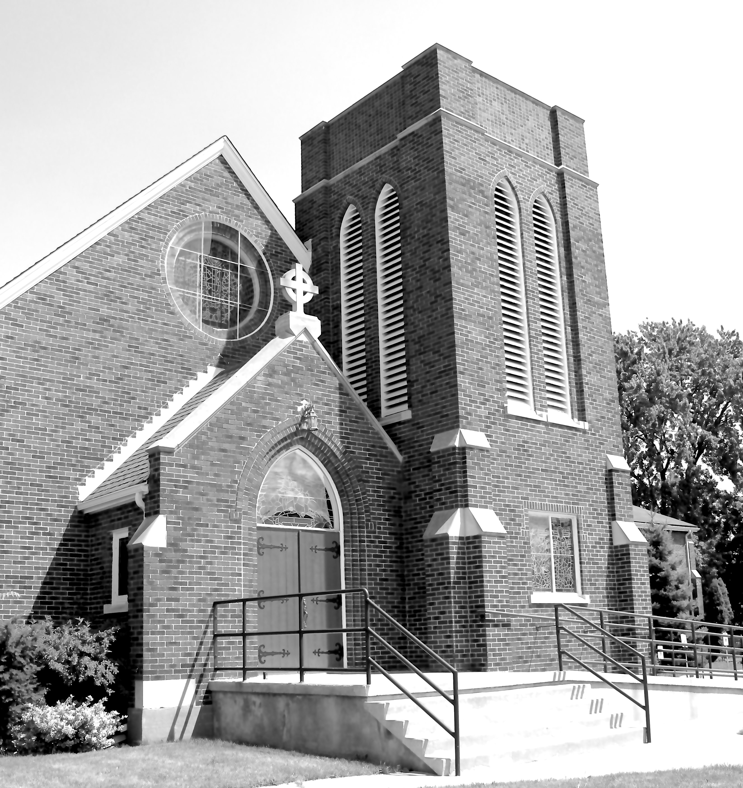
Canon Davis Memorial Church
380 Russell St. North, Sarnia, Ontario, N7T 6S6
(519) 344-9531 • http://www.canondavis.com

2nd SUNDAY OF ADVENT • December 5, 2021

Sermon

Baruch 5:1-9 or Malachi 3:1-4 • Luke 1:68-79 • Philippians 1:3-11 • Luke 3:1-6

There is often a sense of anticipation when a new government comes into power. Part of that anticipation revolves around all the problems left by the outgoing government; …and of course, how effective will the new party be in instituting various reforms.

The new government in power has to come up with programmes that are: clearly different; and clearly effective. Sometimes this is easy with solutions being obvious to everyone but the outgoing party. Other times, solutions evade even the brightest of people. What then can be done? Well, one can look for a partial solution and make it look like a total cure. That is exactly what we may see from time to time, in the political world. In fact, it is often used in the organizational world, in general.

I once heard a government leader explain this process by saying: If things are centralized, announce to the public that better service will soon be achieved by a major programme of decentralizing. Government service will be brought to the people; not the people to the government.

If, on the other hand, the government services structure is decentralized, announce major centralizing service reforms; so that greater efficiencies can be achieved, saving taxpayer money.

Both statements are correct. What is affirming to those affected is the notion that change will be for the better. When we encounter change in human government, things are far from perfect and many people can be cynical. When we step back, however, it is true that redirection can be life giving. That is wonderfully true when one adds God into the situation! The Bible uses different words; but still focuses on the human condition and the types of change that can be truly remedial.

In the readings we are using for our spiritual resources, today, God is telling people to not let one’s sense of guilt or shame become so weighty as to get in the way of picking oneself up and getting on in life. Repent, is one of the words often used. To repent is to take a new direction in life. God is inviting us in these readings to pick ourselves up and change our ways and get on in life with a Godly, positive difference — one of loving our neighbour and being willing to act on that love.

But the burden is not only to be carried by people. We can look forward to receiving the help of God as he makes the pathways straight, the mountains low, and the valleys filled, so they are not to get in our way as our life takes on new positive directions.

What is so important is that God’s people are called upon to help dramatize what is happening within them through the act of baptism. Both Jews and Gentiles are invited to throw off any nagging guilt and make a fresh start in how life is lived.

Multitudes of people turned out for John. The need was obviously great.

Through the work of John came the preparation for Jesus and his ministry of forgiveness and peace.

May the peace of God be ours through God’s Son this day and always.

We now pray in the words of Brother Roger of Taizé:

God of all loving, you call us to live lives rooted in you. Even were we to leave you, by your Holy Spirit you remain in us. And your presence in us is not for one moment only, but for all time. Amen.

Call the CDMC office Tuesday or Thursday mornings
to confirm that you plan to be at our next Sunday service.
(seating is limited) (519) 344-9531

——————————————————————————

You are invited to go each Sunday and/or Wednesday to the link:
tinyurl.com/StAlbans-CDMC

That is the link to St. Alban’s Anglican Church in Burnaby B.C. Follow the instructions. You will find links to the Rev’d Greg Jenkins officiating at an Anglican church service with children’s focus, church music, readings, prayers and a sermon.

If you are also interested in joining their weekly Bible Study, contact Rev. Greg at revgregjenkins@gmail.com He will be more than happy to be in touch about joining in with their group by ZOOM. I hope you will find these services help to deepen your faith.
tinyurl.com/StAlbans-CDMC

——————————————————————————-

