Canon Davis Memorial Church
Anglican Church of Canada
Fourth Sunday of Easter
30th of April, 2023

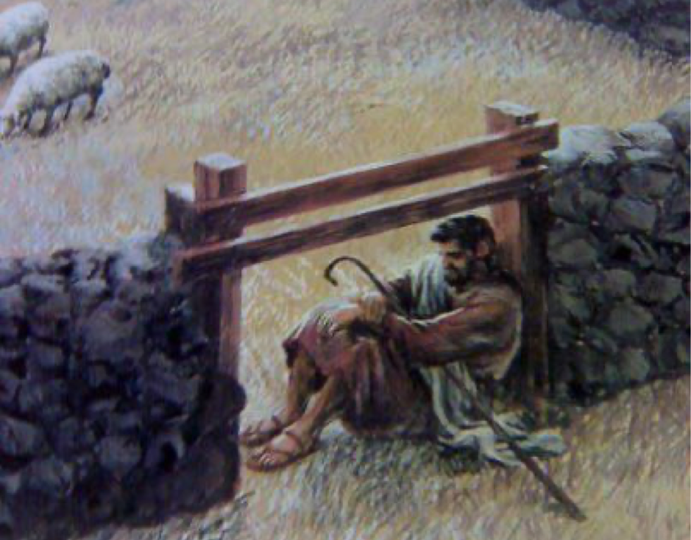

I am the gate

Officiant: Rev’d Paul Woolley
Reader: Ginny Schleihauf Organist: Dorothy Miller
Acolyte: Tom Brown Intercessor: Bill Graham
380 Russell St. North (at Maxwell St.), Sarnia, Ontario, N7T 6S6
Tel: (519) 344-9531 - Email: canondavis@gmail.com – http://www.canondavis.com

April 30, 2023— Fourth Sunday of Easter

THE GATHERING OF THE COMMUNITY

Gathering Hymn # 520 The King of Love My Shepherd Is
Greeting p. 185
Act of Praise Hymn # 365 Glory to God
Kyrie Eleison p. 186

Collect of the Day: O God of peace, who brought again from the dead our Lord Jesus Christ, that great shepherd of the sheep, by the blood of the eternal covenant, make us perfect in every good work to do your will, and work in us that which is well-pleasing in your sight; through Jesus Christ our Lord. Amen.

THE PROCLAMATION OF THE WORD

1st Reading Acts 2: 42-47
Hymn # 519 Psalm 23 The Lord’s My Shepherd
2nd Reading 1 Peter 2: 19-25

Gradual Hymn #484 In Christ There Is No East or West

Gospel John 10: 1-10

The Lord be with you.
And also with you.

The Holy Gospel of our Lord Jesus Christ according to St. John.
Glory to you, Lord Jesus Christ.

THE HOLY GOSPEL OF OUR LORD JESUS CHRIST
ACCORDING TO JOHN
Jesus said, "Very truly, I tell you, anyone who does not enter the sheepfold by the gate but climbs in by another way is a thief and a bandit. The one who enters by the gate is the shepherd of the sheep. The gatekeeper opens the gate for him, and the sheep hear his voice. He calls his own sheep by name and leads them out. When he has brought out all his own, he goes ahead of them, and the sheep follow him because they know his voice. They will not follow a stranger, but they will run from him because they do not know the voice of strangers." Jesus used this figure of speech with them, but they did not understand what he was saying to them. So again Jesus said to them, "Very truly, I tell you, I am the gate for the sheep. All who came before me are thieves and bandits; but the sheep did not listen to them. I am the gate. Whoever enters by me will be saved, and will come in and go out and find pasture. The thief comes only to steal and kill and destroy. I came that they may have life, and have it abundantly."

The Gospel of Christ.
Praise to you, Lord Jesus Christ
Sermon - Paul+

The Apostles’ Creed p. 189

Prayers of the People

As a flock in constant need, we behold our risen Christ and are quick to pray "Good Shepherd, hear us" As Christians in this community, there remains a disparate character in our traditions and practices. We ask that the gospel may not be obscured by our differences or thereby deplored.
Good Shepherd, hear us.

That we may discover the resurrected Christ in life's daily encounters with others, we pray:
Good Shepherd, hear us.
That terrorist activities may be curtailed and that extremist positions may give way to creative reconciliation. We pray:
Good Shepherd, hear us.

That those who have become part of Christ's fold through Holy Baptism may be drawn to continued inquiry, study, and demonstration of their faith. We pray:
Good Shepherd, hear us.

That those suffering in any way in mind body or spirit may receive healing and wholeness. Today we name: ____. We pray:
Good Shepherd, hear us.

As parents, grandparents, godparents and friends, we neglect the spiritual welfare of our children. We fail to articulate our faith in Christ verbally and in our walk. Forgive us, compassionate Lord, we pray:
Good Shepherd, hear us.

The glory alone is yours, O Lord. You seek us before we think of you. You receive us graciously, when we turn to you. You become the source of our encouragement. We thank and praise you for your care. Amen.

Prayer for a Renewed Church: Almighty God, give us a new vision of you, of your love, of your grace and power, and then, give us a new vision of what you would have us do as your Church in this nation and at this time, and an awareness that in the strength of your Spirit, we can do it to your glory. In Jesus’ name we pray. Amen.

Confession and Absolution p. 191
The Peace

Offertory Hymn # 70 Jesus, the Joy of Loving Hearts

Offertory Response Doxology (sung)
Praise God, from Whom all blessings flow.
Praise Him, all creatures here below.
Praise Him above, ye Heavenly Host.
Praise Father, Son, and Holy Ghost.

THE CELEBRATION OF THE HOLY EUCHARIST

Prayer over the Gifts: God of loving care, you spread before us the table of life, and give us the cup of salvation to drink. Keep us always in the fold of your Son Jesus Christ, our Saviour and our shepherd. Amen.

Eucharistic Prayer # 5 p. 204
The Lord’s Prayer (Sung) p. 211

Breaking of the Bread
Lord, we died with you on the cross.
Now we are raised to new life.

We were buried in your tomb.
Now we share in your resurrection.

Live in us, that we may live in you.

Communion

Prayer After Communion:

God of steadfast love, watch over the Church redeemed by the blood of your Son. May we who share in these holy mysteries come safely to your eternal kingdom, where there is one flock and one shepherd. We ask this in the name of Jesus Christ the risen Lord. Amen.

Solo Paul Woolley When I Survey the Wondrous Cross
Glory to God and Blessing p. 214

Announcements

Mission Hymn # 432 Jesus Call Us! O’er the Tumult

Go in peace to love and serve the Lord.
Thanks be to God. Alleluia!

Sung Benediction Go Now in Peace
(in the back of the blue Hymn book)

The Flowers on the Altar today are given to the glory of God, by Sally and Reverend Ray Jenkins in memory of our parents, Marion and Manley Samson, and Doris and Newton Jenkins. They are also in memory of Aunt Alice Jenkins.

Please enter names in the Intercessions Book each week to be read in the service.

__________________________________

News and Events

- Please send all announcements for the bulletin to Karen by 11:00 a.m. Tuesday of each week. Call: 519-344-9531 or E-mail: canondavis@gmail.com.

- If you would like a home visit with Communion or know of someone who would, please let Rev. Ray know as he and/or a Lay Visitor will be available in the coming weeks.

- Please join us for Coffee Hour after service for a time of fellowship in the parish hall.

- They're Here!. The Ladies Guild is excited to announce their pies are ready to be sold. Turkey or Beef $5.50 each Shepherd's Pie $6.00 each. To place your order call the office at 519-344-9531.

Upcoming Events:

- Special Vestry--Sunday, May 14, 2023
We have an individual put forth their name for the position of Deputy Rector's Warden. This is the 1st of 3 consecutive notices. On Sunday, May 14, 2023 we will be holding a Special Vestry after church in the Parish Hall to complete this election. Please plan on attending. God Bless Rev Ray Jenkins, John W. Hayter, Rector's Warden and Sheree Lynn Hayter, People's Warden.

Reminders

May 14 Special Vestry Meeting after service – Parish Hall
May 31 Parish Council Meeting – Boardroom 10:00 a.m.

