Canon Davis Memorial Church
Anglican Church of Canada
Sunday, September 18, 2022 – Fifteenth Sunday after Epiphany

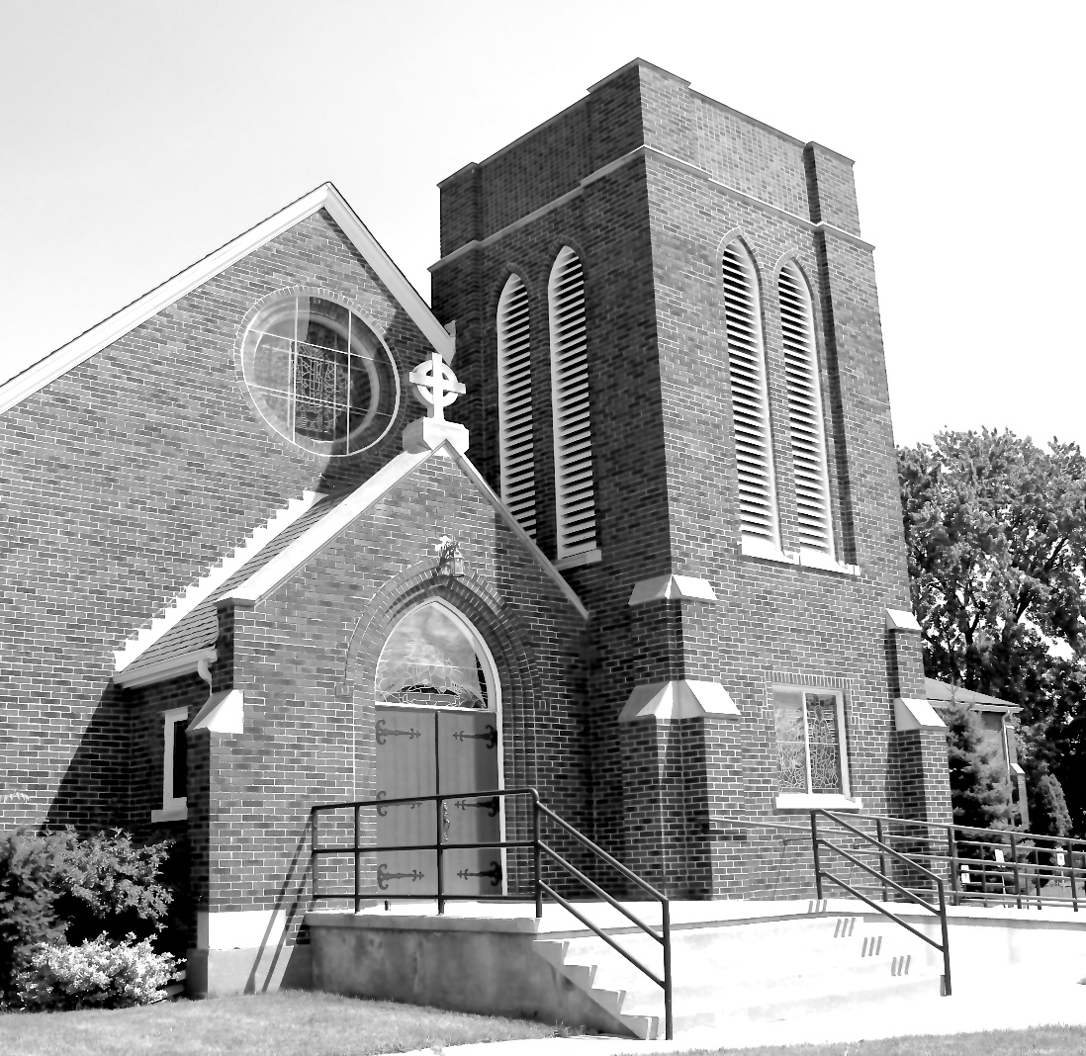

We come and worship God.
We go our way with souls nourished.
Worship Service: Sunday 9:30 a.m.
380 Russell St. North (at Maxwell St.), Sarnia, Ontario, N7T 6S6
(519) 344-9531 - http://www.canondavis.com – http://www.canon davis.com
Canon Davis Memorial Church
Anglican Church of Canada
Sunday, September 18, 2022 – Fifteenth Sunday after Pentecost
9:30 a.m. Holy Eucharist
Officiant—Rev. Ray Jenkins — Assisted By — Tom Brown
Organist—Dorothy Miller —Prayers of the People — Elaine Hayter

THE GATHERING OF THE COMMUNITY

Opening Hymn #415 All Things Bright and Beautiful

The grace of our Lord Jesus Christ, and the love of God, and the fellowship of the Holy Spirit, be with you all.
And also with you.

Almighty God, to you all hearts are open, all desires known, and from you no secrets are hidden. Cleanse the thoughts of our hearts by the inspiration of your Holy Spirit, that we may perfectly love you, and worthily magnify your holy name; through Christ our Lord. Amen.

Glory to God in the highest, and peace to his people on earth.
Lord God, heavenly king, almighty God and Father, we worship you, we give you thanks, we praise you for your glory.

Lord Jesus Christ, only Son of the Father, Lord God, Lamb of God, you take away the sin of the world: have mercy on us; you are seated at the right hand of the Father: receive our prayer.

For you alone are the Holy One, you alone are the Lord, you alone are the Most High, Jesus Christ, with the Holy Spirit, in the glory of God the Father. Amen.

Lord, have mercy. Christ, have mercy. Lord, have mercy.

COLLECT OF THE DAY
Almighty God, you have created the heavens and the earth, and ourselves in your image. Teach us to discern your hand in all your works and to serve you with reverence and thanksgiving, through Jesus Christ our Lord, who is alive and reigns with you and the Holy Spirit, one God, now and for ever.

THE PROCLAMATION OF THE WORD

1st Reading: Jeremiah 8: 18, 9:1
The Word of the Lord.
Thanks be to God.

Psalm 79: 1-9 (to be read responsively)
O God, the heathen have come into your inheritance, they have profaned your holy temple, they have made Jerusalem a heap of rubble. They have given the bodies of your servants as food for the birds of the air, and the flesh of your faithful ones to the beasts of the field.

They have shed their blood like water on every side of Jerusalem, and there was no one to bury them.

We have become a reproach to our neighbours, an object of scorn and derision to those around us.

How long will you be angry, O Lord? will your fury blaze like fire for ever? Pour out your wrath upon the heathen who have not known you and upon the kingdoms that have not called upon your name.

For they have devoured Jacob and made his dwelling a ruin. Remember not our past sins, let your compassion be swift to meet us, for we have been brought very low. Help us, O God our Saviour, for the glory of your name, deliver us and forgive us our sins, for your name’s sake. In you, O Lord, have I taken refuge, let me never be ashamed.

2nd reading Timothy 2: 1-7
The Word of the Lord
Thanks be to God.

Gospel Luke 16: 1-13

THE HOLY GOSPEL OF OUR LORD JESUS CHRIST
ACCORDING TO LUKE

Then Jesus said to the disciples, “There was a rich man who had a manager, and charges were brought to him that this man was squandering his property. So he summoned him and said to him, ‘What is this that I hear about you? Give me an accounting of your management, because you cannot be my manager any longer.’ Then the manager said to himself, ‘What will I do, now that my master is taking the position away from me? I am not strong enough to dig, and I am ashamed to beg. I have decided what to do so that, when I am dismissed as manager, people may welcome me into their homes.’ So summoning his master’s debtors one by one, he asked the first, ‘How much do you owe my master?’ He answered, ‘A hundred jugs of olive oil.’ He said to him, ‘Take your bill, sit down quickly, and make it fifty.’ Then he asked another, ‘And how much do you owe?’ He replied, ‘A hundred containers of wheat.’ He said to him, ‘Take your bill and make it eighty.’ And his master commended the dishonest manager because he had acted shrewdly; for the children of this age are more shrewd in dealing with their own generation than are the children of light. And I tell you, make friends for yourselves by means of dishonest wealth so that when it is gone, they may welcome you into the eternal homes. Whoever is faithful in a very little is faithful also in much; and whoever is dishonest in a very little is dishonest also in much. If then you have not been faithful with the dishonest wealth, who will entrust to you the true riches? And if you have not been faithful with what belongs to another, who will give you what is your own? No slave can serve two masters; for a slave will either hate the one and love the other, or be devoted to the one and despise the other. You cannot serve God and wealth.”
The Gospel of Christ.
Praise to you Lord Jesus Christ.
Sermon

Sermon Hymn #435 Take My Life, and Let It Be

The Apostles’ Creed: Let us confess the faith of our baptism, as we say,
I believe in God, the Father almighty, creator of heaven and earth. I believe in Jesus Christ, his only Son, our Lord. He was conceived by the power of the Holy Spirit and born of the Virgin Mary. He suffered under Pontius Pilate, was crucified, died, and was buried. He descended to the dead. On the third day he rose again. He ascended into heaven, and is seated at the right hand of the Father. He will come again to judge the living and the dead. I believe in the Holy Spirit, the holy catholic Church, the communion of saints, the forgiveness of sins, the resurrection of the body, and the life everlasting. Amen.

Prayers of the People #9
(Let us pray to the Lord, saying, “Lord, have mercy.”)

Let us ask the Lord for a day of fulfilment and peace.
Lord, have mercy.

Let us ask the Lord to teach us to love others as he has loved us.
Lord, have mercy.

Let us ask the Lord for peace and justice in the world.
Lord, have mercy.

Let us ask the Lord to strengthen and relieve those who are in need.
Lord, have mercy.

Let us ask the Lord to renew the Church through the power of his life-giving Spirit.
Lord, have mercy.

PRAYER FOR A RENEWED CHURCH: Almighty God, give us a new vision of you, of your love, of your grace and power, and then, give us a new vision of what you would have us do as your Church in this nation and at this time, and an awareness that in the strength of your Spirit, we can do it to your glory. In Jesus’ name we pray. Amen.

Confession and Absolution: Dear friends in Christ, God is steadfast in love and infinite in mercy; he welcomes sinners and invites them to his table. Let us confess our sins, confident in God’s forgiveness.

The Confession: Most merciful God,
we confess that we have sinned against you in thought, word, and deed, by what we have done, and by what we have left undone. We have not loved you with our whole heart; we have not loved our neighbours as ourselves. We are truly sorry and we humbly repent. For the sake of your Son Jesus Christ, have mercy on us and forgive us, that we may delight in your will, and walk in your ways, to the glory of your name. Amen.

Absolution: Almighty God have mercy upon you, pardon and deliver you from all your sins, confirm and strengthen you in all goodness, and keep you in eternal life; through Jesus Christ our Lord. Amen.

The Peace
Gentle peace…
Flows freely
Encircles fully
Refreshes gently
Comforts warmly
Reassures softly
Forgives easily
Fulfils entirely
Gentle peace…

The peace of the Lord be always with you.
And also with you.

Offertory Hymn #429 For the Beauty of the Earth

Offertory Response Doxology

PRAYER OVER THE GIFTS: God of power, the glory of your works fills us with wonder and awe. Accept our offering this day, and help us to live in peace and harmony with all your creation, for the sake of Jesus Christ our Lord.

Eucharistic Prayer # 5
The Lord be with you.
And also with you.

Lift up your hearts.
We lift them to the Lord.

Let us give thanks to the Lord our God.
It is right to give our thanks and praise.

We give you thanks and praise, almighty God, for the gift of a world full of wonder, and for our life which comes from you. By your power you sustain the universe.
Glory to you for ever and ever.

You created us to love you with all our heart, and to love each other as ourselves, but we rebel against you by the evil that we do.

In Jesus, your son, you bring healing to our world and gather us into one great family. Therefore, with all who serve you on earth and in heaven, we praise your wonderful name, as we say,

Holy, holy, holy Lord,
God of power and might,
heaven and earth are full of your glory.
Hosanna in the highest.

Blessed is he who comes in the name of the Lord. Hosanna in the highest.
We give you thanks and praise, loving Father, because in sending Jesus, your Son, to us you showed us how much you love us. He cares for the poor and the hungry. He suffers with the sick and the rejected.

Betrayed and forsaken, he did not strike back but overcame hatred with love.

On the cross he defeated the power of sin and death. By raising him from the dead you show us the power of your love to bring new life to all your people.
Glory to you for ever and ever.

On the night before he gave up his life for us, Jesus, at supper with his friends, took bread, gave thanks to you, broke it, and gave it to them, saying, “Take this, all of you, and eat it: this is my body which is given for you.”

After supper, Jesus took the cup of wine, said the blessing, gave it to his friends, and said, “Drink this, all of you: this is the cup of my blood, the blood of the new and eternal covenant, which is shed for you and for many, so that sins may be forgiven. Do this in memory of me.”
Glory to you for ever and ever.

Gracious God, with this bread and wine we celebrate the death and resurrection of Jesus, and we offer ourselves to you in him.

Send your Holy Spirit on us and on these gifts, that we may know the presence of Jesus in the breaking of bread, and share in the life of the family of your children.
Glory to you for ever and ever.

Father, you call us to be your servants; fill us with the courage and love of Jesus, that all the world may gather in joy at the table of your kingdom.

We sing your praise, almighty Father, through Jesus, our Lord, in the power of the Holy Spirit, now and for ever.
Glory to you for ever and ever. Amen.

The Lord’s Prayer: Our Father, who art in heaven, hallowed be thy name, thy kingdom come, thy will be done, on earth as it is in heaven. Give us this day our daily bread. And forgive us our trespasses, as we forgive those who trespass against us. And lead us not into temptation, but deliver us from evil. For thine is the kingdom, the power, and the glory, for ever and ever. Amen.

Breaking of the Bread:
We break this bread to share in the body of Christ.
We, being many, are one body, for we all share in the one bread.

The Communion
The gifts of God for the people of God.
Thanks be to God.

PRAYER AFTER COMMUNION: Ruler of the universe, all creation years for its fulfilment in your Son. May we who have shared in holy things grow into maturity in him. This we ask in the name of the same Jesus Christ our Lord.

Doxology
Glory to God, Whose power, working in us, can do infinitely more than we can ask or imagine. Glory to God from generation to generation, in the Church and in Christ Jesus, for ever and ever. Amen.

Blessing
The peace of God which passes all understanding, keep your hearts and minds in the knowledge and love of God and of his son Jesus Christ and the blessing of God Almighty the Father, the Son and the Holy Spirit be with you and those you love for ever more. Amen.

Announcements
Recessional Hymn # 486 Love Divine, All Loves Excelling
Benediction Song Go Now in Peace
(found in the back of the blue hymn book)

The flowers on the Altar today are given to the Glory of God and in loving memory of Margaret Louise and Glen Hayter, a dear and loving Mother and Father, Grandma, and Grandpa, and Great-Grammie and Great Grandpooh, and loved ones a give with love from Sheree Lynn, Mike, Jason, and Lucy.

Please enter names in the Intercessions Book each week to be read in the service.

NEWS AND EVENTS

- Please send all announcements for the bulletin to Karen by 11:00 a.m. Tuesday of each week. E-mail: canondavis@gmail.com or call 519-344-9531
- If you would like a home visit with Communion or know of someone who would, please let Rev. Ray know as he and/or a Lay Visitor will be available in the coming weeks.
- Please join us for Coffee Hour after service for a time of fellowship in the parish hall.
- Happy Birthday and best wishes to Joanna Hayter, Camryn Carroll and Isla Goulding from all of us at Canon Davis Memorial.
- CDM will celebrate the Harvest Home Freewill Breakfast on October 2nd. Please plan to join us.
- The Chancel Guild is asking for cash donations to purchase fruit and vegetables to decorate the Church for Harvest Thanksgiving. All edible food will be donated to the Inn of the Good Shepherd. Please contact Seonaid Laidlaw for more information.

Upcoming Events:

18 Sept Please note that The Christian Music Café has been postponed
until October.

21 Sept Last Chance! Please join us for CDM’s famous and delicious “Fish Dinner”. Cost $20.00 Adults. Call: 519-344-9531 to reserve.

21 Sept Monthly Chancel Guild Meeting at 10:00 a.m. in the church.

28 Sept Parish Council Meeting at 10:00 a.m. in the boardroom.

