Canon Davis Memorial Church
Anglican Church of Canada
Sunday, July 30, 2023 – Ninth Sunday after Pentecost

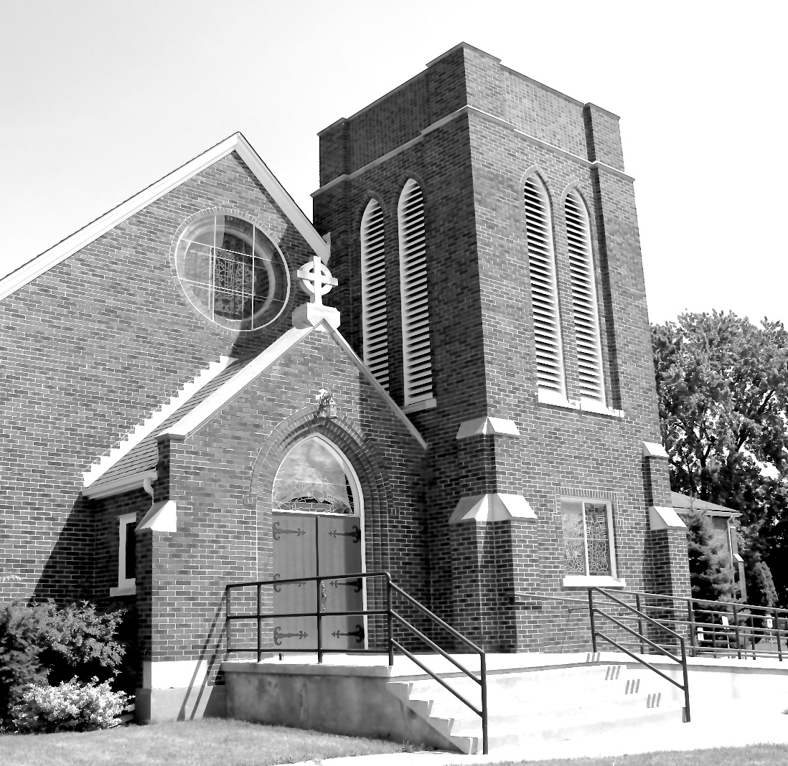

Worship Service: Sunday 9:30 a.m.
Officiant—Rev’d Jon Forbes — Assisted By — Bill Graham
Organist—Dorothy Miller
380 Russell St. North (at Maxwell St.), Sarnia, Ontario, N7T 6S6
(519) 344-9531 - http://www.canondavis.com – canondavis@gmail.com
Prelude

Announcements

THE GATHERING OF THE COMMUNITY

Sentence
Lord, to whom shall we go? You have the words of eternal life.
John 6: 68

Opening Hymn #378 Crown Him with Many Crowns

The grace of our Lord Jesus Christ, and the love of God, and the fellowship of the Holy Spirit, be with you all.
And also with you.

Almighty God, to you all hearts are open, all desires known, and from you no secrets are hidden. Cleanse the thoughts of our hearts by the inspiration of your Holy Spirit, that we may perfectly love you, and worthily magnify your holy name; through Christ our Lord. Amen.

Glory to God in the highest, and peace to his people on earth.
Lord God, heavenly king, almighty God and Father, we worship you, we give you thanks, we praise you for your glory.

Lord Jesus Christ, only Son of the Father, Lord God, Lamb of God, you take away the sin of the world: have mercy on us; you are seated at the right hand of the Father: receive our prayer.

For you alone are the Holy One, you alone are the Lord, you alone are the Most High, Jesus Christ, with the Holy Spirit, in the glory of God the Father. Amen.

Lord, have mercy.
Christ, have mercy.
Lord, have mercy.
Collect of the Day
O God, the protector of all who trust in you, without whom nothing is strong, nothing is holy, increase and multiply upon us your mercy, that with you as our ruler and guide, we may so pass through things temporal, that we lose not the things eternal; through Jesus Christ our Lord, who lives and reigns with you and the Holy Spirit, one God, for ever and ever.

THE PROCLAMATION OF THE WORD

1st Reading: Genesis 29: 15-28
The Word of the Lord.
Thanks be to God.

Psalm 105: 1-11, 45c (to be read responsively)
Give thanks to the Lord and call upon his name; make known his deeds among the peoples.
Sing to him, sing praises to him, and speak of all his marvellous works.

Glory in his holy name; let the hearts of those who seek the Lord rejoice. Search for the Lord and his strength; continually seek his face. Remember the marvels he has done, his wonders and the judgements of his mouth,

O offspring of Abraham his servant, O children of Jacob his chosen.
He is the Lord our God; his judgements prevail in all the world.
He has always been mindful of his covenant, the promise he made for a thousand generations:
The covenant he made with Abraham, the oath that he swore to Isaac, which he established as a statute for Jacob, an everlasting covenant for Israel, saying, "To you will I give the land of Canaan to be your allotted inheritance."
Hallelujah!
2nd Reading: Romans 8: 26-39
The Word of the Lord
Thanks be to God.

Gradual Hymn # 461 Stand Up, Stand Up for Jesus

Gospel

The Holy Gospel of our Lord Jesus Christ according to Matthew
Glory to you, Lord Jesus Christ.

Matthew 13: 31-33; 44-52

The Gospel of Christ.
Praise to you, Lord Jesus Christ.

Sermon

The Apostles’ Creed:
Let us confess the faith of our baptism, as we say,
I believe in God, the Father almighty, creator of heaven and earth. I believe in Jesus Christ, his only Son, our Lord. He was conceived by the power of the Holy Spirit and born of the Virgin Mary. He suffered under Pontius Pilate, was crucified, died, and was buried. He descended to the dead. On the third day he rose again. He ascended into heaven, and is seated at the right hand of the Father. He will come again to judge the living and the dead. I believe in the Holy Spirit, the holy catholic Church, the communion of saints, the forgiveness of sins, the resurrection of the body, and the life everlasting. Amen.

Prayers of the People
(In peace let us pray to the Lord, saying, “Lord, have mercy.”)

For the peace from on high and for our salvation, let us pray to the Lord.
Lord, have mercy.
For the peace of the whole world, for the welfare of the holy Church of God, and for the unity of all, let us pray to the Lord.
Lord, have mercy.

For our bishops, and for all the clergy and people, let us pray to the Lord.
Lord, have mercy.

For Charles our King, for the leaders of the nations, and for all authority, let us pray to the Lord.
Lord, have mercy.

For Sarnia, for every city and community, and for those who live in them in faith, let us pray to the Lord.
Lord, have mercy.

For good weather, and for abundant harvests for all to share, let us pray to the Lord.
Lord, have mercy.

For those who travel by land, water, or air, for the sick and the suffering (especially), for prisoners and captives, and for their safety, health, and salvation, let us pray to the Lord.
Lord, have mercy.

For our deliverance from all affliction, strife, and need, let us pray to the Lord.
Lord, have mercy.

For the absolution and remission of our sins and offences, let us pray to the Lord.
Lord, have mercy.

For all who have died (especially ), let us pray to the Lord.
Lord, have mercy.
Remembering (… and) all the saints, we commit ourselves, one another, and our whole life to Christ our God.
To you, O Lord.

Almighty God, you have given us grace at this time with one accord to make our common supplications to you, and you have promised through your well-beloved Son that when two or three are gathered together you will hear their requests. Fulfil now our desires and petitions, as may be best for us, granting us in this world knowledge of your truth, and in the age to come eternal life; for you, Father, are good and loving, and we glorify you through your Son Jesus Christ our Lord, in the Holy Spirit, now and for ever. Amen.

In our parish cycle of prayer, we pray for…

Prayer for a Renewed Church
Almighty God, give us a new vision of you, of your love, of your grace and power, and then, give us a new vision of what you would have us do as your Church in this nation and at this time, and an awareness that in the strength of your Spirit, we can do it to your glory. In Jesus’ name we pray. Amen.

Confession and Absolution: Dear friends in Christ, God is steadfast in love and infinite in mercy; he welcomes sinners and invites them to his table. Let us confess our sins, confident in God’s forgiveness.

The Confession: Most merciful God,
we confess that we have sinned against you in thought, word, and deed, by what we have done, and by what we have left undone. We have not loved you with our whole heart; we have not loved our neighbours as ourselves. We are truly sorry and we humbly repent. For the sake of your Son Jesus Christ, have mercy on us and forgive us, that we may delight in your will, and walk in your ways, to the glory of your name. Amen.

Absolution: Almighty God have mercy upon you, pardon and deliver you from all your sins, confirm and strengthen you in all goodness, and keep you in eternal life; through Jesus Christ our Lord. Amen.

The Peace
The peace of the Lord be always with you.
And also with you.

Offertory Hymn # 628 O Love, How Deep, How Broad, How High

Prayer over the Gifts
God of grace, accept all we offer you this day, as we look toward the glory you have promised. This we ask in the name of Jesus Christ our Lord.

Eucharist Prayer #4
The Lord be with you.
And also with you.

Lift up your hearts.
We lift them to the Lord.

Let us give thanks to the Lord our God.
It is right to give our thanks and praise.
It is right to give you thanks and praise, O Lord, our God, sustainer of the universe, you are worthy of glory and praise.
Glory to you for ever and ever.

At your command all things came to be: the vast expanse of interstellar space, galaxies, suns, the planets in their courses, and this fragile earth, our island home; by your will they were created and have their being.
Glory to you for ever and ever.

From the primal elements you brought forth the human race, and blessed us with memory, reason, and skill; you made us the stewards of creation.
Glory to you for ever and ever.

But we turn against you, and betray your trust; and we turn against one another. Again and again you call us to return. Through the prophets and sages you reveal your righteous law. In the fullness of time you sent your Son, born of a woman, to be our Saviour. He was wounded for our transgressions, and bruised for our iniquities. By his death he opened to us the way of freedom and peace.
Glory to you for ever and ever.

Therefore we praise you, joining with the heavenly chorus, with prophets, apostles, and martyrs, and with those in every generation who have looked to you in hope, to proclaim with them your glory, in their unending hymn:

Holy, holy, holy Lord,
God of power and might,
heaven and earth are full of your glory.
Hosanna in the highest.
Blessed is he who comes in the name of the Lord.
Hosanna in the highest.
Blessed are you, Lord our God, for sending us Jesus, the Christ, who on the night he was handed over to suffering and death, took bread, said the blessing, broke the bread, gave it to his friends, and said, “Take this, and eat it: this is my body which is given for you. Do this for the remembrance of me.”

In the same way, after supper, he took the cup of wine; he gave you thanks, and said, “Drink this, all of you: this is my blood of the new covenant, which is shed for you and for many for the forgiveness of sins.
Whenever you drink it, do this for the remembrance of me.”
Glory to you for ever and ever.

The Lord’s Prayer: Our Father, who art in heaven, hallowed be thy name, thy kingdom come, thy will be done, on earth as it is in heaven. Give us this day our daily bread. And forgive us our trespasses, as we forgive those who trespass against us. And lead us not into temptation, but deliver us from evil. For thine is the kingdom, the power, and the glory, for ever and ever. Amen.

Breaking of the Bread:
“I am the bread which has come down from heaven,” says the Lord.
Give us this bread for ever.

“I am the vine, you are the branches.”
May we dwell in him, as he lives in us.

The Communion
The gifts of God for the people of God.
Thanks be to God.

Prayer after Communion
God of grace, we have received the memorial of the death and resurrection of your Son. May your love, poured into us,
bring us to your promises. We ask this in the name of our Redeemer Jesus Christ.
Doxology
Glory to God, Whose power, working in us, can do infinitely more than we can ask or imagine. Glory to God from generation to generation, in the Church and in Christ Jesus, for ever and ever. Amen.

Recessional Hymn # 210 Yours Be the Glory, Risen, Conquering Son

Blessing
The peace of God which passes all understanding, keep your hearts and minds in the knowledge and love of God and of his son Jesus Christ and the blessing of God Almighty the Father, the Son and the Holy Spirit be with you and those you love for ever more. Amen.

Benediction Song Go Now in Peace
(found in the back of the blue hymn book)
Dismissal
The flowers on the Altar today are given to the Glory of God from Sally and Rev Ray Jenkins in memory of our parents, Marion and Manley Samson, and Doris and Newton Jenkins and Aunt Alice Jenkins
.

Please enter names in the Intercessions Book each week to be read in the service.
CANON DAVIS MEMORIAL CHURCH
UPDATE AS OF JUNE 30, 2023

The members of Canon Davis Memorial have had a very busy first half of the year. We have all been fundraising for ACW, pie making and we held two delicious luncheons and a Strawberry Social. The Sew Day group was busy with their monthly luncheons and activities and the Ways & Means with their monthly dinners and raffles.

We have had the continued support from our tenants with their rental incomes. Through our current giving’s we have reached 49% of our goal.

Fundraising in our community for London Rd School Playground Equipment has been successful. Through monthly Meat Raffles so far $1680.00 has been raised.

CDM is sending two youth to Camp Huron from London Rd School. The Lambton Deanery, CDM's Ladies Guild and CDM have covered the cost of camp for these two youth.

Everyone has worked very hard these past six months to support their church. As of the end of June we have brought in a total of $55,700.93.
We thank you!

Our expenses unfortunately have increased due to a huge increase to our annual insurance costs, major maintenance for the organ repairs and the boiler system. Along with our monthly expenses in Repair & Maintenance and Utilities which have increased as well. Due to increasing cost, it has left us with a total of $67,258.24. This leaves us with a deficit of ($11,557.31). With all that said, we feel we remain in a good financial position.

On a lighter note, we have had new members join CDM. We have celebrated the retirement of Rev Ray Jenkins and the Installation of a new licensed lay reader, Ginny Schleihauf. We have also been able to fill the position of Deputy Rector's Warden which had been vacant for a couple of years with Ginny Schleihauf. We have had two baptisms, the great grandchildren of Doug and Shirley Frew. We also had a wedding at CDM between Wendy Vicary and Greg Baker.

Last but far from least, CDM has been blessed with our new minister, Rev'd Jon Forbes. It has been a wonderful two months already. Parish Council is so pleased with all the great comments from parishioners. Jon is truly a joyous addition to our family. Let us continue to move forward as a loving, caring and hospitable church in Sarnia.

God Bless 🙏
Carol Spence, John Hayter and
Sheree Lynn Hayter

NEWS AND EVENTS

- Please send all announcements for the bulletin to Karen by 11:00 a.m. Tuesday of each week. Call 519-344-9531 or E-mail: canondavis@gmail.com.
- If you would like a home visit with Communion, please contact the office as a Lay Visitor will be available in the coming weeks.
- Please join us for Coffee Hour after service for a time of fellowship in the
parish hall.

Upcoming Events:

Reminders

15 Sept 7:00 p.m. Free Concert All Saints Anglican Church: An
Evening of Music in Memory of Eleanor Vargo.

