Third Sunday of Advent
12th December 2021

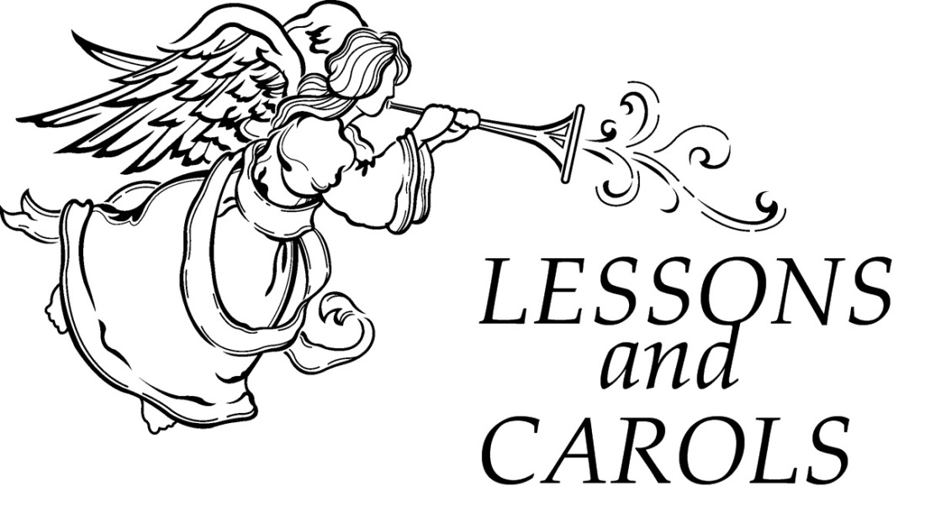

Canon Davis Memorial Church

Anglican Church of Canada
We come and worship God.
We go our way with souls nourished.
Worship Service: Sunday 9:30 a.m.
Email: canondavis@gmail.com Website: www.canondavis.com
380 Russell St. North (at Maxwell St.), Sarnia, Ontario, N7T 6S6 519-344-9531
Advent Festival of Lessons and Carols

Opening Carol #123 Once in Royal David’s City

Lighting of the Advent Wreath: the Candle of Joy

THIRD SUNDAY OF ADVENT — Candle of Joy

Leader: We have lit the first two candles, one for hope and
one for peace. Today we light the third candle, the candle of joy. This should be the easy one, because joy is all around us — in the children, the lights, the music, the gathering together. But how often do we let our preparations - or our memories - push joy to the side? Joy is like an underground spring that wells up within us, but joy is also a choice, an attitude. Like a muscle, it needs to be exercised. So today we open ourselves to joy, trusting that God has already planted it in us. All we need to do is give it care and offer it to share.

All: Loving God, we open ourselves to you, trusting that this is how you made us: you created us for joy-filled hearts and lives. Show us the creative power of hope. Teach us the peace that comes from justice. Fill us with the kind of joy that cannot be contained, but must be shared. Prepare our hearts to be transformed by you, That we may walk in the light of Christ. Amen.
Leader: Rejoice in God always, and again I say, rejoice For God
has created you with the capacity for joy.

All: We will find what makes us joyful, and make that our
gift to the world.

Leader: Trust in God’s good will for all of creation and open yourself to God’s gentle, transforming love.

All: We will welcome new possibilities in our lives.
We will offer ourselves to God’s goodness.
We will go forth in hope, and peace, and joy.

(Three candles are lit)
All sing: “A Candle is Burning”
Words by Sandra Dean, 1986. tune by James Murray 1887 (public domain)

A candle is burning, a candle of joy,
A candle to welcome brave Mary’s new boy.
Our hearts fill with wonder, and eyes light and glow
As joy brightens winter like sunshine on snow.

Bidding Prayer

Blessed Lord, who has caused all holy Scriptures to be written for our learning,: Grant that we may in such wise hear them, read, mark, learn and inwardly digest them, that by patience and comfort of thy Holy Word, we may embrace and ever hold fast the blessed hope of everlasting life, which thou has given us in our Saviour Jesus Christ.

The Gathering of the Community

First Lesson John 1:1-5

In the beginning was the Word, and the Word was with God, and the Word was God.

Carol #89 O Come, O Come, Emmanuel

Second Lesson Genesis 3:8-15

Now the Lord said to Abram, go from your country and your kindred and your father’s house to the land that I will show you.

Carol #109 When the King Shall Come Again

Third Lesson Isaiah 9:2, 6-9

The people who walked in darkness have seen a great light; those who lived in a land of deep darkness on them light has shined.

Carol #140, It Came Upon the Midnight Clear

Fourth Lesson Isaiah 11:1-9

The spirit of the Lord shall rest on him, the spirit of wisdom and understanding, the spirit of counsel and might, the spirit of knowledge and the fear of the Lord.

Carol #137 What Child is This
Fifth Lesson Matthew 1:18-25

Now the birth of Jesus the Messiah took place in this way.

Carol #153 Good Christians All, Rejoice

Sixth Lesson Luke 2:1-7

In those days a decree went out from Emperor Augustus that all the world be registered.

Carol #120, O Little Town of Bethlehem

Seventh Lesson John 1:6-18

No one has ever seen God. It is God the only son who is close to the Father’s heart, who has made him known.

Carol #118 O Come All Ye Faithful

Closing Prayers

O Wisdom, from the mouth of the Most High, you reign over all things to the ends of the earth: come and teach us how to live.

Response: Lord Jesus, come soon!

O Lord, and head of the house of Israel, you appeared to Moses in the fire of the burning bush and you gave the law on Sinai: come with outstretched arm and ransom us.

Response: Lord Jesus, come soon!

O Branch of Jesse, standing as a sign among the nations, all kings will keep silence before you and all peoples will summon you to their aid: come, set us free and delay no more.

Response: Lord Jesus, come soon!

O Key of David and scepter of the house of Israel, you open and none can shut; you shut and none can open: come and free the captives from prison.

Response: Lord Jesus, come soon!

O Morning Star, splendor of the light eternal and bright Sun of righteousness: come and enlighten all who dwell in darkness and in the shadow of death.

Response: Lord Jesus, come soon!

O King of the nations, you alone can fulfil their desires: Cornerstone, you make opposing nations one: come and save the creature you fashioned from clay.

Response: Lord Jesus, come soon!

O Emmanuel, hope of the nations and their Saviour: come and save us, Lord our God.

Response: Lord Jesus, come soon!
Collect for the Third Sunday of Advent:

God of Power and Mercy, you call us once again to celebrate the coming of your Son. Remove those things which hinder love of you, that when He comes, he may find us waiting in awe and wonder for him who lives and reigns with you and the Holy Spirit, one God, now and forever.

Announcements.

Recessional Carol #138 Hark! The Herald Angels Sing

Dismissal

Today, in lieu of memorial flowers from Ruth and Charlie Lavigne and in thanksgiving for blessings received, we remember loved ones.

The Christmas Wreath on the front of the pulpit is given to the Glory of God and in loving memory of Wendy Heasman and family members and friends at this blessed Christmas Season, a gift of Reg and family.

MERRY CHRISTMAS!

News and Events

- Please send all announcements for the bulletin to Karen by 11:00 a.m. Tuesday of each week. Call: 519-344-9531 or email:canondavis@gmail.com

- To register your attendance at Sunday services please contact the office at 519-344-9531. Thank you. Please note: CDM will not have a service on Sunday December 26, 2021.

- Please join us after the service for a time of fellowship in the parish hall.

- Christmas Poinsettias: If you wish to make a donation to the Christmas Poinsettias, please put your donation in an envelope marked “Poinsettias” and include your name, envelope number, and the amount. Please call Karen if you would like your gift acknowledged in the Church bulletins by December 12.

- Our 2021 Drive-in and Take-out Christmas Bazaar was a huge success, considering it was the first time that you didn’t enter the parish hall to attend, and were required to pre-order and drive up to get your purchase. It all went very smoothly and resulted in a net profit of $1,969.00 after expenses. Our success was due to the amazing support and hard work of the volunteers who not only made the turkey pies, butter tarts and soups, but all of those who contributed to bagging, packaging, and delivering the orders to the cars.

- A very special thank you to Karen, Marion, Joan, Carol, Bob, Gerry, Sharon, Sheree, Mike, Phyllis, Bill G., Nancy, MaryJane, Bill, Ginny, Tom, Brenda, Elaine, Sara, Niki and above all John. We couldn’t have done it without you.

Upcoming Events:

Reminders:
Dec 15 Parish Council Meeting 10:00 a.m. Parish Hall
Dec 24 – Christmas Eve service will be held at 5:00 p.m. Please remember to call to register.

