Sunday June 11, 2023—Second Sunday after Pentecost
9:30 a.m. Morning Prayer (BCP) p.4

Opening Hymn # 432 Jesus Calls Us! O’er the Tumult
Greeting

THE GATHERING OF THE COMMUNITY
Exhortation p. 4
General Confession p. 4
Absolution p. 5
The Lord’s Prayer p. 5
Responses p. 6
Venite p. 6

THE PROCLAMATION OF THE WORD
1st Reading Genesis 12: 1-9
Psalm 33: 1-12 (responsively alternate verses) BCP p. 367-368
2nd Reading Romans 4: 13-25
Gospel Matthew 9: 9-13, 18-26

Benedictus p. 9
The Apostles’ Creed p. 10
Versicles p. 10
The Lord’s Prayer p. 11
Responses p. 11

Collect of the Day O God, you have assured the human family of eternal life through Jesus Christ our Saviour. Deliver us from the death of sin and raise us to new life in him, who lives and reigns with you and the Holy Spirit, one God, now and for ever. Amen.
Collect for Peace p. 11
Collect for Grace p. 11
Offertory Hymn Here I am Lord (see insert)
Offertory Response All Things Come of Thee (sung)

Sermon
Sermon Hymn # 606 There’s a Wideness in God’s Mercy
Prayer for the King and Commonwealth p. 12
Prayer for the Clergy and People p. 13
Prayer for All Conditions of Mortals p. 14
General Thanksgiving (said by all) p. 14
Prayer of Saint Chrysostom p. 15

Prayer for a Renewed Church: Almighty God, give us a new vision of you, of your love, of your grace and power, and then, give us a new vision of what you would have us do as your Church in this nation and at this time, and an awareness that in the strength of your Spirit, we can do it to your glory. In Jesus’ name we pray. Amen.

The Grace p. 15

Announcements

Closing Hymn # 97 Jesus Came, the Heavens Adoring
Dismissal
Officiant Go in peace to love and serve the Lord.
People Thanks be to God.
Sung Benediction Howard’s Blessing (vs. 1-2)
(found in the back of the blue hymn book)

The Flowers on the Altar today are given to the Glory of God,
a gift in loving memory of Margaret and Glen Hayter,
dear Mom and Dad of Sheree Lynn and Mike,
a loving Gramma and Gramps of Jason, and
loving Great Grammie and Great Grandpooh of Lucy.

In Love and Thanksgiving for the life and friendship of my dearest and sweetest friend, Alma Lozier Middleton. RIP, Sheree Lynn.

NEWS AND EVENTS

- Please send all announcements for the bulletin to Karen by 11:00 a.m. Tuesday of each week. Call 519-344-9531 or E-mail: canondavis@gmail.com.
- If you would like a home visit with Communion, please contact the office as a Lay Visitor will be available in the coming weeks.
- Please join us for Coffee Hour after service for a time of fellowship in the
parish hall.
- Turkey pies $5.50, Shepherd's Pie $6.00 each. To order, call
519-344-9531.
Upcoming Events:
- The next meat raffle will be held on Tuesday June 13 from 6:00 to 8:00 p.m. at Imperial City Brew House, 1330 Exmouth Street. Draws are $2.00 each and there are 9 draws.
- On Wednesday June 21, The ACW Ladies Guild and Friends Annual Luncheon will be held at 12:30 p.m. in the Parish Hall. Please RSVP by June 11 by contacting Carol at 519 491 9319 or Karen at 519 344 9531. A sign-in sheet will also be available at the back of the church. Free Will Offering.
- Service at Canatara Park The parishes of St Bart’s, St Paul's and St John in the Wilderness are inviting us to join them for a coming together at the pavilion at Canatara Park for a shared worship and lunch. The service is planned for June 25 at 10 AM with a lunch afterward of a BBQ, sides and dessert. Joyce Hodgson is scheduled to preach. Everyone is asked to bring their own chair, coffee or tea if they'd like. For lunch the plan is to BBQ and folks to bring a side or dessert to share. The cost of the pavilion and BBQ’ d food is being split between the three churches. If another parish decides to come and would like to contribute to these costs, that would be welcome. Amanda would like a headcount before June 18. There is a sign-up sheet at the back of the church. Thank you.
Reminders
13 June Meat Raffle – Imperial City Brew House 6:00 – 8:00 p.m.
21 June ACW Ladies Guild and Friends Annual Luncheon – 12:30 p.m.
25 June Service at Canatara Park 10:00 a.m.
28 June Parish Council Meeting – Boardroom 10:00 a.m.
Canon Davis Memorial Church
Anglican Church of Canada

June 11, 2023 – Second Sunday after Pentecost

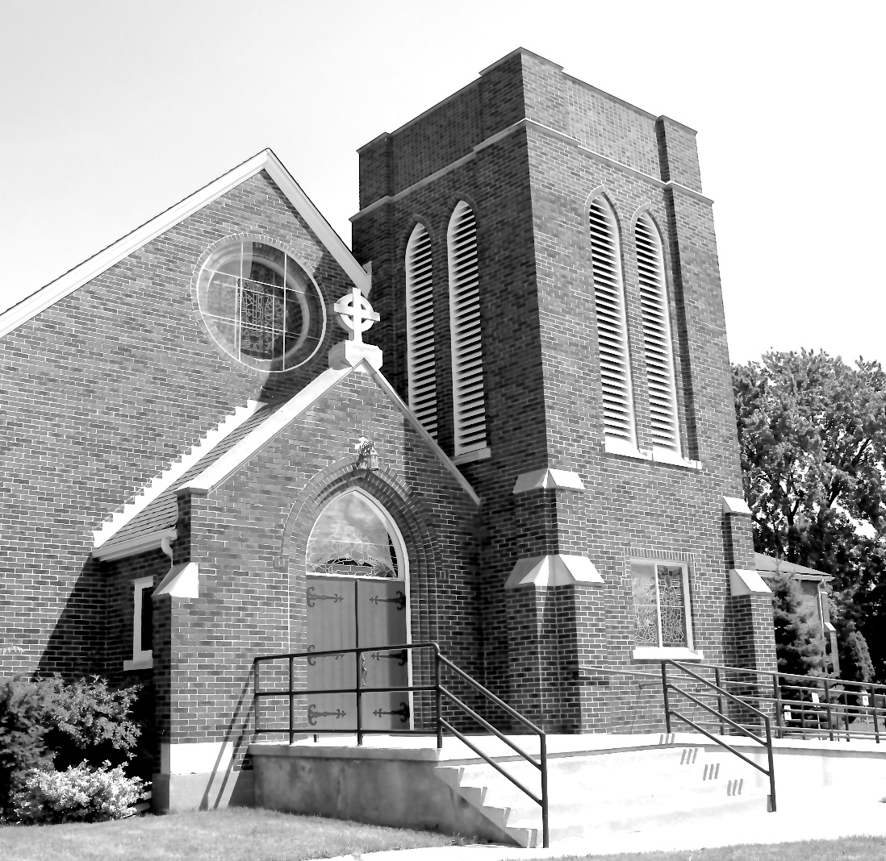

Worship Service: Sunday 9:30 a.m.

Officiant: Bill Graham Organist: Dorothy Miller

380 Russell St. North (at Maxwell St.), Sarnia, Ontario N7T 6S6
(519) 344-9531 – Email: canondavis@gmail.com -- http://www.canondavis.com

