Canon Davis Memorial Church
Anglican Church of Canada
December 11, 2022— 3rd Sunday of Advent

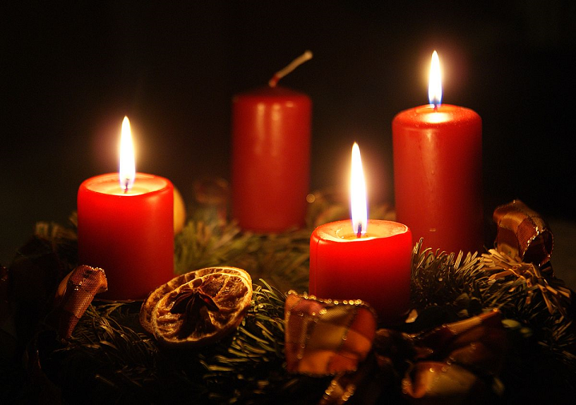

We come and worship God.
We go our way with souls nourished.

Worship Service: Sunday 9:30 a.m.
380 Russell St. North (at Maxwell St.), Sarnia, Ontario, N7T 6S6
(519) 344-9531 — http://www.canondavis.com — Email: canondavis@gmail.com
December 11, 2022 — Third Sunday of Advent
9:30 a.m. Morning Prayer (BCP) p.4
Officiant – Bill Graham — Organist – Dorothy Miller

Opening Hymn # 101 Hail to the Lord’s Anointed
Greeting

THE GATHERING OF THE COMMUNITY

Lighting of the Advent Wreath: the Candle of Joy —

Advent 3 - Today is the third Sunday of Advent - the Sunday of Joy.

Our joy is in God and in his son Jesus Christ. Like peace, joy is a gift from God. It overtakes us and fills us when we remember what God has done and what he has promised to do.

We light this candle today to remind us that Christ came, and is coming, so that all people might have a rich and abundant life. We thank God for the hope he gives us, for the peace he bestows, and for the joy he pours into our hearts.

Lighting of the third Candle (Joy)

Leader: Let us pray: O God of Joy, Emmanuel, send your light into our hearts at this time. Help us to be ready for the time of Christ's appearing. Fix our hearts and our minds upon those things you have done and those you have promised to do that we may have the joy you have promised. As we worship you, strengthen us so that we may always do your will and so bless you and the world you have made. Amen.

All sing: “A Candle is Burning”
Words by Sandra Dean, 1986. tune by James Murray 1887 (public domain)

A candle is burning, a candle of joy,
a candle to welcome brave Mary’s new boy.
Our hearts fill with wonder, and eyes light and glow
as joy brightens winter like sunshine on snow.

Exhortation p. 4
General Confession p. 4
Absolution p. 5
The Lord’s Prayer p. 5
Responses p. 6
Venite p. 6

THE PROCLAMATION OF THE WORD

1st Reading Isaiah 35: 1-10
Psalm 146 4-9 (read by alternate verses) BCP p. 517, 518
2nd Reading James 5: 7-10
Gospel Matthew 11: 2-11

Benedictus p. 9
The Apostles’ Creed p. 10
Versicles p. 10
The Lord’s Prayer p. 11
Responses p. 11

Collect of the Day: God of power and mercy, you call us once again to celebrate the coming of your Son. Remove those things which hinder love of you, that when he comes, he may find us waiting in awe and wonder for him who lives and reigns with you and the Holy Spirit, one God, now and for ever. Amen.
Collect for Peace p. 11
Collect for Grace p. 11
Offertory Hymn # 89 O Come, O Come, Emmanuel
Sung Offertory Response All Things Come of Thee

Sermon
Sermon Hymn # 109 When the King Shall Come Again

Prayer for the King and Commonwealth p. 12
Prayer for the Clergy and People p. 13
Prayer for All Conditions of Mortals p. 14
General Thanksgiving (said by all) p. 14
Prayer of Saint Chrysostom p. 15

Prayer for a Renewed Church: Almighty God, give us a new vision of you, of your love, of your grace and power, and then, give us a new vision of what you would have us do as your Church in this nation and at this time, and an awareness that in the strength of your Spirit, we can do it to your glory. In Jesus’ name we pray. Amen.

The Grace p. 15

Announcements

Closing Hymn # 108 Hark, a Herald Voice Is Sounding

Officiant: Go in peace to love and serve the Lord.
People: Thanks be to God.
Sung Benediction Go Now in Peace
(inside back cover of hymn book)

Please enter names in the Intercessions Book each week to be read in the service.

The Flowers on the Altar today are given to the
Glory of God and in thanksgiving for blessings
received and in memory of loved ones, a gift of
Ruth and Charlie Lavigne.
News and Events

- Please send all announcements for the bulletin to Karen by 11:00 a.m. Tuesday of each week. Call: 519-344-9531 or E-mail: canondavis@gmail.com.
- If you would like a home visit with Communion or know of someone who would, please let Rev. Ray know as he and/or a Lay Visitor will be available in the coming weeks.
- Please join us for Coffee Hour after service for a time of fellowship in the parish hall.
- Happy Birthday to Elaine Hayter, Reg Heasman, Bob Spence, and Jason Hayter from all your friends at Canon Davis Memorial.
- Thank you to the Ladies Guild for all your hard work in decorating the church for Christmas. The decorations are beautiful. Thank you.
- Parish Council is very sorry to announce the following: Ladies Guild will not be making pies until sometime in January 2023. CDM will not be hold a Christmas Bazaar this year. We may hold something near the end of winter or early spring. Ways and Means dinners have been cancelled for the rest of 2022 and will start back up in February 2023.
- The Chancel Guild still has four Sunday openings available for altar flower donors. They are: 2nd Sunday in April, 4th Sunday in June, 2nd Sunday in August and 2nd Sunday in September. If you are interested in being an altar flower donor please contact Seonaid Laidlaw. Thank you.
- Church calendars are still available for purchase after church. The cost is $6.00.
- This year, our Candle Light Service on December 24 will be held at 5:00 p.m. and
- Our Christmas Day Service of the Word on December 25 at 9:30 a.m. Please join us.
- St. Andrew’s Presbyterian Church, 261 Christina St. N. is hosting Community Songs & Carols of Christmas with the Synergy 150 Choir on December 11, 2022 @7:00 p.m. Doors open at 630 p.m. with cookies and hot drinks afterwards. Free will offering for our community benevolence fund.
- The Salvation Army has asked CDM to provide food donations of Mac and Cheese for their Annual Christmas Food Baskets. If you are able to contribute, donations of Mac and Cheese can be dropped off at the back of the church until Thursday December 15, 2022.

Reminders
Dec 14 Parish Council Meeting at 10:00 a.m. in the Boardroom
Dec 18 Please join us for our Lessons and Carols service.
Dec 24 CDM Candle Light Service at 5:00 p.m.
Dec 25 CDM Christmas Day Service at 9:30 a.m

