Sunday January 22, 2023—3rd Sunday after Epiphany
9:30 a.m. Morning Prayer (BCP) p.4

Opening Hymn # 397 Praise the One Who Breaks the Darkness
Greeting

THE GATHERING OF THE COMMUNITY
Exhortation p. 4
General Confession p. 4
Absolution p. 5
The Lord’s Prayer p. 5
Responses p. 6
Venite p. 6

THE PROCLAMATION OF THE WORD
1st Reading Isaiah 9: 1-4
Psalm 27: 1, 5-13 (responsively alternate verses) BCP p. 360, 361
2nd Reading I Corinthians 1: 10-18
Gospel Matthew 4: 12-23

Benedictus p. 9
The Apostles’ Creed p. 10
Versicles p. 10
The Lord’s Prayer p. 11
Responses p. 11

Collect of the Day Almighty God, by grace alone you call us and accept us in your service. Strengthen us by your Spirit, and make us worthy of your call; through Jesus Christ our Lord, who lives and reigns with you and the Holy Spirit, one God, now and for ever. Amen.
Collect for Peace p. 11
Collect for Grace p. 11
Offertory Hymn # 73 One Bread, One Body, One Lord of All
Offertory Response All Things Come of Thee (sung)

Sermon
Sermon Hymn # 430 Will You Come and Follow Me
Prayer for the King and Commonwealth p. 12
Prayer for the Clergy and People p. 13
Prayer for All Conditions of Mortals p. 14
General Thanksgiving (said by all) p. 14
Prayer of Saint Chrysostom p. 15

Prayer for a Renewed Church: Almighty God, give us a new vision of you, of your love, of your grace and power, and then, give us a new vision of what you would have us do as your Church in this nation and at this time, and an awareness that in the strength of your Spirit, we can do it to your glory. In Jesus’ name we pray. Amen.

The Grace p. 15

Announcements

Closing Hymn # 432 Jesus Calls Us! O’er the Tumult
Dismissal
Officiant Go in peace to love and serve the Lord.
People Thanks be to God.
Sung Benediction Howard’s Blessing (vs. 1-2)
(found in the back of the blue hymn book)

The Flowers on the Altar today are given to
the Glory of God and in loving memory of Alex Scrimgeour, a gift of Sylvia and family.

NEWS AND EVENTS

- Please send all announcements for the bulletin to Karen by 11:00 a.m.
Tuesday of each week. Call 519-344-9531 or E-mail: canondavis@gmail.com.

- If you would like a home visit with Communion or know of someone who would, please let Rev. Ray know as he and/or a Lay Visitor will be available in the coming weeks.

- Please join us for Coffee Hour after service for a time of fellowship in the
parish hall.

Upcoming Events:

- Mark your calendars as once again Sew Day returns to Canon Davis. Saturday January 28 from 9:00 till 3:00 p.m. Cost $20.00, lunch included. Bring your projects for a show and tell Sew Day.
- Please join us on Sunday February 5 for BAC’s famous Turkey-Ala-King Brunch.
- Hurrah! Wednesday February 15 is Pork Roast Dinner and Raffle Night. Call 519 344-9531 to reserve your seat. Cost: Adults $20.00 and take out is available.

Reminders
Jan 22 Vestry Reports issued
Jan 28 Sew Day 9:00 a.m. to 3:00 p.m.
Jan 29 Vestry Meeting after church service in the parish hall.
Feb 5 BAC Turkey Ala King Brunch
Feb 15 Pork Roast Dinner 5:00 p.m.
Canon Davis Memorial Church
Anglican Church of Canada

January 22, 2023 – Third Sunday after Epiphany

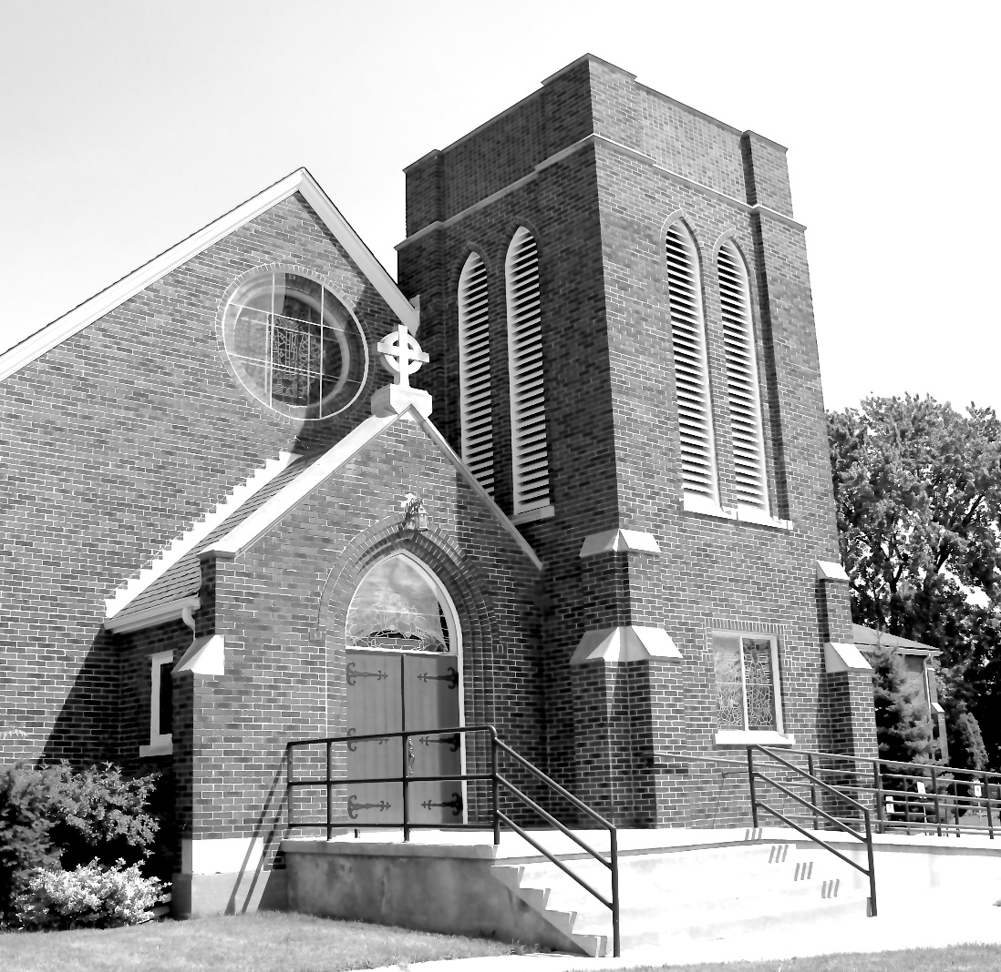

Worship Service: Sunday 9:30 a.m.

Officiant: Bill Graham Organist: Dorothy Miller

380 Russell St. North (at Maxwell St.), Sarnia, Ontario N7T 6S6
(519) 344-9531 – Email: canondavis@gmail.com -- http://www.canondavis.com

