Canon Davis Memorial Church
Anglican Church of Canada
The Sunday of the Passion – Palm Sunday
Sunday, April 2, 2023

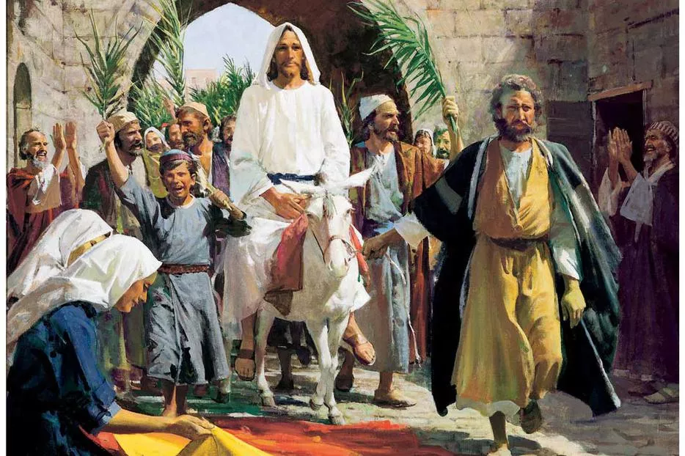

We come and worship God.
We go our way with souls nourished.
Worship Service: Sunday 9:30 a.m.
380 Russell St. North (at Maxwell St.), Sarnia, Ontario, N7T 6S6
(519) 344-9531 - http://www.canondavis.com – http://www.canon davis.com

Canon Davis Memorial Church
Anglican Church of Canada
Sunday, April 2, 2023 – Palm Sunday
9:30 a.m. Holy Eucharist
Officiant — Rev. Ray Jenkins
Assisted By — John Hayter
Organist — Dorothy Miller

Distribution of Palms

THE LITURGY OF THE PALMS

Blessed is he who comes in the name of the Lord.
Hosanna in the highest.

Dear friends in Christ, during Lent we have been preparing for the celebration of our Lord’s paschal mystery. On this day our Lord Jesus Christ entered the holy city of Jerusalem in triumph. The people welcomed him with palms and shouts of praise, but the path before him led to self-giving, suffering, and death. Today we greet our King, although we know his crown is thorns and his throne a cross. We follow him this week from the glory of the palms to the glory of the resurrection by way of the dark road of suffering and death. United with him in his suffering on the cross, may we share his resurrection and new life.

Let us pray.
Assist us mercifully with your help, Lord God of our salvation, that we may enter with joy into the celebration of those mighty acts whereby you give us life and immortality; through Jesus Christ our Lord. Amen.

The Lord be with you
And also with you.

THE HOLY GOSPEL OF OUR LORD JESUS CHRIST
ACCORDING TO MATTHEW

Glory to you, Lord Jesus Christ

When they had come near Jerusalem and had reached Bethphage, at the Mount of Olives, Jesus sent two disciples, saying to them, “Go into the village ahead of you, and immediately you will find a donkey tied, and a colt with her; untie them and bring them to me. If anyone says anything to you, just say this, ‘The Lord needs them.’ And he will send them immediately.” This took place to fulfil what had been spoken through the prophet, saying, “Tell the daughter of Zion, Look, your king is coming to you, humble, and mounted on a donkey, and on a colt, the foal of a donkey.” The disciples went and did as Jesus had directed them; they brought the donkey and the colt, and put their cloaks on them, and he sat on them. A very large crowd spread their cloaks on the road, and others cut branches from the trees and spread them on the road. The crowds that went ahead of him and that followed were shouting, “Hosanna to the Son of David! Blessed is the one who comes in the name of the Lord! Hosanna in the highest heaven!” When he entered Jerusalem, the whole city was in turmoil, asking, “Who is this?” The crowds were saying, “This is the prophet Jesus from Nazareth in Galilee.”

The Gospel of Christ.
Praise to you, Lord Jesus Christ

The Lord be with you.
Praise to you, Lord Jesus Christ

Let us give thanks to the Lord our God.
It is right to give our thanks and praise.

Prayer
It is right to praise you, almighty God, for the acts of love by which you have redeemed us through your Son Jesus Christ our Lord. The Hebrews acclaimed Jesus as Messiah and King, with palm branches in their hand, crying, Hosanna in the highest.

May we also, carrying these emblems, go forth to meet Christ and follow him in the way that leads to eternal life; who lives and reigns in glory with you and the Holy Spirit, now and for ever. Amen.
Let us go forth in peace.
In the name of Christ. Amen.

THE GATHERING OF THE COMMUNITY

Opening Hymn # 181 All Glory, Laud, and Honour

COLLECT OF THE DAY
Almighty and everliving God, in tender love for all our human race you sent your Son our Saviour Jesus Christ to take our flesh and suffer death upon a cruel cross. May we follow the example of his great humility, and share in the glory of his resurrection through Jesus Christ our Lord, who is alive and reigns with you and the Holy Spirit, one God, now and for ever.

THE LITURGY OF THE PASSION

The Lord God has given me the tongue of a teacher, that I may know how to sustain the weary with a word. Morning by morning he wakens—wakens my ear to listen as those who are taught. The Lord God has opened my ear, and I was not rebellious, I did not turn backward. I gave my back to those who struck me, and my cheeks to those who pulled out the beard; I did not hide my face from insult and spitting. The Lord God helps me; therefore I have not been disgraced; therefore I have set my face like flint, and I know that I shall not be put to shame; he who vindicates me is near. Who will contend with me? Let us stand up together. Who are my adversaries? Let them confront me. It is the Lord God who helps me; who will declare me guilty?

Psalm 31: 1-2, 9-16
Have mercy upon me, O Lord, for I am in trouble; my eye is consumed with sorrow, and also my throat and my belly.
For my life is wasted with grief, and my years with sighing; my strength fails me because of affliction, and my bones are consumed.

I have become a reproach to all my enemies and even to my neighbours, a dismay to those of my acquaintance; when they see me in the street they avoid me.
I am forgotten like a dead man, out of mind; I am as useless as a broken pot.

For I have heard the whispering of the crowd; fear is all around; they put their heads together against me; they plot to take my life.
But as for me, I have trusted in you, O Lord. I have said, “You are my God.

My times are in your hand; rescue me from the hand of my enemies, and from those who persecute me.
Make your face to shine upon your servant, and in your loving-kindness save me.”

A Reading from the Letter of Paul to the Philippians

Let the same mind be in you that was in Christ Jesus, who, though he was in the form of God, did not regard equality with God as something to be exploited, but emptied himself, taking the form of a slave, being born in human likeness. And being found in human form, he humbled himself and became obedient to the point of death even death on a cross. Therefore God also highly exalted him and gave him the name that is above every name, so that at the name of Jesus every knee should bend, in heaven and on earth and under the earth, and every tongue should confess that Jesus Christ is Lord, to the glory of God the Father.

The Lord be with you
And also with you.

(Given the length of the passion account, parishioners
may be seated during the reading of the Gospel.)

THE HOLY GOSPEL OF OUR LORD JESUS CHRIST

ACCORDING TO MATTHEW

Glory to you, Lord Jesus Christ.

Now Jesus stood before the governor, and the governor asked him, “Are you the king of the Jews?” Jesus said, “You say so.” But when he was accused by the chief priests and elders, he did not answer. Then Pilate said to him, “Do you not hear how many accusations they make against you?” But he gave him no answer, not even to a single charge, so that the governor was greatly amazed.

Now at the festival the governor was accustomed to release a prisoner for the crowd, anyone whom they wanted. At that time they had a notorious prisoner called Jesus Barabbas. So after they had gathered, Pilate said to them, “Whom do you want me to release for you, Jesus Barabbas or Jesus who is called the Messiah?” For he realized that it was out of jealousy that they had handed him over. While he was sitting on the judgment seat, his wife sent word to him, “Have nothing to do with that innocent man, for today I have suffered a great deal because of a dream about him.” Now the chief priests and the elders persuaded the crowds to ask for Barabbas and to have Jesus killed. The governor again said to them, “Which of the two do you want me to release for you?” And they said, “Barabbas.” Pilate said to them, “Then what should I do with Jesus who is called the Messiah?” All of them said, “Let him be crucified!” Then he asked, “Why, what evil has he done?” But they shouted all the more, “Let him be crucified!”

So when Pilate saw that he could do nothing but rather that a riot was beginning, he took some water and washed his hands before the crowd, saying, “I am innocent of this man’s blood; see to it yourselves.” Then the people as a whole answered, “His blood be on us and on our children!” So he released Barabbas for them, and after flogging Jesus he handed him over to be crucified.

Then the soldiers of the governor took Jesus into the governor’s headquarters, and they gathered the whole cohort around him. They stripped him and put a scarlet robe on him, and after twisting some thorns into a crown they put it on his head. They put a reed in his right hand and knelt before him and mocked him, saying, “Hail, King of the Jews!” They spat on him and took the reed and struck him on the head. After mocking him, they stripped him of the robe and put his own clothes on him. Then they led him away to crucify him.

As they went out, they came upon a man from Cyrene named Simon; they compelled this man to carry his cross. And when they came to a place called Golgotha (which means Place of a Skull), they offered him wine to drink, mixed with gall, but when he tasted it, he would not drink it. And when they had crucified him, they divided his clothes among themselves by casting lots; then they sat down there and kept watch over him. Over his head they put the charge against him, which read, “This is Jesus, the King of the Jews.”

Then two rebels were crucified with him, one on his right and one on his left. Those who passed by derided him, shaking their heads and saying, “You who would destroy the temple and build it in three days, save yourself! If you are the Son of God, come down from the cross.” In the same way the chief priests also, along with the scribes and elders, were mocking him, saying, “He saved others; he cannot save himself. He is the King of Israel; let him come down from the cross now, and we will believe in him. He trusts in God; let God deliver him now, if he wants to, for he said, ‘I am God’s Son.’ The rebels who were crucified with him also taunted him in the same way.
From noon on, darkness came over the whole land until three in the afternoon. And about three o’clock Jesus cried with a loud voice, “Eli, Eli, lema sabachthani?” that is, “My God, my God, why have you forsaken me?” When some of the bystanders heard it, they said, “This man is calling for Elijah.” At once one of them ran and got a sponge, filled it with sour wine, put it on a stick, and gave it to him to drink. But the others said, “Wait, let us see whether Elijah will come to save him.” Then Jesus cried again with a loud voice and breathed his last. At that moment the curtain of the temple was torn in two, from top to bottom. The earth shook, and the rocks were split. The tombs also were opened, and many bodies of the saints who had fallen asleep were raised. After his resurrection they came out of the tombs and entered the holy city and appeared to many. Now when the centurion and those with him, who were keeping watch over Jesus, saw the earthquake and what took place, they were terrified and said, “Truly this man was God’s Son!”

The Gospel of Christ.
Praise to you, Lord Jesus Christ

Sermon

Sermon Hymn # 537 In the Cross of Christ I Glory

Prayers of the People
(With confidence and trust let us pray to the Lord, saying,
“Lord, have mercy.”)

For the one holy catholic and apostolic Church throughout the world, we pray to you, Lord.
Lord, have mercy.

For the mission of the Church, that in faithful witness it may preach the gospel to the ends of the earth, we pray to you, Lord.
Lord, have mercy.
For those preparing for baptism and for their teachers and sponsors, we pray to you, Lord.
Lord, have mercy.

For peace in the world, that a spirt of respect and reconciliation may grow among nations and peoples, we pray to you, Lord.
Lord, have mercy.

For the poor, the persecuted, the sick, and all who suffer; for refugees, prisoners, and all in danger; that they may be relieved and protected, we pray to you, Lord.
Lord, have mercy.

For all whom we have injured or offended, we pray to you, Lord.
Lord, have mercy.

For grace to amend our lives and to further the reign of God, we pray to you, Lord.
Lord, have mercy.

Prayer for a Renewed Church: Almighty God, give us a new vision of you, of your love, of your grace and power, and then, give us a new vision of what you would have us do as your Church in this nation and at this time, and an awareness that in the strength of your Spirit, we can do it to your glory. In Jesus’ name we pray. Amen.

The Peace

Offertory Hymn # 386 When I Survey the Wondrous Cross

Doxology

Praise God, from Whom all blessings flow.
Praise Him, all creatures here below.
Praise Him above, ye Heavenly Host.
Praise Father, Son, and Holy Ghost.

THE CELEBRATION OF THE HOLY EUCHARIST

Prayer over the Gifts: Gracious God, the suffering and death of Jesus, your only Son, makes us pleasing in your sight. Alone we can do nothing, but through his sacrifice, may we receive your love and mercy.

Eucharistic Prayer

The Lord be with you.
And also with you.

Lift up your hearts.
We lift them to the Lord.

Let us give thanks to the Lord our God.
It is right to give our thanks and praise.

We give you thanks and praise, almighty God, for the gift full of wonder, and for our life which comes from you. By your power you sustain the universe.
Glory to you for ever and ever.

You created us to love you with all our heart, and to love each other as ourselves, but we rebel against you by the evil that we do.

In Jesus, your Son, you bring healing to our world and gather us into one great family. Therefore, with all who serve you on earth and in heaven, we praise your wonderful name, as we sing (say),

Holy, holy, holy Lord,
God of power and might,
Heaven and earth and full of your glory.
Hosanna in the highest.

Blessed is he who comes in the name of the Lord.
Hosanna in the highest.

We give you thanks and praise, loving father, because in sending Jesus, your Son, to us you showed us how much you love us. He cares for the poor and the hungry. He suffers with the sick and the rejected.

Betrayed and forsaken, he did not strike back but overcame hatred with love. On the cross he defeated the power of sin and death. By raising him from the dead you show us the power of your love to bring new life to all your people.
Glory to you for ever and ever.

On the night before he gave up his life for us, Jesus, at supper with his friends, took bread, gave thanks to you, broke it, and gave it to them, saying, “Take this, all of you, and eat it: this is my body which is given for you.

After supper, Jesus took the cup of wine, said the blessing, gave it to his friends and said, “Drink this, all of you: this is the cup of my blood, the blood of the new and eternal covenant, which is shed for you and for many, so that sins may be forgiven. Do this in memory of me.”
Glory to you for ever and ever.

Gracious God, with this bread and wine we celebrate the death and resurrection of Jesus, and we offer ourselves to you in him. Send your Holy Spirit on us and on these gifts, that we may know the presence of Jesus in the breaking of bread, and share in the life of the family of your children.
Glory to you for ever and ever.

Father, you call us to be your servants; fill us with the courage and love of Jesus, that all the world may gather in joy at the table of your kingdom.

We sing your praise, almighty Father, through Jesus, our Lord, in the power of the Holy Spirit, now and for ever.
Glory to you for ever and ever. Amen.

The Lord’s Prayer

Our Father, who art in heaven, hallowed be thy name,
thy kingdom come, thy will be done, on earth as it is in heaven.
Give us this day our daily bread.
And forgive us our trespasses,
as we forgive those who trespass against us.
And lead us not into temptation, but deliver us from evil.
For thine is the kingdom, the power, and the glory, for ever and ever. Amen.

Breaking of the Bread

We break this bread
Communion in Christ’s body once broken

Let your Church be the wheat which bears its fruit in dying.
If we have died with him, we shall live with him; if we hold firm, we shall reign with him.

The Communion

The Prayer after Communion God our help and strength, you have satisfied our hunger with this eucharistic food. Strengthen our faith, that through the death and resurrection of your Son, we may be led to salvation, for he is Lord now and for ever.

Announcements

Recessional Hymn #182 Ride On, Ride On in Majesty
Dismissal “Go Now In Peace”
(in the back of the Blue Hymn Book)

The Flowers on the Altar today are given to the Glory of God, and in loving memory of Allan,
a gift of Gerry Rinker and family.

Please enter names in the Intercessions Book each week to be read in the service.

__________________________________

NEWS AND EVENTS

- Please send all announcements for the bulletin to Karen by 11:00 a.m. Tuesday of each week. Call 519-344-9531 or E-mail: canondavis@gmail.com.
- If you would like a home visit with Communion or know of someone who would, please let Rev. Ray know as he and/or a Lay Visitor will be available in the coming weeks.
- Please join us for Coffee Hour after service for a time of fellowship in the parish hall.
- Thank you to the Ladies Guild/ACW and the Ways and Means Committee for hosting the Ladies Luncheon. It was enjoyed by all. It was great to see so many of our Ladies attend and we look forward to getting together in June.
- Easter Lily Memorial: If you have any changes or updates for our Easter Memorial list, please contact Karen at 519-344-9531.
- Happy Birthday and best wishes to Carol Turner, Sylvia Scrimgeour, Nancy Dease, Sheree Hayter, John Dodkin, Carol Mercurio, Simone LeBel and Gord Simmons from all your friends and CDM.

- Upcoming Events:

- Good Friday Service on April 7, at 4:00 p.m. at Canon Davis Memorial. This years’ service will be officiated by the Rev’d Paul Woolley.
- Easter Sunday Service on April 9, at 9:30 a.m. will be officiated by the Venerable Sam Thomas and Rev. Ray Jenkins.
- Wednesday April 19, is Meat Loaf Dinner night here at Canon Davis. Please call John at 519-384-1926 or Karen at 519-344-9531 to reserve for in house dining or to order Take-Out. Cost $20.00
- Easter Cantata, Olivet to Calvary April 8 6:30 p.m. St. Andrew’s Presbyterian Church 261 Christina St. N, Sarnia Free Will Offering and sweets to follow. More information @ 519-332-2662

Reminders
Apr 6 Maundy Thursday Service, Christ Church, Forest
Officiated by Rev’d Paul Woolley
Apr 7 Good Friday Service Canon Davis Memorial 4:00 p.m.
Apr 8 Easter Vigil – All Saints’ Church 6:30 p.m.
Apr 9 Easter Sunday Service 9:30 a.m.
Apr 19 Meat Loaf Dinner – Parish Hall 5:00 p.m.
Apr 26 Parish Council Meeting 10:00 a.m. Board Room

