Canon Davis Memorial Church
Anglican Church of Canada
The Third Sunday in Lent
12th March, 2023

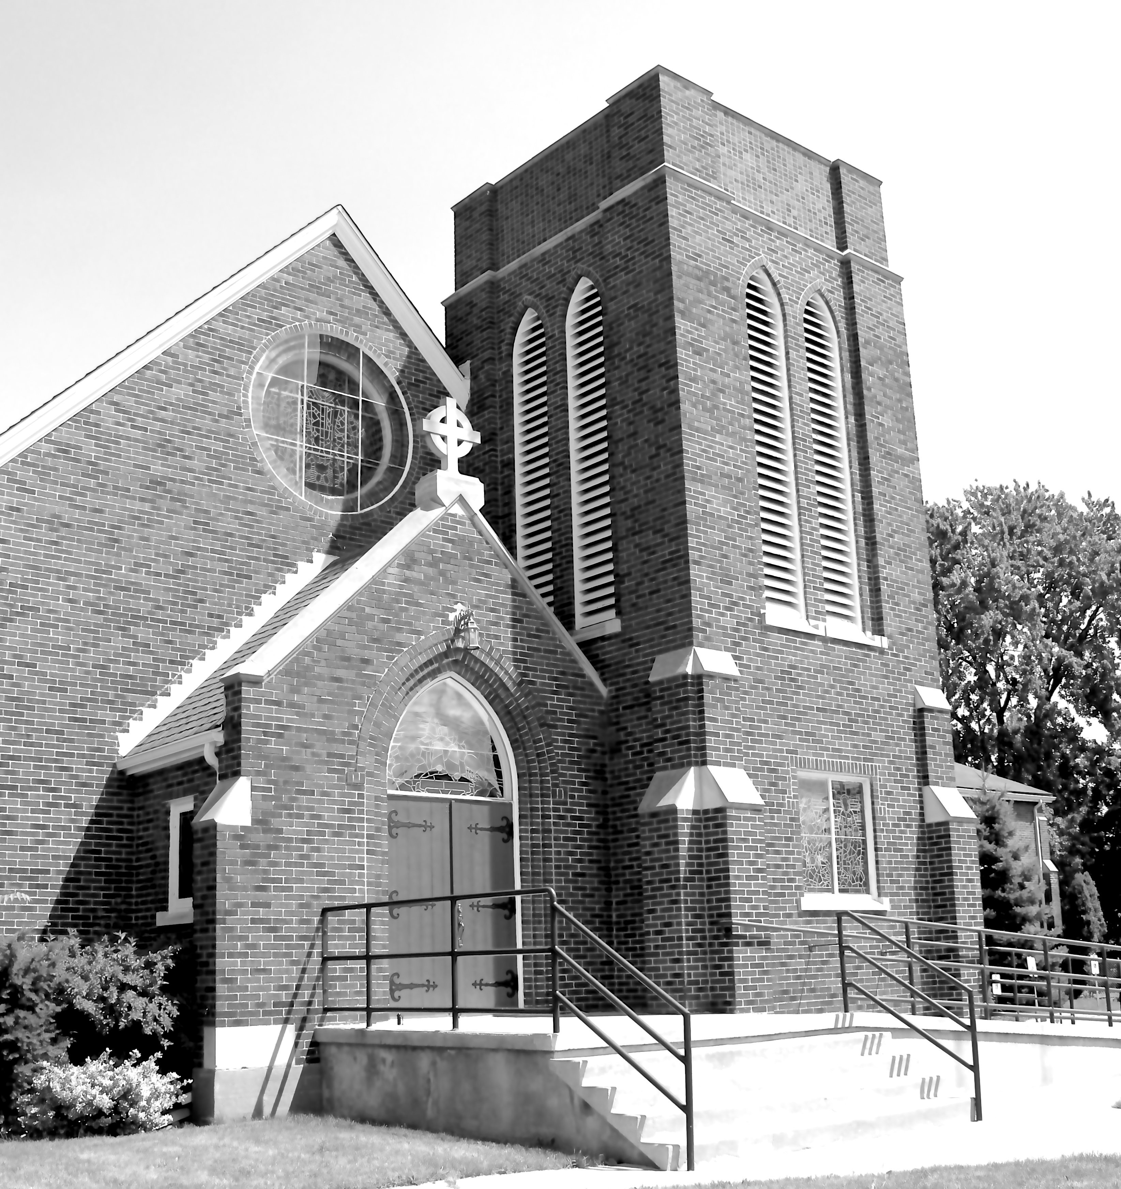

We Come and worship God.
We go our way with souls nourished.

Officiant: Ginny Schleihauf Organist: Dorothy Miller
380 Russell St. North (at Maxwell St.), Sarnia, Ontario, N7T 6S6
Tel: (519) 344-9531 - Email: canondavis@gmail.com – http://www.canondavis.com

12th March, 2023 — Third Sunday in Lent

Service of the Word

Gathering Hymn # 388 Glorious Things of Thee Are Spoken

Officiant: The grace of our Lord Jesus Christ and the love of God and the
fellowship of the Holy Spirit be with you all.
People: And also with you.

Officiant: Let us pray.
We thank you, O God, that you have again brought us together on the Lord’s Day to praise you for your goodness and to ask your blessing. Give us grace to see your hand in the week that is past, and your purpose in the week to come; through Christ our Lord.
People: Amen.

Officiant: Dear friends in Christ, as we turn our hearts and minds to
worship almighty God, let us confess our sins.

People: Most merciful God, we confess that we have sinned
against you in thought, word, and deed, by what we have done and by what we have left undone. We have not loved you with our whole heart; we have not loved our neighbours as ourselves. We are truly sorry and we humbly repent. For the sake of your Son Jesus Christ, have mercy on us and forgive us, that we may delight in your will, and walk in your ways, to the glory of your name. Amen.

Officiant: Merciful God, grant to us, your faithful people, pardon and
peace, that we may be cleansed from all our sins and serve you with a quiet mind through Jesus Christ our Lord, who is alive and reigns with you and the Holy Spirit, one God, now and for ever.
People: Amen.
Officiant: The Peace of the Lord be always with you.
People: And also with you.

Officiant: Let us reconcile to God and one another a sign of Christ’s
peace.

The Collect of the Day
Almighty God, whose Son Jesus Christ gives the water of eternal life, may we always thirst for you, the spring of life and source of goodness; through him who lives and reigns with you and the Holy Spirit, one God, now and for ever.

First Reading Exodus 17: 1-7
Officiant: The Word of the Lord.
People: Thanks be to God.

Psalm 95 (Response in bold.)

Come, let us sing to the Lord; let us shout for joy to the rock of our salvation.
Let us come before his presence with thanksgiving and raise a loud shout to him with psalms.
For the Lord is a great God, and a great king above all gods. In his hand are the caverns of the earth, and the heights of the hills are his also.
The sea is his, for he made it, and his hands have molded the dry land.
Come, let us bow down, and bend the knee, and kneel before the Lord our Maker.
For he is our God, and we are the people of his pasture and the sheep of his hand. Oh, that to-day you would hearken to his voice!
Harden not your hearts, as your forebears did in the wilderness, at Meribah, and on that day at Massah, when they tempted me.
They put me to the test, though they had seen my works.
Forty years long I detested that generation and said, "This people are wayward in their hearts; they do not know my ways."
So I swore in my wrath, "They shall not enter into my rest."
Second Reading Romans 5: 1-11
Officiant: The Word of the Lord.
People: Thanks be to God.

Officiant: The Lord be with you.
People: And also with you.

Officiant: The Holy Gospel of our Lord Jesus Christ
according to John
People: Glory to you, Lord Jesus Christ.

The Gospel John 4: 5-42

THE HOLY GOSPEL OF OUR LORD JESUS CHRIST
ACCORDING TO JOHN

Jesus came to a Samaritan city called Sychar, near the plot of ground that Jacob had given to his son Joseph. Jacob's well was there, and Jesus, tired out by his journey, was sitting by the well. It was about noon. A Samaritan woman came to draw water, and Jesus said to her, "Give me a drink." (His disciples had gone to the city to buy food.) The Samaritan woman said to him, "How is it that you, a Jew, ask a drink of me, a woman of Samaria?" (Jews do not share things in common with Samaritans.) Jesus answered her, "If you knew the gift of God, and who it is that is saying to you, 'Give me a drink,' you would have asked him, and he would have given you living water." The woman said to him, "Sir, you have no bucket, and the well is deep. Where do you get that living water? Are you greater than our ancestor Jacob, who gave us the well, and with his sons and his flocks drank from it?" Jesus said to her, "Everyone who drinks of this water will be thirsty again, but those who drink of the water that I will give them will never be thirsty. The water that I will give will become in them a spring of water gushing up to eternal life." The woman said to him, "Sir, give me this water, so that I may never be thirsty or have to keep coming here to draw water." Jesus said to her, "Go, call your husband, and come back." The woman answered him, "I have no husband." Jesus said to her, "You are right in saying, 'I have no husband'; for you have had five husbands, and the one you have now is not your husband. What you have said is true!" The woman said to him, "Sir, I see that you are a prophet. Our ancestors worshipped on this mountain, but you say that the place where people must worship is in Jerusalem." Jesus said to her, "Woman, believe me, the hour is coming when you will worship the Father neither on this mountain nor in Jerusalem. You worship what you do not know; we worship what we know, for salvation is from the Jews. But the hour is coming, and is now here, when the true worshippers will worship the Father in spirit and truth, for the Father seeks such as these to worship him. God is spirit, and those who worship him must worship in spirit and truth." The woman said to him, "I know that Messiah is coming" (who is called Christ). "When he comes, he will proclaim all things to us." Jesus said to her, "I am he, the one who is speaking to you." Just then his disciples came. They were astonished that he was speaking with a woman, but no one said, "What do you want?" or, "Why are you speaking with her?" Then the woman left her water jar and went back to the city. She said to the people, "Come and see a man who told me everything I have ever done! He cannot be the Messiah, can he?" They left the city and were on their way to him. Meanwhile the disciples were urging him, "Rabbi, eat something." But he said to them, "I have food to eat that you do not know about." So the disciples said to one another, "Surely no one has brought him something to eat?" Jesus said to them, "My food is to do the will of him who sent me and to complete his work. Do you not say, 'Four months more, then comes the harvest'? But I tell you, look around you, and see how the fields are ripe for harvesting. The reaper is already receiving wages and is gathering fruit for eternal life, so that sower and reaper may rejoice together. For here the saying holds true, 'One sows and another reaps.' I sent you to reap that for which you did not labour. Others have laboured, and you have entered into their labour." Many Samaritans from that city believed in him because of the woman's testimony, "He told me everything I have ever done." So when the Samaritans came to him, they asked him to stay with them; and he stayed there two days. And many more believed because of his word. They said to the woman, "It is no longer because of what you said that we believe, for we have heard for ourselves, and we know that this is truly the Saviour of the world."
Officiant: The Gospel of the Christ
People: Praise to you, Lord Jesus Christ.

Sermon

Sermon Hymn # 508 I Heard the Voice of Jesus Say

Officiant: Let us confess our faith as we say.
People: I believe in God, the Father Almighty, creator of heaven
and earth.
I believe in Jesus Christ, his only Son, our Lord.
He was conceived by the power of the Holy Spirit and
born of the Virgin Mary.
He suffered under Pontius Pilate, was crucified, died, and
was buried.
He descended to the dead.
On the third day he rose again.
He ascended into heaven, and is seated at the right hand
of the Father.
He will come again to judge the living and the dead.
I believe in the Holy Spirit, the holy catholic Church, the communion of saints, the forgiveness of sins, the resurrection of the body, and the life everlasting. Amen.
Prayers of the People

In peace we pray to you, Lord God.
Silence
For all people in their daily life and work;
For our families, friends, and neighbours, and for all those who are alone.
For this community, our country, and the world;
For all who work for justice, freedom, and peace.
For the just and proper use of your creation;
For the victims of hunger, fear, injustice, and oppression.
For all who are in danger, sorrow, or any kind of trouble;
For those who minister to the sick, the friendless, and needy.
For the peace and unity of the Church of God;
For all who proclaim the gospel, and all who seek the truth.
For Todd our bishop, and for all bishops and other ministers;
For all who serve God in the Church.
For our own needs and those of others.
Silence.
In our parish cycle of prayer, we pray for…
Hear us, Lord.
For your mercy is great.
We thank you, Lord, for all the blessings of this life.
Silence. (The people may add their own thanksgivings.)

We will exalt you, O God our king;
And praise your name for ever and ever.
We pray for those who have died in the peace of Christ, and for those whose faith is known to you alone, that they may have a place in your eternal kingdom.
Silence.
Lord, let your loving kindness be upon them;
Who put their trust in you.
Gracious God, you have heard the prayers of your faithful people; you know our needs before we ask, and our ignorance in asking. Grant our requests as may be best for us. This we ask in the name of your Son Jesus Christ our Lord.
Amen

Offertory Hymn # 474 Jesus Where’er Thy People Meet

Offertory Response All Things Come of Thee

People: Yours, Lord, is the greatness, the power, the glory, the
splendour, and the majesty; for everything in heaven and on earth is yours. All things come from you, and of your own do we give you.

Officiant: And now, as our Saviour Christ has taught us,
we are bold to say,
People: Our Father, who art in heaven,
hallowed be thy name,
thy kingdom come,
thy will be done, on earth as it is in heaven.
Give us this day our daily bread.
And forgive us our trespasses,
as we forgive those who trespass against us.
And lead us not into temptation, but deliver us from evil.
For thine is the kingdom,
the power, and the glory, for ever and ever. Amen.

Officiant: Glory to God
People: whose power, working in us, can do infinitely more than
we can ask or imagine. Glory to God from generation to generation, in the Church and in Christ Jesus, for ever and ever. Amen.

Announcements

Closing Hymn # 592 Where Cross the Crowded Ways of Life

Officiant: May the God of hope fill us all with joy and peace in believing
through the power of the Holy Spirit. Amen.

Sung Benediction Howard’s Blessing (vs 1-2)
(in the back of the blue Hymn book)

The Flowers on the Altar today are given to
the Glory of God, and in loving memory of
Kathy, a gift of Bill and family.

Please enter names in the Intercessions Book each week to be read in the service.
News and Events

- Please send all announcements for the bulletin to Karen by 11:00 a.m. Tuesday of each week. Call: 519-344-9531 or E-mail: canondavis@gmail.com.
- If you would like a home visit with Communion or know of someone who would, please let Rev. Ray know as he and/or a Lay Visitor will be available in the coming weeks.
- Please join us for Coffee Hour after service for a time of fellowship in the parish hall.
- To all the ladies of Canon Davis. As I stated in my report to Vestry this year the Ladies Guild has not held formal meetings since the advent of COVID. I thought perhaps you would enjoy holding a social get-together other than our lunch at Olive’s in June. Please let me know if you would like to attend a lunch on Wednesday, March 29 at 12:30 p.m. in the Parish Hall (free will offering). Carol Mercurio 519-491-9319. Hope to see you there.

Upcoming Events:
- Join us on Wednesday March 15 for Canon Davis’ famous Corned Beef and Cabbage dinner. Call 519 344-9531 to reserve your seat. Cost: Adults $20.00 and take out is available.
- Sew Day Returns to Canon Davis on Saturday March 25, 2023 from 9:00 a.m. to 3:00 p.m. Cost $20.00, lunch included. Bring your projects for a show and tell Sew Day.
- Anglican Church Women-Diocese of Huron Annual Meeting and Conference Saturday 29 April 2023 at St. Paul’s Cathedral. If you are interested in attending copies of the Registration/Lunch form are at the back of the church. For more information, please see Carol Mercurio for details.
- Sunday 9th April, the Venerable Sam Thomas along with Rev. Ray Jenkins will officiate at our Easter Service.
- Saturday May 6 from 10:00 a.m. to 3:00 p.m. at Church of St. Jude is the Bishop of Huron’s Prayer Conference. Please contact Karen for more details.

Reminders
Mar 15 Corned Beef and Cabbage Dinner
Mar 22 Parish Council
Mar 25 Sew Day 9:00 a.m. to 3:00 p.m.
Mar 29 Ladies Lunch – Parish Hall 12:30 p.m.

