Sunday March 26, 2023—Fifth Sunday in Lent
9:30 a.m. Morning Prayer (BCP) p.4

Opening Hymn # 354 Come, Thou Fount of Every Blessing
Greeting

THE GATHERING OF THE COMMUNITY
Exhortation p. 4
General Confession p. 4
Absolution p. 5
The Lord’s Prayer p. 5
Responses p. 6
Venite p. 6

THE PROCLAMATION OF THE WORD
1st Reading Ezekiel 37: 1-6
Psalm 130 (responsively alternate verses) BCP p. 502
2nd Reading Romans 8: 6-11
Gospel John 11: 1-45

Benedictus p. 9
The Apostles’ Creed p. 10
Versicles p. 10
The Lord’s Prayer p. 11
Responses p. 11

Collect of the Day Almighty God, your Son came into the world to free us all from sin and death. Breathe upon us with the power of your Spirit, that we may be raised to new life in Christ, and serve you in holiness and righteousness all our days; through the same Jesus Christ, our Lord. Amen.
Collect for Peace p. 11
Collect for Grace p. 11
Offertory Hymn # 585 Lord, Whose Love in Humble Service
Offertory Response All Things Come of Thee (sung)

Sermon
Sermon Hymn # 649 Breathe on Me, Breath of God
Prayer for the King and Commonwealth p. 12
Prayer for the Clergy and People p. 13
Prayer for All Conditions of Mortals p. 14
General Thanksgiving (said by all) p. 14
Prayer of Saint Chrysostom p. 15

Prayer for a Renewed Church: Almighty God, give us a new vision of you, of your love, of your grace and power, and then, give us a new vision of what you would have us do as your Church in this nation and at this time, and an awareness that in the strength of your Spirit, we can do it to your glory. In Jesus’ name we pray. Amen.

The Grace p. 15

Announcements

Closing Hymn # 631 The Kingdom of God is Justice and Joy
Dismissal
Officiant Go in peace to love and serve the Lord.
People Thanks be to God.
Sung Benediction Howard’s Blessing (vs. 1-2)
(found in the back of the blue hymn book)

The Flowers on the Altar today are given to the Glory of God, and in loving memory Margaret Louise and Glen Hayter,
a dear and loving Mother and Father, Grandma and Grandpa, and Great-Grammie and Great Grandpooh, and loved ones a gift with love from Sheree Lynn, Mike, Jason, and Lucy.

NEWS AND EVENTS

- Please send all announcements for the bulletin to Karen by 11:00 a.m.
Tuesday of each week. Call 519-344-9531 or E-mail: canondavis@gmail.com.
- If you would like a home visit with Communion or know of someone who would, please let Rev. Ray know as he and/or a Lay Visitor will be available in the coming weeks.
- Please join us for Coffee Hour after service for a time of fellowship in the
parish hall.

Upcoming Events:
- To All the Ladies of Canon Davis, please join us for a Social Ladies Lunch Get-Together on Wednesday, March 29 at 12:30 in the Parish Hall (free will offering). Please let Carol Mercurio know if you are attending and/or if you need a ride. Carol can be reached at 519-491-9319.
- Easter Lily Memorial: If you have any changes or updates for our Easter Memorial list, please contact Karen at 519-344-9531.
- Good Friday Service on April 7, at 4:00 p.m. at Canon Davis Memorial. This years’ service will be officiated by the Rev’d Paul Woolley.
- Easter Sunday Service on April 9, at 9:30 a.m. will be officiated by the Venerable Sam Thomas and Rev. Ray Jenkins.
- Wednesday April 19, is Meat Loaf Dinner night here at Canon Davis. Please call John at 519-384-1926 or Karen at 519-344-9531 to reserve for in house dining or to order Take-Out. Cost $20.00
- Easter Cantata, Olivet to Calvary St. Andrew’s Presbyterian Church 261 Christina St. N, Sarnia Free Will Offering and sweets to follow. More information @ 519-332-2662
Reminders
Mar 29 Ladies of Canon Davis Lunch 12:30 p.m. Parish Hall
Apr 7 Good Friday Service 4:00 p.m.
Apr 8 Easter Vigil – All Saints’ Church 6:30 p.m.
Apr 9 Easter Sunday Service
Apr 19 Meat Loaf Dinner – Parish Hall 5:00 p.m.
Apr 26 Parish Council Meeting 10:00 a.m. Board Room
Canon Davis Memorial Church
Anglican Church of Canada

March 26, 2023 – Fifth Sunday in Lent

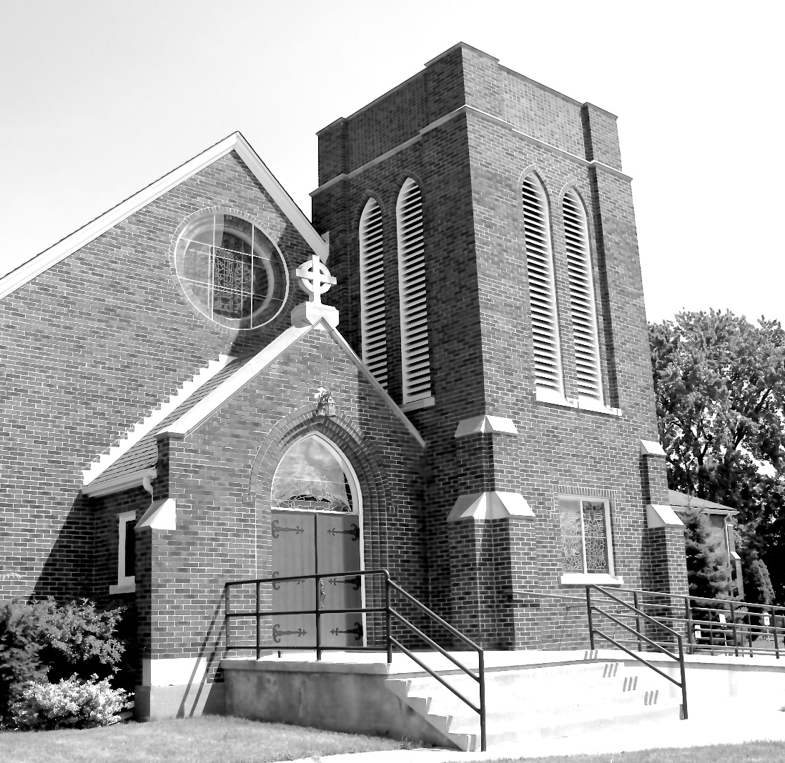

Worship Service: Sunday 9:30 a.m.

Officiant: Bill Graham Organist: Dorothy Miller

380 Russell St. North (at Maxwell St.), Sarnia, Ontario N7T 6S6
(519) 344-9531 – Email: canondavis@gmail.com -- http://www.canondavis.com

