Canon Davis Memorial Church

380 Russell St. North, Sarnia, Ontario, N7T 6S6
(519) 344-9531 • http://www.canondavis.com
ASCENSION OF THE LORD • May 13, 2021
Acts 1:1-11 • Psalm 47 or Psalm 93 • Ephesians 1:15-23 • Luke 24:44-53

Dear Friends,
Ascension Sunday brings a number of images to my mind. Most of us have likely projected various images in their heads of what our Lord must have looked like as he was lifted up and carried into heaven. The image encompasses more as we are told that Jesus ascended into a cloud.

It also raises a few questions about how this took place. We have so many images of the nature of Heaven; and a predominant concept of Heaven as being up in the clouds above the earth. Surprisingly, the idea of a heaven above the earth while popular among many, briefly was also endorsed by the “Godless Communists”.

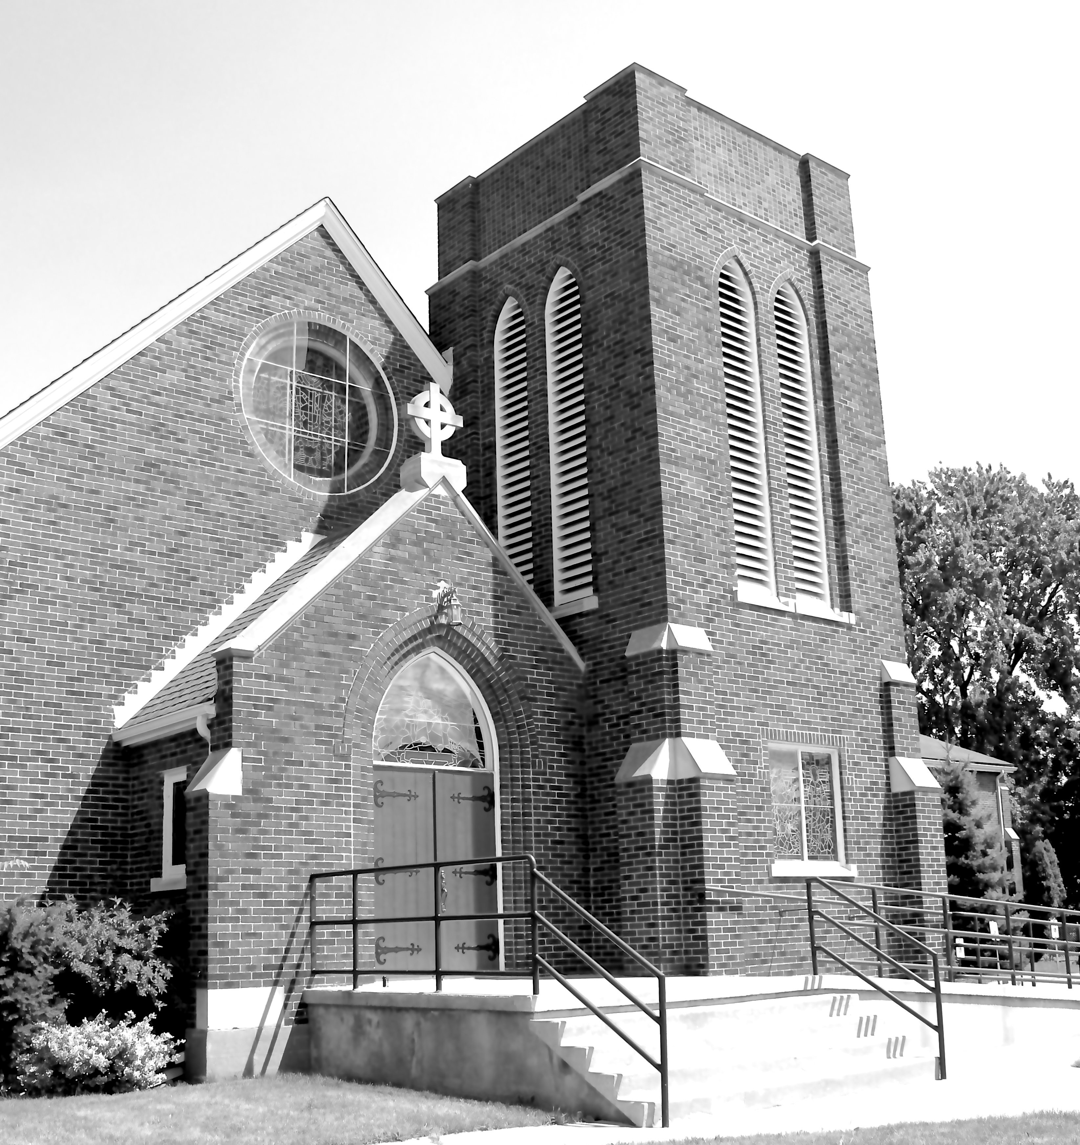
You may remember or heard about the first human-made satellite to fly around our planet was the USSR’s Sputnik. Why were the Russians so delighted with our traditional idea of the location of Heaven? You see, if Heaven were real, Sputnik would have bumped into it. So they saw their orbiting satellite as proof positive that there was no Heaven up there. Somehow I never was able to grasp why they saw this as something positive!

But story of the Ascension of Christ is not given to us to provide the location of Heaven. Interestingly heaven is seen as: a place where God and the angels live; where God and the faithful abide; and as a state of mind. In today’s readings, one meaning refers to where Jesus was going to be with God the Father.

We seldom hear much about what was going on in the world at that ancient time. Life for the Jews was that of a people whose lands were occupied by a huge military power.

Justice was not well defined and often abused. The laws were not enforced in any uniform way. For example, tax collectors routinely violated local laws as they fleeced ordinary folk of what little moneys they possessed. To say the least, the hopes of the Jews were few and seen to be futile. Yes, there were calls for insurrection among certain segments to fight to end the Roman occupancy.
These were not happy times. The culture of the Romans was quite different as well. Central to Roman life was the worship of many gods. These gods had human traits and reinforced many human failings.

In this troubling environment, we are invited to witness a spectacular event. What is to be noted here is that we hear a description of the Ascension, itself AND how things are going to be with God and God’s people. Firstly, Jesus is not going into Heaven as a way of abandoning his people, but actually to come closer. Secondly, people who embrace the ways of Christ are going to be seen as living their lives in a Christ-like manner. Thirdly, these people are going to be empowered by the return to earth of Christ through the Holy Spirit! Through the Holy Spirit, Jesus comes to dwell within us and we thereby become instruments of building a better way of living on earth. Jesus works through us in bringing people in touch with the kingdom of God.

In a chaotic society, God begins to move decisively to bring about pockets of renewal and true life. With God, joy can be ours, with Christ mutual dwelling is ours, with the Holy Spirit transformation and power strengthens us. As the Letter to the Ephesians puts it: …and what is the immeasurable greatness of his power for us who believe, according to the working of his great power.

Even in the worst of times, if we look around us, there are places and situations where one can see the unmistakable presence of God working for the better through his beloved people. That can be with all of us.

Again, with good hearts we hear words from Ephesians: …so that, with the eyes of your heart enlightened, you may know what is the hope to which he has called you, what are the riches of his glorious inheritance among the saints.

A new world awaits and we rejoice!

God, indeed, works with and through God’s people, as they seek to be agents of God’s love, healing and peace. We are known and loved by God! The blessings of our loving, Creator God be upon you and those you love.

——————————————————————————
This Sunday we are seeking to worship in unity as one. The links are found here.
If in addition you wish to also worship with the service from St. Alban’s, you may use our usual link.

Our 2021 Diocesan Synod begins this Sunday, May 16th from 10:30 am to 11:15 am at St. Paul's Cathedral with an Online Worship Service. It will be live-streamed on Facebook and from our website. Everyone is welcome and it is hoped that parishes will encourage their parishioners to join with the diocese to worship on May 16th.

The links to the Worship Service and the two days of Synod are as follows:
- Diocesan Synod Worship Service - May 16th (from 10:30 am to 11:15 am)
- Diocesan Synod, Day One - May 16th (Stream to start at 12:00 pm)
- Diocesan Synod, Day Two - May 17th (Stream to start at 8:30 am)

——————————————————————————-

We are joining with many parishes in our deanery in providing telephone support to our members and friends. This support is designed to keep us up to date, while not requiring a computer. A CDMC Pastoral Letter will be read this week through our phone ministry.

