Sunday July 31, 2022—Eighth Sunday after Pentecost
9:30 a.m. Morning Prayer (BCP) p.4

Opening Hymn # 379 Rejoice, the Lord Is King
Greeting

THE GATHERING OF THE COMMUNITY
Exhortation p. 4
General Confession p. 4
Absolution p. 5
The Lord’s Prayer p. 5
Responses p. 6
Venite p. 6

THE PROCLAMATION OF THE WORD
1st Reading Hosea 11: 1-11
Psalm 107: 1-9, 43 (responsively at the half verse) BCP p. 471, 472, 474
2nd Reading Colossians 3: 1-11
Gospel Luke 12: 13-21

Benedictus p. 9
The Apostles’ Creed p. 10
Versicles p. 10
The Lord’s Prayer p. 11
Responses p. 11

Collect of the Day Almighty God, your Son Jesus Christ fed the hungry with the bread of his life and the word of his kingdom. Renew your people with your heavenly grace, and in all our weakness sustain us by your true and living bread, who lives and reigns with you and the Holy Spirit, one God, now and for ever. Amen.
Collect for Peace p. 11
Collect for Grace p. 11
Offertory Hymn This Is My Father’s World
Offertory Response All Things Come of Thee (sung)

Sermon
Sermon Hymn #522 Rock of Ages, Cleft for Me
Prayer for the Queen and Commonwealth p. 12
Prayer for the Clergy and People p. 13
Prayer for All Conditions of Mortals p. 14
General Thanksgiving (said by all) p. 14
Prayer of Saint Chrysostom p. 15

Prayer for a Renewed Church: Almighty God, give us a new vision of you, of your love, of your grace and power, and then, give us a new vision of what you would have us do as your Church in this nation and at this time, and an awareness that in the strength of your Spirit, we can do it to your glory. In Jesus’ name we pray. Amen.

The Grace p. 15

Announcements

Closing Hymn #577 God of Grace and God of Glory
Dismissal
Officiant Go in peace to love and serve the Lord.
People Thanks be to God.
Sung Benediction Howard’s Blessing (vs. 1-2)
(found in the back of the blue hymn book)

The Flowers on the Altar today are given to
the Glory of God, a gift from the Chancel Guild.

NEWS AND EVENTS

- Please send all announcements for the bulletin to Karen by 11:00 a.m. Tuesday of each week. Call 519-344-9531 or E-mail: canondavis@gmail.com.

- If you would like a home visit with Communion or know of someone who would, please let Rev. Ray know as he and/or a Lay Visitor will be available in the coming weeks.

- Please join us for Coffee Hour after service for a time of fellowship in the parish hall. Volunteers for coffee goodies are needed for August. Please see the sign-up sheet at the back of the church.

- Happy Birthday and best wishes to Rev. Ray Jenkins, Kristopher Dodkin and Joan Dew in August from all of us at Canon Davis Memorial.

Upcoming Events:

18 Sept 2:00 p.m. The Christian Music Café is coming to Canon Davis.
Please join us for this monthly musical event. Refreshments and treats will be available. Free will offering.

21 Sept Please mark your calendar as CDM’s famous and delicious “Fish
Dinner” is back with in house dining.

28 Sept Parish Council Meeting 10:00 a.m. in the boardroom.

Canon Davis Memorial Church
Anglican Church of Canada
July 31, 2022 – Eighth Sunday after Pentecost

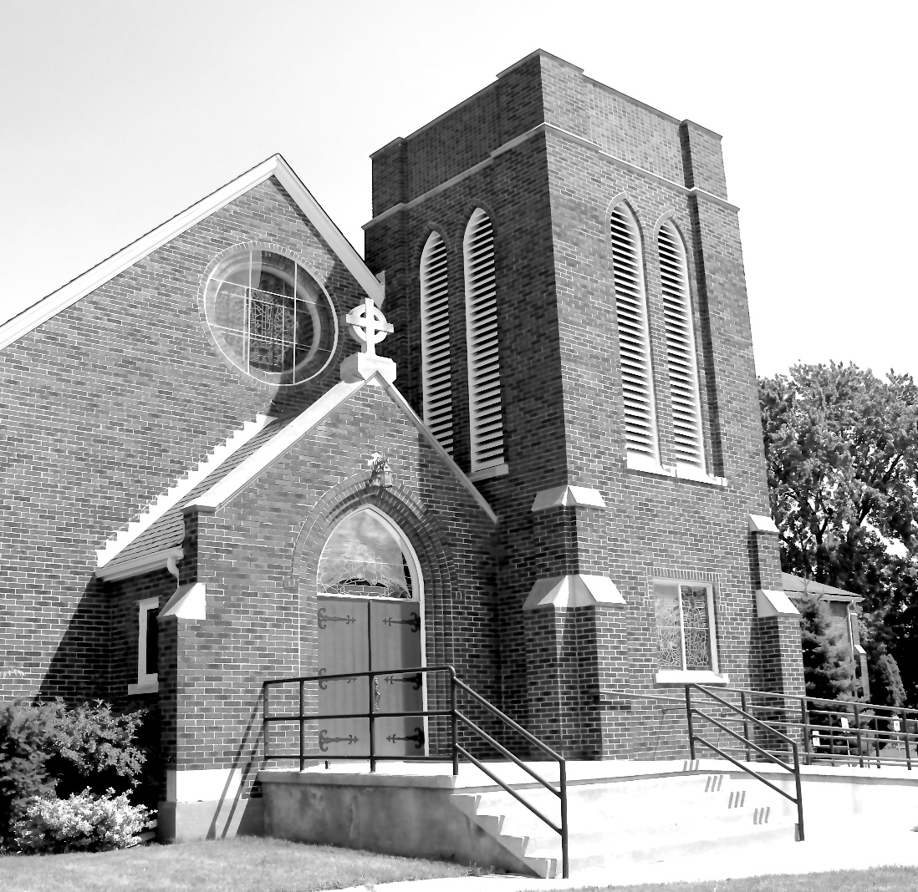

Worship Service: Sunday 9:30 a.m.

Officiant – Bill Graham — Organist – Dorothy Miller

380 Russell St. North (at Maxwell St.), Sarnia, Ontario N7T 6S6
(519) 344-9531 – Email: canondavis@gmail.com -- http://www.canondavis.com

