Sunday April 3, 2022—Fifth Sunday of Lent
9:30 a.m. Morning Prayer (BCP) p.4

Opening Hymn # 445 God the Creator
Greeting

THE GATHERING OF THE COMMUNITY
Exhortation p. 4
General Confession p. 4
Absolution p. 5
The Lord’s Prayer p. 5
Responses p. 6
Venite p. 6

THE PROCLAMATION OF THE WORD
1st Reading Isaiah 43: 16-21
Psalm 126 BCP p. 500
2nd Reading Philippians 3: 4b-14
Gospel John 12: 1-8

Benedictus p. 9
The Apostles’ Creed p. 10
Versicles p. 10
The Lord’s Prayer p. 11
Responses p. 11

Collect of the Day Most merciful God, by the death and resurrection of your Son Jesus Christ, you created humanity anew. May the power of his victorious cross transform those who turn in faith to him who lives and reigns with you and the Holy Spirit, one God, now and for ever. Amen.
Collect for Peace p. 11
Collect for Grace p. 11
Offertory Hymn # 386 When I Survey the Wondrous Cross

Offertory Response All Things Come of Thee (sung)

Sermon
Sermon Hymn # 500 Sister, Let Me Be Your Servant
Prayer for the Queen and Commonwealth p. 12
Prayer for the Clergy and People p. 13
Prayer for All Conditions of Mortals p. 14
General Thanksgiving (said by all) p. 14
Prayer of Saint Chrysostom p. 15

Prayer for a Renewed Church: Almighty God, give us a new vision of you, of your love, of your grace and power, and then, give us a new vision of what you would have us do as your Church in this nation and at this time, and an awareness that in the strength of your Spirit, we can do it to your glory. In Jesus’ name we pray. Amen.

The Grace p. 15

Announcements

Closing Hymn # 467 Forth in Thy Name, O Lord, I Go

Dismissal
Officiant Go in peace to love and serve the Lord.
People Thanks be to God.
Sung Benediction Howard’s Blessing
(found in the back of the blue hymn book)

The Flowers on the Altar today are given to the Glory of God, a gift of the Chancel Guild.

.NEWS AND EVENTS

- Please send all announcements for the bulletin to Karen by 10:00 a.m. Tuesday of each week. E-mail: canondavis@gmail.com. Or Call: 519-344-9531
- If you would like to speak with Rev’d Paul Woolley, he can be reached at 519-464-2055.
- Please join us for Coffee Hour after service for a time of fellowship in the parish hall. Volunteers for coffee goodies needed. Please see the sign-up sheet at the back of the church.
- Easter Lily Memorial: If you have any changes or updates for our Easter Memorial list, please contact Karen at 519-344-9531.
- We are looking to start up our choir. If you are interested in joining us please call Carol Spence 519-312-5371 or Dorothy Miller 519-336-9836
- The Chancel Guild is meeting Wednesday April 13 at 10:00 a.m. in the church to prepare the church for the Good Friday service.
- Happy Birthday and best wishes to Carol Turner, Sylvia Scrimgeour, Pat Harrison, Nancy Dease, Sheree Hayter-Dawson, John Dodkin, Carol Mercurio and Gord Simmons from all of us at Canon Davis Memorial.

Upcoming Events:

- Spring Cleaning of Canon Davis Memorial. If you are available to help, please call Karen at 519-344-9531.
- Apr 13 Mark your calendar for this upcoming event for CDM’s Meatloaf Dinner. Adults $20.00 Children $12.00 Please call 519 344 9531 to place your order.
- Apr 15 Good Friday Service will be held at Canon Davis Memorial Church at 10:00 a.m. Please call Karen at 519-344-9531 to register.

Reminders:
- Apr 6 Town Hall Meeting, in regards to Clustering, with one of the Diocesan Consultants will be held here at Canon Davis Memorial, at 10:00 a.m., in the Church. The meeting is expected to last one hour. If you are planning on attending, please register with Karen in the office (519-344-9531). There are also plans to record the meeting so that those who cannot attend may be able to view the meeting later.

Canon Davis Memorial Church
Anglican Church of Canada
April 3, 2022 – Fifth Sunday in Lent

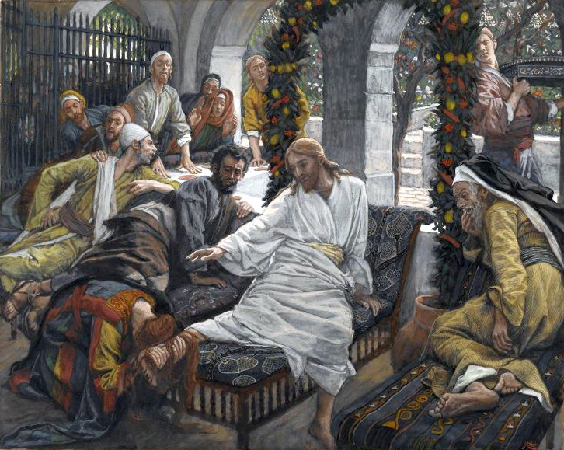Anointing the Feet of Jesus

Worship Service: Sunday 9:30 a.m.

Officiant – Bill Graham — Organist – Dorothy Miller

380 Russell St. North (at Maxwell St.), Sarnia, Ontario N7T 6S6
(519) 344-9531 – Email: canondavis@gmail.com -- http://www.canondavis.com

