Sunday September 11, 2022—14th Sunday after Pentecost
9:30 a.m. Morning Prayer (BCP) p.4

Opening Hymn # 391 Sing Ye Praises to the Father
Greeting

THE GATHERING OF THE COMMUNITY
Exhortation p. 4
General Confession p. 4
Absolution p. 5
The Lord’s Prayer p. 5
Responses p. 6
Venite p. 6

THE PROCLAMATION OF THE WORD
1st Reading Jeremiah 4: 11-12, 22-28
Psalm 14: (responsively at the half verse) BCP p. 343. 344
2nd Reading Timothy 1: 12-17
Gospel Luke 15: 1-10

Benedictus p. 9
The Apostles’ Creed p. 10
Versicles p. 10
The Lord’s Prayer p. 11
Responses p. 11

Collect of the Day Almighty God, you call your Church to witness that in Christ we are reconciled to you. Help us so to proclaim the good news of your love, that all who hear it may turn to you; through Jesus Christ our Lord, who lives and reigns with you and the Holy Spirit, one God, now and for ever. Amen.
Collect for Peace p. 11
Collect for Grace p. 11
Offertory Hymn # 606 There’s a Wideness in God’s Mercy
Offertory Response All Things Come of Thee (sung)

Sermon
Sermon Hymn #428 God Who Gives to Life Its Goodness
Prayer for the Queen and Commonwealth p. 12
Prayer for the Clergy and People p. 13
Prayer for All Conditions of Mortals p. 14
General Thanksgiving (said by all) p. 14
Prayer of Saint Chrysostom p. 15

Prayer for a Renewed Church: Almighty God, give us a new vision of you, of your love, of your grace and power, and then, give us a new vision of what you would have us do as your Church in this nation and at this time, and an awareness that in the strength of your Spirit, we can do it to your glory. In Jesus’ name we pray. Amen.

The Grace p. 15

Announcements

Closing Hymn #619 Fairest Lord Jesus
Dismissal
Officiant Go in peace to love and serve the Lord.
People Thanks be to God.
Sung Benediction Howard’s Blessing (vs 1-2)
(found in the back of the blue hymn book)

The Flowers on the Altar today are given to
the Glory of God, a gift of the Chancel Guild.

NEWS AND EVENTS

- Please send all announcements for the bulletin to Karen by 11:00 a.m.
Tuesday of each week. Call 519-344-9531 or E-mail: canondavis@gmail.com.
- If you would like a home visit with Communion or know of someone who would, please let Rev. Ray know as he and/or a Lay Visitor will be available in the coming weeks.
- Please join us for Coffee Hour after service for a time of fellowship in the
parish hall.
- A big thank you to those who were able to come out for the Fall Clean Up day on Saturday.

Upcoming Events:

18 Sept 2:00 p.m. The Christian Music Café is coming to Canon Davis.
Please join us for this monthly musical event. Refreshments and treats will be available. Free will offering.

21 Sept Please join us for CDM’s famous and delicious “Fish Dinner”. Please call Karen to reserve your seat at 519 344-9531.
Cost: Adults $20.00

24 Sept Sew Day Saturday from 9:00 to 3:00 p.m. Cost $20.00 and lunch included. Bring your projects and we will have show and tell.

28 Sept Parish Council Meeting 10:00 a.m. in the boardroom.

Canon Davis Memorial Church
Anglican Church of Canada

September 11, 2022 – Fourteenth Sunday after Pentecost

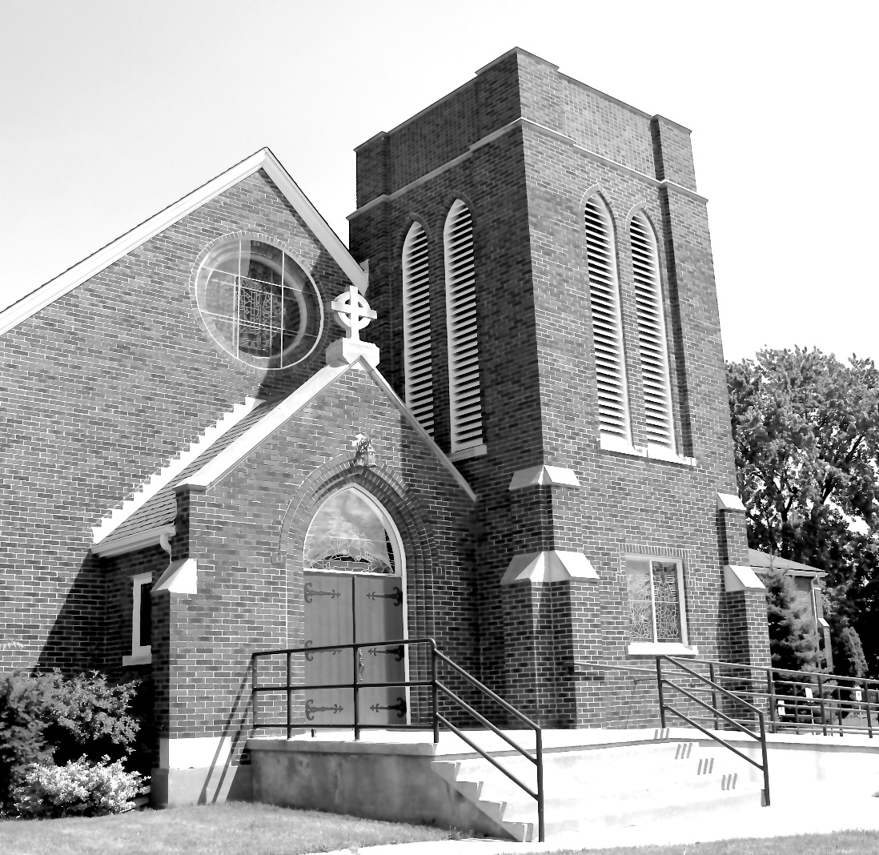

Worship Service: Sunday 9:30 a.m.

Officiant: Bill Graham - Organist: Dorothy Miller - Reader:

380 Russell St. North (at Maxwell St.), Sarnia, Ontario N7T 6S6
(519) 344-9531 – Email: canondavis@gmail.com -- http://www.canondavis.com

