Sunday January 28, 2024—Fourth Sunday after Epiphany
\
9:30 a.m. Morning Prayer (BCP) p.4

Processional Hymn # 306 O for a Thousand Tongues to Sing
Greeting

THE GATHERING OF THE COMMUNITY

Exhortation p. 4
General Confession p. 4
Absolution p. 5
The Lord’s Prayer p. 5
Responses p. 6
Venite p. 6

THE PROCLAMATION OF THE WORD

1st Reading Deuteronomy 18: 15-20
Psalm 111 (responsively alternate verses) BCP p. 477
2nd Reading I Corinthians 8: 1-13
Gospel

The Holy Gospel of our Lord Jesus Christ according to Mark
Glory to you, Lord Jesus Christ.

Mark 1: 21-28

They went to Capernaum; and when the sabbath came, Jesus entered the synagogue and taught. They were astounded at his teaching, for he taught them as one having authority, and not as the scribes. Just then there was in their synagogue a man with an unclean spirit, and he cried out, "What have you to do with us, Jesus of Nazareth? Have you come to destroy us? I know who you are, the Holy One of God." But Jesus rebuked him, saying, "Be silent, and come out of him!" And the unclean spirit, convulsing him and crying with a loud voice, came out of him. They were all amazed, and they kept on asking one another, "What is this? A new teaching - with authority! He commands even the unclean spirits, and they obey him." At once his fame began to spread throughout the surrounding region of Galilee.
The Gospel of Christ.
Praise to you, Lord Jesus Christ.

Benedictus p. 9
The Apostles’ Creed p. 10
Versicles p. 10
The Lord’s Prayer p. 11
Responses p. 11

Collect of the Day
Living God, in Christ you make all things new. Transform the poverty of our nature by the riches of your grace, and in the renewal of our lives make known your glory; through Jesus Christ our Lord, who is alive and reigns with you and the Holy Spirit, one God, now and for ever.

Collect for Peace p. 11
Collect for Grace p. 11
Offertory Hymn # 572 Let There Be Light

Offertory Response All Things Come of Thee (sung)

Sermon

Sermon Hymn # 500 Sister, Let Me Be Your Servant
Prayer for the King and Commonwealth p. 12
Prayer for the Clergy and People p. 13
Prayer for All Conditions of Mortals p. 14
General Thanksgiving (said by all) p. 14
Prayer of Saint Chrysostom p. 15
Prayer for a Renewed Church: Almighty God, give us a new vision of you, of your love, of your grace and power, and then, give us a new vision of what you would have us do as your Church in this nation and at this time, and an awareness that in the strength of your Spirit, we can do it to your glory. In Jesus’ name we pray. Amen.

The Grace p. 15
Announcements

Recessional Hymn # 576 For the Healing of the Nations
Dismissal
Officiant: Go in peace to love and serve the Lord.
People: Thanks be to God.
Sung Benediction Howard’s Blessing (vs. 1-2)
(found in the back of the blue hymn book)

The Flowers on the Altar today are given to
the Glory of God, and in loving memory of Alex Scrimgeour,
a gift of Sylvia and family.
_____________________________________________

NEWS AND EVENTS

- Please send all announcements for the bulletin to Karen by 11:00 a.m. Tuesday of each week or call: 519-344-9531 or email: canondavis@gmail.com.
- If you would like to contact Rev’d Jon Forbes or would like a home visit with Communion or know of someone who would, Rev’d Jon may be reached at 1-905-818-9488 or email jonforbes@outlook.com
- Please join us for Coffee Hour after service for a time of fellowship in the parish hall.

Upcoming Events:
- 2024 Vestry this year is Sunday, February 4, 2024, after the service in the Parish Hall. Vestry packages are available at the back of the church.

Reminders
4 Feb Vestry Meeting - Parish Hall after church service
Canon Davis Memorial Church
Anglican Church of Canada

Sunday, January 28, 2024 – Fourth Sunday after Epiphany

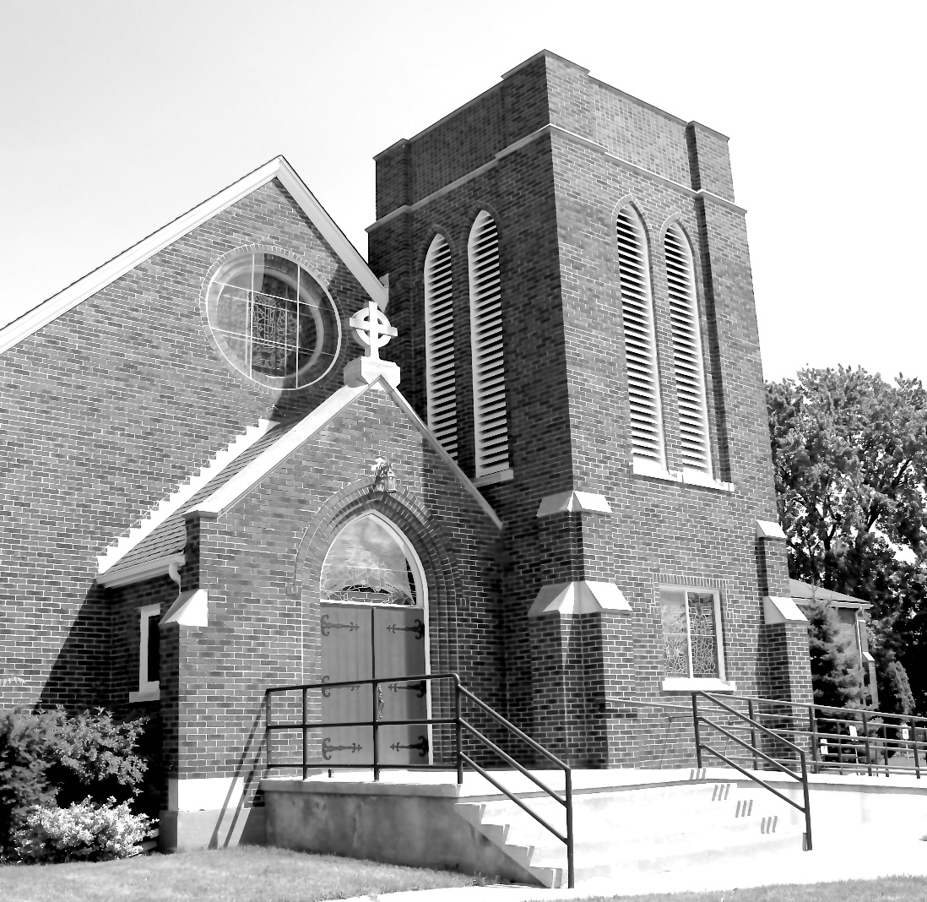

Worship Service: Sunday 9:30 a.m.

Officiant: Bill Graham Organist: Dorothy Miller
380 Russell St. North (at Maxwell St.), Sarnia, Ontario N7T 6S6
(519) 344-9531 – Email: canondavis@gmail.com -- http://www.canondavis.com

