January 29, 2023 — 4th Sunday after Epiphany
9:30 a.m. Morning Prayer (BCP)

Opening Hymn ##388 Glorious Things of Thee are Spoken
Greeting
Exhortation p. 4
General Confession p. 4
Absolution p. 5
The Lord’s Prayer p. 5
Responses p. 6
Venite p. 6

THE PROCLAMATION OF THE WORD

1st Reading Micah 6: 1- 8
Psalm 15 (read by alternate verses) BCP p. 344
2nd Reading 1 Corinthians 1 18-31
Gospel Matthew 5 1-12

Benedictus p. 9
The Apostles’ Creed p. 10
Versicles p. 10
The Lord’s Prayer p. 11
Responses p. 11

Collect of the Day: Living God, in Christ you make all things new. Transform the poverty of our nature by the riches of your grace, and in the renewal of our lives make known your glory; through Jesus Christ our Lord, who is alive and reigns with you and the Holy Spirit, one God, now and for ever. Amen.

Collect for Peace p. 11
Collect for Grace p. 11

Offertory Hymn #439 Blest are the Pure in Heart
Sung Offertory Response Doxology

Sermon - Paul+

Sermon Hymn #619 Fairest Lord Jesus

Prayer for the King and Commonwealth p. 12
Prayer for the Clergy and People p. 13
Prayer for All Conditions of Mortals p. 14
General Thanksgiving (said by all) p. 14
Prayer of Saint Chrysostom p. 15

Prayer for a Renewed Church: Almighty God, give us a new vision of you, of your love, of your grace and power, and then, give us a new vision of what you would have us do as your Church in this nation and at this time, and an awareness that in the strength of your Spirit, we can do it to your glory. In Jesus’ name we pray. Amen.

The Grace p. 15

Announcements

Closing Hymn # 602 Lift High the Cross

Officiant: Go in peace to love and serve the Lord.
People: Thanks be to God.

Sung Benediction Go Now in Peace
(inside back cover of hymn book)

News and Events

- Please send all announcements for the bulletin to Karen by 11:00 a.m. Tuesday of each week. Call: 519-344-9531 or E-mail: canondavis@gmail.com.

- Please enter names in the Intercessions Book each week to be read in the service.

- If you would like a home visit with Communion or know of someone who would, please let Rev. Ray know as he and/or a Lay Visitor will be available in the coming weeks.

- Please join us in the parish hall for The Annual Vestry Meeting after service.

- Please join us on
Sunday February 5 for BAC’s famous Turkey-Ala-King Brunch after church
- Wednesday February 15 for a scrumptious Pork Roast Dinner and Raffle Night. Call 519 344-9531 to reserve your seat. Cost: Adults $20.00 and take out is available and on
- Shrove Tuesday for a Pancake Dinner in the Parish Hall at 5:00 p.m. Cost: Adults $10.00. No reservation needed.

Reminders
Jan 29 Vestry Meeting after church service in the parish hall.
Feb 5 BAC Turkey Ala King Brunch
Feb 15 Pork Roast Dinner 5:00 p.m.
Feb 21 Shrove Tuesday Pancake Dinner 5:00 p.m.

Canon Davis Memorial Church
Anglican Church of Canada
January 29th, 2023
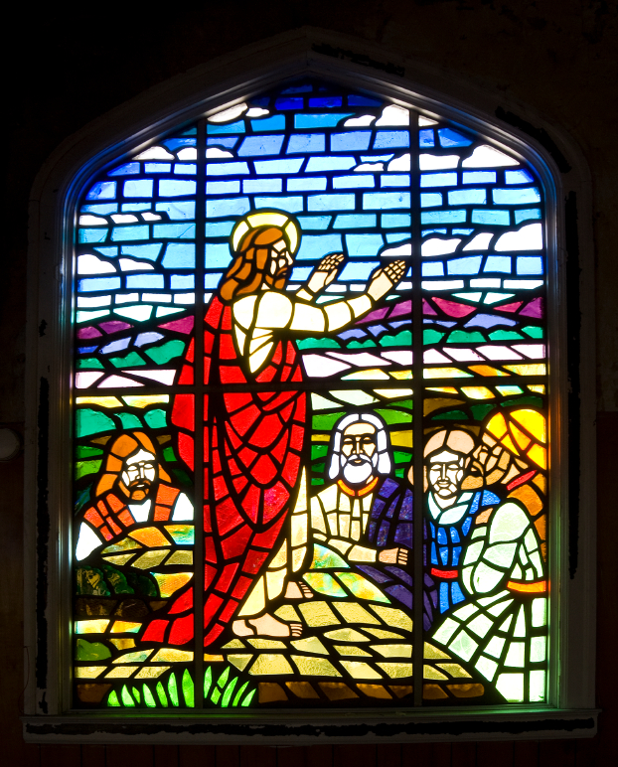
Fourth Sunday after Epiphany

We come and worship God.
We go our way with souls nourished.

Officiant: Rev’d Paul Woolley
Organist: Dorothy Miller Reader: Simone Le Bel
80 Russell St. North (at Maxwell St.), Sarnia, Ontario, N7T 6S6
Tel: (519) 344-9531 - Email: canondavis@gmail.com – http://www.canondavis.com

