Canon Davis Memorial Church
Anglican Church of Canada
Sunday, February 5, 2023 – Fifth Sunday after Epiphany

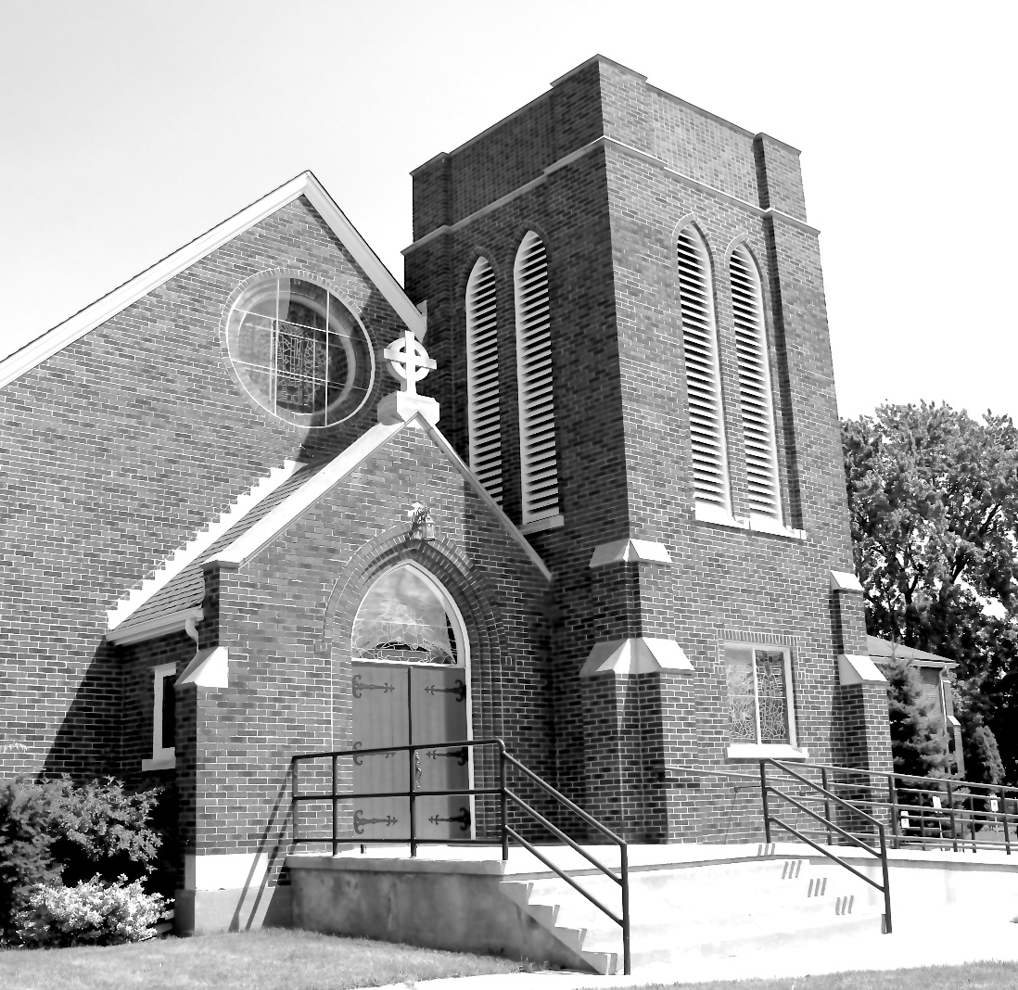

We come and worship God.
We go our way with souls nourished.
Worship Service: Sunday 9:30 a.m.
380 Russell St. North (at Maxwell St.), Sarnia, Ontario, N7T 6S6
(519) 344-9531 - http://www.canondavis.com – http://www.canon davis.com
Canon Davis Memorial Church
Anglican Church of Canada
Sunday, February 5, 2023 – 5th Sunday after Epiphany
9:30 a.m. Holy Eucharist
Officiant—Rev. Ray Jenkins — Assisted By — Tom Brown
Organist—Dorothy Miller

THE GATHERING OF THE COMMUNITY

Opening Hymn #525 The Church’s One Foundation

The grace of our Lord Jesus Christ, and the love of God, and the fellowship of the Holy Spirit, be with you all.
And also with you.

Almighty God, to you all hearts are open, all desires known, and from you no secrets are hidden. Cleanse the thoughts of our hearts by the inspiration of your Holy Spirit, that we may perfectly love you, and worthily magnify your holy name; through Christ our Lord. Amen.

Glory to God in the highest, and peace to his people on earth.
Lord God, heavenly king, almighty God and Father, we worship you, we give you thanks, we praise you for your glory.

Lord Jesus Christ, only Son of the Father, Lord God, Lamb of God, you take away the sin of the world: have mercy on us; you are seated at the right hand of the Father: receive our prayer.

For you alone are the Holy One, you alone are the Lord, you alone are the Most High, Jesus Christ, with the Holy Spirit, in the glory of God the Father. Amen.

Lord, have mercy. Christ, have mercy. Lord, have mercy.
COLLECT OF THE DAY
Merciful Lord, grant to your faithful people pardon and peace, that we may be cleansed from all our sins and serve you with a quiet mind, through Jesus Christ our Lord, who is alive and reigns with you and the Holy Spirit, one God, now and for ever.

THE PROCLAMATION OF THE WORD

1st Reading: Isaiah 58: 1-9a

Shout out, do not hold back! Lift up your voice like a trumpet! Announce to my people their rebellion, to the house of Jacob their sins. Yet day after day they seek me and delight to know my ways, as if they were a nation that practiced righteousness and did not forsake the ordinance of their God, they ask of me righteous judgements, they delight to draw near to god. “Why do we fast, but you do not see? Why humble ourselves, but you do not notice?” Look, you serve your own interest on your fast day, and oppress all your workers. Look you fast only to quarrel and to fight and to strike with a wicked fist. Such fasting as you do today will not make your voice heard on high. Is such the fast that I choose, a day to humble oneself? Is it to bow down the head like a bulrush, and to lie in sackcloth and ashes? Will you call this a fast, a day acceptable to the Lord? Is not this the fast that I choose: to loose the bonds of injustice, to undo the thongs of the yoke, to let the oppressed go free and to break every yoke? Is it not to share your bread with the hungry, and bring the homeless poor into your house, when you see the naked, to cover them, and not to hide yourself from your own kin? Then your light shall break forth like the dawn, and your healing shall spring up quickly, your vindicator shall go before you, the glory of the Lord shall be your rear guard. Then you shall call, and the Lord will answer, you shall cry for help, and he will say, Here I am.

The Word of the Lord.
Thanks be to God.
Psalm 112: 1-9 (to be read responsively)

Hallelujah! Happy are they who fear the Lord and have great delight in his commandments!

Their descendants will be mighty in the land, the generation of the upright will be blessed.

Wealth and riches will be in their house, and their righteousness will last for ever

Light shines in the darkness for the upright, the righteous are merciful and full of compassion.

It is good for them to be generous in lending and to manage their affairs with justice.

For they will never be shaken, the righteous will be kept in everlasting remembrance.

They will not be afraid of any evil rumours, their heart is right, they put their trust in the Lord.

Their heart is established and will not shrink, until they see their desire upon their enemies.

They have given freely to the poor, and their righteousness stands fast for ever, they will hold up their head with honour.

2nd Reading: I Corinthians 2: 1-12

When I came to you, brothers and sisters, I did not come proclaiming the mystery of God to you in lofty words or wisdom. For I decided to know nothing among you except Jesus Christ, and him crucified. And I came to you in weakness and in fear and in much trembling. My speech and my proclamation were not with plausible words of wisdom, but with a demonstration of the Spirit and of power, so that your faith might rest not on human wisdom but on the power of God. Yet among the mature we do speak wisdom, though it is not a wisdom of this age or of the rulers of this age, who are doomed to perish. But we speak God’s wisdom, secret and hidden, which God decreed before the ages for our glory. None of the rulers of this age understood this, for if they had, they would not have crucified the Lord of glory. But, as it is written, “What no eye has seen, nor ear heard, nor the human heart conceived, what God has prepared for those who love him” – these things God has revealed to us through the Spirt, for the Spirt searches everything, even the depths of God. For what human being knows what is truly human except the human spirit that is within? So also no one comprehends what is truly God’s except the Spirit of God. Now we have received not the spirit of the world, but the Spirit that is from God, so that we may understand the gifts bestowed on us by God.

The Word of the Lord
Thanks be to God.

Gospel Matthew 5: 13-20
THE HOLY GOSPEL OF OUR LORD JESUS CHRIST
ACCORDING TO MATTHEW

Glory to you, Lord Jesus Christ.

Jesus said, “You are the salt of the earth, but if salt has lost its taste, how can its saltiness be restored? It is no longer good for anything, but is thrown out and trampled under foot. You are the light of the world. A city built on a hill cannot be hid. No one after lighting a lamp put it under the bushel basket, but on the lampstand, and it give light to all in the house. In the same way, let your light shine before others, so that they may see the good works and give glory to your Father in heaven. Do not think that I have come to abolish the law or the prophets, I have come not to abolish but to fulfil. For truly I tell you, until heaven and earth pass away, not one letter, not one stroke of a letter, will pass from the law until all is accomplished. Therefore, whoever breaks one of the least of these commandments, and teaches others to do the same, will be called least in the kingdom of heaven, but whoever does them and teaches them will be called great in the kingdom of heaven. For I tell you, unless your righteousness exceeds that of the scribes and Pharisees, you will never enter the kingdom of heaven.

The Gospel of Christ.
Praise to you, Lord Jesus Christ.

Sermon
Sermon Hymn #439 Blest Are the Pure in Heart

The Apostles’ Creed:

Let us confess the faith of our baptism, as we say,
I believe in God, the Father almighty, creator of heaven and earth. I believe in Jesus Christ, his only Son, our Lord. He was conceived by the power of the Holy Spirit and born of the Virgin Mary. He suffered under Pontius Pilate, was crucified, died, and was buried. He descended to the dead. On the third day he rose again. He ascended into heaven, and is seated at the right hand of the Father. He will come again to judge the living and the dead. I believe in the Holy Spirit, the holy catholic Church, the communion of saints, the forgiveness of sins, the resurrection of the body, and the life everlasting. Amen.

Prayers of the People #9
(Let us pray to the Lord, saying, “Lord, have mercy.”)

Let us ask the Lord for a day of fulfilment and peace.
Lord, have mercy.

Let us ask the Lord to teach us to love others as he has loved us.
Lord, have mercy.

Let us ask the Lord for peace and justice in the world.
Lord, have mercy.

Let us ask the Lord to strengthen and relieve those who are in need.
Lord, have mercy.

Let us ask the Lord to renew the Church through the power of his life-giving Spirit.
Lord, have mercy.

In our parish cycle of prayer, we pray for…

PRAYER FOR A RENEWED CHURCH: Almighty God, give us a new vision of you, of your love, of your grace and power, and then, give us a new vision of what you would have us do as your Church in this nation and at this time, and an awareness that in the strength of your Spirit, we can do it to your glory. In Jesus’ name we pray. Amen.

Confession and Absolution: Dear friends in Christ, God is steadfast in love and infinite in mercy; he welcomes sinners and invites them to his table. Let us confess our sins, confident in God’s forgiveness.

The Confession: Most merciful God,
we confess that we have sinned against you in thought, word, and deed, by what we have done, and by what we have left undone. We have not loved you with our whole heart; we have not loved our neighbours as ourselves. We are truly sorry and we humbly repent. For the sake of your Son Jesus Christ, have mercy on us and forgive us, that we may delight in your will, and walk in your ways, to the glory of your name. Amen.

Absolution: Almighty God have mercy upon you, pardon and deliver you from all your sins, confirm and strengthen you in all goodness, and keep you in eternal life; through Jesus Christ our Lord. Amen.
The Peace
Gentle peace…
Flows freely
Encircles fully
Refreshes gently
Comforts warmly
Reassures softly
Forgives easily
Fulfils entirely
Gentle peace…

The peace of the Lord be always with you.
And also with you.

Offertory Hymn #645 Come Down, O Love Divine

Offertory Response Doxology

Praise God, from Whom all blessings flow
Praise Him, all creatures here below.
Praise Him above, ye Heavenly Host.
Praise Father, Son, and Holy Ghost.

PRAYER OVER THE GIFTS:

God of compassion and forgiveness, receive our offering this day, and make us one with him who is our peace, Jesus Christ our Saviour.

EUCHARISTIC PRAYER # 5
The Lord be with you.
And also with you.

Lift up your hearts.
We lift them to the Lord.

Let us give thanks to the Lord our God.
It is right to give our thanks and praise.

We give you thanks and praise, almighty God, for the gift of a world full of wonder, and for our life which comes from you. By your power you sustain the universe.
Glory to you for ever and ever.

You created us to love you with all our heart, and to love each other as ourselves, but we rebel against you by the evil that we do.

In Jesus, your son, you bring healing to our world and gather us into one great family. Therefore, with all who serve you on earth and in heaven, we praise your wonderful name, as we say,

Holy, holy, holy Lord,
God of power and might,
heaven and earth are full of your glory.
Hosanna in the highest.

Blessed is he who comes in the name of the Lord. Hosanna in the highest.

We give you thanks and praise, loving Father, because in sending Jesus, your Son, to us you showed us how much you love us. He cares for the poor and the hungry. He suffers with the sick and the rejected.

Betrayed and forsaken, he did not strike back but overcame hatred with love.

On the cross he defeated the power of sin and death. By raising him from the dead you show us the power of your love to bring new life to all your people.
Glory to you for ever and ever.

On the night before he gave up his life for us, Jesus, at supper with his friends, took bread, gave thanks to you, broke it, and gave it to them, saying, “Take this, all of you, and eat it: this is my body which is given for you.”
After supper, Jesus took the cup of wine, said the blessing, gave it to his friends, and said, “Drink this, all of you: this is the cup of my blood, the blood of the new and eternal covenant, which is shed for you and for many, so that sins may be forgiven. Do this in memory of me.”
Glory to you for ever and ever.

Gracious God, with this bread and wine we celebrate the death and resurrection of Jesus, and we offer ourselves to you in him.

Send your Holy Spirit on us and on these gifts, that we may know the presence of Jesus in the breaking of bread, and share in the life of the family of your children.
Glory to you for ever and ever.

Father, you call us to be your servants; fill us with the courage and love of Jesus, that all the world may gather in joy at the table of your kingdom.

We sing your praise, almighty Father, through Jesus, our Lord, in the power of the Holy Spirit, now and for ever.
Glory to you for ever and ever. Amen.

The Lord’s Prayer: Our Father, who art in heaven, hallowed be thy name, thy kingdom come, thy will be done, on earth as it is in heaven. Give us this day our daily bread. And forgive us our trespasses, as we forgive those who trespass against us. And lead us not into temptation, but deliver us from evil. For thine is the kingdom, the power, and the glory, for ever and ever. Amen.

Breaking of the Bread:
We break this bread to share in the body of Christ.
We, being many, are one body, for we all share in the one bread.

The Communion
The gifts of God for the people of God.
Thanks be to God.
PRAYER AFTER COMMUNION:
Eternal God, in you we find peace beyond all telling. May we who share in this heavenly banquet be instruments of your peace on earth, in the name of Jesus Christ the Lord.

Doxology
Glory to God, Whose power, working in us, can do infinitely more than we can ask or imagine. Glory to God from generation to generation, in the Church and in Christ Jesus, for ever and ever. Amen.

Blessing
The peace of God which passes all understanding, keep your hearts and minds in the knowledge and love of God and of his son Jesus Christ and the blessing of God Almighty the Father, the Son and the Holy Spirit be with you and those you love for ever more. Amen.

Announcements
Recessional Hymn # 502 You Are Salt for the Earth
Benediction Song Go Now in Peace
(found in the back of the blue hymn book)

The flowers on the Altar today are given to
the Glory of God and celebrating the joy and happiness our families have shared and in loving memory of friends and family, a gift of the Heasmans.

Please enter names in the Intercessions Book each week to be read in the service.

NEWS AND EVENTS

- Please send all announcements for the bulletin to Karen by 11:00 a.m. Tuesday of each week. E-mail: canondavis@gmail.com or call 519-344-9531
- If you would like a home visit with Communion or know of someone who would, please let Rev. Ray know as he and/or a Lay Visitor will be available in the coming weeks.
- Please join us after the service for BAC’s famous Turkey-Ala-King Brunch and for a time of fellowship in the parish hall.
- Happy Birthday and best wishes to Mary Warren, Faye Farnworth, Diana Duke, Tom Brown from all your friends and CDM.

Upcoming Events:

- Wednesday February 15 for a scrumptious Pork Roast Dinner and Raffle Night. Call 519 344-9531 to reserve your seat. Cost: Adults $20.00 and take out is available.
- Shrove Tuesday for a Pancake Dinner in the Parish Hall at 5:00 p.m. Cost: Adults $10.00. No reservation needed. And, No Take-Out.

Reminders
Feb 5 BAC Turkey Ala King Brunch
Feb 15 Pork Roast Dinner 5:00 p.m.
Feb 21 Shrove Tuesday Pancake Dinner 5:00 p.m.
Feb 23 Parish Council Meeting – Boardroom 10:00 a.m.

