Sunday October 16, 2022—19th Sunday after Pentecost
9:30 a.m. Morning Prayer (BCP) p.4

Opening Hymn # 387 All Praise to Thee
Greeting

THE GATHERING OF THE COMMUNITY

Exhortation p. 4
General Confession p. 4
Absolution p. 5
The Lord’s Prayer p. 5
Responses p. 6
Venite p. 6

THE PROCLAMATION OF THE WORD

1st Reading Jeremiah 31: 27-34
Psalm 119: 97-104 (responsively at the half verse) BCP p. 491
2nd Reading II Timothy 3: 14, 4: 5
Gospel Luke 18: 1-8
Benedictus p. 9
The Apostles’ Creed p. 10
Versicles p. 10
The Lord’s Prayer p. 11
Responses p. 11

Collect of the Day Almighty and everliving God, increase in us your gift of faith, that forsaking what lies behind and reaching out to what is before, we may run the way of your commandments and win the crown of everlasting joy; through Jesus Christ our Lord, who lives and reigns with you and the Holy Spirit, one God, now and for ever. Amen.
Collect for Peace p. 11
Collect for Grace p. 11
Offertory Hymn # 531 You Who Dwell in the Shelter of the Lord
Offertory Response All Things Come of Thee (sung)

Sermon
Sermon Hymn #615 Just As I Am
Prayer for the Queen and Commonwealth p. 12
Prayer for the Clergy and People p. 13
Prayer for All Conditions of Mortals p. 14
General Thanksgiving (said by all) p. 14
Prayer of Saint Chrysostom p. 15

Prayer for a Renewed Church: Almighty God, give us a new vision of you, of your love, of your grace and power, and then, give us a new vision of what you would have us do as your Church in this nation and at this time, and an awareness that in the strength of your Spirit, we can do it to your glory. In Jesus’ name we pray. Amen.

The Grace p. 15

Announcements

Closing Hymn # 565 Guide Me, O Thou Great Jehovah
Dismissal
Officiant Go in peace to love and serve the Lord.
People Thanks be to God.
Sung Benediction Go Now in Peace
(found in the back of the blue hymn book)

The Flowers on the Altar today are given to
the Glory of God, and in loving memory of Cliff Farnworth, a gift of his wife, Faye and Family.

NEWS AND EVENTS

- Please send all announcements for the bulletin to Karen by 11:00 a.m.
Tuesday of each week. Call 519-344-9531 or E-mail: canondavis@gmail.com.
- If you would like a home visit with Communion or know of someone who would, please let Rev. Ray know as he and/or a Lay Visitor will be available in the coming weeks.
- Please join us for Coffee Hour after service for a time of fellowship in the parish hall.
- Mark your calendars as on Saturday October 29 and November 29 Sew Day returns to CDM from 9:00 till 3:00 p.m. Cost $20.00, lunch included. Bring your projects for a show and tell Sew Day.

Upcoming Events:

Oct 26 Parish Council Meeting at 10:00 a.m. in the Boardroom
Oct 29 Sew Day in the Parish Hall
Nov 29 Sew Day in the Parish Hall

Canon Davis Memorial Church
Anglican Church of Canada

October 16, 2022 – Nineteenth Sunday after Pentecost

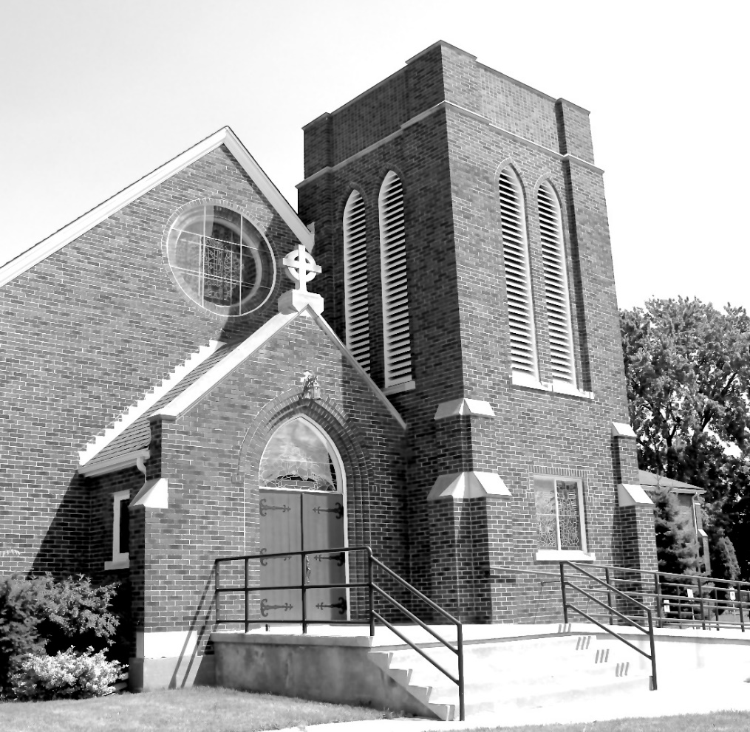

We come and worship God.
We go our way with souls nourished.

Worship Service: Sunday 9:30 a.m.
Officiant: Bill Graham - Organist: Dorothy Miller
380 Russell St. North (at Maxwell St.), Sarnia, Ontario N7T 6S6
(519) 344-9531 – Email: canondavis@gmail.com -- http://www.canondavis.com

